Daily Scrum or Standup Meeting
Team name: Marianas Trench
Scrum Master: Benji Stewart
Date: 11/6/19

Team Member | What did you do since the last scrum? | What do you plan to do before the next scrum? | What obstacles do you have?
Errick Aliifua | Worked on Profile page | Finish User profile page | Django
Elijiah Blake | Got stuck on other homework | Finish the add items page | Homework from other classes  work schedule because of a deadline coming up
Connor Osborne | We have an email account that sends emails for profile activation | Make activation work | Homework
Benji Stewart | Not since monday | Work on favorite items page or current bids page | Need database test info  General javascript knowledge

Burndown
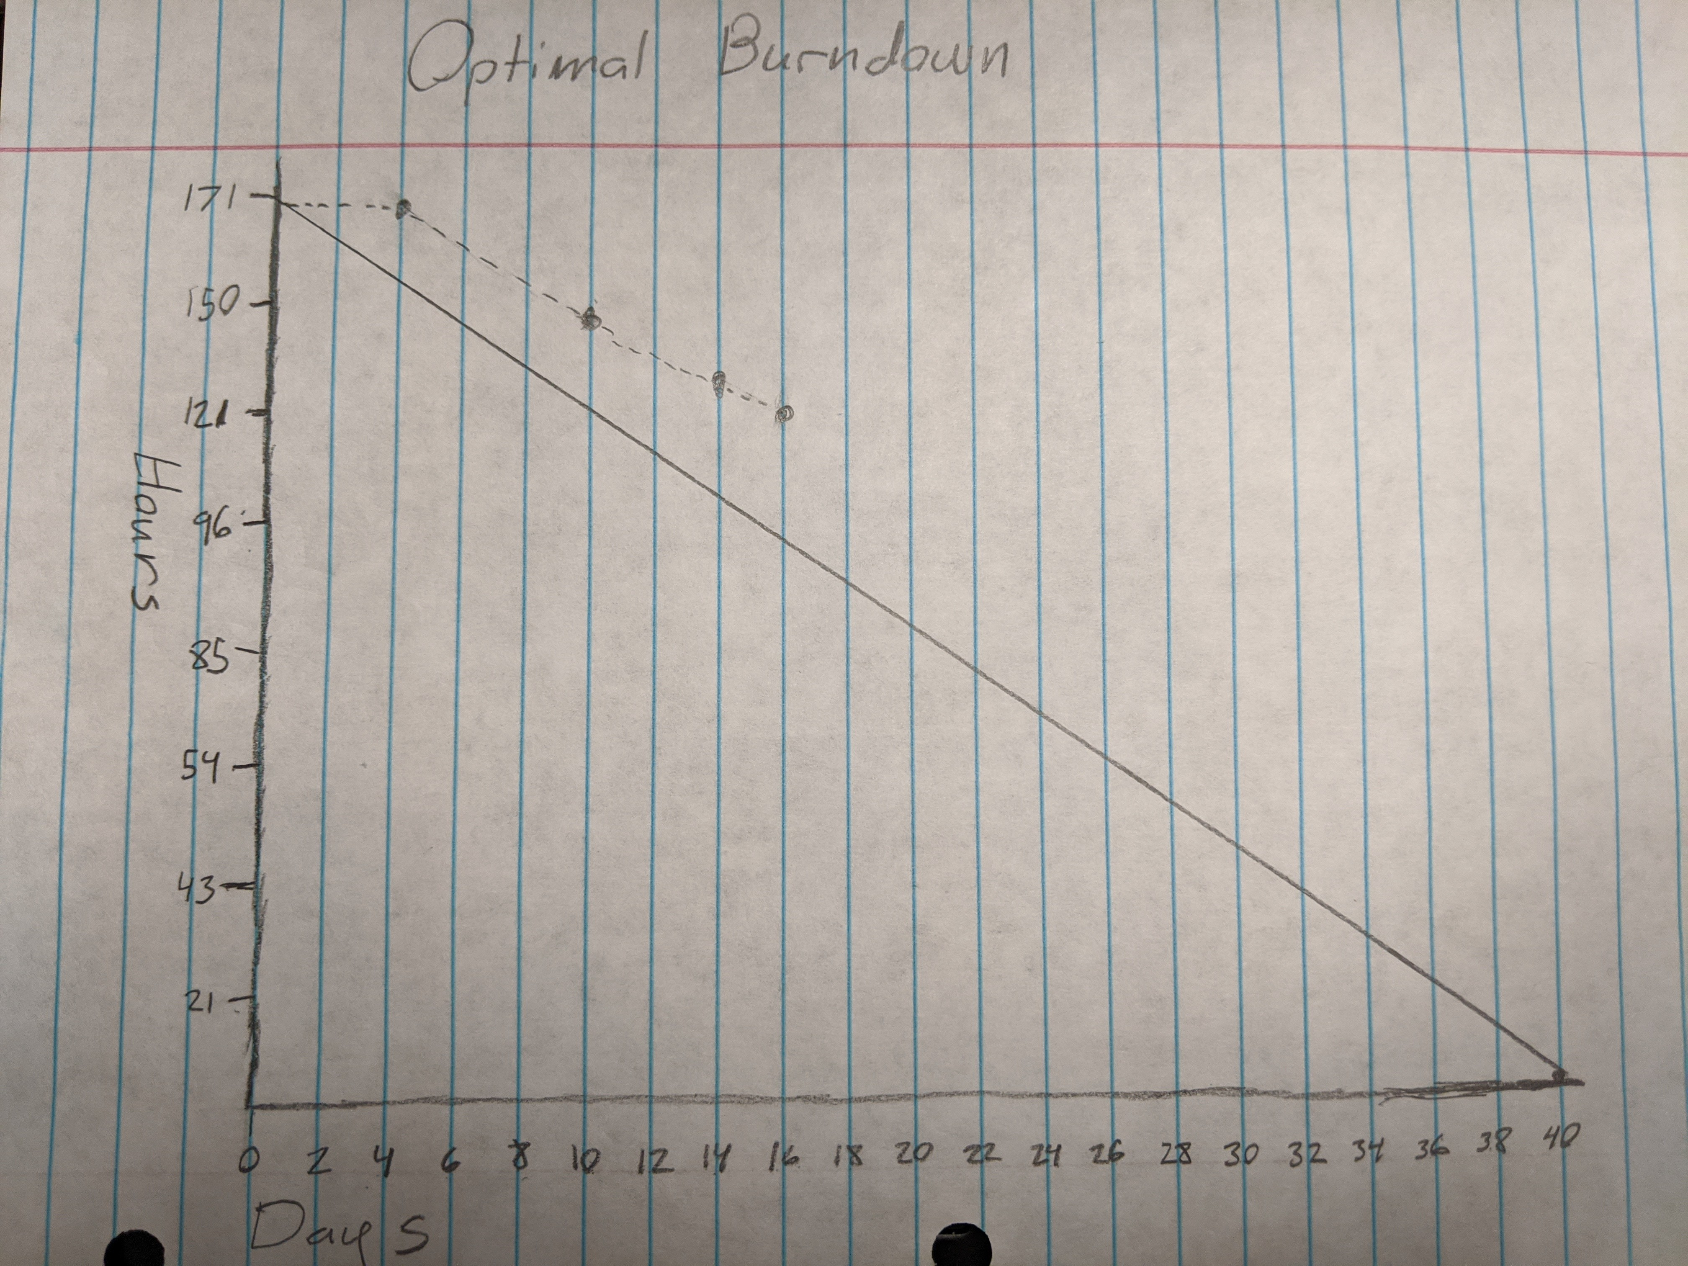

Screenshot of your project board

