Daily Scrum or Standup Meeting
Team name: Marianas Trench
Scrum Master: Benji Stewart
Date: 11/13/19

Team Member | What did you do since the last scrum? | What do you plan to do before the next scrum? | What obstacles do you have?
Errick Aliifua | finished the profile page and started working on the starting auction | will finish the start auction and pull another issue to work on | Ranch  (food sickness)
Elijiah Blake | Varified the Django admin page functionality for the add items  Got most of the details view page done | Finish details view page | Homework from other classes  work schedule because of a deadline coming up  HACKUSU
Connor Osborne | User Id  refactoring login info | Make the favorites list model for the databse | Other members parts so they can be incorporated together.
Benji Stewart | Got the navigation pop down menu and get items from the database | Get the images displaying correctly and do the favorites page

Burndown

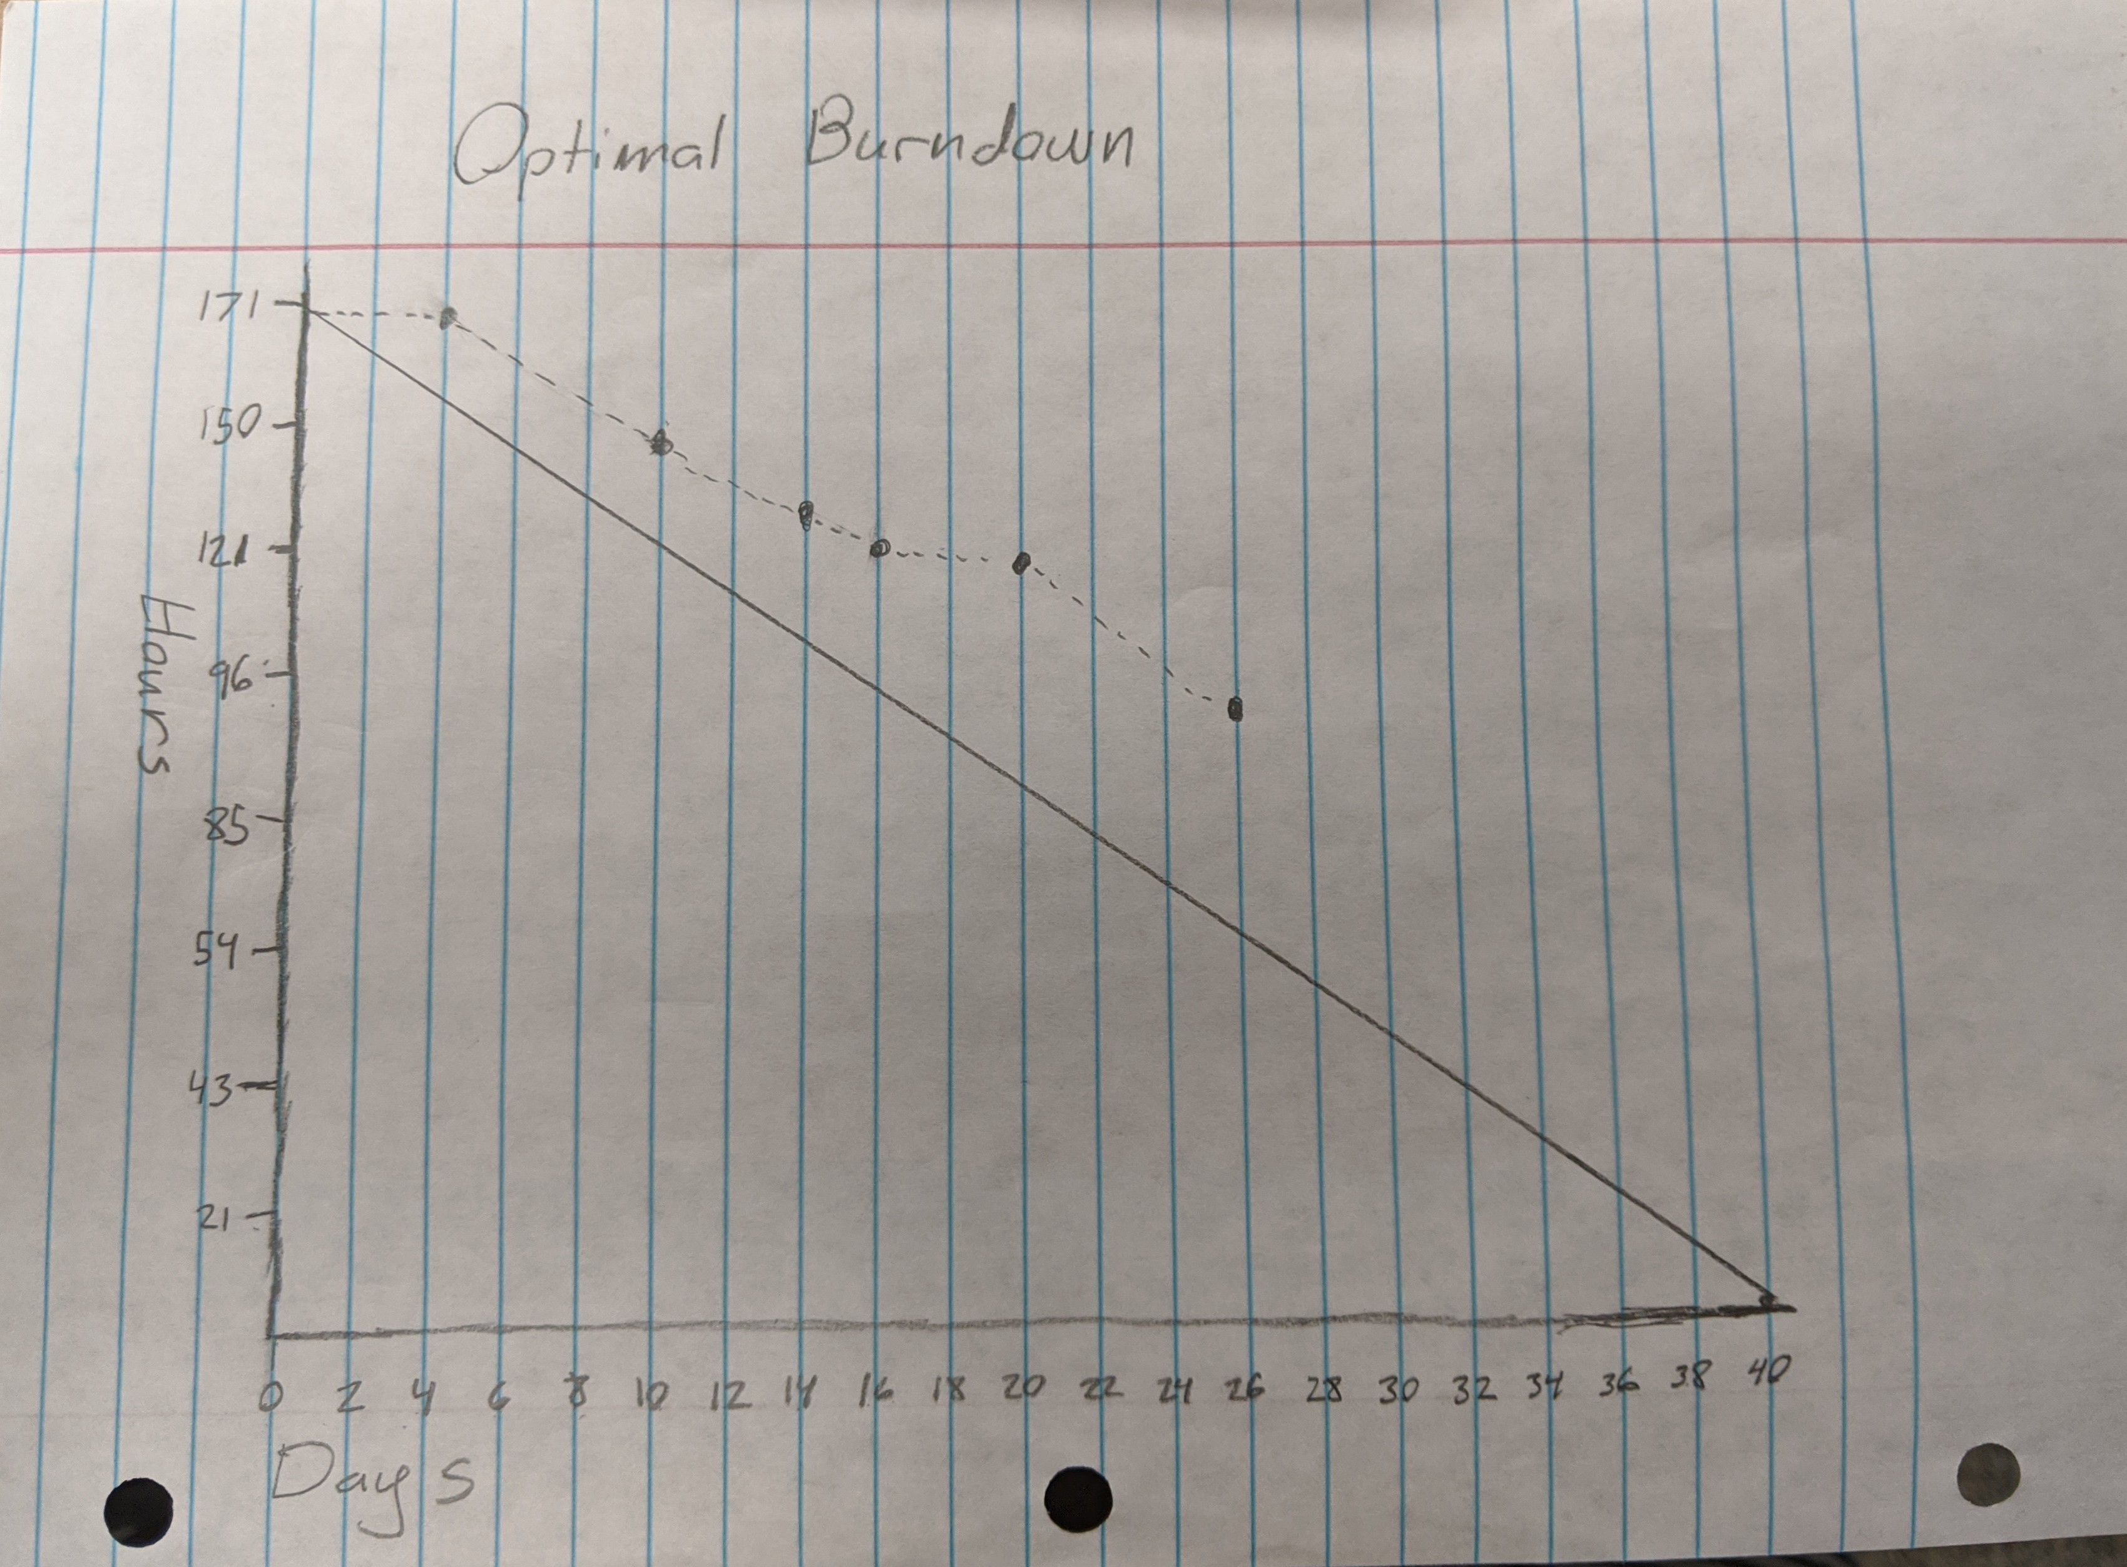

Screenshot of your project board

