Daily Scrum or Standup Meeting
Team name: Marianas Trench
Scrum Master: Benji Stewart
Date: 11/15/19

Team Member | What did you do since the last scrum? | What do you plan to do before the next scrum? | What obstacles do you have?
Errick Aliifua | Refactoring, and working on the favorites model. | Finish favorites model and view | Homework in other classes.
Elijiah Blake | I didn’t get more done the last two days because of my lab finals | Finish details view page | Homework from other classes  work schedule because of a deadline coming up  HACKUSU
Connor Osborne | Not here today | Make the favorites list model for the databse (Same as before) | Not here today
Benji Stewart | No since two days ago | Get the images displaying correctly and do the favorites page | Time  HackUSU

Burndown

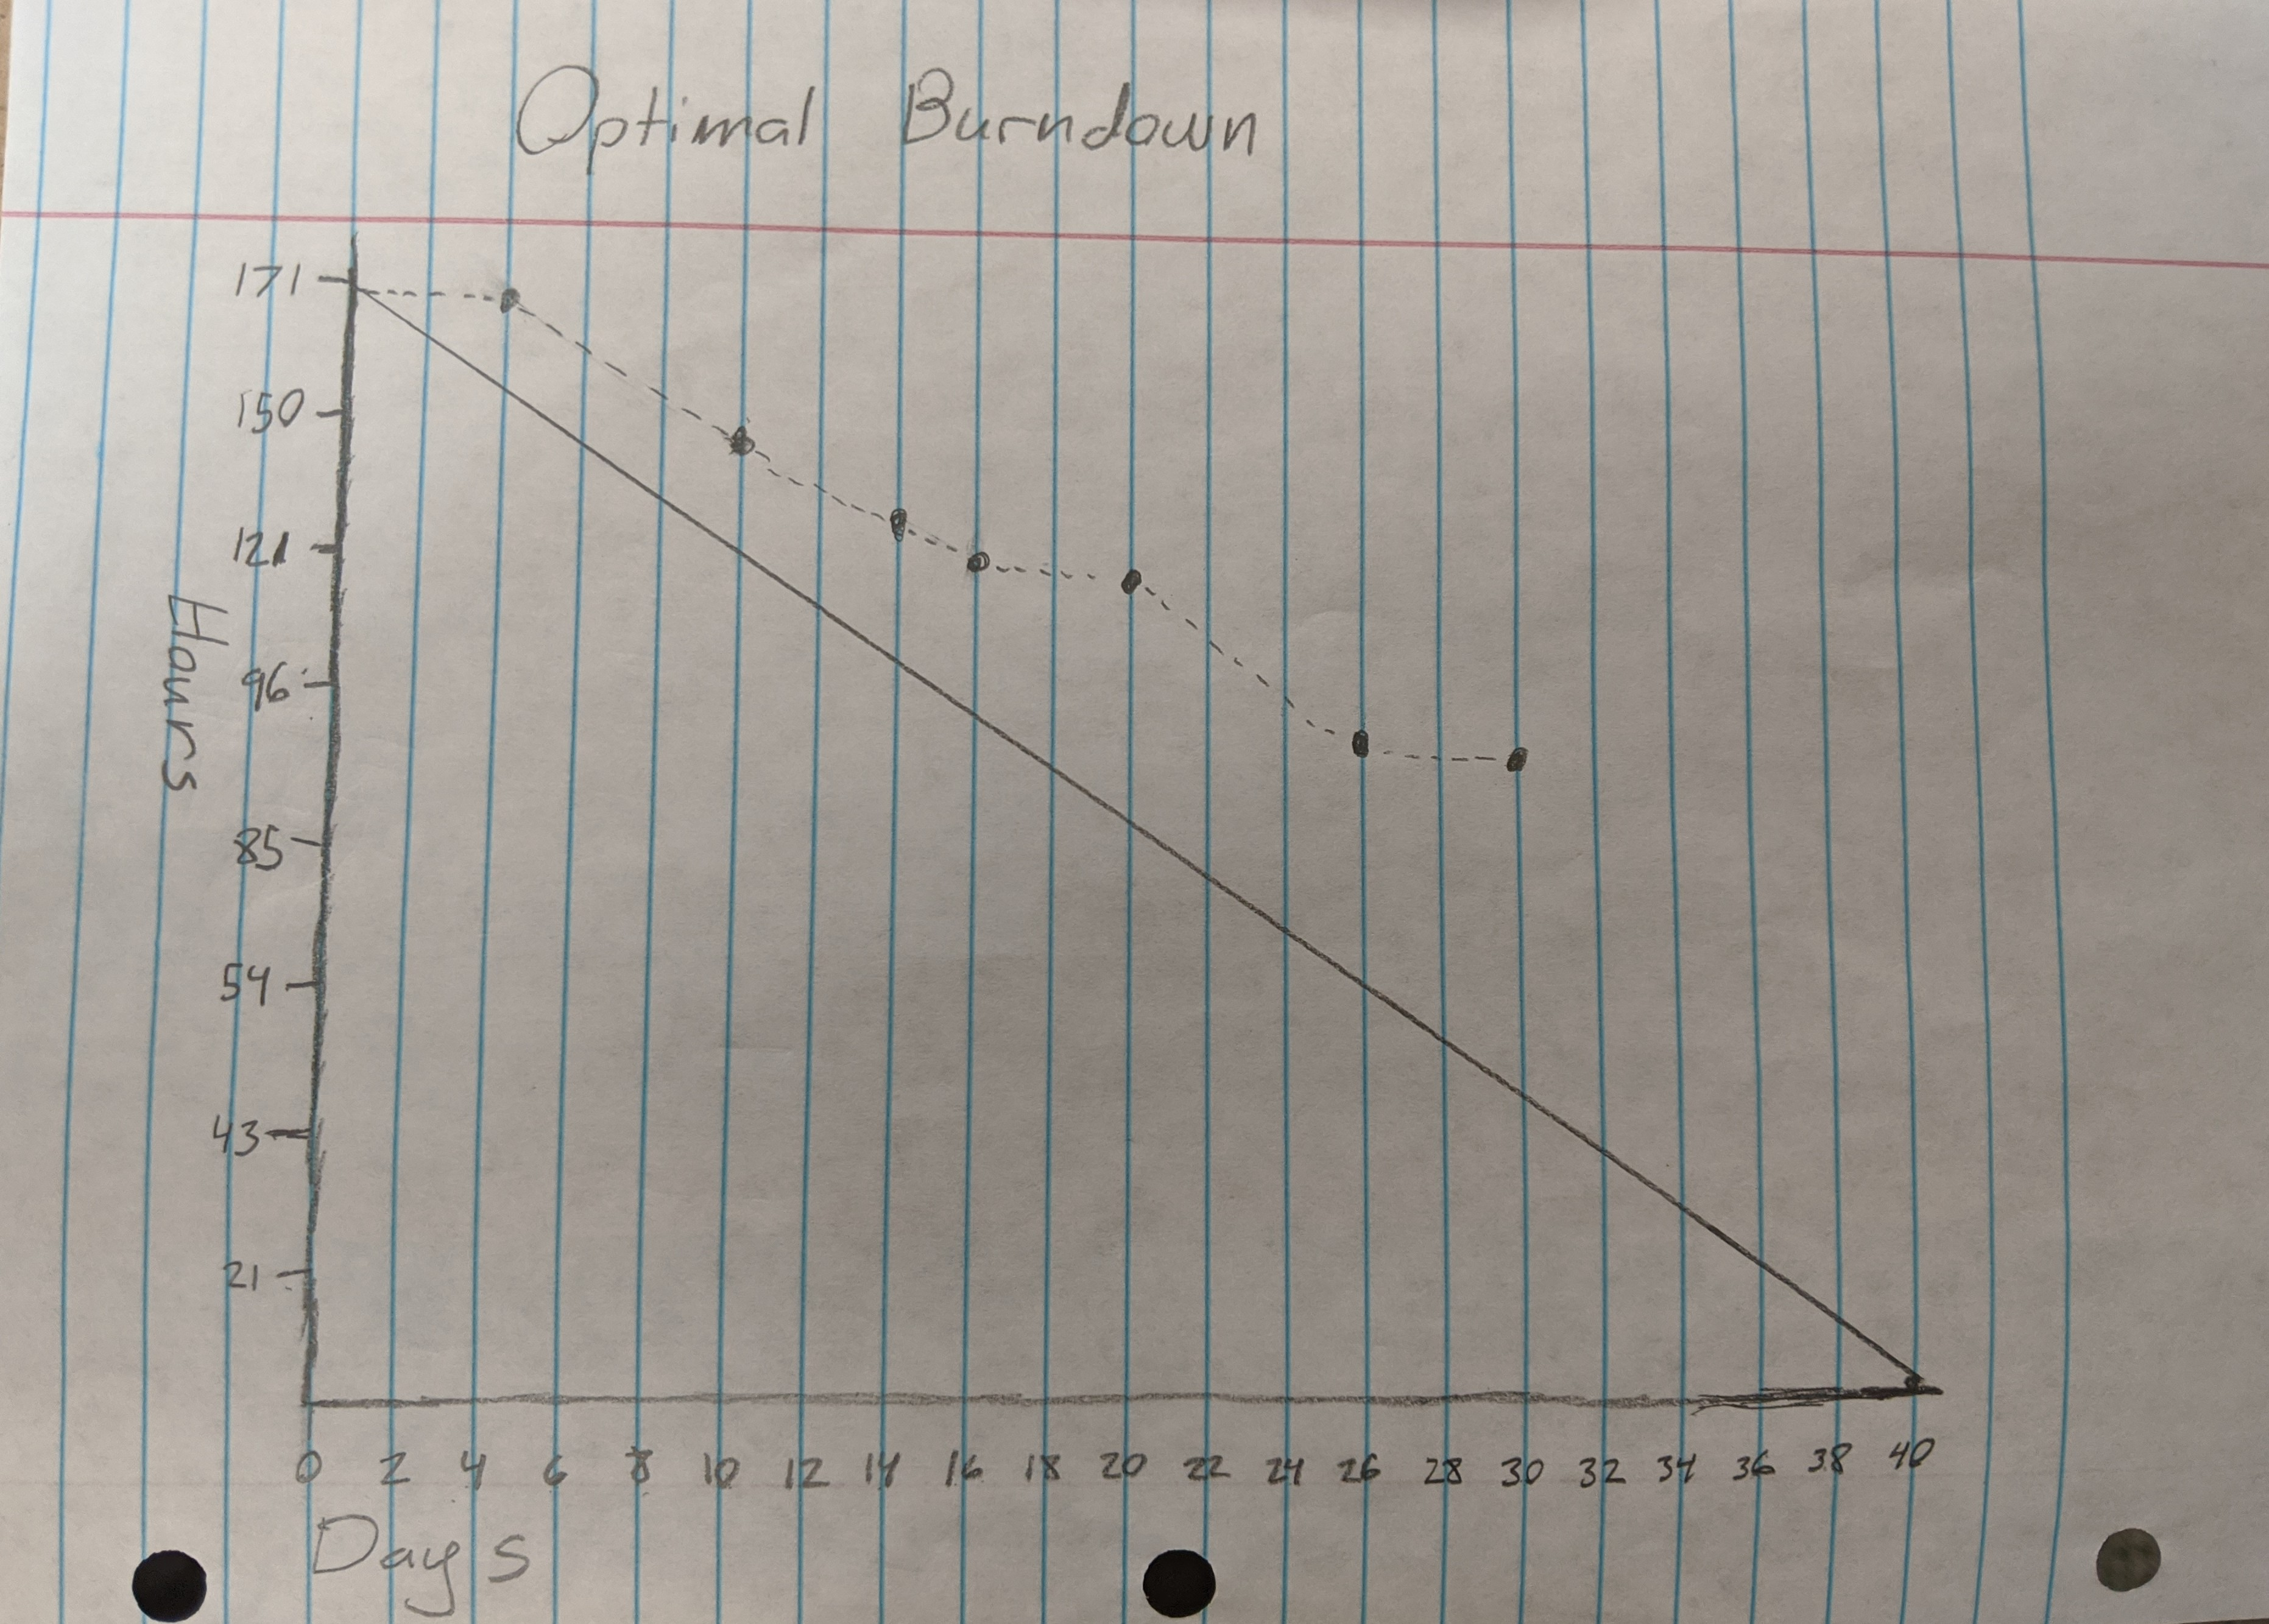

Screenshot of your project board

