Daily Scrum or Standup Meeting
Team name: Marianas Trench
Scrum Master: Benji Stewart
Date: 11/18/19

Team Member | What did you do since the last scrum? | What do you plan to do before the next scrum? | What obstacles do you have?
Errick Aliifua | Not since last | Finish start auction | Homework
Elijiah Blake | Got research done for unit tests in Django and worte two tests that work for the urls.py file | Finish the unit tests | An exam and 2 OTHER final projects due this wekk
Connor Osborne | Favorites model and view mostly done but not tested ;) | Get favorites tested and confirmed working | Homework in other classes
Benji Stewart | Not | Final projects for other classes | A presentation in another class

Burndown

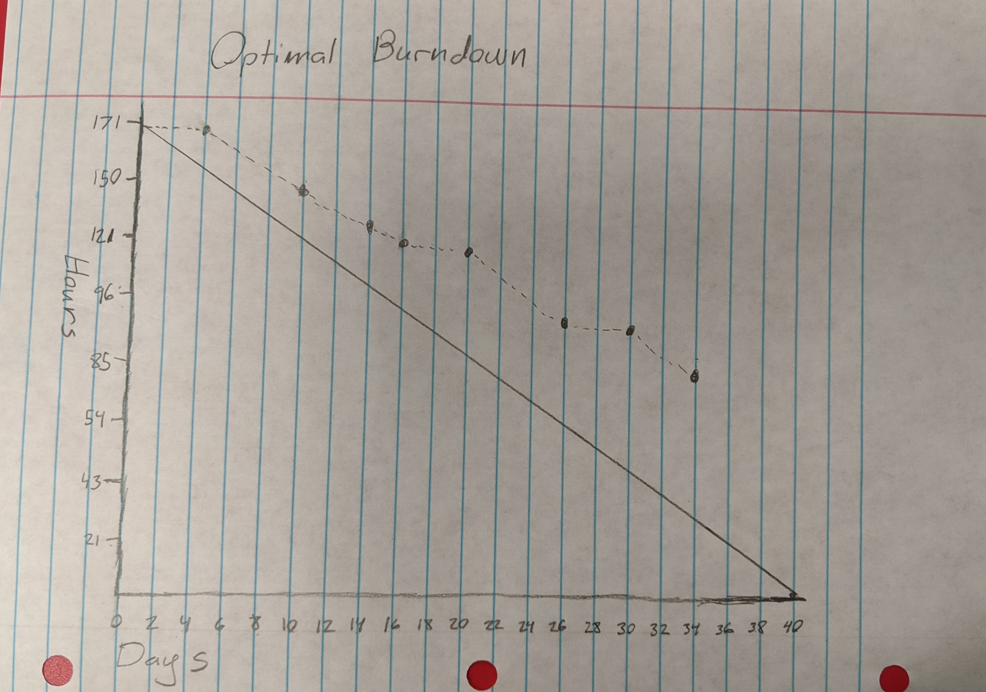

Screenshot of your project board

