Daily Scrum or Standup Meeting
Team name: Marianas Trench
Scrum Master: Benji Stewart
Date: 11/20/19

Team Member | What did you do since the last scrum? | What do you plan to do before the next scrum? | What obstacles do you have?
Errick Aliifua | Not since last | Finish start auction | Time
Elijiah Blake | Not since last time | Finish the view items page | final projects due this wekk
Connor Osborne | Updated databse models | Make sure pages all link correctly | Other classwork
Benji Stewart | Not since last time | Fix Images redering | Knowledge of django framework  Bugs

Burndown
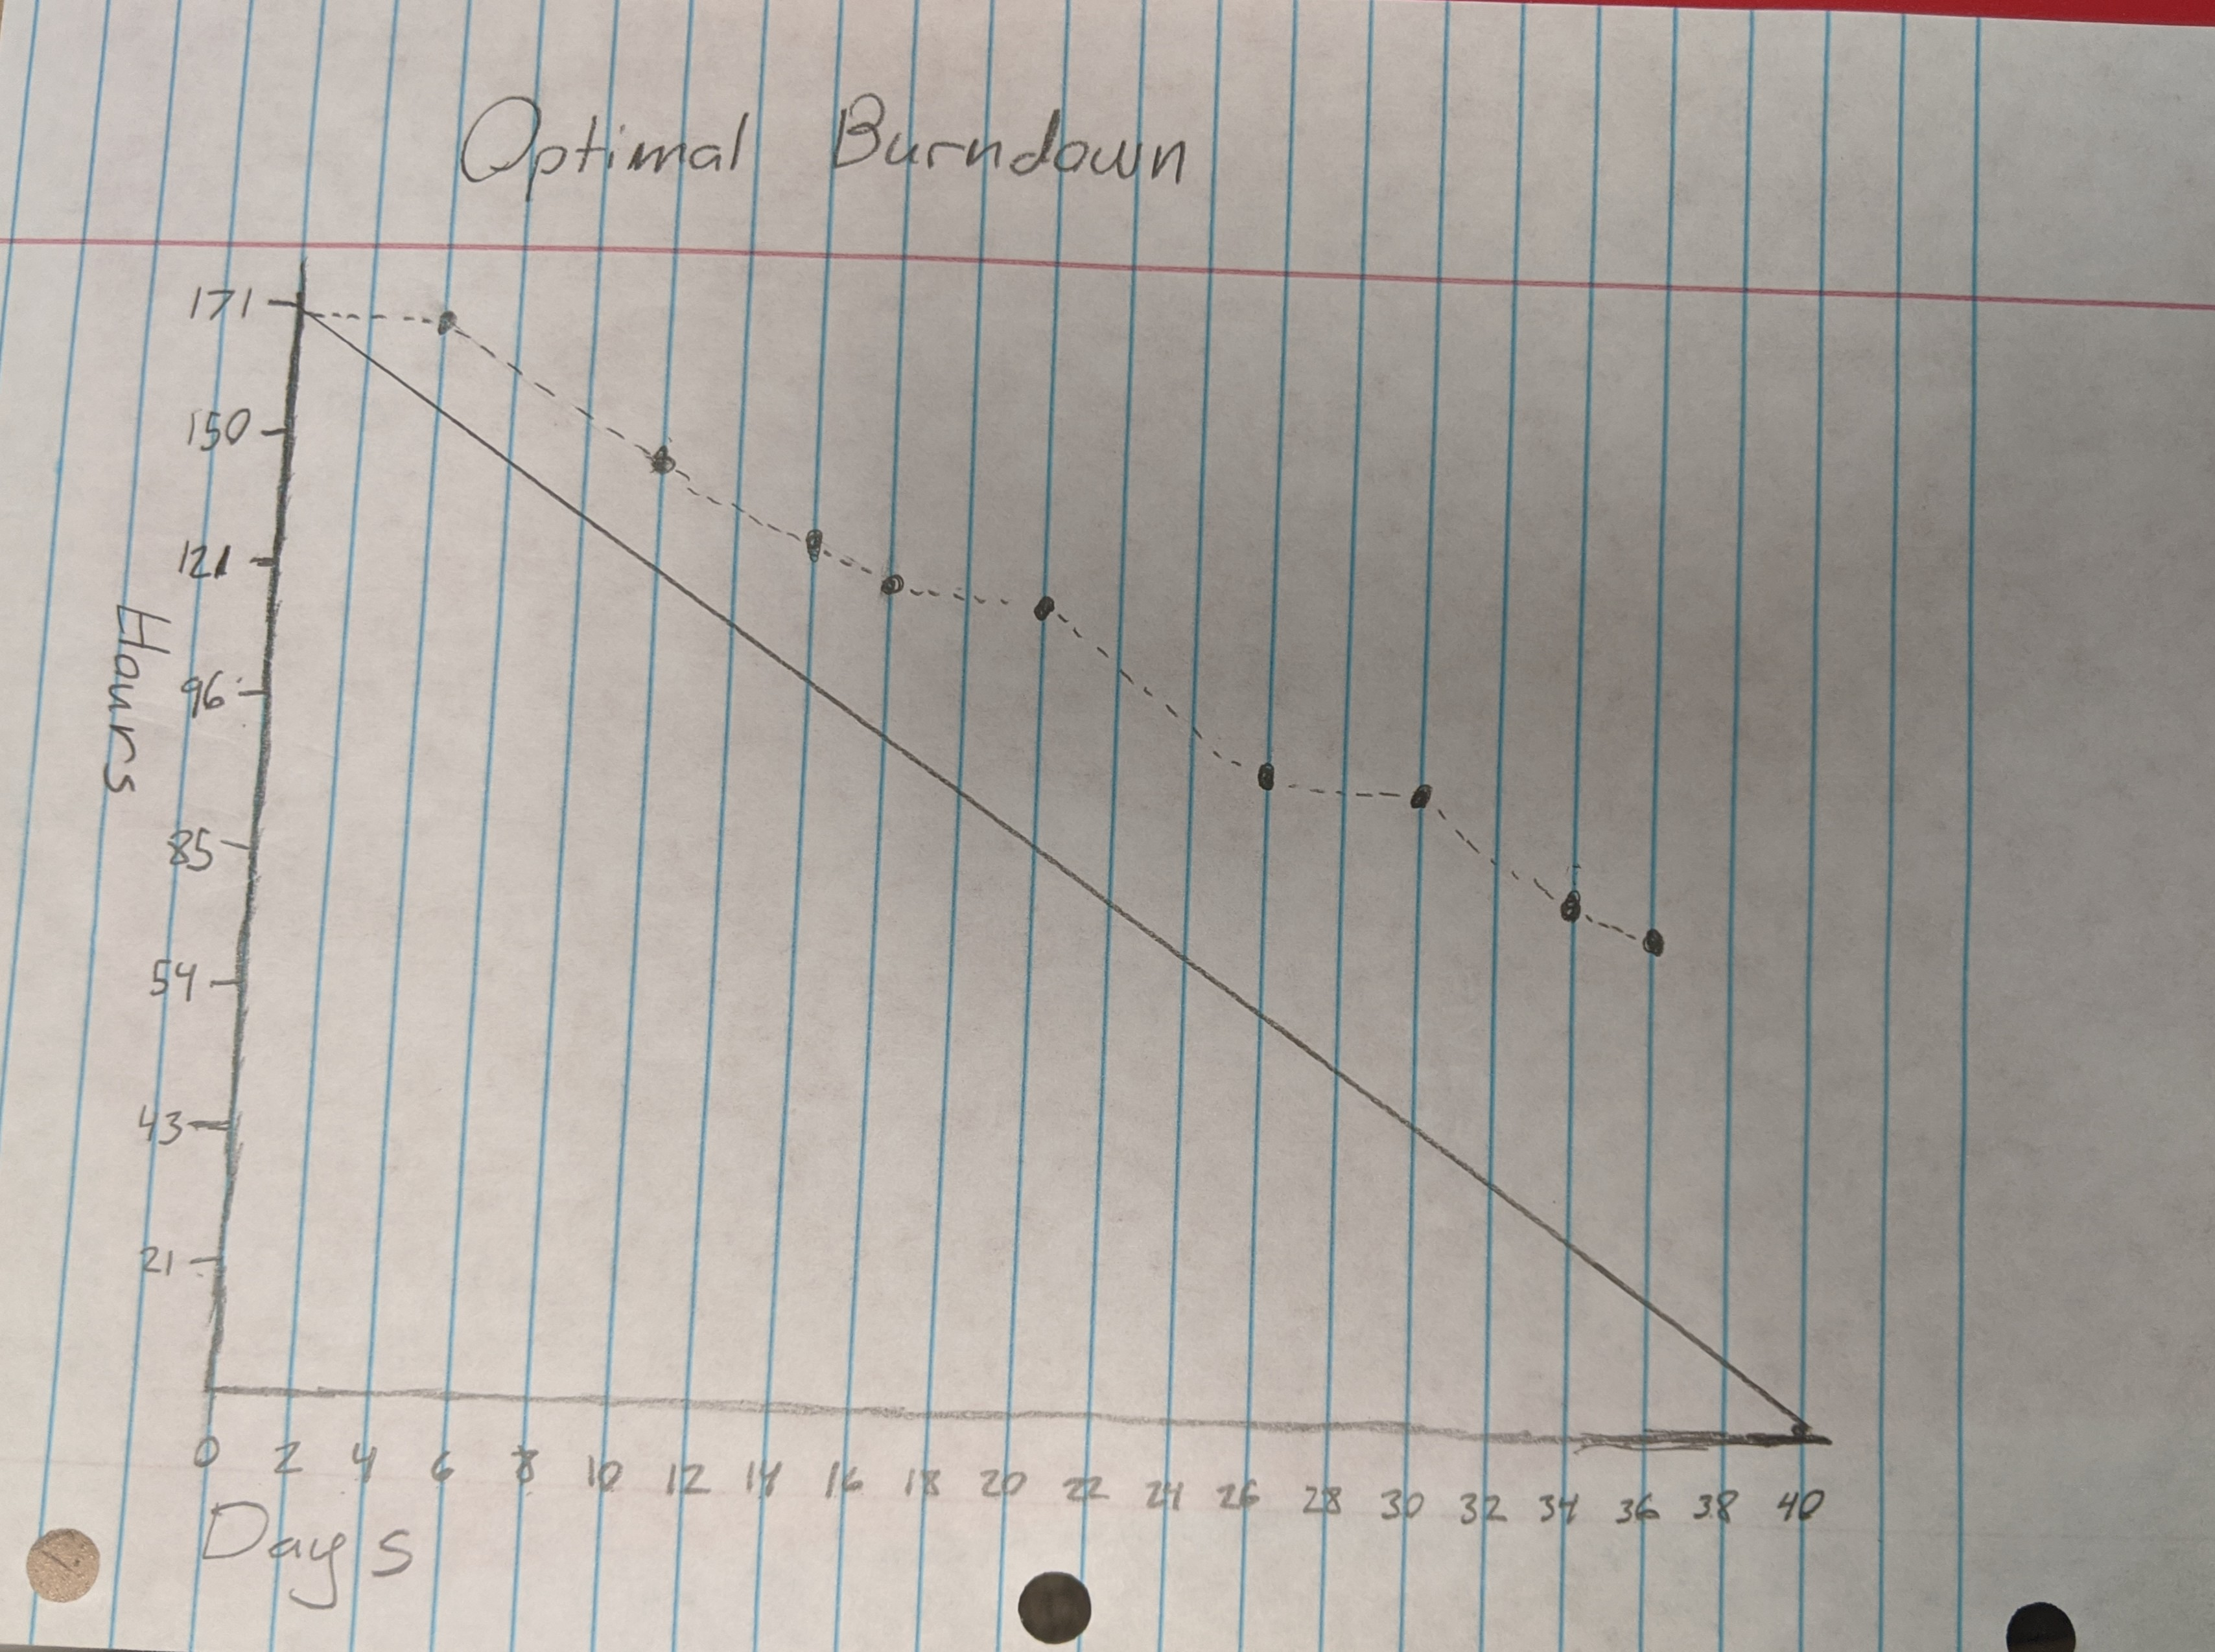

Screenshot of your project board

