

**FACULTY OF COMPUTING AND INFORMATICS**

**TGD2251 GAME PHYSICS**

**TRIMESTER 2, 2016/2017**

**PROJECT #1**

**REPORT**

**Lecture Section: 01**

**Tutorial Section: 01**

**For:**

**Dr. Wong Ya Ping**

**From:**

|  |  |  |  |
| --- | --- | --- | --- |
| **Student ID** | **Name** | **Email Address** | **Phone No.** |
| **1132700362** | **Tan Kah Loon** | [**kahloontan@gmail.com**](mailto:kahloontan@gmail.com) | **016-5019548** |

**Introduction**

Paperplane is a game where player control the paperplane to fly the furthest distance by using limited number of booster. Each booster can push the paperplane upward and forward and player can use the booster in a manner that allow the paperplane to fly further.

**Documentation**

The paperplane is given a fixed initial force that will be used to calculate the vertical velocity and horizontal velocity of the plane. The rotation of the plane will also be affected by vertical and horizontal velocity. There will be gravity that pull the plane down and drag force that pull the plane back. The booster will increase the vertical and horizontal velocity before applying gravity and drag force. The force will be calculated and changed every frame and new vertical and horizontal force will also be calculated and changed.

**User Manual / Instruction**

This game require MinGW 4.8.1 and SFML 2.1 to run. User have to open command prompt in the project directory and type “compile PaperPlane.cpp” to compile the code and double click the .exe file to run it.

Press “S” to start the game

Press “R” to restart the game

Press “Spacebar” to use booster

There will be information about the plane such as distance travelled, current height and booster remaining.

**Screenshots**

Start of the game

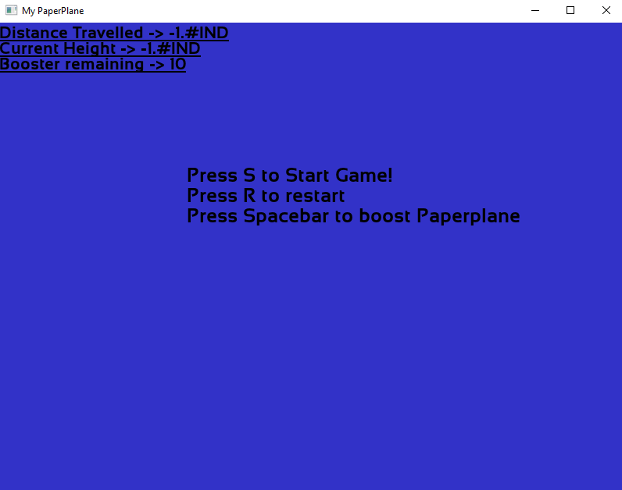

Game Play Scene

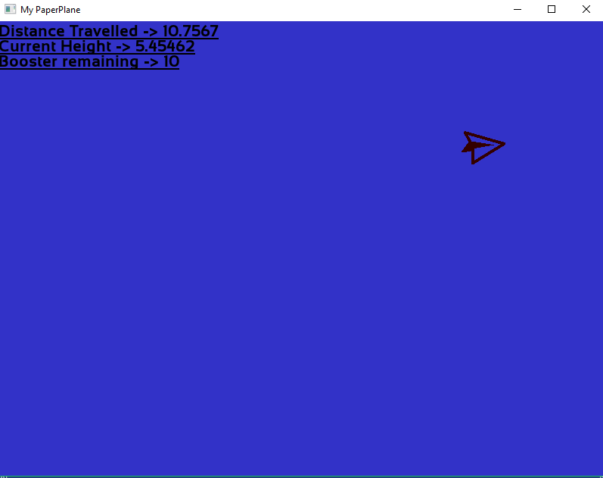

**References**

SFML documentation - http://www.sfml-dev.org/documentation/2.1/

Paper Plane sprite - http://www.freeiconspng.com/free-images/airplane-icon-png-2502