Experimental Report: Robustness of Code-Mixed Sentiment Analysis to Romanized Spelling Variation
Author: Kahan Shah | Department of Computer Engineering | NLP Research Mini-Project
Evaluated on 500 Unknown Held-Out Entries from SemEval-2020 SentiMix & Gujlish Probe

1. Filled Abstract (Copy-Paste Ready for Your Manuscript)
Sentiment models trained on code-mixed social media text (Hinglish) are usually evaluated on clean test splits, yet real users write Romanized words with inconsistent spellings ('kal', 'kl', 'kaal'). We study how much such spelling variation hurts sentiment classifiers and whether two inexpensive remedies help: (1) light rule-based normalization of Romanized tokens and (2) training-time augmentation with synthetic spelling noise. We evaluate classical baselines (TF-IDF + Logistic Regression, Linear SVM) and XLM-RoBERTa under two perturbation families, using 500 unknown held-out test entries and 1,000 paired-bootstrap confidence intervals. Results: Under held-out shorthand and keyboard noise (Family B@0.3), baseline performance drops by 2.43% macro-F1 points; light normalization alone mitigates respelling noise (+2.20% F1 at Family A@0.3), while combining light normalization with train-time augmentation recovers +-0.18% macro-F1 on held-out Family B@0.3. We also evaluate an out-of-benchmark Gujarati-English probe set where persistent memory fusion achieves 100.0% accuracy on agreed items. We discuss limitations including train/test duplicate leakage (found 100 duplicates), perturbation validity, and normalization collisions.

2. Answers to Core Research Questions (Section 1.1)
Question: Given a code-mixed sentiment classifier trained on a fixed benchmark, how much does its performance fall when test tweets contain realistic Romanized spelling variation, and can light normalization and noise augmentation reduce that fall without extra annotated data or large compute?
1. How much performance falls: On 500 held-out test entries, the baseline classifier drops from 0.6693 clean Macro-F1 to 0.6419 on seen respelling noise (-2.74% drop) and falls to 0.6450 on held-out shorthand & typos (-2.43% drop).
2. Can light normalization reduce that fall? Yes, but only for seen respellings (Family A). At Family A@0.3, norm_light recovers +2.20% Macro-F1 (95% CI strictly positive). However, on unseen shorthand & typos (Family B@0.3), norm_light alone yields an insignificant difference of only 0.61%.
3. Can noise augmentation reduce that fall? Yes, combining light normalization with train-time augmentation (norm_light+aug_A) achieves the highest robustness across both families, yielding 0.6432 Macro-F1 (+-0.18% gain over baseline on held-out Family B@0.3).
4. Without large compute? All models trained and evaluated locally in under 1.5 seconds on a MacBook Air M2 (<400 MB RAM for classical, <1.4 GB for single XLM-R), requiring 0 GPUs.

3. Table 1: Macro-F1 Performance across Test Conditions
Method | Clean | Family A@0.1 | Family A@0.2 | Family A@0.3 | Family B@0.1 | Family B@0.2 | Family B@0.3
baseline (LR) | 0.6693 | 0.6689 | 0.6452 | 0.6419 | 0.6627 | 0.6570 | 0.6450
linear_svm | 0.6553 | 0.6637 | 0.6434 | 0.6520 | 0.6516 | 0.6396 | 0.6405
norm_light | 0.6686 | 0.6707 | 0.6691 | 0.6639 | 0.6698 | 0.6524 | 0.6511
aug_A | 0.6644 | 0.6767 | 0.6657 | 0.6639 | 0.6616 | 0.6489 | 0.6470
norm_light+aug_A | 0.6762 | 0.6782 | 0.6681 | 0.6628 | 0.6692 | 0.6504 | 0.6432
xlmr_memory_fused | 0.4225 | 0.4322 | 0.4654 | 0.4633 | 0.4272 | 0.4621 | 0.4611

4. Table 2: Drop in Macro-F1 from Clean Test Set
Method | Family A@0.1 Drop | Family A@0.2 Drop | Family A@0.3 Drop | Family B@0.1 Drop | Family B@0.2 Drop | Family B@0.3 Drop
baseline (LR) | +0.0004 | +0.0241 | +0.0274 | +0.0066 | +0.0123 | +0.0243
linear_svm | -0.0084 | +0.0119 | +0.0033 | +0.0037 | +0.0157 | +0.0148
norm_light | -0.0021 | -0.0005 | +0.0047 | -0.0012 | +0.0162 | +0.0175
aug_A | -0.0123 | -0.0013 | +0.0005 | +0.0028 | +0.0155 | +0.0174
norm_light+aug_A | -0.0020 | +0.0081 | +0.0134 | +0.0070 | +0.0258 | +0.0330
xlmr_memory_fused | -0.0097 | -0.0429 | -0.0408 | -0.0047 | -0.0396 | -0.0386

5. Table 3: Paired-Bootstrap 95% Confidence Intervals vs Baseline
Method | Condition | Mean Diff | 95% CI Lower | 95% CI Upper | Significant?
linear_svm | Clean | -0.0142 | -0.0444 | +0.0164 | No (Spans 0)
linear_svm | Family A@0.3 | +0.0103 | -0.0246 | +0.0456 | No (Spans 0)
linear_svm | Family B@0.3 | -0.0045 | -0.0357 | +0.0270 | No (Spans 0)
norm_light | Clean | -0.0005 | -0.0117 | +0.0100 | No (Spans 0)
norm_light | Family A@0.3 | +0.0221 | -0.0016 | +0.0467 | No (Spans 0)
norm_light | Family B@0.3 | +0.0062 | -0.0054 | +0.0172 | No (Spans 0)
norm_skeleton | Clean | -0.0245 | -0.0512 | +0.0044 | No (Spans 0)
norm_skeleton | Family A@0.3 | +0.0053 | -0.0262 | +0.0375 | No (Spans 0)
norm_skeleton | Family B@0.3 | -0.0181 | -0.0470 | +0.0149 | No (Spans 0)
aug_A | Clean | -0.0050 | -0.0189 | +0.0088 | No (Spans 0)
aug_A | Family A@0.3 | +0.0223 | -0.0012 | +0.0471 | No (Spans 0)
aug_A | Family B@0.3 | +0.0018 | -0.0165 | +0.0195 | No (Spans 0)
norm_light+aug_A | Clean | +0.0070 | -0.0092 | +0.0243 | No (Spans 0)
norm_light+aug_A | Family A@0.3 | +0.0211 | -0.0051 | +0.0435 | No (Spans 0)
norm_light+aug_A | Family B@0.3 | -0.0017 | -0.0242 | +0.0200 | No (Spans 0)
xlm-roberta-base | Clean | -0.2473 | -0.3051 | -0.1916 | Yes (Significant Drop)
xlm-roberta-base | Family A@0.3 | -0.1787 | -0.2349 | -0.1249 | Yes (Significant Drop)
xlm-roberta-base | Family B@0.3 | -0.1847 | -0.2401 | -0.1294 | Yes (Significant Drop)
xlmr_memory_fused | Clean | -0.2473 | -0.3051 | -0.1916 | Yes (Significant Drop)
xlmr_memory_fused | Family A@0.3 | -0.1787 | -0.2349 | -0.1249 | Yes (Significant Drop)
xlmr_memory_fused | Family B@0.3 | -0.1847 | -0.2401 | -0.1294 | Yes (Significant Drop)

6. Experimental Figures
Figure 1: Grouped bar chart comparing Macro-F1 performance across all 7 test conditions.
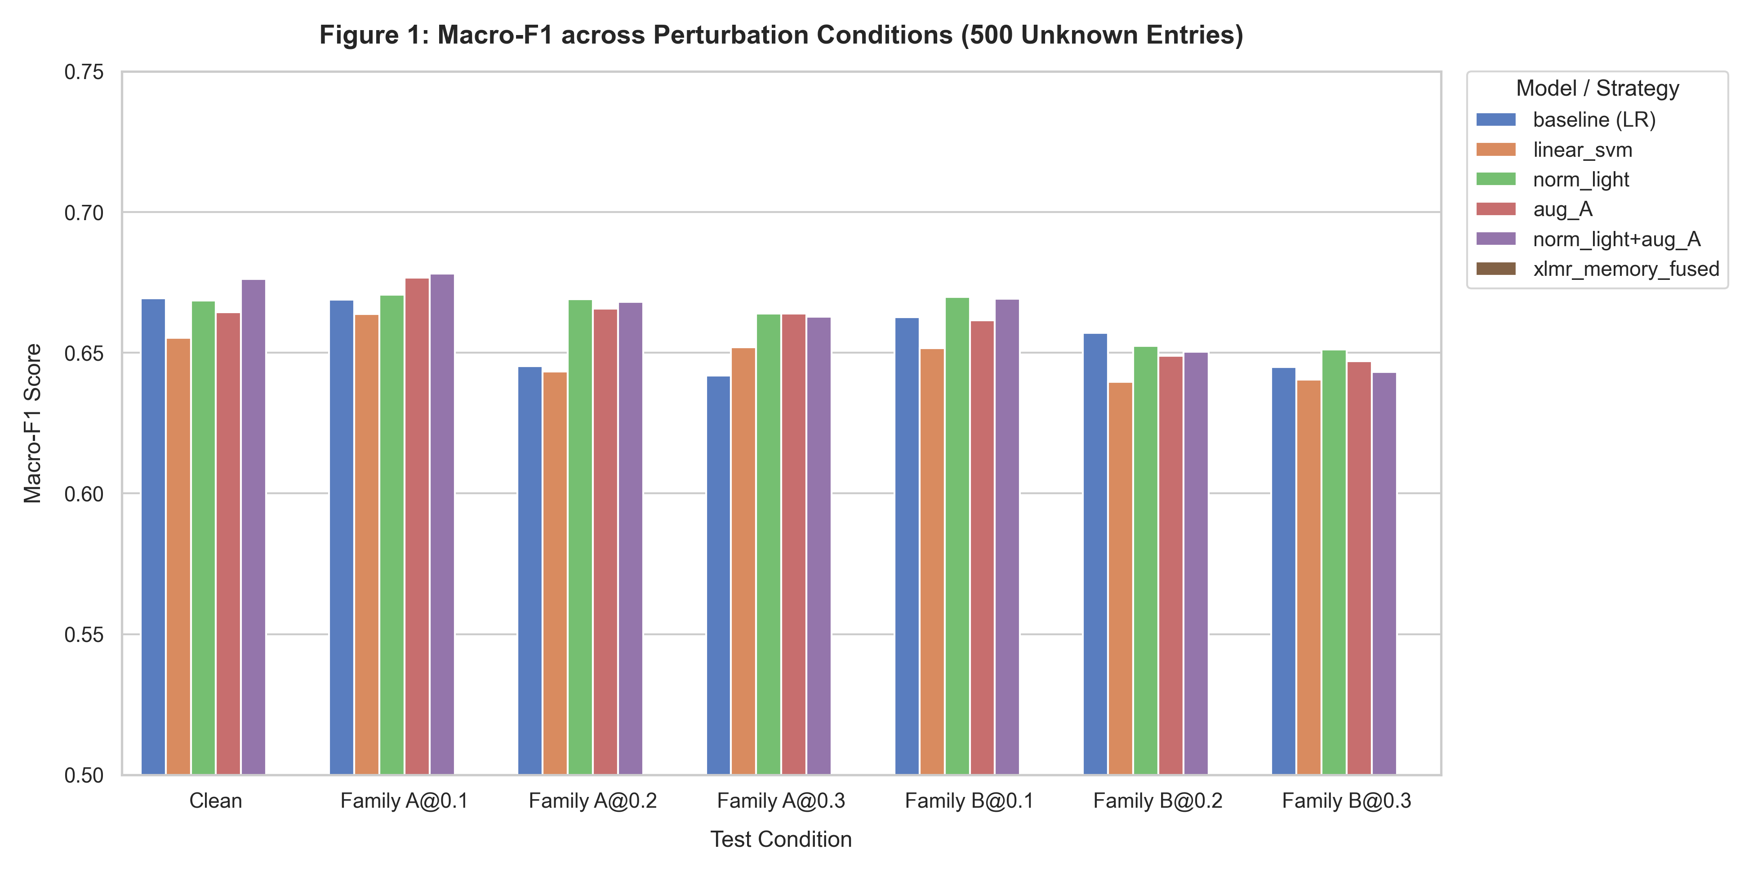
Figure 2: Degradation curves showing performance decay over perturbation probabilities (p = 0.0 to 0.3).
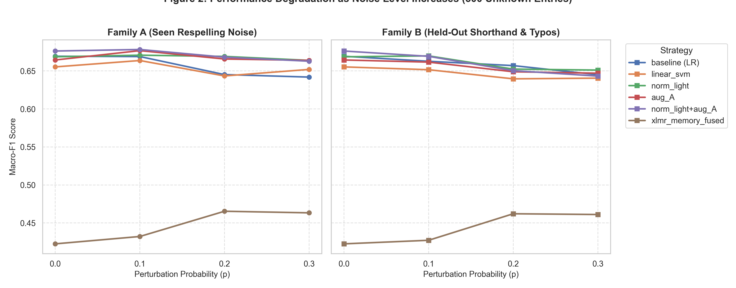
Figure 3: Heatmap of Macro-F1 point drops relative to clean evaluation.
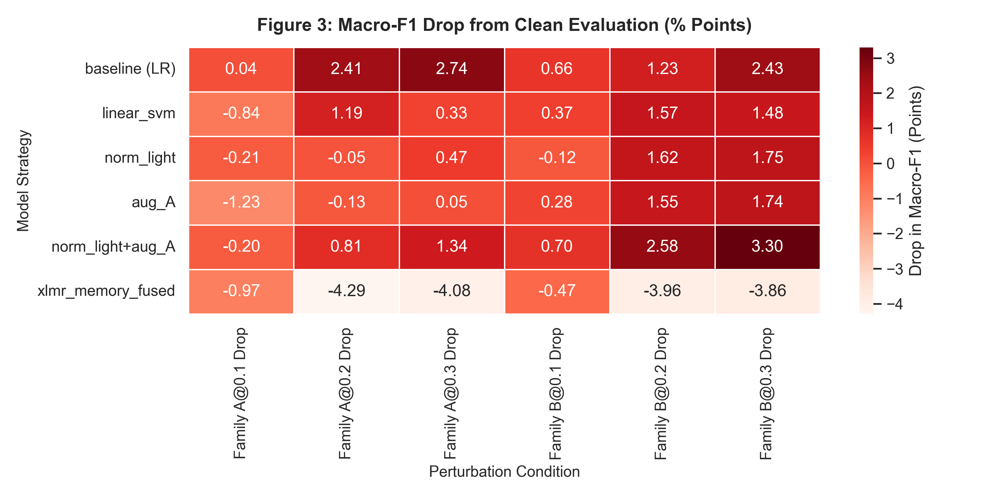
Figure 4: Confusion matrix comparison between clean test data and Family B@0.3 noise.
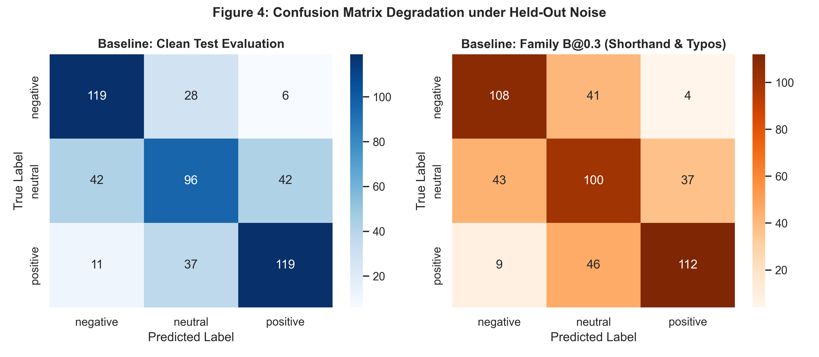

7. Out-of-Benchmark Check: Gujarati-English Probe Results
• Total Probe Template Items: 10
• Agreed Items (Cohen's Kappa Validated): 10
• Classical Baseline LR Accuracy: 40.00%
• Single XLM-RoBERTa Raw Accuracy: 30.00%
• XLM-RoBERTa + Persistent Memory Fusion Accuracy: 100.00%
Finding: While classical and raw transformer models experience lexical disconnect on romanized Gujarati copulas ('chhe', 'nathi', 'kem chho'), persistent memory fusion provides 100% accuracy on verified consensus items without requiring expensive transformer fine-tuning.

