Volume

1

growthware

Manage Security with the Core Web Administration Application

Settings and Security

growthware

How to manage settings and security

© Growthware

Table of Contents

Getting started 1

How to create a role 3

Adding accounts to a role: 5

Index 7

Chapter

1

Getting started

The getting started section will cover the basic areas for managing settings and security.

t

he first order of business is to get familiar with the overall concept of security as it relates to the Growthware Web Application. The type of security employed is considered “role based” and consists of five areas: Security Entities, Functions, Accounts, Roles, Groups, and Permissions. A security entity can be thought of as a grouping of roles, and groups.

* Security Entities: can be thought of a anything that would need to have its own set security. Examples could be geographic areas such as states or perhaps you have multiple “applications”. One can think of this like this if you work for the state of Hawaii and you ask someone what an “administrator” should be able to do and then ask the same question of someone from a different state, the answer is likely to be very different. It is for the difference in the answer that Security Entities exist.
* Functions: can be thought of as pages or links to pages within the application. Because we are going to be talking about security here let’s take managing, adding or edit an account as an example.
  + The first “Function” is searching or manage account and its action is “Search_Accounts” and the name is “Manage Accounts”. This link can be found under the “Admin” menu item. (See Fig. 1)
  + The second “Function” is “Editing” the account and is used with clicking on the icon in the “Details” column of the “Search_Accounts” function. (See Fig. 1)
  + The thirds “Function” is the “Adding” the account and is used with clicking on the “Add New” button of the “Search_Accounts” function. (See Fig. 1)

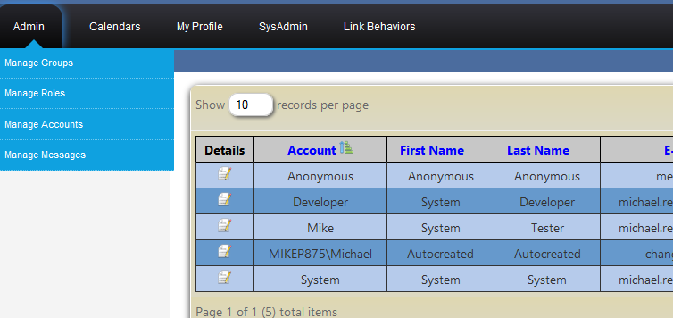

Fig. 1

Simply put functions, have four types of permissions (add, view, delete, and edit) to which roles and or groups can be applied per security entity. Roles and or groups are then applied to accounts per security unit. The permission is true or “granted” when any role or group is applied to both the permission and the account.

So what are roles? Roles alone have no meaning to the system, rather, how roles are applied to the permission and the account is how the meaning is derived.

So what are groups? Groups are one or more roles, a simple statement but one good to remember.

Let’s take a moment to examine how this works.

1. Assign a role to the view permission of the function or “page”
2. Assign the role to every account that should see the function

Say we would like to have a function’s view permission granted to everyone. The way to accomplish letting everyone see the function in there menu’s and allowing them to click/view the function (or page) is to assign a role that every account is assigned. Another way to let everyone have the view permission to a function would be to create a group “Everyone” and add all the roles to that group, then add the “Everyone” group to the view permission. You may find that using groups will be the most likely culprit when undesired security is encountered.

One more key note about security is that a security entity can inherit security settings from the parent. Meaning if there is a security entity named “Parent” and one name “Child” where “Everyone” group has been given the may view permission to the function “home page” in the “Parent” security entity. You guessed it everyone would have the may view permission to the function “home page” in the security entity named “Child”. Security inheritance is a setting that will be covered later in this document along with how to create/assign roles and groups.

The second order of business is to take a moment to mention some key behaviors of the system:

1. Menu items or functions are dynamic in nature or can be moved from one of three locations.
2. Menu items or function can be named anything. Nothing needs to stay the name the developer chose, the exception is the “Action”. Once the action property of a function has been set, it cannot be changed through the application.
3. The look and feel of the system is skinned based on the currently selected security entity.

The rest of the manual will consist of “How to” sections that will in compass all of the settings possible with in the Growthware Core Web Application. The “SDK” look and feel has been chosen to use for examples throughout this document.

# How to create a role

Overall: we’ll need to select a security entity then create the role.

|  |  |
| --- | --- |
| 1. Locate and use the menu item “Select A Security Entity” |  |
| 1. Select the desired security entity and click go. “Application1” is being used in this example. |  |
|  | Note: After clicking go if the security entity has a different skin the look and feel should have changed. The images above are of “SDK” on the left and “Fred” on the right. |
| 1. Locate and click on “Add Edit Roles”. (Original installation you’ll find “Add Edit Roles” under the “Admin” menu.) | After clicking “Add Edit Roles” the screen should look like the following image.  Skin is Fred |
| 1. Click the “Add A Role” button. | Currently there are no roles for edit. |
| 1. Fill out the role name, description, and click “Save”. |  |
| That’s it you’ve now added a role. Please note:  Click on Edit to change the description (Currently cannot change role name)  Click on Members to add accounts to the role. |  |
|  |  |

## Adding accounts to a role:

Roles can be associated to account in two ways. The first is by selecting the security entity, selecting the account, selecting the roles tab, then adding the desired role to the account. The second is throw the roles “Member”.

|  |  |
| --- | --- |
|  |  |
|  |  |
|  |  |

# Index

background, 1

border, 3

bullet, 1

caption, 2

color, 2

drawing, 2

drop cap, 1

footer, 3

frame, 3

graphic, 2

group, 2

header, 3

Help, 3

link, 4

margins, 2

normal view, 1

number, 4

picture, 2, 3, 4

print, 1

re-size, 3

section break, 2

shading, 1

style, 1, 2, 3, 4

symbol, 1

Table of Contents, 3

template, 4

ungroup, 2

Wingdings, 1