# MLflow

MLflow is an open-source platform that helps manage the machine learning lifecycle. It provides tools for tracking experiments, demonstrate how to log experiments, parameters and metrics, during the model development, packaging models and deploying them to production.

Here is a link to the MLflow documentation: <https://mlflow.org/docs/latest/index.html>

# Experiment Tracking:

MLflow logs what data you used, what code you ran, and how well each attempt (model) performed. This makes it easy to track progress, compare different models, and learn from your mistakes.

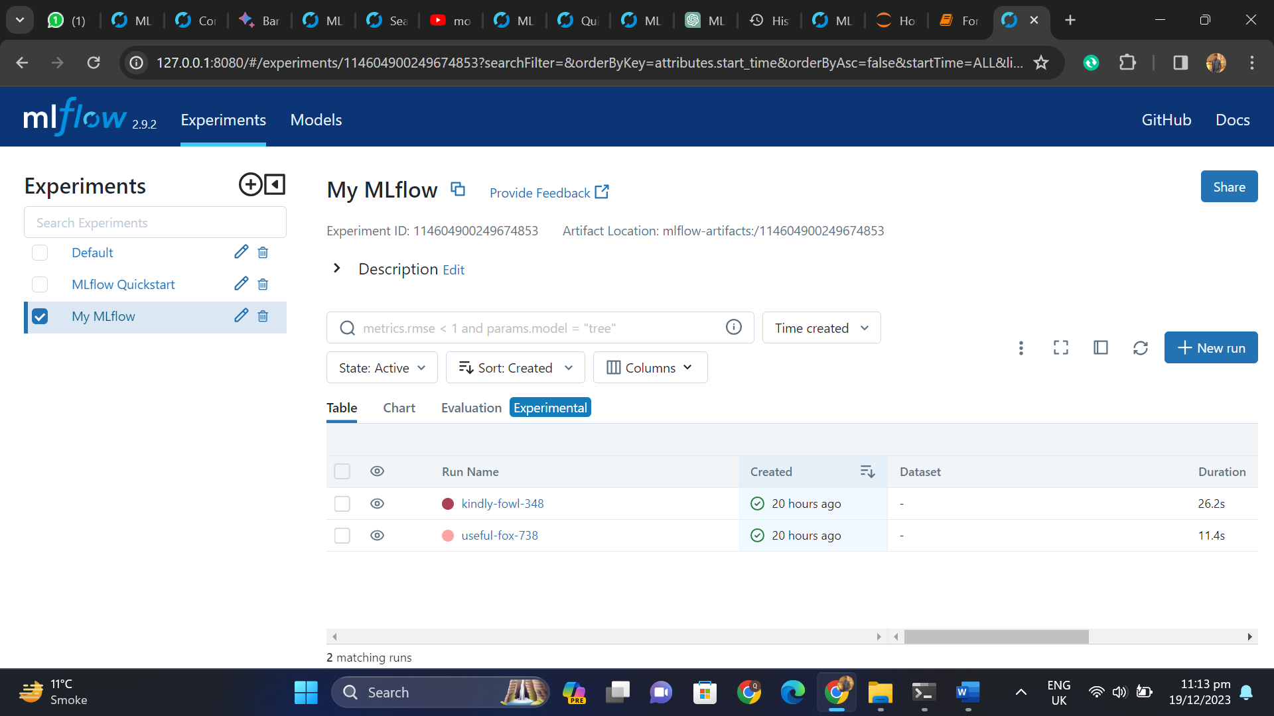

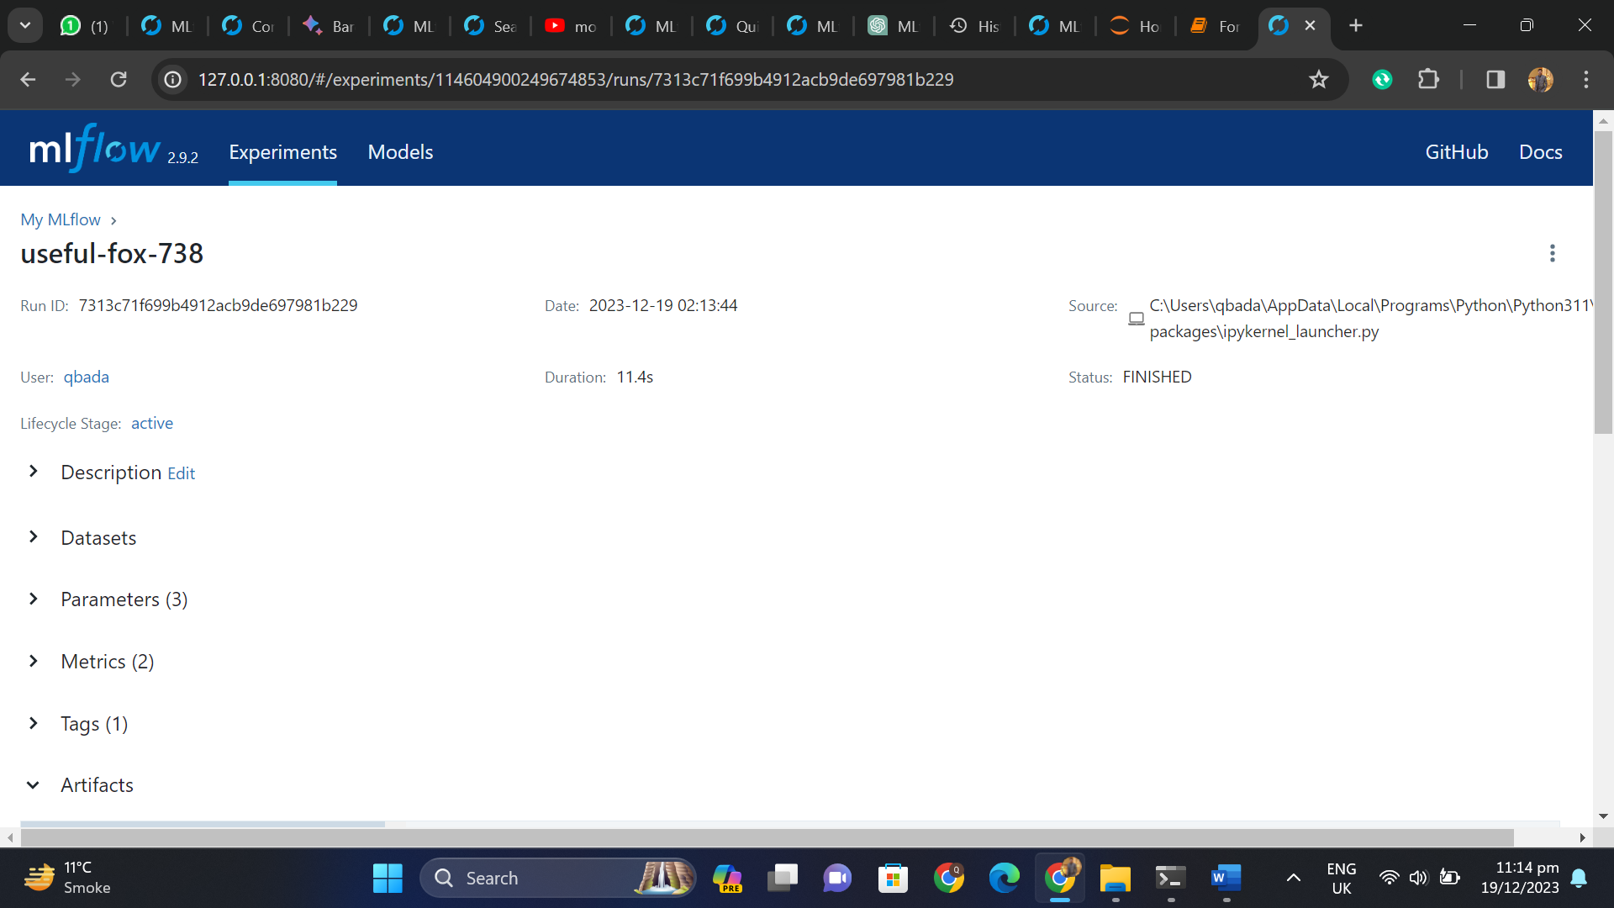

Logging Parameters and Metrics:

MLflow lets you record both parameters and metrics so you can see how changing parameters affects the final results. This helps you tune your model and make it even better.

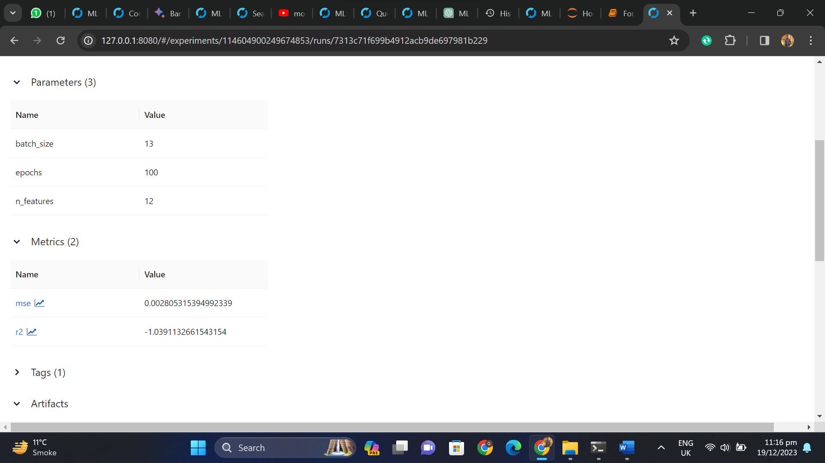

# Deployment:

Deployment means putting your model out there.

