My Dream

**Ocular**

The project

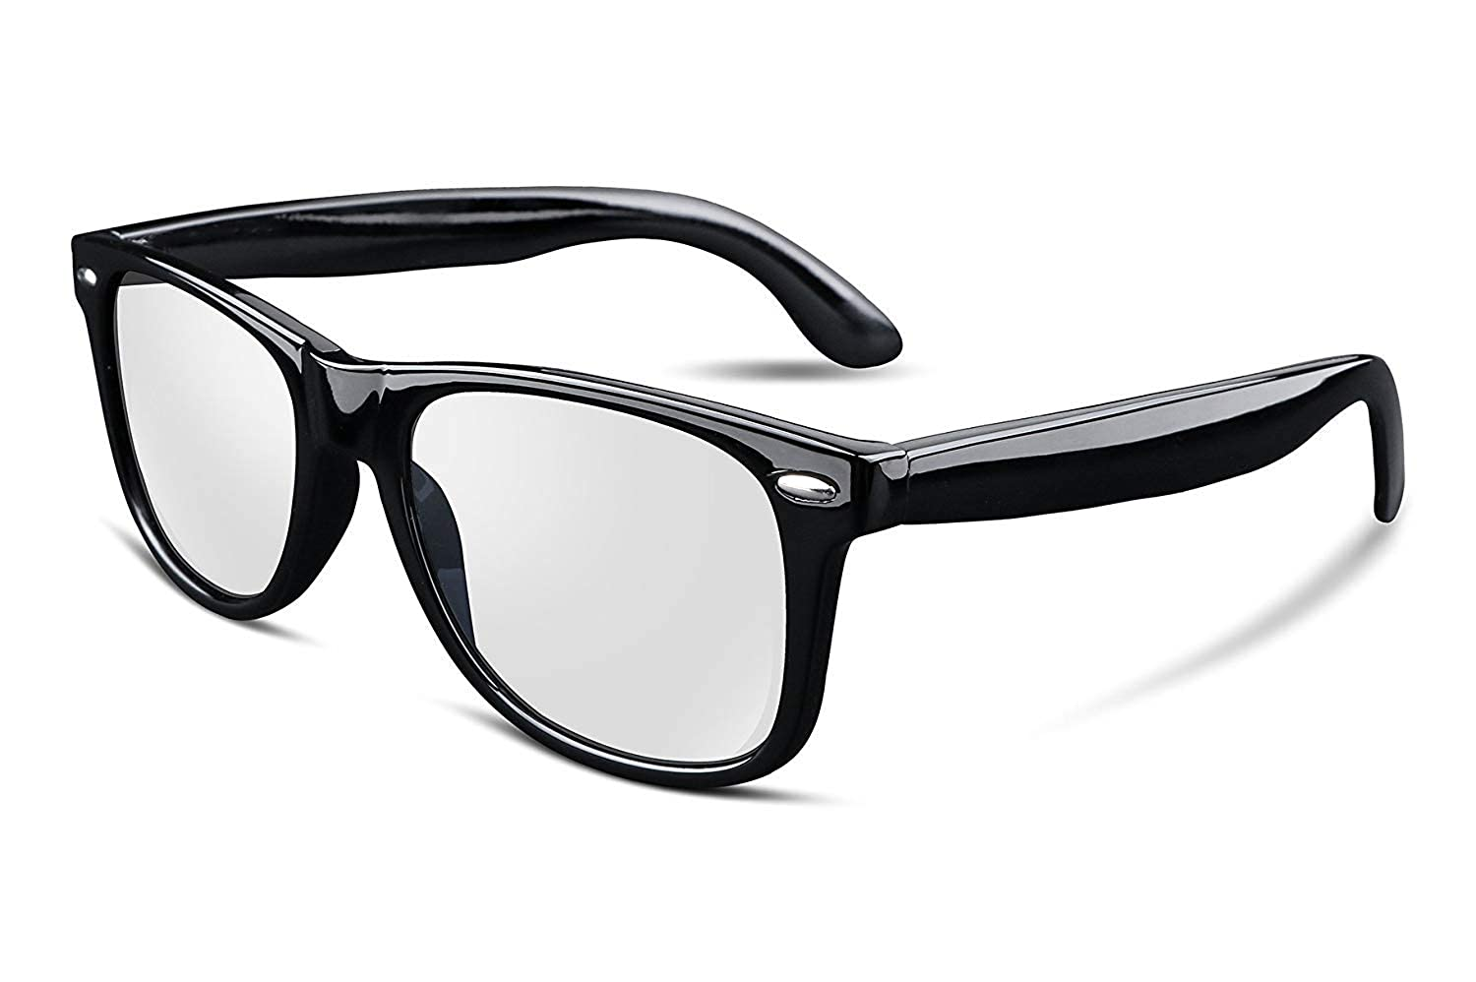

**I can’t see but I can do**

**Ocular** a gadget that can be a helping hand for all the blind people all over the world. The main aim of this device is to make a blind to perform the simple tasks of daily life without any effort. A tool that leads to new ways to live dark life independently. It helps the blind to perform 70% of the daily life task individually. The sensors built in the device does almost all task which can be done by the native eyes. The person using this device can perform the task by following the instructions and get any task done by giving commands to it. It’s easy and safe to use and maintain. It does not record or capture anything, it just uses the data stored in the phone which is connected with it. One can use his/her phone through command. This device follows the command of the voice only which is saved as admin and gets activated only when the scanned retina matches the one which was stored at the time of the first activation.

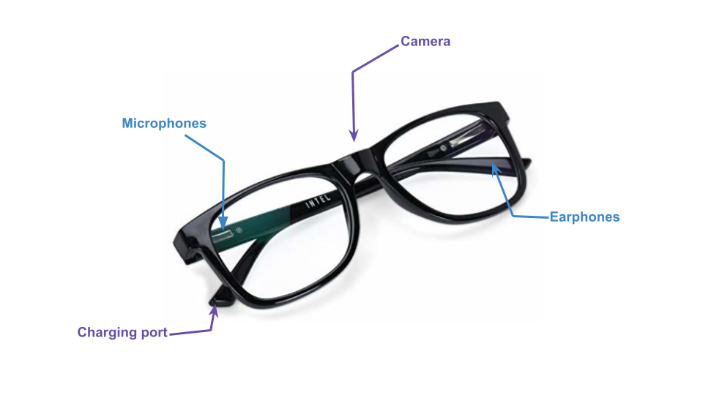

The product is a combination of high quality of the camera, microphone, and earphone which make the device capable enough to see, hear and speak combining which can give it the best analysis and result. It comes up with a good battery backup, it is unbreakable, scratch-proof, and waterproof, resulting which gives it a good life span to be used. This device helps a blind to read, text anyone through his phone, locate his location, can cross the road, can climb up or down the stairs, helps to identify the person in front of him/her by providing details like the name (if available in phone or google), gender and age (if the person is a stranger) and so-on. If a person masters using the product, he/she can play any game like chess, cube, carom or archery, etc. In emergency cases, it can send messages to nearby hospitals, police stations and the contacts saved for such situations.

Functions :

1. Voice recognition:

To differentiate between audience talk and queries send by the user, Voice recognition is necessary. It is also use to unlock the device. Queries from the user to device can be send by different ways like -

* By slight touch on the specific part of the device.
* By mentioning the device name before the query, just like "hey google".

1. Eye scan :

It is used to keep the update of the eye condition and also to unlock the device.

1. GPS :

Mainly to send emergency alert messages to the police, hospital and saved contacts. The message will show the general condition of the owner like bp, heart rate etc.

1. Alert :

Recognizing the speed of the upcoming object. Analysing whether the object will hit the owner or not. If yes, then alert the owner to bend down and protect him/herself.

Security alert while performing any confidential work ex: Atm online digital etc. It alerts the owner of the surroundings.

1. End of the Land :

If the owner is on stage or at clif or on a building terrace or climbing up or down the stairs, the device will alert him/her beforehand. The device informs the number of the stairs, length and width of each one, which helps the user to move easily.

1. Identification :

Identification of color, garments, food, human, animal.

* If any stranger comes and tries to talk, the device will inform the basic details like gender and age.
* Device will be capable of identifying the known people or people who have met recently. It stores different kinds of data regarding faces like - Eye scan , face point etc which will be used to recognize the person even if he/she is in a different form. ex: with bandaid, spectacles, eye lens or face mask etc.
* If any known person is in surroundings, the device will inform the owner about it. It will also inform the owner if any famous personalities are around him/her (worldwide).
* It can also identify the object's size like height, width, length etc.
* Identification of any electrical appliances (on/off) and their temperature.
* And also switches of known places (home etc). It can direct to exact fan swtich once the order is safe.

1. Direction :

Direction to different doors ex: bedroom door, main door, class room front and back door, etc.

* Directs to the free seat in a seminar or any place to seat in a public area.
* Directs to any particular product.
* Directs to write in a straight line, indicates the end of line and end of paper and end of all pages.
* Helps to play any game.
* Helps to cook and any household activities.

1. Languages :

It reads out any text in any language, and the owner can simply flow the device as if he/she is reading.

Any language translation, which helps to understand and speak that language.

Note : Ultimate goal is to reduce internet consumption, storage and battery. If possible make it with "no internet usage".

