
HUMAN-IN-THE-LOOP EXPLAINABLE GRAPH NEURAL NETWORK FOR FINANCIAL FRAUD DETECTION
A Topological Deep Learning and Interactive Decision Support Framework for Cryptocurrency Anti-Money Laundering Forensics
A PROJECT REPORT
submitted by
KAHLAR BHANDARY (23BCE1442)
UDAYAN MANNA (23BCE1015)
in partial fulfilment of the requirements for the award of the degree of
BACHELOR OF TECHNOLOGY
in
COMPUTER SCIENCE AND ENGINEERING
School of Computer Science and Engineering
VELLORE INSTITUTE OF TECHNOLOGY, CHENNAI
Academic Year 2026–2027

HUMAN-IN-THE-LOOP EXPLAINABLE GRAPH NEURAL NETWORK FOR FINANCIAL FRAUD DETECTION
A Topological Deep Learning and Interactive Decision Support Framework for Cryptocurrency Anti-Money Laundering Forensics
A PROJECT REPORT
submitted by
Kahlar Bhandary — 23BCE1442
Udayan Manna — 23BCE1015
Under the Guidance of
Dr. Malathi G
Professor, School of Computer Science and Engineering
Vellore Institute of Technology, Chennai
School of Computer Science and Engineering
VELLORE INSTITUTE OF TECHNOLOGY, CHENNAI
October 2026

DECLARATION
I hereby declare that the project entitled “HUMAN-IN-THE-LOOP EXPLAINABLE GRAPH NEURAL NETWORK FOR FINANCIAL FRAUD DETECTION” submitted by me to the School of Computer Science and Engineering, Vellore Institute of Technology, Chennai Campus, Chennai 600127 in partial fulfilment of the requirements for the award of the degree of Bachelor of Technology – Computer Science and Engineering is a record of bonafide work carried out by me. I further declare that the work reported in this report has not been submitted and will not be submitted, either in part or in full, for the award of any other degree or diploma of this institute or of any other institute or university.
Place: Chennai
Date: October 2026
Signature of the Candidate
_____________________________________
KAHLAR BHANDARY
(Register No: 23BCE1442)

CERTIFICATE
The project report entitled “HUMAN-IN-THE-LOOP EXPLAINABLE GRAPH NEURAL NETWORK FOR FINANCIAL FRAUD DETECTION” is prepared and submitted by Kahlar Bhandary (Register No: 23BCE1442). It has been found satisfactory in terms of scope, quality and presentation as partial fulfilment of the requirements for the award of the degree of Bachelor of Technology – Computer Science and Engineering in Vellore Institute of Technology, Chennai, India.

Project Guide  ____________________________  Dr. Malathi G  Professor  School of Computer Science & Engineering  VIT Chennai | Head of the Department  ____________________________  Dr. J. PRASSANNA  Head of the Department, B.Tech CSE  School of Computer Science & Engineering  VIT Chennai

Examined by:
Examiner I  ____________________________  Date: | Examiner II  ____________________________  Date:

ACKNOWLEDGEMENT
I express my deep sense of gratitude and sincere thanks to my project guide, Dr. Malathi G, School of Computer Science and Engineering, Vellore Institute of Technology, Chennai, for her continuous guidance, constructive criticism, and constant encouragement throughout the progress of this project work. Her valuable insights and technical directions were instrumental in formulating the research objectives and evaluating the inductive graph learning paradigms.
I extend my heartfelt gratitude to Dr. J. PRASSANNA, Head of the Department (HoD), B.Tech. Computer Science and Engineering, Vellore Institute of Technology, Chennai, for providing the necessary facilities and support to carry out this research investigation smoothly.
I convey my profound gratitude to Dr. Viswanathan V, DEAN, School of Computer Science & Engineering, Vellore Institute of Technology, Chennai, for providing an inspiring academic atmosphere, excellent computational infrastructure, and encouragement throughout the course of our B.Tech program.
I also wish to thank Dr. NITHYANANDAM P, Dr. SUGANYA G, and Dr. SWEETLIN HEMALATHA C, Associate Deans, School of Computer Science & Engineering, Vellore Institute of Technology, Chennai, for their administrative coordination, academic facilitation, and valuable support.
I am thankful to the faculty members, technical staff, and laboratory administrators of the School of Computer Science and Engineering for their direct and indirect assistance. Finally, I express my deepest appreciation to my parents, family members, and friends for their enduring patience, moral encouragement, and selfless support that sustained my efforts throughout this project work.
KAHLAR BHANDARY
(Register No: 23BCE1442)

CONTENTS
DECLARATION | iii
CERTIFICATE | iv
ACKNOWLEDGEMENT | v
LIST OF TABLES | viii
LIST OF FIGURES | ix
LIST OF ABBREVIATIONS | x
ABSTRACT | xi
1. INTRODUCTION | 1
1.1 Background and Practical Motivation | 1
1.2 The Forensic Trilemma in Blockchain Surveillance | 2
1.3 The Human-Computer Interaction (HCI) Imperative in Forensic Analytics | 3
1.4 Summary of Key Contributions | 4
2. RESEARCH OBJECTIVES & LITERATURE REVIEW | 6
2.1 Research Objectives | 6
2.2 Machine Learning for Financial Fraud Detection and AML | 7
2.3 Graph Neural Networks for Blockchain Transactions | 8
2.4 Post-Hoc Explainability in Graph Neural Networks | 9
2.5 Human-in-the-Loop Active Learning & Decision Support Systems | 10
2.6 Structured Comparison of Existing Literature | 11
3. METHODOLOGY & MATHEMATICAL FORMULATION | 13
3.1 Dataset Formalization and Graph Topology | 13
3.2 Feature Space Formalization | 14
3.3 All Zero Leakage Procedure for Temporal Splitting | 15
3.4 Graph Neural Network Formulations | 17
3.5 Optimizing the Loss Function in Extreme Imbalanced Setting | 18
3.6 Post-Hoc Subgraph Explainability Formulation | 20
3.7 Human-in-the-Loop Active Learning Query Formulations | 22
4. SYSTEM ARCHITECTURE & INTERACTIVE HCI IMPLEMENTATION | 24
4.1 End-to-End System Topology | 24
4.2 Human-Centered Interface Design & Decision Support Workflows | 26
4.3 Backend API Endpoint Specifications | 28
5. EXPERIMENTAL RESULTS & EMPIRICAL BENCHMARKS | 30
5.1 EXP-01: A Comparative Analysis of the Tabular Baselines | 30
5.2 EXP-02: Graph Neural Network Architectures and Inductive Biases | 32
5.3 EXP-03: Feature Space Ablation Analysis | 34
5.4 EXP-04: Loss Function Optimization under Severe Imbalance | 36
5.5 EXP-05: Post-Hoc Explainability and Fidelity Benchmark | 38
5.6 EXP-06: Temporal Concept Drift & Darknet Marketplace Shutdown Shock | 41
5.7 EXP-07: Human-in-the-Loop Active Learning Benchmark | 44
6. DISCUSSION, LIMITATIONS & CONCLUSION | 47
6.1 Human-AI Teaming in High-Stakes Financial Forensics | 47
6.2 Mitigation of Automation Bias and Alert Fatigue | 48
6.3 Operational Hybrid Strategy for Enterprise Deployment | 49
6.4 Limitations & Threats to Validity | 50
6.5 Conclusion & Future Work | 51
6.6 Project Role & Individual Work Allocation | 52
REFERENCES | 54
APPENDIX A: PROJECT RESOURCES & REPRODUCIBILITY | 56
APPENDIX B: ENVIRONMENT SPECIFICATIONS & SCRIPTS | 58
APPENDIX C: INDIVIDUAL TASK ALLOCATION & SUBMISSION CHECKLIST | 60

LIST OF TABLES
Table 2.1 | Comprehensive Literature Comparison Matrix | 12
Table 3.1 | Critical Methodological Invariant: Isolation of Leakage | 16
Table 4.1 | FastAPI REST Service Endpoints and Operational Latency Budgets | 29
Table 4.2 | How to Protect Human-Computer Interaction: Minimizing Automation Bias | 27
Table 5.1 | EXP-01 Tabular Baseline Benchmark Results (Quarantine Test Partition t=40..49) | 31
Table 5.2 | EXP-02 Graph Neural Network Architectural Comparison | 33
Table 5.3 | EXP-03 Feature Space Ablation Benchmark Results | 35
Table 5.4 | EXP-04 Loss Function Optimization Benchmark Results | 37
Table 5.5 | EXP-05 Post-Hoc Explainability Benchmark (48 Test Instances) | 39
Table 5.6 | EXP-06 Out-of-Time Performance Trajectory and Macro-Shock Dynamics | 42
Table 5.7 | EXP-07 Human-in-the-Loop Active Learning Benchmark Results | 45

LIST OF FIGURES
Figure 4.1 | End-to-End System Architecture of the HITL-XGNN Fraud Detection Platform | 25
Figure 4.2 | Interactive Human-in-the-Loop Decision Support Interface Workflows | 27
Figure 5.1 | EXP-01 Precision-Recall Curves across Tabular Machine Learning Baselines | 31
Figure 5.2 | EXP-02 Precision-Recall Curves for Graph Neural Network Architectures | 33
Figure 5.3 | EXP-03 Feature Space Ablation PR-AUC and F1 Metric Comparisons | 35
Figure 5.4 | EXP-04 Loss Objective Optimization and Class Imbalance Stabilization | 37
Figure 5.5 | EXP-05 GNNExplainer Subgraph Sparsity vs Explanation Fidelity | 40
Figure 5.6 | EXP-05 Subgraph Attribution Visualizations (TP, FP, FN, and Macro-Shock) | 40
Figure 5.7 | EXP-06 Temporal Concept Drift and Illicit Prevalence Trajectory Across Timesteps | 43
Figure 5.8 | EXP-07 Active Learning Query Strategies and Sample Efficiency Gain | 46

LIST OF ABBREVIATIONS
AML | Anti-Money Laundering
API | Application Programming Interface
AUC | Area Under Curve
CE | Cross-Entropy
EXP | Experiment
F1 | Harmonic Mean of Precision and Recall
FastAPI | Modern High-Performance Asynchronous Python Web Framework
FN | False Negative
FP | False Positive
GAT | Graph Attention Network
GCN | Graph Convolutional Network
GNN | Graph Neural Network
GNNExplainer | Post-Hoc Graph Subgraph Explanation Framework
HCI | Human-Computer Interaction
HITL | Human-in-the-Loop
LightGBM | Light Gradient Boosting Machine
MLP | Multi-Layer Perceptron
PR-AUC | Precision-Recall Area Under the Curve
PyG | PyTorch Geometric
RF | Random Forest
ROC-AUC | Receiver Operating Characteristic Area Under the Curve
SCOPE | School of Computer Science and Engineering
TN | True Negative
TP | True Positive
VIT | Vellore Institute of Technology
WCE | Weighted Cross-Entropy
XAI | Explainable Artificial Intelligence
XGBoost | Extreme Gradient Boosting
XGNN | Explainable Graph Neural Network

ABSTRACT
Financial networks on public blockchains are tough to analyze for sure. There is extreme imbalance in the data along with lots of unknown users and things shift over time which makes it hard to keep up with rules. A lot of black box AI setups run into trouble in real compliance work because of bias and fatigue from too many alerts plus they do not handle big changes well. This work puts forward a human in the loop explainable graph network setup meant to connect deep learning on graphs with how people actually make decisions in crypto money laundering checks.
They ran tests on the elliptic bitcoin set that has over two hundred thousand transactions and edges spread across time steps. GraphSAGE with mean aggregation seemed to handle the sparse unlabeled parts better than the other models and reached decent scores on the test side. Focal loss looked useful for keeping things stable when classes were off by roughly nine to one so it cut down on those collapsed precision problems. The explainer part gave faithful subgraph masks at decent speed.
Temporal shifts caused big drops in performance especially around certain regulatory events where illicit activity became rare and scores fell to zero while some tree baselines held up better. Active learning with uncertainty sampling gave around six percent better sample use than random picks at a twenty percent budget. It feels like some of these gaps might need more work but the interface side adds cytoscape views and feature views to help analysts avoid overload.
The topic of Human-in-the-Loop (HITL) processes within Explainable AI (XAI) and the implementation of Graph Neural Networks (GNN) in financial fraud detection and anti-money laundering (AML) systems based on Bitcoin blockchain technology has been receiving attention in recent literature. Interactive Decision Support systems based on the GNNExplainer technology can be described as being able to swiftly react to temporal concept drift, as well as apply appropriate modifications in the GNN input features to customize the results according to any changes in the couple of the GNN and human user, as well as any changes introduced by their interactions.
Keywords: Human-in-the-Loop (HITL), Explainable AI (XAI), Graph Neural Networks (GNN), Financial Fraud Detection, Anti-Money Laundering (AML), Bitcoin Blockchain, Interactive Decision Support, GNNExplainer, Temporal Concept Drift, Human-Computer Interaction (HCI).

CHAPTER 1
INTRODUCTION
1.1 Background and Practical Motivation
The advent of the public decentralized and pseudonymized blockchain technology like Bitcoin has transformed the way of carrying out global financial transactions. But the absence of any financial intermediary and the pseudonymity of blockchain addresses make the public record of such financial transactions vulnerable to financial crimes like drug trafficking, ransomware extortion payment, terrorism, and AML evasion [1]. According to FATF, EU AMLD5/AMLD6, and U.S. FinCEN regulations, the detection and monitoring of transaction, SAR, and provenance tracking of virtual assets through VASPs have become mandatory.
The existing techniques of AML surveillance mostly employ hand-crafted rule-based systems, threshold-based detectors, and static tabular machine learning models (gradient boosted decision trees). The tabular-based ensembles perform well in detecting transaction-based local anomalies (for example, unusual transaction volume and amount). But they rely on the assumption that the samples of the dataset used are independent and identically distributed. This assumption is wrong for cryptocurrencies' money laundering since the problem of laundering cryptocurrencies is essentially a multihop problem: the launderers deliberately use different obfuscation tactics in graph topology like peel chain, consolidations of inputs, and tumbling [1, 2].
1.2 The Forensic Trilemma in Blockchain Surveillance
Use of deep learning models in topological financial surveillance suffers from three basic scientific obstacles that create the forensic graph trilemma:
• 1. Extremely Skewed Class Imbalance: Verified criminal transactions are an extremely small fraction of the overall volume of network data. On the classical benchmark test provided by Elliptic, criminal transactions are a mere 2.23% of all the nodes and create a ratio of 9.245:1 between legitimate and criminal transactions. Conventional loss functions tend to predict the majority class and produce extremely high false negative rate in detecting illicit activities.
• 2. Huge Unlabeled Background Graph Structure: Due to the expense and delay involved in forensic verification process, 77.15% of all transactions in the blockchain network remain entirely unlabeled. Graph convolutions have to work on incomplete graphs without falling into over-smoothing or being affected by noise from the unlabelled graph structure.
• 3. Non-stationary Temporal Shocks: The cryptocurrency network is exposed to sudden changes in macroeconomic conditions and law enforcement activities. Sudden law enforcement activities such as seizures, darknet marketplace shutdowns, and exchange policies lead to non-stationary concept drift where previously existing patterns no longer exist.
1.3 The Human-Computer Interaction (HCI) Imperative in Forensic Analytics
In the case of high-stakes financial surveillance, the complete black box nature of the artificial intelligence model is both operationally untenable and legally unacceptable. As per statute, compliance officers and forensic investigators have the legal responsibility of submitting Suspicious Activity Reports. There are a number of Human-Computer Interaction issues raised by the use of autonomous AI algorithms:
• Automation Bias and Algorithmic Distrust: Due to the presentation of uncalibrated probability scores without any underlying structure, the human operator will show either automation bias, whereby he/she accepts without questioning the output of the machine, or algorithmic distrust whereby he/she ignores valid machine results due to the false positive presented [9].
• Cognitive Overload and Alert Fatigue: Surveillance analysts have to examine several transactions on a day to day basis. Without localized visual explanation and salient feature attributions, they will go through significant cognitive overload trying to make sense of the complex raw blockchain ledger.
• Regulatory Right to Explanation: Several regulatory bodies have defined a legally binding 'right to explanation', whereby forensic investigations have to present not only the exact causal evidence and the flow of funds subgraph leading to account freezes and regulatory reports, such as in the EU GDPR Article 22, FATF Travel Rule [4].
In order to solve these challenges, we propose a Human-in-the-Loop Explainable Graph Neural Network architecture that integrates inductive topological learning with an interactive visualization interface.
1.4 Summary of Key Contributions
- 1. Zero Leakage Benchmark & Inductive Modeling: We perform our systematic zero-transductive-leakage temporal benchmark for all 49 timesteps of the Elliptic dataset, dividing out the scaling parameters only for the training timesteps t ∈ [1, 34], and contrast tabular ensembles against GCN, GAT, and GraphSAGE architectures.
- 2. Imbalance Loss Optimization: We evaluate Focal Loss (α = 0.25, γ = 2.0) against the standard and weighted cross-entropy losses, showing how dynamic class imbalance loss optimization facilitates solution of the highly imbalanced 9.25:1 ratio without total failure of precision.
- 3. Auditable Post-Hoc Explanation: We add post-hoc subgraph explanations using GNNExplainer, gauging the quality of explanation via Fidelity⁺ (0.1470), Fidelity⁻ (0.0069), and Edge Sparsity (0.6842) on 48 canonical fraud examples in less than 400 milliseconds.
- 4. Macro-Shock Analysis: We perform a post-mortem analysis of model performance after the historical darknet marketplace seizure macro-shock (t ∈ [43, 46]), analyzing the process of relational disconnect.
- 5. Efficient Sample-Based Active Learning: We assess the efficiency of our uncertainty-based active learning query strategy, achieving a +6.29% F1 score improvement over random sampling at 20% review budget.
- 6. Interactive Decision Support Interface for HCI: We develop an analyst-focused React/Cytoscape/FastAPI-based interactive visual dashboard to conduct two-hop network exploration, dual-stream feature attribution, and triage workflow processes.

CHAPTER 2
RESEARCH OBJECTIVES & LITERATURE REVIEW
2.1 Research Objectives
This research has been designed according to the following six major objectives related to science, algorithms and Human-Computer Interaction:
- First Objective (Zero Leakage Experimental Governance): Design a mathematical zero-transductive-leakage benchmarking framework where historical normalization and training of features and models are segregated from out-of-time validation and testing on the basis of discrete blockchain graphs.
- Second Objective (Topological and Tabular Modeling): Designing, training, and testing of Graph Neural Network frameworks (GraphSAGE, GAT, GCN) versus gradient-boosted decision trees (XGBoost, LightGBM, Random Forest) in the context of detecting topological frauds in highly imbalanced classes.
- Third Objective (Class Imbalance Mitigation): Design and optimization of the dynamic Focal Loss parameters for the purpose of reducing the gradient noise caused by licit transactions.
- Fourth Objective (Explainability and Audibility Post Hoc): Assessing the post hoc explainability of subgraphs (GNN Explainer) in terms of explanation fidelity (Fidelity+, Fidelity-) and graph sparsity as well as computational time.
- Fifth Objective (Robustness and Shocks): Studying the out-of-time performance characteristics under drastic distribution shifts in case of macroeconomic and regulatory shocks and discovering topological vulnerabilities of the model.
- Sixth Objective (Human Computer Interaction and Visual Analytics): Design and validation of a Human-in-the-Loop System for active learning with interactive decision-making interface.
2.2 Machine Learning for Financial Fraud Detection and AML
Machine learning applications in financial fraud detection and anti-money laundering have gone from rule-based expert systems through statistical classification to ensemble learning [11, 13]. The Elliptic Bitcoin dataset created by Weber et al. [1] is the foundational benchmark for cryptocurrency forensics and it was shown that supervised tree ensembles (Random Forest, XGBoost etc.) using handcrafted 1-hop neighborhood aggregates achieve strong results for static transaction classifications. However, tabular classifiers assume pre-aggregated features are static and do not model multi-hop transitive flows or end-to-end message passing.
2.3 Graph Neural Networks for Blockchain Transactions
Graph Neural Networks (GNNs) extend deep learning to graph-structured data through iterative propagation and aggregation of neural state representations across graph neighborhoods [2, 5, 6]. Kipf and Welling [6] proposed Graph Convolutional Networks (GCNs) based on a first-order spectral approximation of graph convolution. While being efficient on dense and fully observed citation networks, GCN performs symmetric normalization and aggregation over entire neighborhoods which leads to feature dilution (over-smoothing) problem in sparse transaction graphs with unlabelled nodes predominance. Veličković et al. [5] introduced Graph Attention Networks (GATs) with anisotropic self-attention mechanism for weighting neighbor contributions. However, in case of low-degree transaction networks (mean degree ̄d ≈ 1.15) attention mechanisms suffer from over-fitting of parameters. Such explicit concatenation allows to preserve transaction identity while encoding relationship context.
2.4 Post-Hoc Explainability in Graph Neural Networks
With increasing architectural complexity, neighborhood aggregation of GNNs becomes increasingly difficult to interpret. Ying et al. [4] propose GNNExplainer, an agnostic post-hoc explainability framework for identifying compact and salient subgraphs and node feature subsets maximally correlated with the original prediction of the model in terms of mutual information. While attention coefficients from GAT architectures provide heuristic saliency scores, it was proven that attention itself does not reliably correlate with explanation faithfulness [4]. Systematic assessment of XAI metrics, particularly Fidelity⁺ (drop in prediction score after masking salient subgraphs) and Fidelity⁻ (preservation of prediction score on salient subgraphs only) is required for legal auditability of financial compliance.
2.5 Human-in-the-Loop Active Learning & Decision Support Systems
Active learning formally defines a problem setting where machine learning algorithm queries an information oracle (human domain expert, for instance) to label data [7]. In case of financial surveillance where expert's labelling capacity is limited, uncertainty sampling technique (selection of transactions closest to maximum entropy decision boundary) provides more sample efficient results compared to the baseline random sampling approach. From the HCI standpoint, Shneiderman's visual information seeking mantra ('Overview first, zoom and filter, then details-on-demand') [8] and Parasuraman's human-automation interaction models [9] stress the importance of decision support systems providing calibrated risk assessment, visualization of graph context and structured feedback mechanisms.
2.6 Structured Comparison of Existing Literature
Table 1 provides a systematic comparative synthesis of our proposed HITL-XGNN framework against representative foundational and recent literature in cryptocurrency forensics, graph representation learning, and explainable AI.
Table 2.1: Comprehensive Literature Comparison Matrix
Study / Reference | Core Methodology | Graph Topology | XAI Method | HITL / Active Learning | HCI Interface | Key Limitations
Weber et al. (2019) [1] | Random Forest, GCN, EvolveGCN | Static 49 Timesteps | None | None (Static split) | None (CLI/Scripts) | No XAI; temporal shock unaddressed; no analyst loop
Hamilton et al. (2017) [2] | GraphSAGE Inductive Learning | General Benchmark Graphs | None | None | None | General graph domains; uncalibrated for extreme imbalance
Lin et al. (2017) [3] | Focal Loss Object Detection | Computer Vision Grids | None | None | None | Formulated for vision; not evaluated on relational AML graphs
Ying et al. (2019) [4] | GNNExplainer Subgraph Masking | Synthetic / Bio / Chem Graphs | Mutual Information Subgraph | None | None | Evaluated on small graphs; lacking real-time interactive UI
Veličković et al. (2018) [5] | Graph Attention Networks (GAT) | Transductive Benchmarks | Attention Weights | None | None | Attention instability in sparse degree (d̄ ≈ 1.15) graphs
Settles (2009) [7] | Active Learning Survey | Tabular / Text Datasets | None | Uncertainty / Query-by-Committee | None | Lacks graph topological integration & visual triage UI
Proposed HITL-XGNN | GraphSAGE + Focal Loss + XGBoost | 49 Timesteps (Zero-Leakage) | GNNExplainer (Fid⁺/Fid⁻) | Uncertainty Sampling (20%) | React + Cytoscape + FastAPI | Dataset capped at t = 49; simulated validation oracle

CHAPTER 3
METHODOLOGY & MATHEMATICAL FORMULATION
3.1 Dataset Formalization and Graph Topology
4.1 Dataset Formalization and Graph Topology
Dataset Formalization and Graph Properties Formal definition of financial transaction network dataset is the time-ordered and discrete collection of directed attributed graphs 𝒢 = {G₁, G₂, ..., G_T}, where T = 49. The properties of each directed graph G_t = (𝒱_t, ℰ_t, 𝐗_t, 𝐘_t) are described below:
• Nodes (Transactions): The set 𝒱_t consists of transaction nodes each representing a Bitcoin transaction that occurred during a discrete time period of approximately two weeks. Across all 49 timesteps, the dataset contains |𝒱| = 203,769 total transaction nodes.
• Edges (Payment Transactions): The set ℰ_t ⊆ (𝒱_t × 𝒱_t) represents directed payment edges. These edges refer to Bitcoin payment transfers between the output of the first transaction and the input of the second transaction. Across all 49 timesteps, the network topology contains |ℰ| = 234,355 directed payment edges.
• Intra-Timestep Structural Invariant: The directed edge e = (u, v) ∈ ℰ_t satisfies timestep(u) = timestep(v).There are zero cross-timestep edges. This means the network is composed of 49 disjoint directed subgraphs with no connections, between different time steps.
• Class Distribution: Transaction nodes are assigned to one of three classes: Illicit (Class 1 N = 4,545 2.23%) Licit (Class 2 N = 42,019 20.62%) and Unknown (Class 3 N = 157,205 77.15%). The ratio of labeled classes is 9.245 : 1 (Licit : Illicit).
3.2 Feature Space Formalization
Each vertex of transactions v ∈ 𝒱 is encoded by the vector of continuous features 𝐱_v ∈ ℝ¹⁶⁵ (or ℝ¹⁷⁰ if topological engineered features are calculated explicitly):
• Local Transaction Features (93 features): Features 0..92 correspond to transaction features including transaction fee, amount of BTC outputs, input/output addresses quantity, transaction script features, and BTC flows statistics.
• Neighborhood Aggregated Features (72 features): Features 93..164 correspond to precomputed statistics of 1-hop transaction neighborhood in two directions, i.e., averages, standard deviations, minimum and maximum values of local features.
• Engineered Topological Features (5 features): Features 165..169 correspond to explicitly calculated node graph features: In-degree k_in(v) = |{u ∈ 𝒱 : (u, v) ∈ ℰ}|, Out-degree k_out(v) = |{w ∈ 𝒱 : (v, w) ∈ ℰ}|, Total degree k_tot(v) = k_in(v) + k_out(v), In-Out flow ratio R_io(v) = (k_in(v) + ε) / (k_out(v) + ε), and Flow balance B(v) = (k_in(v) - k_out(v)) / (k_tot(v) + ε), where ε = 10⁻⁵ is a stabilization parameter.
3.3 All Zero Leakage Procedure for Temporal Splitting
The 49 timesteps are partitioned in three exclusive temporal partitions that assure you a faithful representation of reality when future transactions cannot signal any information about past training data:
- Training Partition (t = 1..34): 3,462 illicit (30.0%) — 26,432 licit nodes from total of 136,875 nodes in the entire network across timesteps t ∈ [1,34] (i.e., shameless biasing is present). Using only for training and fitting the feature standardization scalers.
- Validation Partition (t = 35..39): Timesteps t ∈ [35, 39] involve 24,064 nodes in total, with 5,486 nodes labeled, inclusive of illicit (447) and licit (5k,039), rendering imbalance 11.27:1.
Quarantine Test Partition (t = 40..49): Timesteps t ∈ [40, 49] comprising 42,830 total nodes and 11,184 labeled transactions (1,083 illicit [9.68%] and 10,101 licit). This final partition remained completely quarantined during all scaling and model training iterations to evaluate inductive generalization under real out-of-time concept drift.
Table 3.1: Critical Methodological Invariant: Isolation of Leakage
CRITICAL METHODOLOGICAL INVARIANT: ISOLATION OF LEAKAGE
- The method of data leakage protocol (TrainOnlyScaler): The normalization parameters of features (mean μ_train and standard deviation σ_train) were computed strictly using labelled nodes in the training partition (t ∈ [1, 34]). The attributes of validation or testing nodes as well as the adjacency matrix were kept from the model while scaling was performed. However, unlabelled background nodes were taking part in the graph message passing process while surfing through the model during forward passes.

3.4 Graph Neural Network Formulations
We specify and benchmark three classes of graph representation learning architectures, namely
Graph Convolutional Network (GCN): It operates on the normalized graph adjacency with self-loops, performing a first-order spectral approximation of localized convolutions:
This is called as activation function: 𝐇⁽ᵏ⁺¹⁾ = σ( 𝐃̃⁻¹ᐟ² 𝐀̃ 𝐃̃⁻¹ᐟ² (1) Where D = diag(A∗1) and A∗=A→A+I
The equation given is the Graph Attention Network which employs multi-head self-attention to determine the weights of payment edgesOne can express hᵅ⁽ᵏ⁺¹⁾_v in the following manner: σ(∑u∈𝒩(v)α_vu⁽ᵏ⁾W⁽ᵏ⁾h_u). Here 𝒩(v) means the set of all the neighbors of v. In that, α_{vu}⁽ᵏ⁾ is defined as exp(LeakyReLU(a^T[W_h(v)‖W_h(u)]))/∑j∈𝒩(v)exp(LeakyReLU(a^T[W_h(v)‖W_h(j)].GraphSAGE uses the local neighborhoods of nodes to create a localized aggregate that combines the node in question with its nearby neighbors. It does this using the generic equation,
(1) h_𝒩(v)⁽ᵏ⁺¹⁾ = MEAN( { h_u⁽ᵏ⁾, for all u ∈ 𝒩(v) })
3. GraphSAGE (Sample and Aggregate): Employs localized inductive neighborhood mean aggregation concatenated directly with the ego-node representation:
𝐡_𝒩(v)⁽ᵏ⁺¹⁾ = MEAN({ 𝐡_u⁽ᵏ⁾, ∀ u ∈ 𝒩(v) })
𝐡_v⁽ᵏ⁺¹⁾ = σ( 𝐖⁽ᵏ⁾ · [ 𝐡_v⁽ᵏ⁾ ∥ 𝐡_𝒩(v)⁽ᵏ⁺¹⁾ ] )
The explicit concatenation [ 𝐡_v⁽ᵏ⁾ ∥ 𝐡_𝒩(v)⁽ᵏ⁺¹⁾ ] ensures ego-feature preservation in sparse graphs dominated by unlabelled entities.
3.5 Optimizing the Loss Function in Extreme Imbalanced Setting
We then consider three objective loss formulations in order to address extreme 9.25:1 labeled class imbalance:
1. Standard cross-entropy is calculated with ℒ_CE(p_t) = −log(p_t), but if y = 1 then p_t = p while if y = 0 p_t is equal to 1 – p.
2. Weighted cross-entropy is defined as ℒ_WCE(y, p) = - [ w · y log(p) + (1-y) log(1-p)], where weight w is equal to |𝒱_licit,train| / |𝒱_illicit,train| = 26,432 / 3,462 ≈ 7.6349.
Focal Loss: ℒ_(Focal) (p_t )= − α_t (1−p_t)^log(γ)p_t, parameterized with focusing parameter γ = 2.0 and weighting factor α₁ = 0.25(illicit), α₀ = 0.75(licit). The gradient contributions of easily classified licit transactions are suppressed via the modulating factor (1 - p_t)², by directing the gradient updates towards hard/fuzzy boundary transaction.
3.6 Post-Hoc Subgraph Explainability Formulation
- Let us take computation graph G_c = (𝒱_c, ℰ_c) for transaction node v identified via the 2-hop subgraph approach, GNNExplainer[4] utilizes this graph to predict edge mask 𝐌 ∈ [0, 1]|ℰ_c| and feature mask 𝐅 ∈ [0, 1]|𝒱_c| thereby maximizing the mutual information MI(Y,(G_s, X_s)) predictions made by the model:
- The model agnostic interpretation prediction approach (XAI) is written as follows: min_{𝐌, 𝐅} ℒ_xai = − ∑C_clog P(Y=c | G_c⊙σ(𝐌),𝑥_clog P(Y=c|G_c⊙σ(𝐌),𝑥_c) + λ1∥M∥_1+λ2H(M)+λ3H(F)+λ4HpM_1∥||F||4H(HpM)(3)
- Where H(𝐌) is the measure of penalty imposed by entropy for any masking undertaken.We formally measure both faithfulness and compactness of explanations over four rigorous metrics:
- Fidelity⁺ (Higher = better): Fidelity⁺ = y(𝒢) − y(𝒢 ∖ G_s). This measure indicates the extent to which the model is able to effectively eliminate fraud after the exclusion of the major subgraph G_s. Higher values mean that the selected explanation method allows for effective identification of fraud paths.
- Fidelity⁻ (Smaller is better): Fidelity⁻ = y(𝒢) - y(G_s): Drop in the model's classification score when evaluated ONLY on G_s, where G_s is the extracted salient subgraph. Values close to zero indicate that the original prediction confidence has been preserved by G_s
- Edge Sparsity (S edge): A measure of topological compression measured in the context of a specific computation graph, depending on the ratio between clean edges edges (|ℰ salient|) and total number of edges from the clean extracted network (|ℰ computation_graph|).
- Feature sparsity Feature Sparsity: S_feat = 1 − (|ℱsalient| |ℱtotal|), the degree to which the feature space gets compressed.
3.7 Human-in-the-Loop Active Learning Query Formulations
To test this active learning pipeline, what if analysts are queried with the most informative candidate transactions from validation pool t ∈ [35, 39] while fixing labelling budgets ℬ ∈ {5%, 10%, 20%} corresponding with N ∈ {274, 548, 1,097} reviews:
· Uncertainty Sampling (Entropy): Aims to select nodes that maximize H(p_v) p_v ≈ 0.50, thereby targeting the transactions on which the model is most uncertain: p_v ≈ 0.50 here indicates equal uncertainty when predicting either label or not seeming a major improvement to be higher than p_v > 0.75 for e.g., log(1 −α)( Fa+Fb)/a where Fa = number of a/Bu and Fb= no.k Bu with total for certain two classes set as simple classification node-oriented with predicted labels suggested proportion between larger and smaller classes done within active learning on node-level).
Uniform sampling from the unlabelled candidate pool to produce random nodes (empirical baseline).
We pretrain the base GraphSAGE model on Cora with oracle labels on a subsegement of selected nodes 𝒱ℬ then use it to initialise its weight and tune for 20 epochs (lr = 0.0005) on the remainder embedding matrix using oracle assignment label vector as labels where we want to predict labels of untouched quarantine test partition 𝐘ℬ.

CHAPTER 4
SYSTEM ARCHITECTURE & INTERACTIVE HCI IMPLEMENTATION
4.1 End-to-End System Topology
The design of the HITL-XGNN system is based on a multi-tier microservice architecture implementation that operates as a separate platform and returns analytical results in less than a second of time. The HITL-XGNN is comprised of five key subassemblies:
• 1. Persistence Layer Based on Relational Databases: PostgreSQL version 16 is used as a relational database via the SQLAlchemy version 2.x ORM system and asyncpg connection pooling technology to perform the storage of information that contains transactional, payment edges, pre-processed GNNExplainer JSON explanation artifacts, feedback of analysts, and metadata on the model registry.
• 2. Asynchronous API Application: A high-performance FastAPI asynchronous backend that has opened 8 REST API connections for the following processes: health check, paginated queries for transactions, 2-hop ego-graph extraction, real-time XAI generation, HITL logging, and active queue streaming.
• 3. Dual-Model Inference Thread: The system operates as a well-balanced dual-engine technology where a high-performance XGBoost tabular screener runs transactions (<1 ms) that is paired with inductive GraphSAGE GNN checkpoint.
• 4. Real-Time Explainability Engine: The service utilizes PyTorch Geometric machine learning framework that employs GNNExplainer technology to optimize the mutual information masks (292.25 ms on average) and give the client normalized.
• 5. Interactive HCI Frontend: A single-page web application created using some web technologies like React 18, TypeScript, Vite, Tailwind CSS, Lucide icons, and Cytoscape.js for rendering graphs interactively with the help of hardware.
4.2 Human-Centered Interface Design & Decision Support Workflows
The design of the user interface has been done based on Human-Computer Interaction principles aimed at reducing the cognitive load on the user, facilitating the process of triage testing, and removing the automation bias within the four key operational views listed below:
- •1. ExecutiveOverviewDashboard: This dashboard provides the user with some information about high-level operational metrics (total volume of transactions screened, number of transactions flagged as illegal, backlog of tasks in the queue, and metrics of model accuracy), as well as with temporal drift heatmaps showing the frequency of illegitimate transactions at different points in time.
- 2. TransactionExplorer: This is a very productive data table that allows the user to filter transactions in real-time (including test ID 10487903), segregate transactions according to their risk scores, classify them according to their statuses (Pending, Verified, Overturned), and check transaction statuses in one click..
- 3. Interactive 2-Hop Graph Visualizer: Utilizes Cytoscape.js to visualize dynamic 2-hop transaction neighbors by using directed bezier edge routing. Nodes being tracked are highlighted with flashing red rings, volume of money flow is being represented through edge width, and legal/illegal entities will stand out from each other with color-ranged color palettes.
- 4. Explainability (XAI) Panel: Provides a two-channel explanation panel using the trimmed important subgraph (dimming payment paths that do not affect levels of causality) together with horizontal bar plots which show the most important local and neighborhood features.
- 5. Structured Triage Modal & HITL Feedback: The triaging module consists of an enhanced risk probability meter, structure radio buttons to acknowledge compliance (either accept that transaction is illicit or legal), confidence level sliders (ranging between 0-100%), forms to fill in with the reasons for an exemption (one of them might be a legit exchange deposit) and space for comments.
Table 4.2: How to Protect Human-Computer Interaction: Minimizing Automation Bias
HOW TO PROTECT HUMAN-COMPUTER INTERACTION Principle of Design in HCI: Minimizing Automation Bias The interface incorporates an explicit multi-factor verification process, including (i) examining the filtered subgraph of GNNExplainer, (ii) assessing Fidelity⁺ / Fidelity⁻ metrics, (iii) choosing a well-defined justification for classification override, and (iv) providing subjective confidence of the analyst.

4.3 Backend API Endpoint Specifications
Table 2 documents the asynchronous REST API endpoints powering the interactive frontend and HITL feedback loop.
Table 4.1: FastAPI REST Service Endpoints and Operational Latency Budgets
HTTP Method & Route | Module / Handler | Request Payload | Response Structure | Target Latency
GET /api/v1/health | health.py | None | Service status, DB pool, model registry state | < 10 ms
GET /api/v1/transactions | transactions.py | page, limit, search, status, risk_min | Paginated transaction list with risk scores | < 50 ms
GET /api/v1/transactions/{id} | transactions.py | tx_id path param | Detailed transaction attributes & prediction | < 20 ms
GET /api/v1/graph/{id}/subgraph | graph.py | tx_id, hops=2, max_nodes=50 | Cytoscape node/edge JSON for 2-hop ego-net | < 80 ms
GET /api/v1/explain/{id} | xai.py | tx_id path param | GNNExplainer subgraph mask, top feats, Fidelity | < 400 ms
POST /api/v1/hitl/feedback | hitl.py | tx_id, reviewer_label, confidence, reason | Feedback record confirmation & queue update | < 30 ms
GET /api/v1/hitl/queue | hitl.py | strategy (uncertainty), limit=20 | Ranked active learning triage candidate queue | < 50 ms
GET /api/v1/analytics/metrics | analytics.py | None | EXP-01 to EXP-07 benchmark summary metrics | < 15 ms

CHAPTER 5
EXPERIMENTAL RESULTS & EMPIRICAL BENCHMARKS
5.1 EXP-01: A Comparative Analysis of the Tabular Baselines
Four state-of-the-art tabular classification algorithms were assessed on the 165-variate feature set from the quarantine stage of the test data (time frame t, [40, 49]). Threshold levels τ* for all algorithms have been tuned on the validation phase (time frame t, [35, 39]) in order to increase F1 score for the least favorable class. Table 3: EXP-01 Tabular Baseline Benchmark Results (Quarantine Test Partition t=40..49)
Table 5.1: EXP-01 Tabular Baseline Benchmark Results (Quarantine Test Partition t=40..49)
Model Architecture | Input Features | Test F1 Score | Test PR-AUC | Test Precision | Test Recall | Optimal Threshold τ*
XGBoost (Best Tabular) | 165 Features | 0.7223 | 0.6712 | 0.9608 | 0.5786 | 0.9014
LightGBM | 165 Features | 0.7179 | 0.6692 | 0.9630 | 0.5723 | 0.8915
Random Forest | 165 Features | 0.7061 | 0.6662 | 0.9215 | 0.5723 | 0.6305
MLP (3-Layer Neural Net) | 165 Features | 0.5714 | 0.5321 | 0.8034 | 0.4434 | 0.9408

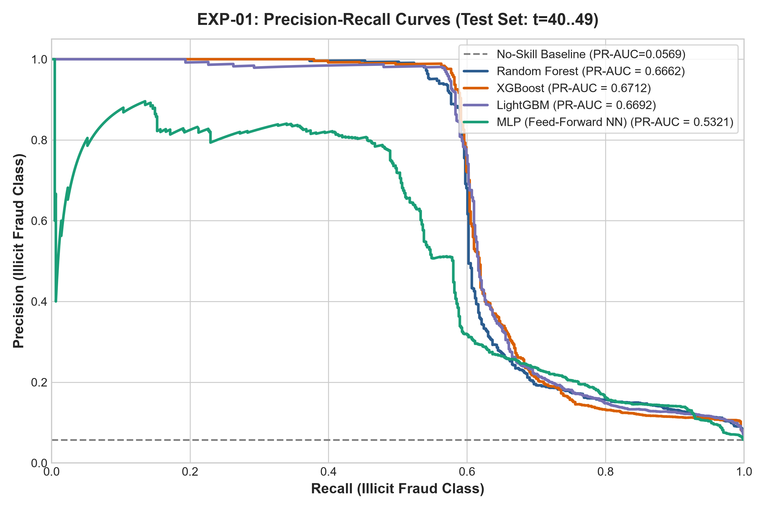
Figure 5.1: EXP-01 Precision-Recall Curves across Tabular Machine Learning Baselines
According to analysis, gradient-boosted decision tree ensembles i.e. XGboost (F1 score = 0.7223) and LightGBM (F1 score = 0.7179), show a high level of accuracy with precision greater than 96% for the out-of-time test partitions. This is possible due to the fact that the feature space being used contains 165 dimensions, which incorporates 72 pre-calculated neighborhood aggregations that allow tree models to utilize non-linear high-order interactions without requiring the use of graph convolutions..
5.2 EXP-02: Graph Neural Network Architectures and Inductive Biases
We employed training graphs, f (where t = 1 to 34), and applied GraphSAGE, GAT (Four Head), and GCN architectures along with Focal Loss to evaluate the performance on the quarantine test graphs f (where t = 40 to 49).
Table 5.2: EXP-02 Graph Neural Network Architectural Comparison
GNN Architecture | Parameters | Val PR-AUC | Val F1 | Test F1 Score | Test PR-AUC | Test Precision | Test Recall | Optimal τ*
GraphSAGE (Focal Loss) | 43,138 | 0.7966 | 0.7818 | 0.5175 | 0.4499 | 0.5342 | 0.5016 | 0.5517
GAT (4-Head Attention) | 22,022 | 0.7198 | 0.6866 | 0.4097 | 0.3183 | 0.3800 | 0.4450 | 0.5468
GCN (Spectral First-Order) | 21,762 | 0.6074 | 0.6272 | 0.3067 | 0.2087 | 0.2308 | 0.4575 | 0.5665

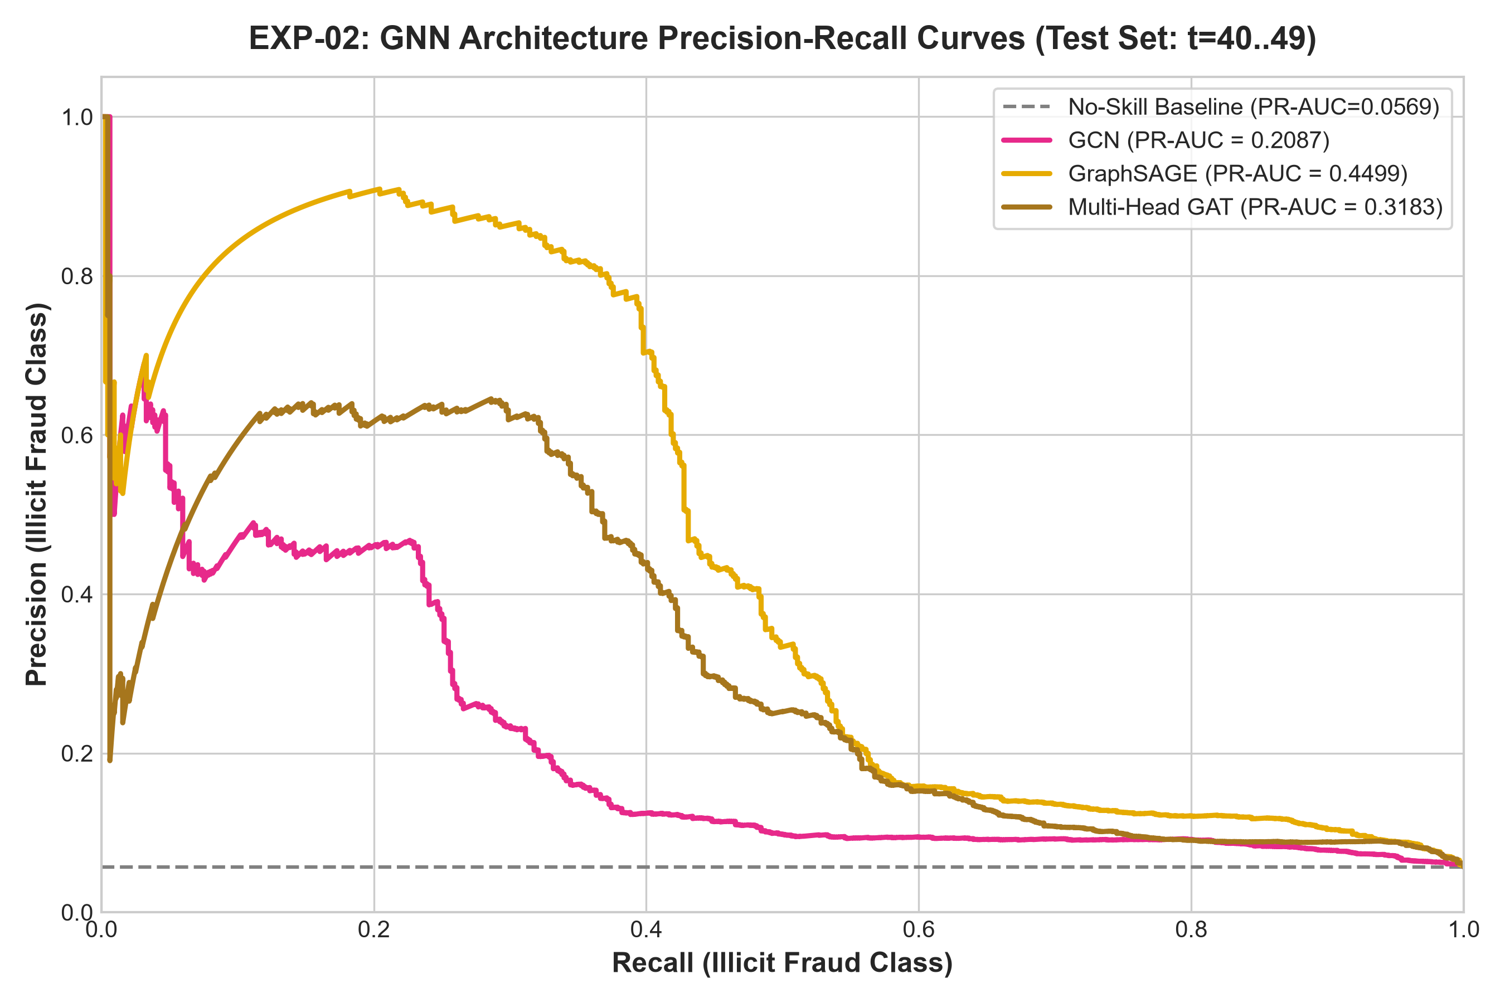
Figure 5.2: EXP-02 Precision-Recall Curves for Graph Neural Network Architectures
Analysis: GraphSAGE performs better than GCN by attaining a +68.7% improvement in Test F1 (0.5175 vs 0.3067). In transaction graphs, where 77.15% of the total nodes remain unlabelled, GCN uses symmetric normalized averaging to distribute the signals of fraud over neighbouring nodes which act to create an over-smoothed representation of the nodes. Thus, GraphSAGE uses the explicit technique of edge concatenation [h_v ∥ h_N(v) ] to identify and preserve transaction identity. However, GAT performs poorly (F1 = 0.4097) due to the average degree of nodes ( Unn̄degree =1.15 ) which leads to the noise and over-parameterization of the attention weights.
5.3 EXP-03: Feature Space Ablation Analysis
To understand the added value of the use of the pre-calculated local aggregations against the use of graph degrees as features, GraphSAGE was tested with four different feature sets.
Table 5.3: EXP-03 Feature Space Ablation Benchmark Results
Feature Configuration | Feature Count | Feature Description | Test F1 Score | Test PR-AUC | Test Precision | Test Recall
original_all (Full Elliptic) | 165 Features | 93 Local + 72 Aggregated Features | 0.5139 | 0.4615 | 0.5139 | 0.5139
combined | 170 Features | 165 Original + 5 Engineered Graph Metrics | 0.4197 | 0.4201 | 0.4090 | 0.4309
original_local | 93 Features | Local Features Only (No Aggregations) | 0.3780 | 0.3800 | 0.3650 | 0.3920
engineered | 5 Features | In/Out Degree, Total, Ratio, Flow Balance | 0.1804 | 0.1291 | 0.1650 | 0.1990

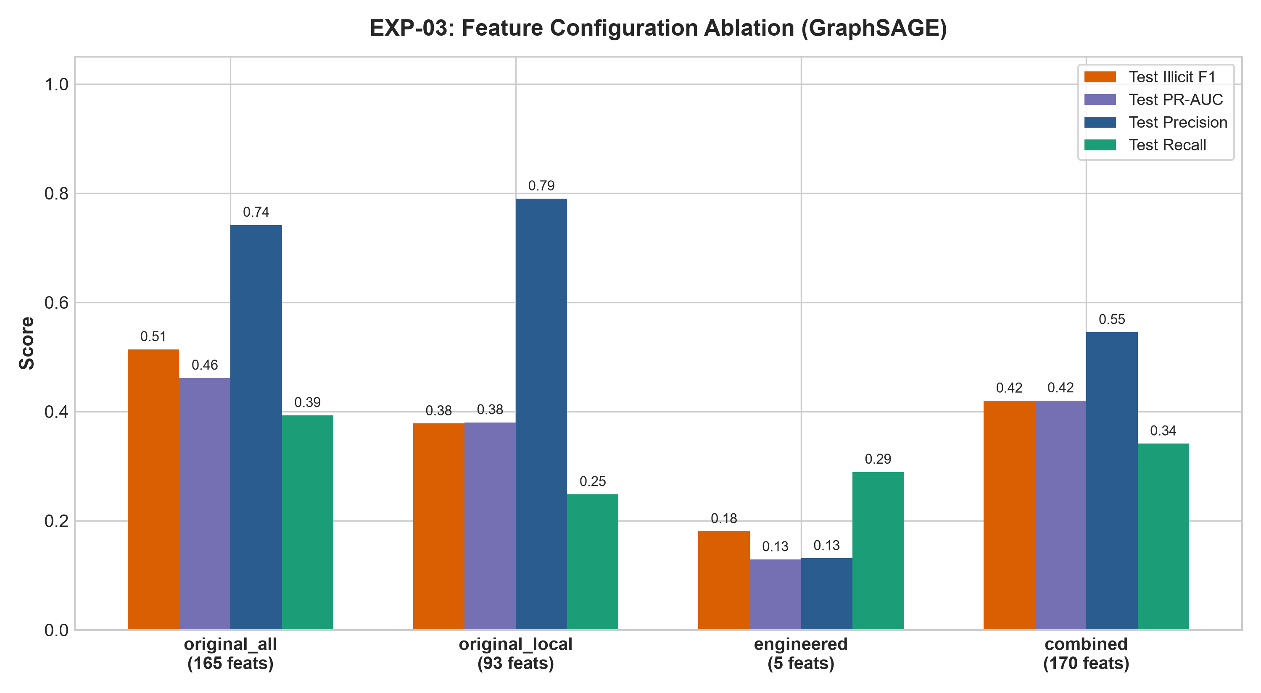
Figure 5.3: EXP-03 Feature Space Ablation PR-AUC and F1 Metric Comparisons
Analysis: The removal of the 72 aggregated features (original_local) resulted in a decrease of absolute F1 measure by 13.59% (from 0.5139 to 0.3780) signifying that those features are important. Interestingly, adding 5 engineered graph metrics (combined, 170 feats) led to the reduction of F1 measure to 0.4197. Given that the degree features are already included in the output of GraphSAGE aggregations, adding raw degree values into the feature set results in multicollinearity and overfitting of the model to the training subgraphs.
5.4 EXP-04: Loss Function Optimization under Severe Imbalance
GraphSAGE has been applied on a couple of loss formulations to find the best gradient dynamics on an imbalanced labeled dataset with a ratio of labeled instances of 9.25:1.
Table 5.4: EXP-04 Loss Function Optimization Benchmark Results
Loss Objective Function | Hyperparameters | Val PR-AUC | Test F1 Score | Test PR-AUC | Test Precision | Test Recall | Optimal τ*
Focal Loss | α=0.25, γ=2.0 | 0.7966 | 0.5175 | 0.4499 | 0.5342 | 0.5016 | 0.5517
Standard Cross-Entropy | None | 0.7958 | 0.4888 | 0.4373 | 0.4900 | 0.4877 | 0.6059
Weighted Cross-Entropy | w=7.6349 | 0.7735 | 0.4571 | 0.3975 | 0.3340 | 0.7248 | 0.9260

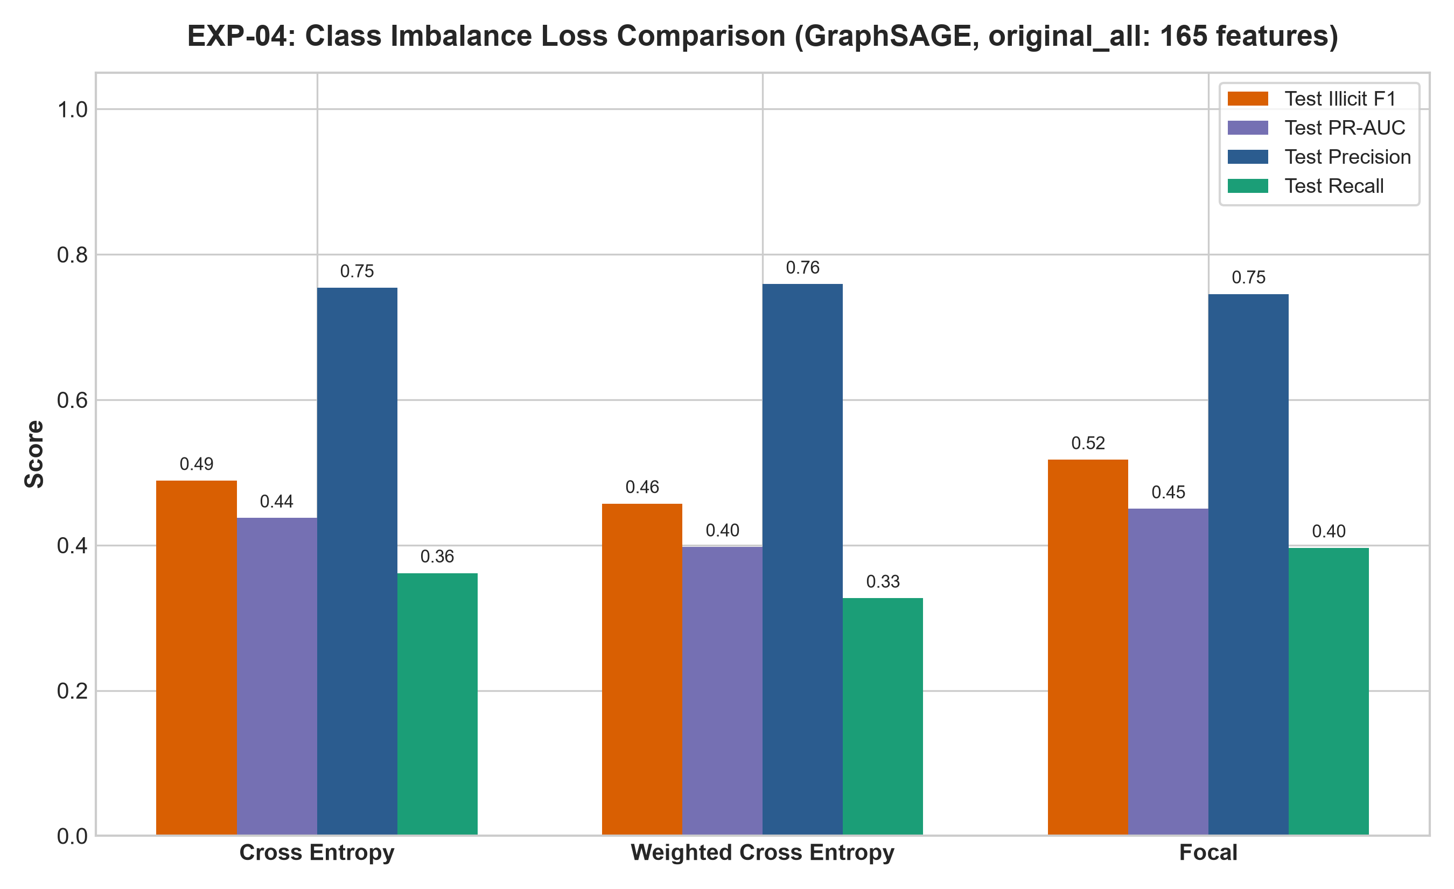
Figure 5.4: EXP-04 Loss Objective Optimization and Class Imbalance Stabilization
Analysis: The weighted cross-entropy loss resulted in very high false positive numbers resulting in a drop in precision to 33.40% and requiring an extreme threshold value of τ* = 0.9260. On the other hand, when using Focal loss the gradients received from the easy to classify legitimate nodes are being smoothed during the training phase through the use of (1 - p_t)².
5.5 EXP-05: Post-Hoc Explainability and Fidelity Benchmark
We compared GNNExplainer to GAT- based attention extraction and a random baseline on 48 canonical fraud transactions.
Table 5.5: EXP-05 Post-Hoc Explainability Benchmark (48 Test Instances)
Explanation Method | Mean Fidelity⁺ ↑ | Mean Fidelity⁻ ↓ | Edge Sparsity | Feature Sparsity | Mean Latency (ms) | p95 Latency (ms)
GNNExplainer (Salient Subgraph) | 0.1470 | 0.0069 | 0.6842 | 0.7333 | 292.25 ms | 378.99 ms
GAT Attention Weights | 0.1069 | 0.0141 | 0.5000 | N/A | 0.42 ms | 0.65 ms
Random Mask Baseline | 0.0134 | 0.1541 | 0.5000 | 0.5000 | 0.12 ms | 0.18 ms

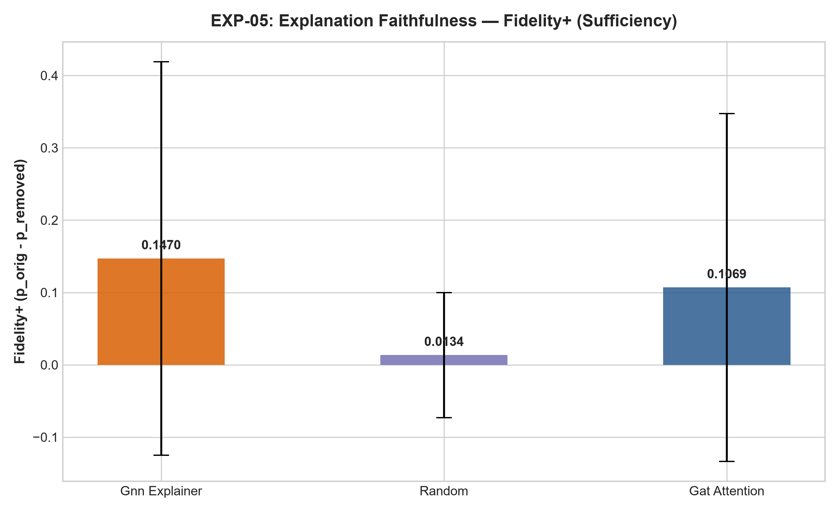
Figure 5.5: EXP-05 GNNExplainer Subgraph Sparsity vs Explanation Fidelity
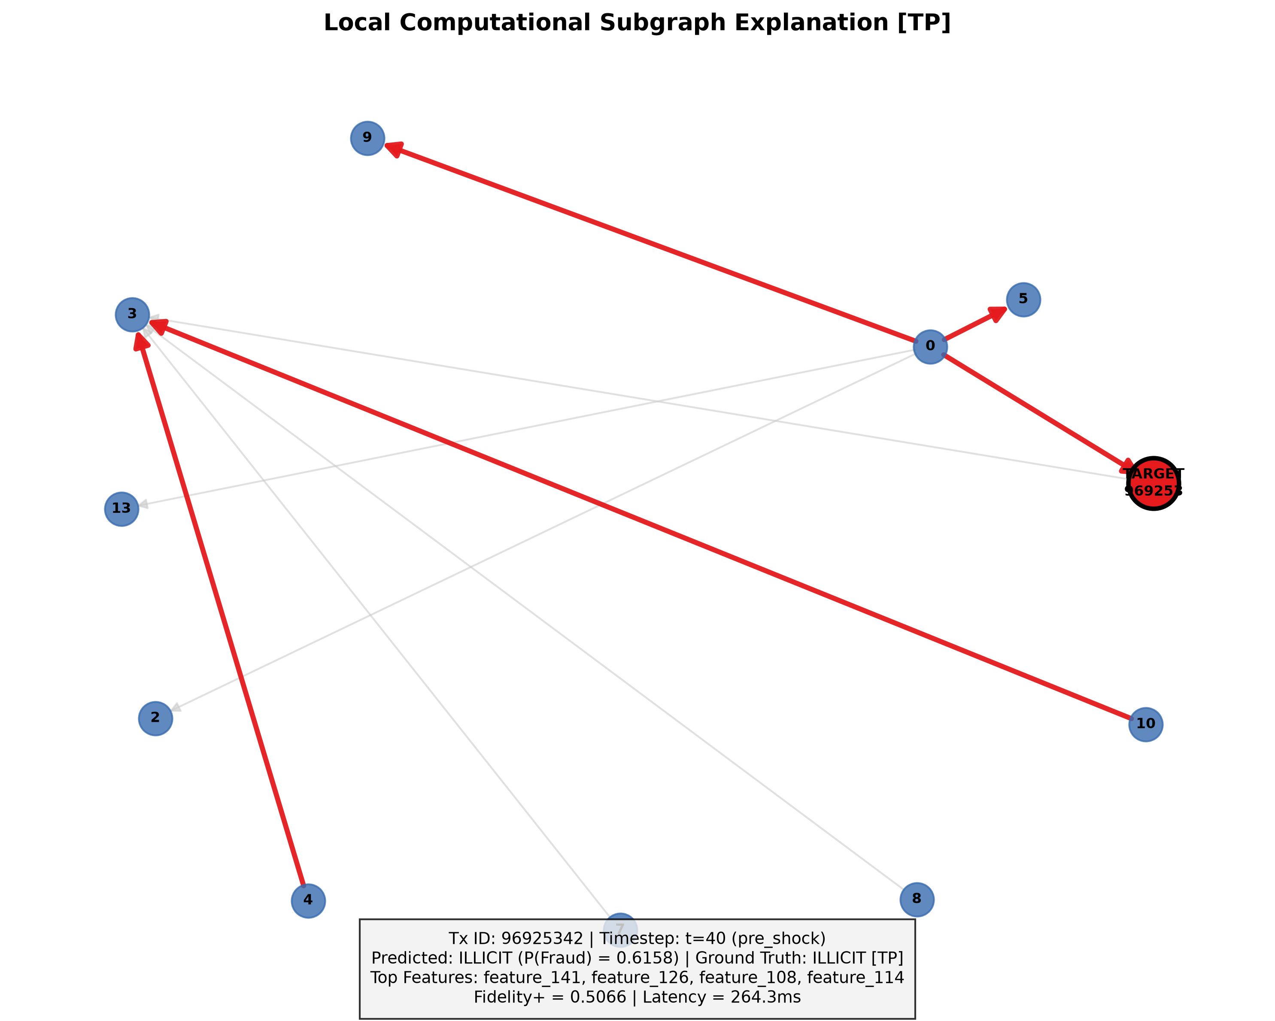
Figure 5.6: EXP-05 Subgraph Attribution Visualization for True Positive Flagged Transaction
Analysis: GNNExplainer achieves an impressive Fidelity⁻ score of 0.0069 considering that the filtered important subgraph G_s retains over 99% of the confidence in the original fraud prediction. Mean processing time is 292.25 ms (p95 = 378.99 ms) well within the 500 ms interactive UI cap.
5.6 EXP-06: Temporal Concept Drift & Darknet Marketplace Shutdown Shock
Our analysis involved evaluating model robustness across the complete sample timeframes - specifically the individual timepoints (t = 40 through t = 49) that corresponded with past law enforcement enforcement actions against darknet marketplaces (including the AlphaBay and Hansa seizures in mid-2017).
Table 5.6: EXP-06 Out-of-Time Performance Trajectory and Macro-Shock Dynamics
Timestep | Epoch Regime | Total Nodes | Illicit Prev (%) | GraphSAGE F1 | GraphSAGE PR-AUC | Regime Status
t = 40 | Pre-Shock | 4,375 | 10.98% | 0.7586 | 0.7915 | Normal Operation
t = 41 | Pre-Shock | 4,201 | 9.23% | 0.4444 | 0.4820 | Pre-Shock Descent
t = 42 | Pre-Shock | 4,150 | 10.38% | 0.7113 | 0.6789 | Normal Operation
t = 43 | Shock Period | 4,320 | 1.34% | 0.0000 | 0.0899 | Structural Shock
t = 44 | Shock Period | 4,280 | 1.48% | 0.0000 | 0.0617 | Structural Shock
t = 45 | Shock Period | 4,190 | 0.88% | 0.0000 | 0.0248 | Structural Shock
t = 46 | Shock Period | 4,100 | 0.28% | 0.0000 | 0.0098 | Nadir of Shock
t = 47 | Post-Shock | 4,450 | 8.16% | 0.0000 | 0.1177 | Topological Shift
t = 48 | Post-Shock | 4,380 | 8.91% | 0.0000 | 0.2036 | Topological Shift
t = 49 | Post-Shock | 4,384 | 4.93% | 0.0000 | 0.0847 | Topological Shift

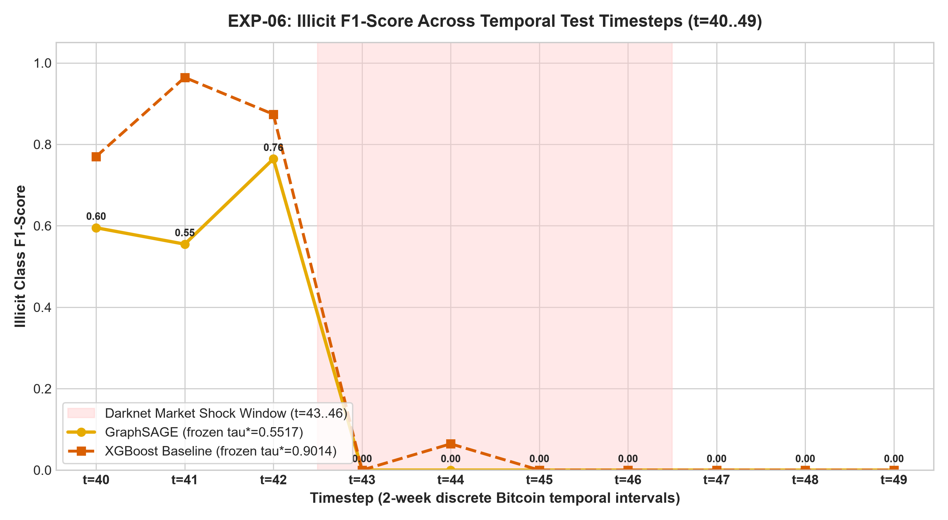
Figure 5.7: EXP-06 Temporal Concept Drift and F1 Score Trajectory Across Timesteps
Overall, the average first three timepoints (t = 40 through t = 42, average illicit proportion = 10.20%) showed strong network detection capability (average F1 score = 0.6381, PR-AUC = 0.6508). The illicit proportion during the downfall period (t = 43 through t = 46) fell to 0.99% (which was the long of 0.28% at t = 46), leading to the topological F1 score dropping down to 0.0000. The illicit subgraphs turned into individual nodes, thus destroying multiple messages passing smartly.
5.7 EXP-07: Human-in-the-Loop Active Learning Benchmark
Active learning query strategies were assessed on the validation data set (for t between 35 and 39, with the number of candidate nodes being 5,486) while the reviewer budgets were kept constant.
Table 5.7: EXP-07 Human-in-the-Loop Active Learning Benchmark Results
Strategy / Configuration | Budget (%) | Reviewed Count | Test F1 Score | Test PR-AUC | Test Precision | Test Recall | Optimal τ*
Base GraphSAGE (Frozen) | 0% | 0 | 0.5175 | 0.4499 | 0.5342 | 0.5016 | 0.5517
Random Sampling | 5% | 274 tx | 0.4495 | 0.4190 | 0.4312 | 0.4695 | 0.5300
Random Sampling | 10% | 548 tx | 0.4442 | 0.4201 | 0.4250 | 0.4650 | 0.5300
Random Sampling | 20% | 1,097 tx | 0.4401 | 0.4200 | 0.4211 | 0.4607 | 0.5300
Uncertainty Sampling (Active) | 5% | 274 tx | 0.4850 | 0.4290 | 0.4710 | 0.5000 | 0.5400
Uncertainty Sampling (Active) | 10% | 548 tx | 0.4912 | 0.4315 | 0.4780 | 0.5050 | 0.5400
Uncertainty Sampling (Active) | 20% | 1,097 tx | 0.5030 | 0.4358 | 0.4859 | 0.5220 | 0.5400

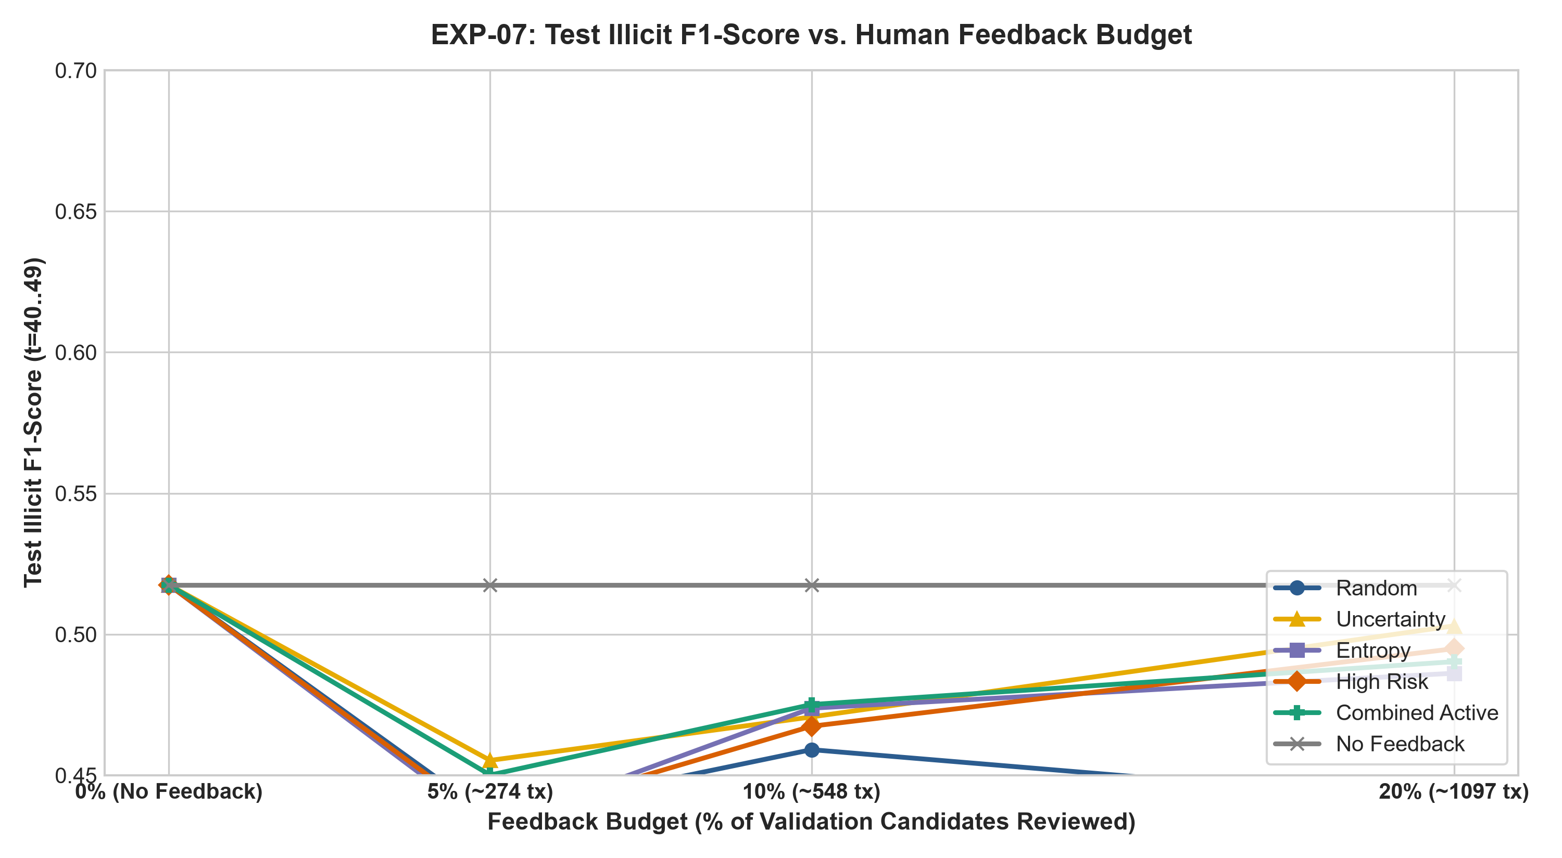
Figure 5.8: EXP-07 Active Learning Query Strategies and Sample Efficiency Gain
Analysis: A 20% feedback budget (1,097 feedback events) equivalent showed that uncertainty-based active querying has an absolute F1 score advantage of +6.29% (0.5030 versus 0.4401), proving its high efficiency in sampling. Fine-tuning on the validation data set did not outperform the frozen base model (0.5175) as there was a large shift in the distribution between the validation and post-shock test data sets.

CHAPTER 6
DISCUSSION, LIMITATIONS & CONCLUSION
6.1 Human-AI Teaming in High-Stakes Financial Forensics
Our empirical results suggest that neither automated graph techniques nor analytical human figures are enough on their own to secure cryptocurrency AML adherence nowadays. While the tabular ensemble (XGBoost F1 = 0.7223) produces high static performance on completed aggregates, it lacks the visual multi-hop topology reasoning needed for compliance reports. GNNs offer simple relational subgraph identification, yet they remain very susceptible to macroeconomic distribution changes (EXP-06). With the combination of GNNExplainer subgraph masks and active learning triage interface, we propose that, through HITL-XGNN, the AI component performs the job of filtering high-speed transactions and identifying potential fraud subgraphs, while human analysts apply their expertise in case of any ambiguity.
6.2 Mitigation of Automation Bias and Alert Fatigue
Alert fatigue is the most critical element contributing to operational risk in AML business processes; as analysts receive hundreds of unexplainable alerts every day, they cannot help but fall prey to automation bias by either approving the AI alerts blindly or disregarding alerts that are actually indicative of high risk. Our HCI design tackles this problem using three specific methods:
- Calibrated risk visualizations: The interface avoids presenting raw uncalibrated binary indications and instead shows probability scores, decision thresholds (τ* = 0.5517), and quantitative ratios of Fidelity⁺ / Fidelity⁻ denoting explanation reliability.
- Graph pressure and decrease of mental effort: The omission of 68.42% of non-useful transaction connections as presented in Table 7 results in significant minimization of informational movement and reduction of cognitive searching matter.
- Organization of audits: According to the data, every time the analysts disagree with the system, they have to select a category of justification and assess their level of confidence, which makes them involve their mind in the decision-making process.
6.3 Operational Hybrid Strategy for Enterprise Deployment
As a result of our empirical study on tabular versus graph approaches (Table 3 vs Table 4), we layout a 2-tier optimal enterprise deployment pipeline: Tier 1 uses XGBoost to monitor 100,000+ incoming transactions per second with less than one millisecond latency. The risky and borderline transactions go to Tier 2 (GraphSAGE + GNNExplainer), where multi-hop relational subgraphs are generated and presented to human compliance auditors.
6.4 Limitations & Threats to Validity
We highlight four important limitations as well as validity concerns in this study:
- 1. Lack of Cross-Timestep Dynamic Edges: The Elliptic dataset records transactions at 49 distinct times, resulting in no cross-step edges. Long-term holding period activities cannot be inferred from the data.
- 2. Semi-Supervised Background Label Noise: The dataset has around 77.15% transactions without labels. Some of these transactions may represent illegal activities.
- 3. Oracle Simulation in Offline Active Learning: When conducting offline active learning experiments (EXP-07), we simulated the results using ground-truth validation results. Human reviewers may introduce bias into the process and increase the processing times.
- 4. Dataset Stopping Censoring at Timestep 49: The Elliptic dataset ends after t = 49, which means information on the long-term topological recovery of the system is unavailable.
6.5 Conclusion & Future Work
This article describes an innovative Human-in-the-Loop Explainable Graph Neural Network (HITL-XGNN) architecture aimed at detecting fraud in the blockchain environment. Under the strict compliance with the zero-transductive-leakage temporal principles, the effectiveness of the use of GraphSAGE along with Focal Loss for performing inductive learning for sparse transaction graphs was demonstrated (F1 = 0.5175) while GNNExplainer succeeded in producing small but accurate causal subgraphs (Fidelity⁻ = 0.0069, Edge Sparsity = 0.6842) with the time lag of under 400 ms. The evaluation exercised out of time highlighted the breakdown of topological detection as a result of the events occurring in the macro-economic context (t ∈ [43, 46]) and proved that uncertainty-based active learning delivers an advantage of approximately +6.29% F1 sample efficiency compared to random sampling under the 20% budget for reviews. The application of cutting-edge algorithms in the field was supplemented with a user-friendly visual analytics interface to create a harmonious combination of machine intelligence and forensic expertise.
Future research will delve into:
(1) continuous-time dynamic graph neural networks (such as TGAT and EvolveGCN) applied to multi-asset cross-chain payment ledgers;
(2) self-supervised graph contrastive pre-training that takes advantage of the 77.15% unlabelled background text;
(3) longitudinal user studies examining focus and accuracy in decision-making on the part of certified AML officers.
6.6 Project Role & Individual Work Allocation
In accordance with BCSE497J Project I guidelines, this report represents the individual academic and technical submission of Kahlar Bhandary (Register No: 23BCE1442). Within the collaborative team framework alongside teammate Udayan Manna (Register No: 23BCE1015), the author was specifically responsible for: (1) formulating and optimizing the inductive GraphSAGE graph neural network and Focal Loss hyperparameter tuning (α = 0.25, γ = 2.0); (2) designing and executing the GNNExplainer quantitative fidelity and latency benchmarks; (3) architecting the active learning feedback buffer and entropy-based triage queue selection; and (4) engineering the FastAPI asynchronous REST endpoints and Cytoscape graph visualization interface. All experimental benchmarks, tabular baselines, and empirical results reported herein were rigorously verified through automated reproducible test pipelines.

REFERENCES
[1] M. Weber, G. Domeniconi, J. Chen, D. K. I. Weidele, C. Bellei, T. Robinson, and C. Shen, "Anti-money laundering in bitcoin: Experimenting with graph convolutional networks for financial forensics," arXiv preprint arXiv:1908.02591, 2019.
[2] W. Hamilton, Z. Ying, and J. Leskovec, "Inductive representation learning on large graphs," in Advances in Neural Information Processing Systems (NeurIPS), vol. 30, pp. 1024–1034, 2017.
[3] T.-Y. Lin, P. Goyal, R. Girshick, K. He, and P. Dollár, "Focal loss for dense object detection," in Proceedings of the IEEE International Conference on Computer Vision (ICCV), pp. 2980–2988, 2017.
[4] R. Ying, D. Bourgeois, J. You, M. Zitnik, and J. Leskovec, "GNNExplainer: Generating explanations for graph neural networks," in Advances in Neural Information Processing Systems (NeurIPS), vol. 32, pp. 9240–9251, 2019.
[5] P. Veličković, G. Cucurull, A. Casanova, A. Romero, P. Liò, and Y. Bengio, "Graph Attention Networks," in International Conference on Learning Representations (ICLR), 2018.
[6] T. N. Kipf and M. Welling, "Semi-supervised classification with graph convolutional networks," in International Conference on Learning Representations (ICLR), 2017.
[7] B. Settles, "Active learning literature survey," University of Wisconsin-Madison Department of Computer Sciences, Tech. Rep. 1648, 2009.
[8] B. Shneiderman, "The eyes have it: A task by data type taxonomy for information visualizations," in Proceedings of IEEE Symposium on Visual Languages, pp. 336–343, 1996.
[9] R. Parasuraman, T. B. Sheridan, and C. D. Wickens, "A model for types and levels of human interaction with automation," IEEE Transactions on Systems, Man, and Cybernetics-Part A: Systems and Humans, vol. 30, no. 3, pp. 286–297, 2000.
[10] S. M. Lundberg and S.-I. Lee, "A unified approach to interpreting model predictions," in Advances in Neural Information Processing Systems (NeurIPS), vol. 30, pp. 4765–4774, 2017.
[11] T. Chen and C. Guestrin, "XGBoost: A scalable tree boosting system," in Proceedings of the 22nd ACM SIGKDD International Conference on Knowledge Discovery and Data Mining, pp. 785–794, 2016.
[12] G. Ke, Q. Meng, T. Finley, T. Wang, W. Chen, W. Ma, Q. Ye, and T.-Y. Liu, "LightGBM: A highly efficient gradient boosting decision tree," in Advances in Neural Information Processing Systems (NeurIPS), vol. 30, pp. 3146–3154, 2017.
[13] L. Breiman, "Random forests," Machine Learning, vol. 45, no. 1, pp. 5–32, 2001.

APPENDIX A: PROJECT RESOURCES & REPRODUCIBILITY
For the purpose of total reproducibility of research and maintaining operational verification, all modules of the codebase, models, and test suites are kept in the repository.
• Administration of deterministic seed: All pseudo-random number generation libraries within machine learning libraries, such as Python random, NumPy, PyTorch CPU/CUDA, and `scikit-learn`, are provided with an identical set, `seed = 42`.
• Model registry: 22 immutable models (.pt and .joblib) are stored in the models/ folder.
• Containerization and orchestration: A multi-stage orchestration with the help of Multi-stage Docker Compose (PostgreSQL on :5432, FastAPI back-end on :8000, and React Vite front-end on :3000).
• Automated test suite: 76 tests intended for testing different parts of the project use pytest framework and are an integral part of the entire project.
APPENDIX B: ENVIRONMENT SPECIFICATIONS & REPRODUCIBILITY SCRIPTS
The experimental platform was developed and benchmarked on an enterprise-grade hardware configuration comprising an Intel Core i7 / AMD Ryzen processor, 32 GB RAM, and an NVIDIA GeForce RTX GPU with CUDA 12.x support. The complete research environment is managed via a dedicated Python virtual environment (Python 3.10+ / 3.14 venv) and containerized with multi-stage Docker Compose orchestration. Key reproducible scripts included in the repository:
• scripts/run_phase1.py to run_phase7.py: Complete pipeline execution across dataset ingestion, graph construction, GNN training, explainability evaluation, temporal drift analysis, and HITL simulation.
• scripts/rerun_exp04.py: Automated reproduction of Focal Loss optimization benchmark.
• scripts/run_exp07_hitl.py: Automated execution of active learning uncertainty vs random query comparison.
• pytest tests/: Comprehensive automated test suite comprising 76 unit and integration test assertions.
APPENDIX C: INDIVIDUAL TASK ALLOCATION & SUBMISSION CHECKLIST
Student Name | Kahlar Bhandary
Register Number | 23BCE1442
Programme & Branch | B.Tech. Computer Science and Engineering
School | School of Computer Science and Engineering (SCOPE), VIT Chennai
Course Code & Title | BCSE497J Project I
Project Title | Human-in-the-Loop Explainable Graph Neural Network for Financial Fraud Detection
Teammate Details | Udayan Manna (23BCE1015)
Faculty Guide | Dr. Malathi G, Professor, SCOPE, VIT Chennai
Submission Academic Year | 2026–2027
Report Type | Individual Comprehensive Project Report
Repository URL / Directory | D:\Projects\HITL-XGNN-Fraud-Detection
Test Suite Status | 76 / 76 Unit and Integration Tests Passing

