@

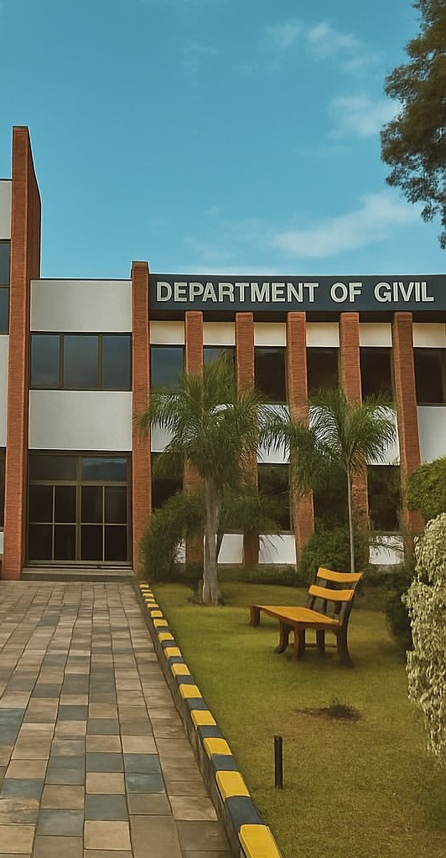

Visit Us Online
lms.uet.edu.pk
cse.uet.edu.pk
uet.acm@gmail.com

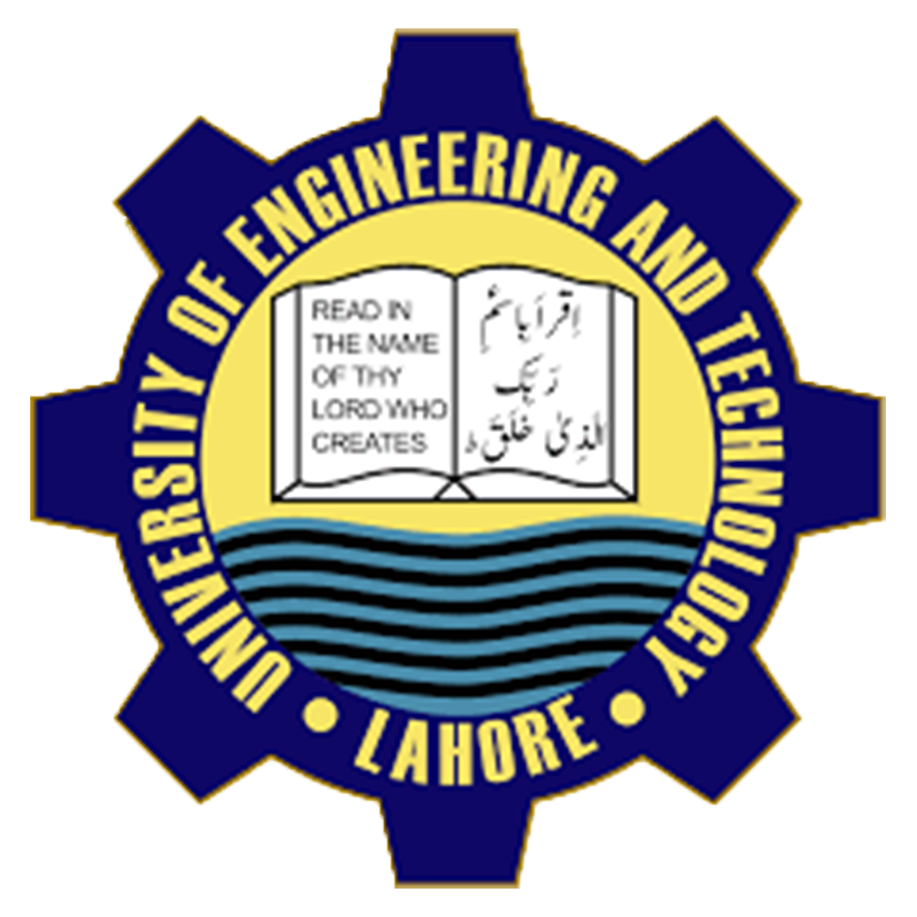

Department of
Mechanical
and Engineering
UET Lahore.

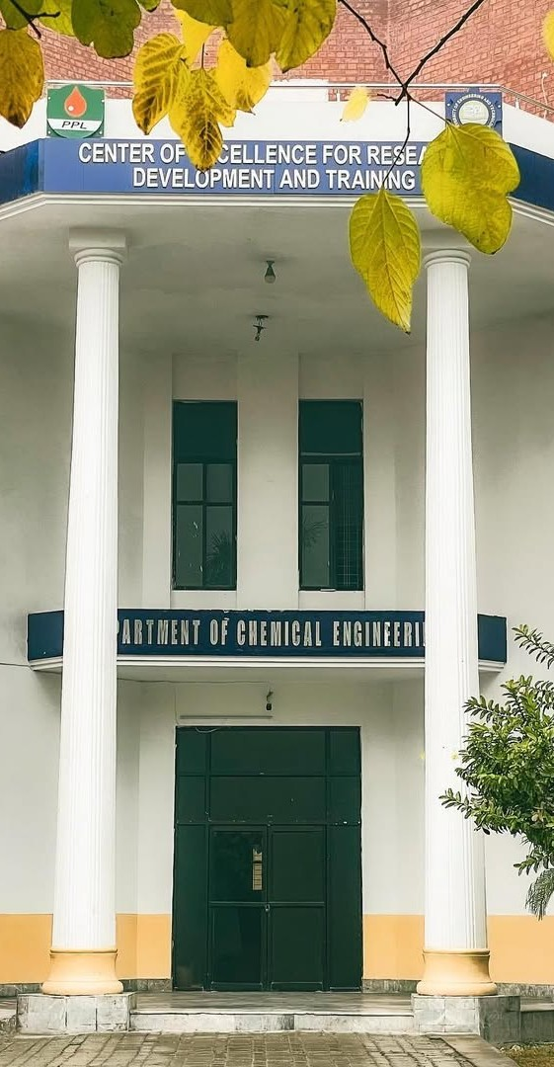

Internationally Recognized

UET Graduates are Eligible to work Globally as It is Associated Washington Accord. Programs Offered in Computer Science Department are Recognized by Washington Accord

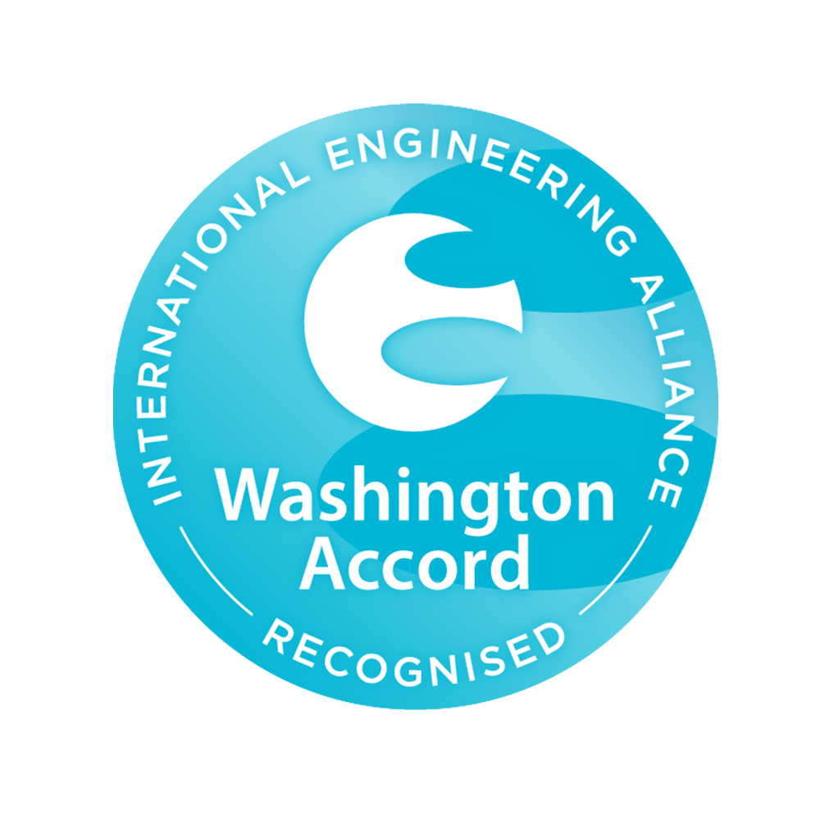
Internationally
Recognized

Department of Civil Engineering

Department of Chemical Engineering

Visit Us Online:
Lms.uet.edu.pk
Cse.uet.edu.pk
Uet.acm@gmail.ccom

U.E.T Graduates are eligible to work globally as it is associated to Washington programs offered in computer science department are recognized by Washington accord.
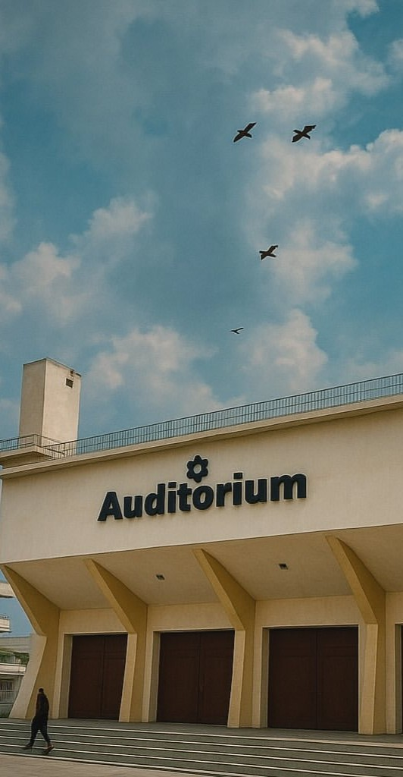

Courses offered:
- BS Computer Engineering
- BS Computer Science
- MS Computer Engineering
- MS Computer Science
Careers:
- Software Development
- Network & Computer System Administrator’s
- Computer Network & Architects
The Science of Today is technology of tomorrow.
~ Edward Teller

Technical Societies:
UET ACM is one of the most celebrated scientific society which is actively participated in different events in collaboration with ICOSST(KICS),
- IEEE UET Society
- Computer Club
- IET Society

Computer Facilities
Computer cell is providing complete facilities with advance internet service to whole universities.
Dean : Prof. Dr.Suhail Aftab qurashi

Chairman : Prof. Dr. Muhammad Shahbaz.

Contact US:

Uet admissions:
042-99029216

Registrar:
042-99029216
Deputy Registrar:
042-99029216

Assistant Registrar:
042-99029216

