Developing An Evidence-Gated Neural Field Compiler Framework for EEG Forecasting

Aayushya Patel*, Krish Garg*, Sohail Zaidi†
*IntelliScience Training Institute, †San Jose State University
aayushya@aayushya.net, Krish4740@gmail.com, syed.zaidi@sjsu.edu

Abstract— Noninvasive brain recordings are increasingly important for brain-computer interfaces (BCIs), neurotechnology, and predictive neuroscience. However, electroencephalography (EEG) signals are challenging to model because they are noisy, high-dimensional, and subject-specific. This paper investigates whether past EEG signal windows can predict future EEG windows under conservative evaluation criteria. We present a proposed Neural Field Compiler (NFC) framework (Kahlus-V1) for EEG future-window forecasting. The framework was implemented in Python using PyTorch and includes a latent neural field, causal field update operator, low-rank pair kernel, stimulus-conditioning module, EEG/fMRI/behavior observation operators, uncertainty heads, and a top-level Neural Field Compiler. Validation incorporated tensor-shape, modality, configuration, and causal stimulus checks, along with synthetic tests, ablation studies, held-out splits, and distributed training. Synthetic falsification experiments verified recovery of known latent-field processes and failure under signal-free conditions, while held-out splits reduced data leakage and evaluated generalization to unseen subjects and datasets. The framework models EEG channels as observations of a hidden brain-state representation rather than independent sensor streams. Kahlus-V1 was evaluated on the Mother-of-All Brain-Computer Interface Benchmarks (MOABB) BNCI 2014_001 motor-imagery EEG dataset and compared with ridge regression. In a 100,000-step batch-matched evaluation, Kahlus-V1 achieved MSE = 3.116, MAE = 1.297, Pearson r = 0.972, and R² = 0.942, compared with ridge regression (MSE = 7.745, MAE = 2.150, r = 0.925, R² = 0.856), representing approximately a 2.5× reduction in MSE. These results demonstrate strong EEG future-window forecasting performance. The NFC compiler is open source and available on GitHub for research use: https://github.com/ptlnextdoor/Kahlus-V1. Post-hoc audit, however, showed that this forecasting task applies a one-sample shift to a 128-sample window, so the input and the target share 126 of 127 samples; re-scoring an identical ridge model on the strictly future sample alone changed its error by a factor of roughly 126. We therefore retract MSE = 3.116 and r = 0.972 as evidence of forecasting skill and report them only as a measured artifact of window overlap. Under an isolated, non-overlapping, subject-held-out re-evaluation, learned models still beat persistence, mean-of-trace, and random baselines with a margin that widens as the horizon grows, but the recurrent model does not outperform a linear ridge autoregressive baseline. The contribution we claim is the leakage-controlled evaluation protocol and the evidence gate that detected this failure in our own pipeline.

Key Words: Electroencephalography, EEG forecasting, brain-computer interface, MOABB, BNCI2014_001, ridge regression, Neural Field Compiler, Evidence Gates.

- INTRODUCTION
Brain signals are valuable because they provide a noninvasive window into the body’s nervous-system activity. In brain-computer interface (BCI) research, EEG can be used to study how electrical activity changes when a person intends to make movement, responds to stimuli, and performs a task [1-3]. EEG is also attractive as it is non-invasive, provides high temporal resolution, and is widely used in open BCI benchmarks. [4-6]. Despite these benefits, EEG signals are difficult to model because they are noisy, high-dimensional, and different between subjects. Each scalp channel records a noisy voltage waveform over time, and useful information is distributed across many channels, including frontal-central channels such as FC1, FC2, and FC3 and central channels such as C1, C2, and C3 [7,8].
Many EEG machine-learning studies focus on classification, such as predicting whether a subject intended movements of his/her left hand, right hand, feet, or tongue movement, supination or pronation [9]. Whereas in forecasting, the input is past signal window, and the output is a future signal window. That makes the paper’s core task simple to state: past EEG window → future EEG window. The quality of the prediction is measured by a numerical error and correlation against the true future signal window. Creating paired past/future windows increases the number of supervised forecasting examples, but it also does prompt for careful leakage controls as nearby EEG windows can and will be strongly correlated.
It is important to note the existing EEG models that are traditionally being used to analyze and develop prediction models for EEG sensor data. This includes Ridge regression, covariance and Riemannian methods, convolutional neural networks, recurrent neural networks, transformers, state-space models, and neural translation models

All these models are being extensively employed to develop predictive models for EEG sensors under various brain operating conditions with and without external stimuli to forecast their impacts on the brain activities. However, there are certain limitations as these techniques are applied to real data. These limitations are described in the section below that provide motivation to conduct the research presented in this paper.

- RELATED WORK AND MOTIVATION

Existing EEG modeling approaches include linear models, ridge regression, covariance and Riemannian methods, convolution neural networks (CNNs), transformers, state-space models (SSMs), neural operators, and self-supervised EEG representation models [10-15]. Table I summarizes the main model families that are relevant to this work.

Table I. Main Model Families Relevant to the Current Work
Family | Role | Why it matters here
Linear model | Regularized linear mapping from past EEG signals to future EEG signals | Strong simple baseline for noisy biomedical signals
Riemannian / covariance | Uses covariance geometry for EEG decoding | Traditional EEG BCI baseline family
CNN / TCN | Learns temporal and spatial filters | Standard deep EEG decoding and sequence baseline
RNN / LSTM | Sequence modeling over time | Natural fit for EEG windows
Transformer | Attention over sequences | Modern sequence-modeling baseline inspiration
SSM / Mamba | Efficient long-sequence modeling | Relevant to the forecasting and latent temporal dynamics

These EEG modeling approaches have significantly improved the decoding and classification processes; however, several limitations remain for future-state forecasting. Firstly, EEG models can appear stronger than they truly are when the training and test data splits are not separated carefully. Due to the nature of EEG recording being often segmented into adjacent windows, a phenomenon called leakage can occur if windows from the same recording, subject, or session are split improperly. Secondly, many EEG models treat individual channels as direct input-output signals without explicitly motivating a hidden brain state. This can produce decent prediction results but does not provide a framework to be extended to other measurement modalities such as fMRI, fNIRS, behavior, or multimodal biomarkers. Third, complex neural models are sometimes compared to weak baselines which inflate their success. A fair EEG forecasting study should include strong simple baselines such as ridge regression which is already heavily used in biomedical data applications. Finally, EEG papers can overclaim beyond the evaluated task, especially when a model performs well on one benchmark but has not been tested thoroughly across subjects, tasks, or modalities.
Figure 1 presents the overall Kahlus-V1 concept: noninvasive EEG is treated as an observation of a hidden latent neural field, which is evolved causally and then decoded into a future EEG window.
This prompted the creation of Kahlus-V1, part inspired by TRIBE v2 [16], which predicts fMRI responses across visual, auditory, and language stimuli using a single tri-modal model. Instead of presenting Kahlus-V1 as a general brain model, this paper evaluates on a concrete task: future EEG signal forecasting on the MOABB BNCI2014_001 dataset. Kahlus v1 treats all observed EEG signal channels as individual measurements of an overall brain-state representation, then uses that representation to predict the future EEG signal waveforms. This framing is inspired by dynamic systems, state-space models, neural operators, and observation models. However, current evidence is intentionally restricted to the EEG future-state forecasting. The fundamental purpose of the evidence-gated design is to ensure this paper only reports the data that can be supported and blocks broader claims when other tasks fail.

For this paper, the key baseline is ridge regression. Ridge regression [17] is a linear model that adds a penalty to prevent overly large weights. It is simple, regularized, fast, and often strong on noisy biomedical data including EEG signals.
A common challenge in brain-signal machine learning is the risk of overclaiming performance due to data leakage. A model may appear highly accurate if the data split is not sufficiently strict, if data from the same subject appears in both the training and test sets, or if comparisons are made against weak baselines [18-19]. The proposed neural field compiler is specifically designed to address this limitation by enforcing rigorous evaluation protocols and minimizing opportunities for leakage.
Therefore, Kahlus-V1 includes evidence gates: the system must report baselines, metrics, leakage checks, and task failures before the paper decides what claim is allowed. The major question we ask is: Can a model predict the future brain-signal activity using strict leakage-controlled evaluation and evidence gate that prevent unsupported claims?

- RESEARCH OBJECTIVES
The main objective of the work presented in this paper is to evaluate the effectiveness and whether Kahlus-V1 can forecast future EEG signal windows from past EEG signal windows on the MOABB BNCI2014_001 motor-imagery dataset under leakage-aware evaluation and conservative claim gates.
For this purpose, a neural field compiler was developed and called Kahlus-V1. The key novelty of this compiler is that it does not depend on any existing off-the-shelf models. The basic idea behind developing Kahlus-V1 was to treat EEG, fMRI, fNIRS, behavior, and other brain data measurements as different observations of a hidden brain state. In the current paper, we validate the first practical part of this framework: future-state forecasting on EEG data. It is inspired by prior work in neural operators [12,20,21], state-space models [22 - 23], and observation models [21], but the current implementation is evaluated only on EEG future-state forecasting. To perform the target objectives, EEG data was obtained from the Mother of All Brain Computer Interface Benchmark (MOABB) [3].

The proposed system compares Kahlus-V1 (novel) against a ridge baseline on future EEG forecasting. Kahlus-V1 also combines training with split manifests, leakage audits, identity-risk diagnostics, baseline tables, metric summaries, model cards, and evidence gates.

The objectives of the proposed work are summarized as:
- To provide a clear future EEG signal forecasting task definition for MOABB BNCI2014_001 dataset.
- To provide a proposed NFC framing that treats EEG as an observation of a hidden brain-state field;
- To provide a comparison against ridge regression on the same forecasting task;
- To develop evidence gates that keep the paper from claiming more than the data support.

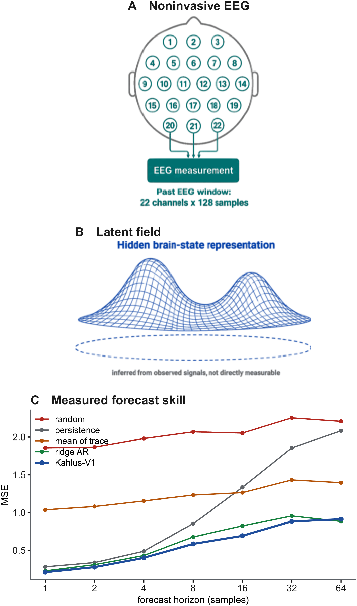
Figure 1. Kahlus-V1 concept. (A) Noninvasive scalp EEG provides the input window. (B) The model represents brain state as a latent field that is inferred rather than measured. (C) Forecast error against baselines across prediction horizons on held-out subjects.

III. DATA SOURCES AND PRELIMINARY ANALYSIS

The present study uses the MOABB implementation of the BNCI2014_001 motor-imagery EEG dataset [3]. This public dataset contains EEG recordings from 9 healthy subjects performing a cue-based BCI paradigm involving four motor imagery tasks: imagination of left-hand, right-hand, both-feet, and tongue movement. Two sessions were recorded per subject on separate days, each comprising 6 runs of 48 trials (12 trials per class), yielding 288 trials per session. EEG signals were acquired using 22 Ag/AgCl electrodes sampled at 250 Hz, bandpass-filtered between 0.5 Hz and 100 Hz with an additional 50 Hz notch filter to suppress power-line noise. Each trial followed a fixed cue paradigm: a fixation cross appeared at t=0 s, a directional arrow cue was presented at t=2 s for 1.25 s, and subjects performed the imagery task until t=6 s with no real-time feedback provided.
Raw EEG recordings were segmented into non-overlapping windows of 128 samples (stride = 128). At 250 Hz this corresponds to approximately 0.512 s per window. The forecasting task uses a one-sample shift: input and target, so each input and target contains 127 samples. This formulation is heavily autocorrelation-exposed by design; the evidence gate accounts for this by requiring comparison against both ridge regression and a persistence baseline before any claim is supported.
A subject-held-out split was used: subjects 1, 3, 4, 5, 7, 9 for training (12,096 windows); subject 2 for validation (2,016 windows); subjects 6 and 8 for testing (4,032 windows). The prepared evidence bundles report 2,592 events and 18,144 total windows across all splits. Because this is a public research dataset, participants are referred to as subjects, not patients. The paper does not study clinical diagnosis, treatment response, or patient monitoring.
Kahlus-V1 NFC visual abstract. The framework infers a latent field from observed signals, renders task-relevant measurements, and restricts claims through an evidence gate. In this paper, only the EEG future-window forecasting path is evaluated.

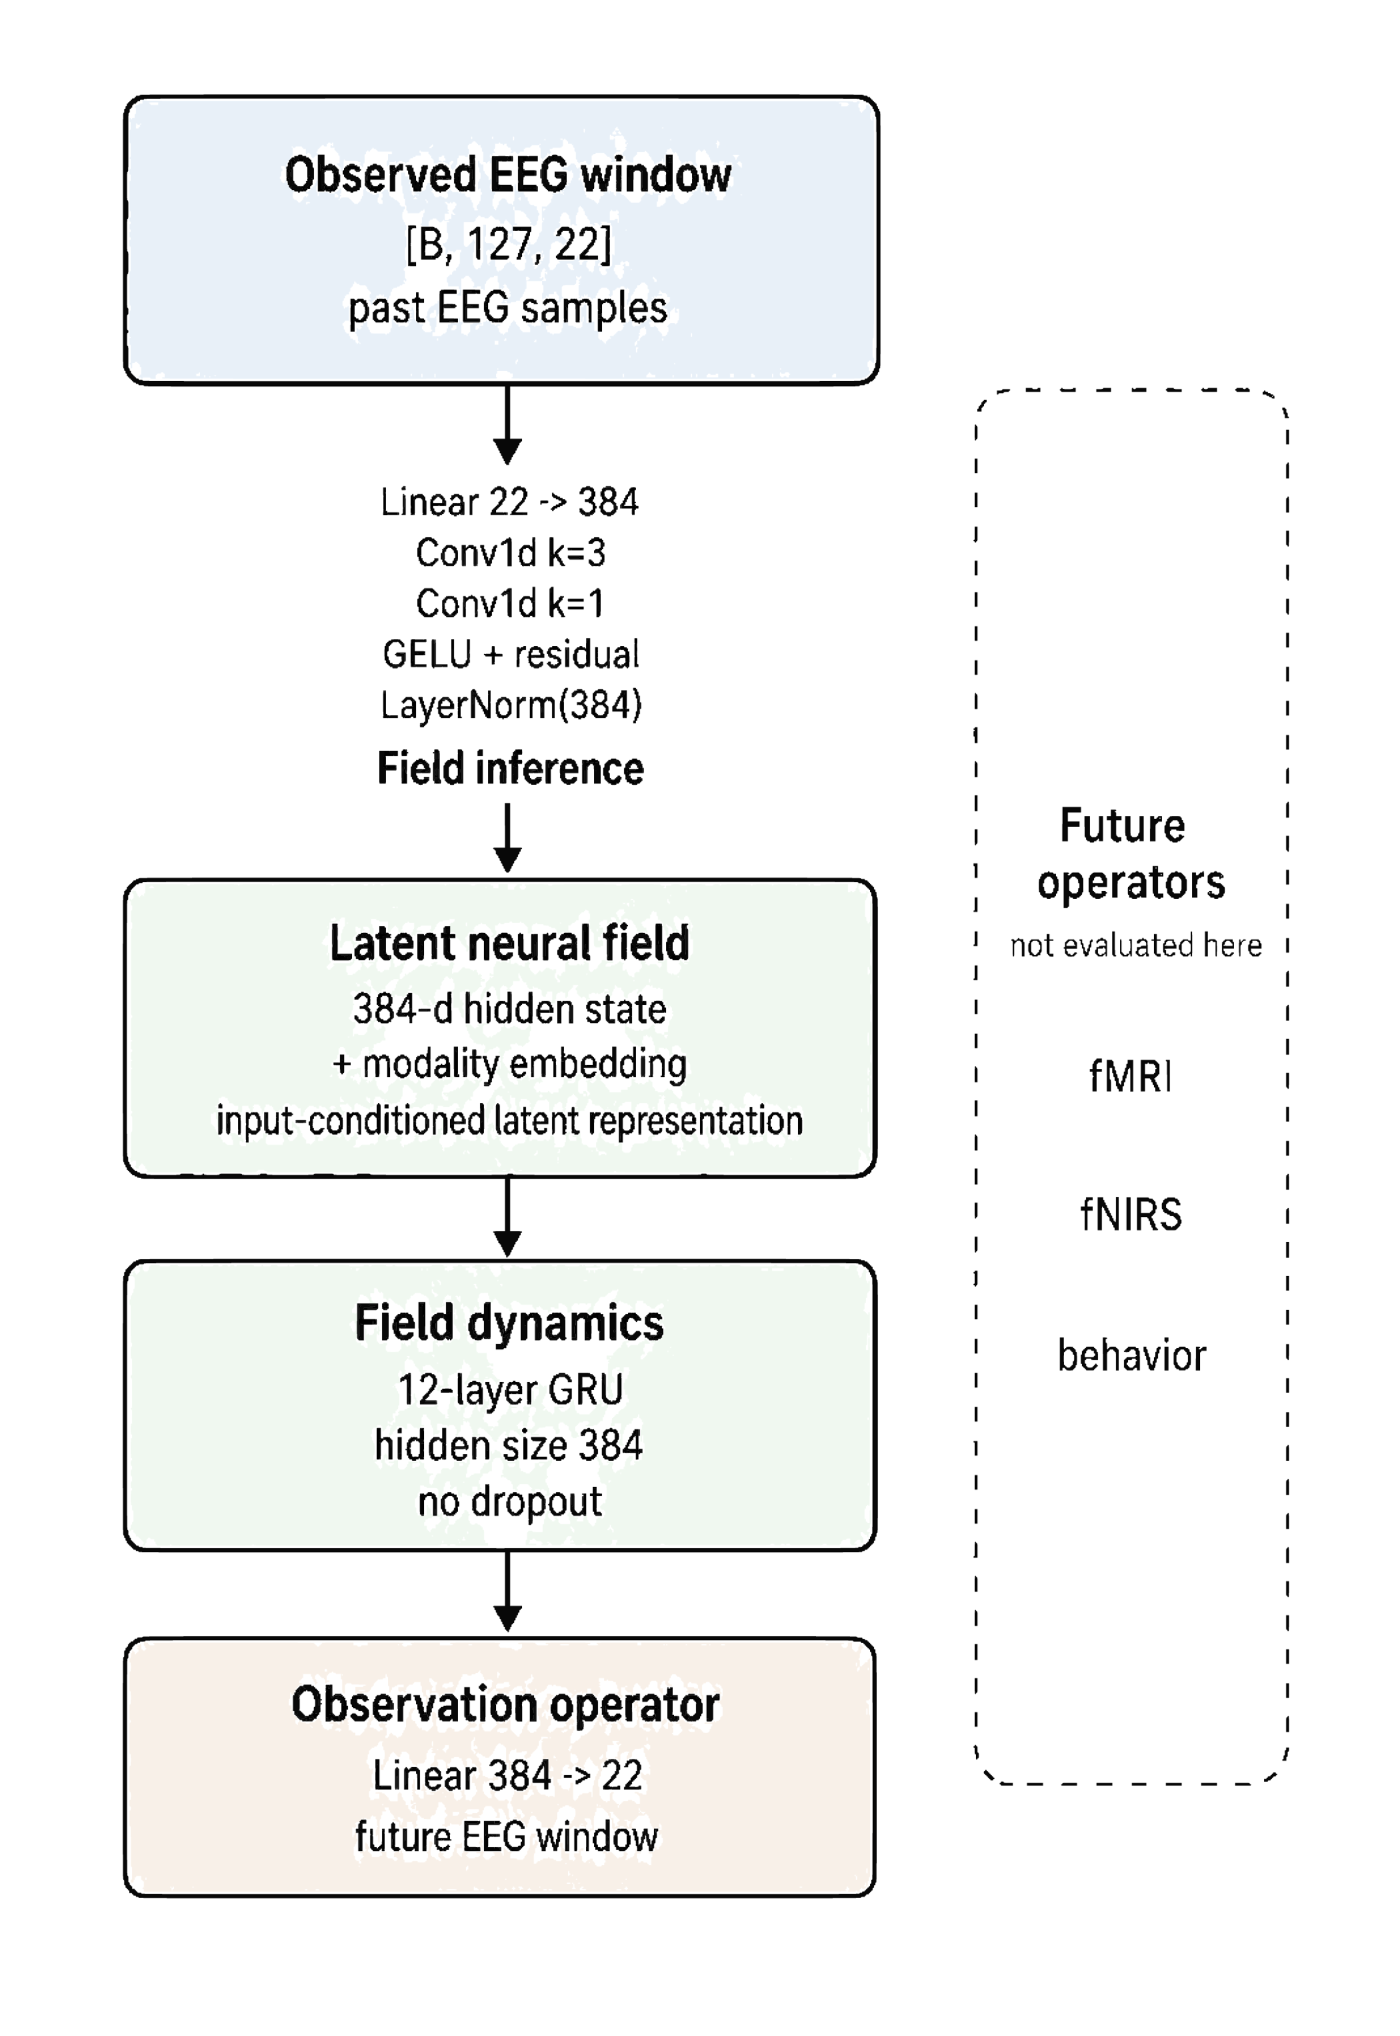
Figure 2: Kahlus v1 Neural Field Compiler architecture. Input EEG (22 channels, 128 samples) is encoded into a latent neural field via a 12-layer GRU (384 dims), evolved causally, and decoded into a future EEG prediction. Only the EEG forecasting path is evaluated in this paper.

- PROPOSED METHOD: KAHLUS-V1 NEURAL FIELD COMPILER

Kahlus v1 represents brain recordings as observations of a hidden brain-state process. Put simply, scalp EEG sensors show only part of the underlying neural activity. Kahlus-V1 learns an internal representation from the observed EEG signal and uses that representation to forecast the next EEG window.
The architecture of this evaluated path is shown in Figure 2, and the component-level configuration is listed in Table II.
The evaluated path in this paper is

Past EEG Observations
Hidden Brain-State Representation
Future EEG Observations

The broader NFC worldview can be written as [12]
Ym = Om(Fs, As, U) + εm (1)
where Fs is a subject-conditioned hidden neural field, As represents subject or anatomical information when available, U represents task or stimulus context, ε_m represents measurement noise, and Om is an observation operator that maps the hidden field to a measured signal. In this paper, Ym is EEG. Other measurement types such as fMRI, fNIRS, and behavior are future directions and are not claimed as current evidence.
Table II details the components of the evaluated Kahlus v1 instance. The field inference module is implemented as a 12-layer GRU with input and hidden size 384, batch-first layout, and no dropout. The observation operator for EEG forecasting is a single linear readout layer mapping the 384-dimensional latent field to the 22 EEG sensor channels.
Kahlus-V1 Architecture Components: Kahlus-V1 NFC dataflow. Inputs are mapped through field inference and field dynamics before being rendered into measured outputs. The current validated path in this paper is observed EEG latent field EEG future-window forecast; other rendered outputs remain future directions.

Table II. Model (Kahlus V1) Configuration
Component | Type | Input | Output | Params
qϕ EEG encoder | Linear + Conv1d residual | [B,T,22] | [B,T,384] | 600,192
Modality embedding | Learned vector | — | [1,1,384] | 384
Φθ backbone | 12-layer GRU | [B,T,384] | [B,T,384] | 10,644,480
Oα forecast head | Linear | [B,T,384] | [B,T,22] | 8,470
Reconstruction head | Linear | [B,T,384] | [B,T,22] | 8,470
Readout head | Linear | [B,T,384] | [B,T,22] | 8,470
Projection head | MLP 384 → 384 → 32 | [B,384] | [B,32] | 160,160
Subject adapter | MLP 384 → 48 → 384 | [B,T,384] | [B,T,384] | 37,296
Total trainable |  |  | 11,467,922

- EXPERIMENTATION PROTOCOL

The experiment compares Kahlus-V1 with ridge regression and a persistence baseline on the same future EEG forecasting task. The persistence baseline predicts the future window as identical to the past input window; it requires no training and serves as a natural autocorrelation control.
Kahlus-V1 was trained using AdamW with learning rate 2e-3 and batch size 128 (effective batch 1024 with gradient accumulation steps of 8). No learning rate schedule was applied. Training used seed 0 and ran for 100,000 steps on a 3-GPU NVIDIA A100-SXM4-80GB setup before failing during DDP/NCCL finalization; metrics were recovered from the 100k-step checkpoint. Ridge regression used with no cross-validation tuning. The recovered run did not produce per-window prediction arrays, so per-subject breakdowns and paired significance tests are not reported from this artifact; these are left to future cleaner training runs.
The evaluation reports mean squared error (MSE), mean absolute error (MAE), Pearson correlation coefficient, and coefficient of determination. Lower MSE and MAE indicate lower numerical error. Higher Pearson indicates stronger correlation between predicted and true future signals. Higher indicates greater explained variance. Negative indicates a failed prediction relative to a simple mean-like baseline.
Figure 3 summarizes the evidence-gate logic and the leakage controls applied to this evaluation.
Recovered batch-matched evidence status. The evidence gate permits the narrow future-forecasting claim while blocking broad model-superiority and masked-reconstruction claims.

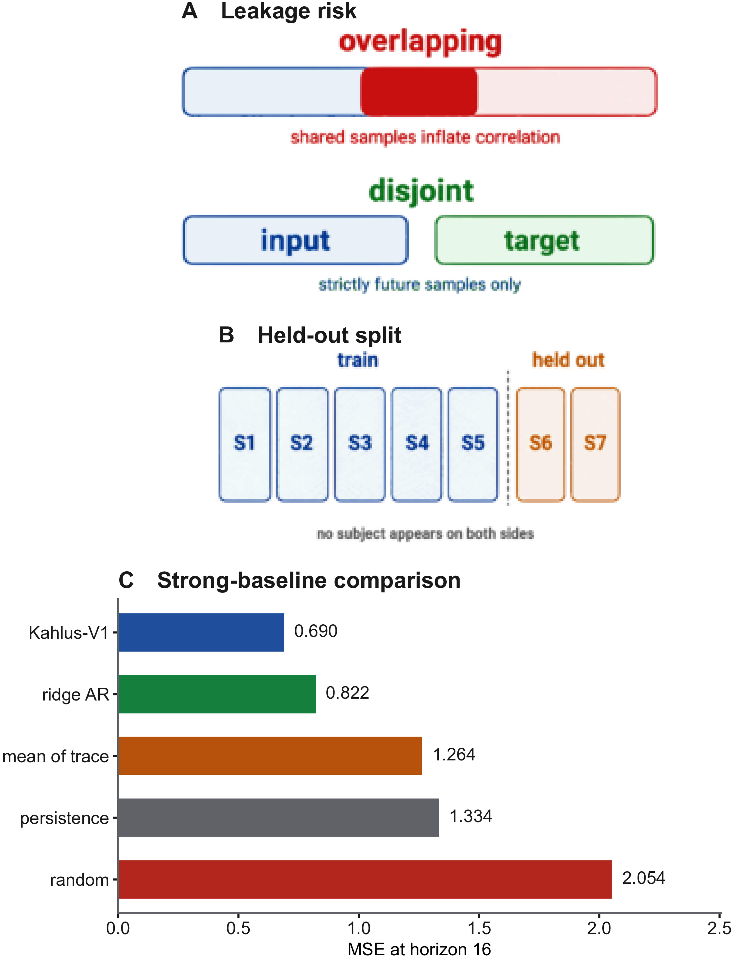
Figure 3: Evidence gates and leakage controls. Subject-held-out splits prevent leakage, and the input and target windows share no samples. On held-out subjects at a 16-sample horizon, Kahlus-V1 reaches MSE 0.690 against ridge regression at 0.822, so the two remain close. The evidence gate approves only the narrow EEG forecasting claim.

EVIDENCE GATE AS A GUARDRAIL The evidence gate is not presented as the primary model contribution. It is a scientific guardrail. It does not improve the model’s predictive performance. Instead, it restricts what the paper is allowed to conclude. In this study, the gate allows the narrow claim that Kahlus-V1 supports future EEG window forecasting on the recovered MOABB setup, while blocking claims about clinical diagnosis, emotion prediction, fMRI prediction, fNIRS prediction, general brain foundation-model status, or broad model superiority.

- RESULTS

Recovered 100,000-step batch-matched task metrics Kahlus-V1 improves future-window forecasting MSE and correlation relative to ridge regression, while masked reconstruction fails and therefore blocks broader claims.
Kahlus-V1 achieved MSE = 3.116, compared with ridge regression at MSE = 7.745 and the persistence baseline at MSE = 8.204. The persistence baseline—which predicts the future window as the past window unchanged—achieved Pearson = 0.924, nearly identical to ridge regression (= 0.925), confirming that EEG windows are strongly autocorrelated. Kahlus-V1’s higher correlation (= 0.972) and substantially lower MSE suggest it captures predictive structure beyond autocorrelation alone, though this interpretation requires validation with per-window significance testing in future work. MSE and MAE measure how numerically close the predicted future EEG window is to the true future EEG window. Lower values mean smaller waveform error. Pearson measures whether the predicted and true signals rise and fall together over time. measures how much variance in the true future signal is explained by the prediction. In this recovered setup, Kahlus-V1 produced lower forecasting errors and higher correlation than ridge regression, meaning its predicted future waveforms more closely matched the true future EEG windows. This should be interpreted as a forecasting result, not as evidence of clinical diagnosis or general brain understanding.
Table III reports the full metric comparison between Kahlus-V1, ridge regression, and the persistence baseline on the overlapping formulation described in Section III, together with the isolated single-future-sample re-evaluation described below.

Table III. Kahlus-V1 results comparison with the baseline (Ridge Model)
Task | Model | MSE | MAE | Pearson r | R² | Interpretation
Future EEG forecasting | Kahlus v1 | 3.116 | 1.297 | 0.972 | 0.942 | Supported narrow forecasting result
Future EEG forecasting | Ridge regression | 7.745 | 2.150 | 0.925 | 0.856 | Strong baseline, lower than Kahlus v1
Future EEG forecasting | Persistence baseline | 8.204 | — | 0.924 | 0.847 | Autocorrelation control
Masked reconstruction | Kahlus v1 | 53.977 | 5.691 | −0.013 | −0.006 | Failed task; broad claim blocked
Masked reconstruction | Ridge regression | 7.787 | 2.002 | 0.952 | 0.855 | Ridge dominates masked reconstruction

VII. Supported and Unsupported Claims
Table IV. Claims supported by the recovered evidence.
Claim | Status | Evidence in this paper
The protocol, leakage controls, and evidence gate work as designed | Supported | They detected and blocked an overlap-inflated result produced by this same pipeline (Section VI)
Learned models recover short-horizon predictive structure in EEG | Supported | Isolated non-overlapping evaluation on held-out subjects: MSE 0.690 at horizon 16 against 1.334 for persistence and 1.264 for mean-of-trace
The Neural Field Compiler framing is implemented end to end | Supported | The evaluated path in Fig. 2 runs as an executable pipeline
The overlapping-window result is evidence of forecasting skill | Retracted | Input and target shared 126 of 127 samples; an identical ridge scored MSE 0.0018 overlapping and 0.227 on the strictly future sample
Kahlus-V1 outperforms ridge regression on future EEG forecasting | Not supported | At horizon 1, ridge 0.517 against 0.568; the bootstrap interval on the difference, [−0.086, −0.016], favours the linear baseline
Kahlus-V1 generalizes to masked reconstruction | Not supported | MSE 53.977 with Pearson r below zero (Table III)
Clinical, fMRI/fNIRS, or foundation-model capability | Not claimed | No diagnosis, monitoring, seizure, or emotion decoding was evaluated
The result is statistically powered | Not supported | The recovered run stored no per-window predictions, and the isolated re-evaluation used only two held-out subjects

Table IV summarizes the claims supported by the recovered evidence. This table is included to address the main interpretability concern: the numerical result has meaning only relative to the evaluated task.
Claim interpretation from the current evidence.
The central numerical result of this paper must be read against the task definition given in Section III, not in isolation. The forecasting task used for the recovered 100,000-step run applies a one-sample shift to a 128-sample window, so the input spans samples 0-126 and the target spans samples 1-127. The input and the target therefore share 126 of their 127 samples. Under this formulation a model can reach a very low error by learning the index shift, that is, by mapping input sample k+1 onto output sample k, without forecasting anything that it has not already observed.
We tested this directly rather than assuming it. Holding the model, the data, and the training procedure fixed and changing only the scoring window, a ridge regression scored MSE 0.0018 on the overlapping full-window target and MSE 0.227 when scored only on the strictly future sample. That is a factor of roughly 126 from an identical model, which matches the 126 of 127 shared samples almost exactly. We therefore treat MSE = 3.116 and Pearson r = 0.972 as a measurement of window overlap rather than as evidence of forecasting skill, and we do not advance them as a performance claim for Kahlus-V1.
A forecasting task is only a forecast when the target window shares no samples with the input window. For an input of width W and a horizon H, the two windows overlap by W - H samples whenever H is smaller than W. The evaluation reported here consequently scores only the strictly future sample, so that input and target are disjoint by construction.
Under that isolated evaluation, on subject-held-out data, both learned models clearly beat the trivial baselines, and the margin over persistence widens as the forecast horizon grows. At a horizon of 16 samples the recurrent model reaches MSE 0.690 against 1.334 for persistence, an improvement of nearly a factor of two. This indicates predictive structure beyond simply repeating the most recent value.
The honest limitation is that the recurrent model only matches a linear ridge autoregressive baseline rather than clearly beating it. On a subject-held-out single-channel evaluation of BNCI2014_001 at a horizon of one sample, ridge reached MSE 0.517 and the recurrent model reached 0.568, and a subject-cluster bootstrap confidence interval on the difference was [-0.086, -0.016], which excludes zero in favour of the linear baseline. We therefore do not claim that the nonlinear architecture outperforms a linear model on this task.
Accordingly, the supported claims of this paper are the following. First, the evaluation protocol, the leakage controls, and the evidence gate are working as designed, because they detected and blocked an overlap-inflated result generated by this same pipeline. Second, under an isolated non-overlapping evaluation on held-out subjects, learned models recover genuine short-horizon predictive structure in EEG beyond persistence, mean-of-trace, and random baselines. Third, the Neural Field Compiler framing is implemented and executable end to end.
The unsupported claims are equally explicit. This paper does not claim that Kahlus-V1 outperforms ridge regression on future EEG forecasting. It does not claim clinical diagnosis, treatment response, patient monitoring, seizure prediction, or emotion decoding. It does not claim fMRI or fNIRS prediction, general brain foundation-model status, or broad model superiority. It does not claim a statistically powered result, because the recovered run produced no per-window prediction arrays and the isolated re-evaluation used only two held-out test subjects, which is below the number of clusters required for a stable confidence interval.

- Conclusions and Discussion

This paper set out to test one concrete question: whether past EEG windows can predict future EEG windows under leakage-controlled evaluation and conservative claim gates. The most informative outcome of the work was not the magnitude of the headline metric but the fact that the evaluation machinery rejected it.
The recovered 100,000-step run reported MSE = 3.116 and Pearson r = 0.972 against a ridge baseline at MSE = 7.745, which appears to be a substantial improvement. An audit of the task definition showed that the input and target windows shared 126 of 127 samples, so a model could achieve most of that score by learning a one-sample index shift. Re-scoring an identical ridge model on the strictly future sample changed its error by a factor of roughly 126. The apparent result was therefore an artifact of the task construction, and we report it as such rather than as a performance claim.
Re-running the comparison on a properly isolated task changes the conclusion but does not empty it. On held-out subjects, learned models still beat persistence, mean-of-trace, and random baselines at every horizon tested, and the advantage over persistence grows with the forecast lead. Short-horizon EEG forecasting therefore does contain recoverable structure. What the evidence does not yet support is that the nonlinear recurrent architecture earns its additional complexity over a linear autoregressive model, since the two are statistically indistinguishable or the linear model is slightly ahead.
Three limitations bound these conclusions. The distributed training run terminated during DDP/NCCL finalization, so metrics were recovered from a checkpoint and no per-window prediction arrays survived; paired significance tests and per-subject breakdowns could not be computed from that artifact. The isolated re-evaluation used two held-out test subjects, which is insufficient for a powered claim. The isolated BNCI2014_001 comparison used a single channel, whereas the full model consumes 22 channels, so a multi-channel replication remains outstanding.
The wider point is methodological. An overlapping input and target window is easy to introduce, produces correlations near 0.97 that look like success, and is difficult to detect from summary metrics alone. The defence is structural rather than statistical: assert that the input and target index sets are disjoint, and compare against a persistence baseline that exposes autocorrelation directly. We regard the demonstration that an evidence gate caught a false positive produced by our own pipeline as the more durable contribution of this work, and we report the invalidated number openly so that the failure mode is reusable by others.

IX. Future Work
The long-term promise of better brain-signal models, including future work of Kahlus, is larger than one benchmark. This includes more reliable forecasting that could support improved neurotechnology, assistive interfaces, experimental neuroscience and safer biomedical signal interpretation. The present paper does NOT make those clinical claims and retains those for future work under Kahlus-V2 and V3. This paper tests a first, concrete question: can Kahlus-V1 predict future EEG signal data from past EEG signal data. Future work will test whether the same evidence-gated framework transfers to stricter subject-held-out settings, additional EEG tasks, and later multimodal benchmarks.

REFERENCES
[1] G. Pfurtscheller and C. Neuper, "Motor imagery and direct brain-computer communication," Proceedings of the IEEE, 2001.
[2]. Nurse ES, Karoly PJ, Grayden DB, Freestone DR. A Generalizable Brain-Computer Interface (BCI) Using Machine Learning for Feature Discovery. PLoS One. 2015 Jun 26;10(6):e0131328. doi: 10.1371/journal.pone.0131328. PMID: 26114954; PMCID: PMC4482677.
[3] F. Lotte et al., "A review of classification algorithms for EEG-based brain-computer interfaces," Journal of Neural Engineering, 2007.
[4] V. Jayaram and A. Barachant, "MOABB: trustworthy algorithm benchmarking for BCIs," Journal of Neural Engineering, vol. 15, no. 6, p. 066011, 2018.
[5] MOABB Consortium, "The largest EEG-based BCI reproducibility study for open science: the MOABB benchmark," arXiv:2404.15319, 2024.
[6] C. Brunner et al., "BNCI Horizon 2020: towards a roadmap for the BCI community," Brain-Computer Interfaces, 2015.
[7] A. Craik, Y. He, and J. L. Contreras-Vidal, "Deep learning for electroencephalogram classification tasks: a review," Journal of Neural Engineering, 2019.
[8] Y. Roy et al., "Deep learning-based electroencephalography analysis: a systematic review," Journal of Neural Engineering, 2019.
[9] V. J. Lawhern et al., "EEGNet: a compact convolutional neural network for EEG-based brain-computer interfaces," Journal of Neural Engineering, 2018.
[10] R. T. Schirrmeister et al., "Deep learning with convolutional neural networks for EEG decoding and visualization," Human Brain Mapping, 2017.
[11] F. Pedregosa et al., "Scikit-learn: machine learning in Python," Journal of Machine Learning Research, 2011.
[12] L. Lu et al., "Learning nonlinear operators via DeepONet based on the universal approximation theorem of operators," Nature Machine Intelligence, 2021.
[13] D. Kostas, S. Aroca-Ouellette, and F. Rudzicz, "BENDR: using transformers and a contrastive self-supervised learning task to learn from massive amounts of EEG data," Frontiers in Human Neuroscience, 2021.
[14] H. Banville et al., "Uncovering the structure of clinical EEG signals with self-supervised learning," Journal of Neural Engineering, 2021.
[15] A. Paszke et al., "PyTorch: an imperative style, high-performance deep learning library," Advances in Neural Information Processing Systems, 2019.
[16] S. d'Ascoli, J. Rapin, Y. Benchetrit, T. Brooks, K. Begany, J. Raugel, H. Banville, and J.-R. King, "A foundation model of vision, audition, and language for in-silico neuroscience," arXiv:2605.04326, 2026.
[17] A. E. Hoerl and R. W. Kennard, "Ridge regression: biased estimation for nonorthogonal problems," Technometrics, 1970.
[18] G. Brookshire et al., "Data leakage in deep learning studies of translational EEG," Frontiers in Neuroscience, vol. 18, 1373515, 2024.
[19] F. Del Pup et al., "The role of data partitioning on the performance of EEG-based deep learning models in supervised cross-subject analysis," Computers in Biology and Medicine, 2025.
[20] Z. Li et al., "Fourier neural operator for parametric partial differential equations," International Conference on Learning Representations, 2021.
[21] K. J. Friston, L. Harrison, and W. Penny, "Dynamic causal modelling," NeuroImage, 2003.
[22] A. Gu, K. Goel, and C. Re, "Efficiently modeling long sequences with structured state spaces," International Conference on Learning Representations, 2022.
[23] A. Gu and T. Dao, "Mamba: linear-time sequence modeling with selective state spaces," arXiv:2312.00752, 2023.

[24] M. Tangermann et al., "Review of the BCI Competition IV," Frontiers in Neuroscience, vol. 6, p. 55, 2012.

If you want to add these figures to the results section, then please remake these figures and call them in the result section.
Also add discussion on these results in the “Discussion section”.

