Sample Outputs
Real generated Facebook ad copy from the deployed app, run against 3 real Vigoshop.si products, as evidence the tool works end-to-end.

1. Electric Tooth Cleaner
Auto Settings used: Gemini determines itself based on picture
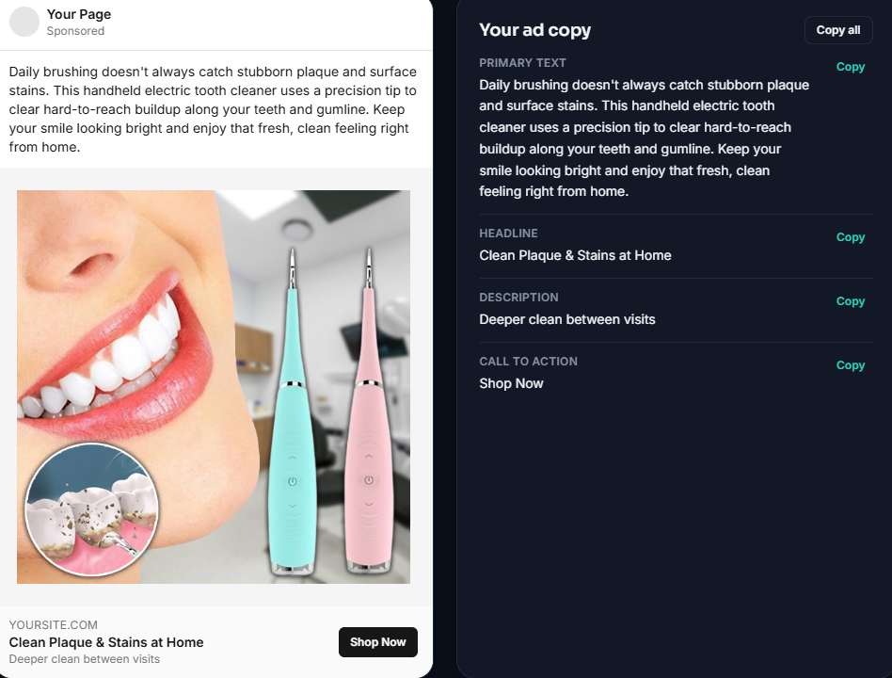
Primary text: Daily brushing doesn't always catch stubborn plaque and surface stains. This handheld electric tooth cleaner uses a precision tip to clear hard-to-reach buildup along your teeth and gumline. Keep your smile looking bright and enjoy that fresh, clean feeling right from home.
Headline: Clean Plaque & Stains at Home
Description: Deeper clean between visits
CTA: Shop Now

2. Facial Epilator
Custom Settings used:
Audience=Women 18–45 who want quick, convenient facial hair removal at home and prefer a simple alternative to frequent salon visits
Tone=Persuasive
Language=English
Product name=Facial Epilator
Key selling point=Quick and convenient facial hair removal at home
CTA=Shop Now
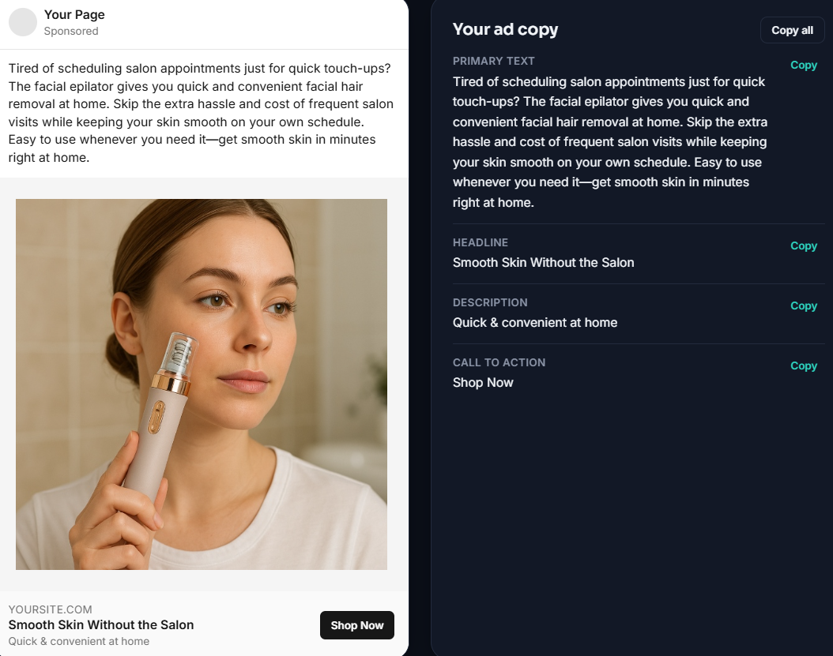
Primary text: Tired of scheduling salon appointments just for quick touch-ups? The facial epilator gives you quick and convenient facial hair removal at home. Skip the extra hassle and cost of frequent salon visits while keeping your skin smooth on your own schedule. Easy to use whenever you need it—get smooth skin in minutes right at home.
Headline: Smooth Skin Without the Salon
Description: Quick & convenient at home
CTA: Shop Now

3. Fridge Organizer Bin
Custom Settings used:
Audience=Custom People who want a more organized, tidy and space-efficient refrigerator
Tone=Friendly
Language=English
Product name=Fridge Organizer Bin
Key selling point=Keeps food items organized and easy to find while making better use of refrigerator space
CTA=Shop Now
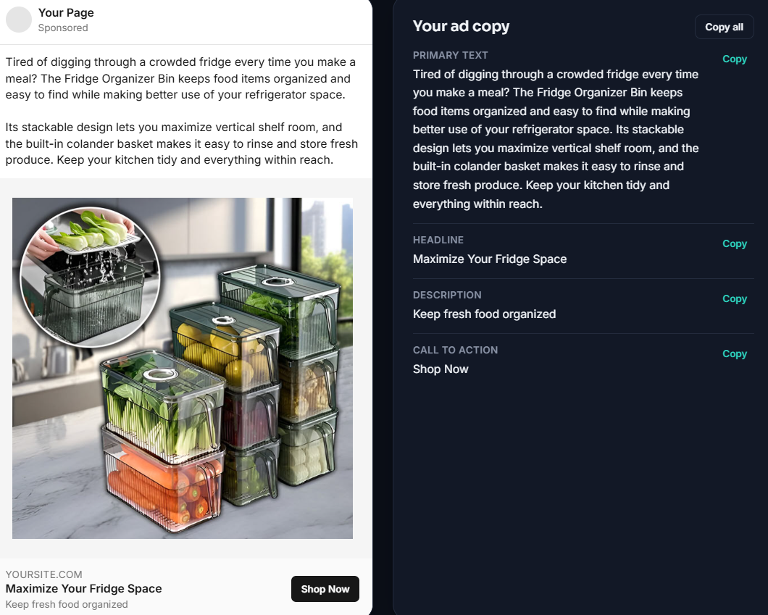
Primary text: Tired of digging through a crowded fridge every time you make a meal? The Fridge Organizer Bin keeps food items organized and easy to find while making better use of your refrigerator space. Its stackable design lets you maximize vertical shelf room, and the built-in colander basket makes it easy to rinse and store fresh produce. Keep your kitchen tidy and everything within reach.
Headline: Maximize Your Fridge Space
Description: Keep fresh food organized
CTA: Shop Now

