★ Launched at DEVCON 17th Anniversary — Beta Release ★

NVIDIA Jetson Orin Nano
R&D for Edge Offline Computing
Kai
Edge Offline AI Robot
R&D by Cohort 4 AI Engineering Interns

Product Name | NVIDIA Jetson Orin Nano R&D for Edge Offline Computing
Robot Name | Kai — Edge Offline AI Robot
Document Version | 2.3
Status | Active R&D — Phase 2 (conversational) shipped and running live; Beta launched at DEVCON 17th Anniversary
Date | August 2026
Prepared By | Jhondel Mellomida
Team | Cohort 4 AI Engineering Interns — AI Engineering Department

— Confidential R&D Document —

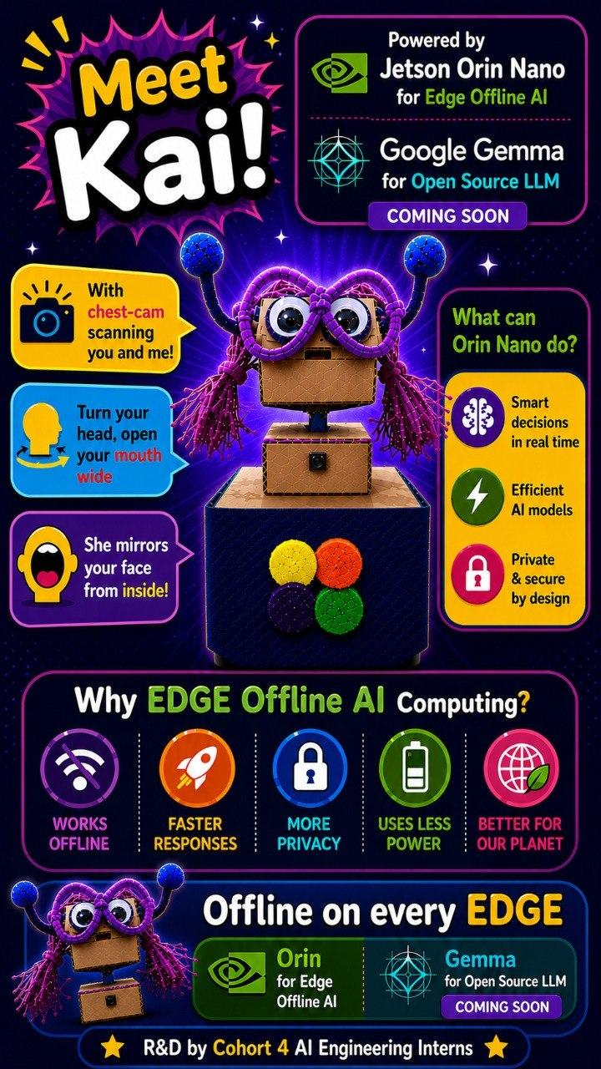

1. Introduction

1.1 Purpose
This document is the R&D reference for Kai — NVIDIA Jetson Orin Nano R&D for Edge Offline Computing. It is not a traditional production PRD but a living record of the team's hands-on exploration of edge AI hardware, with face detection as the primary proving ground. Requirements and specifications here are working hypotheses expected to evolve as hardware understanding deepens.

1.2 Scope
This document covers the face tracking pipeline (11 parameters), on-device AI model execution, robot actuation over USB serial, the offline voice stack (wake word, speech-to-text, retrieval, LLM, text-to-speech), the web dashboard, and the hardware constraints discovered during hands-on R&D by Cohort 4 AI Engineering Interns. Physical chassis manufacturing and cloud infrastructure remain out of scope.

1.3 References
• LoFi Robot Face Tracking App: https://cardboard.lofirobot.com/apps/face-tracking/
• LoFi Robot Face App Info: https://cardboard.lofirobot.com/face-app-info/
• NVIDIA Jetson Orin Nano: https://developer.nvidia.com/embedded/jetson-orin-nano
• MediaPipe Face Landmarker: https://ai.google.dev/edge/mediapipe/solutions/vision/face_landmarker
• Google Gemma (gemma2:2b): https://ai.google.dev/gemma
• Related BRD / SDD / SOW: TBD
• Kai source code (Apache-2.0): https://github.com/DelMellomida/kai

2. Vision & Strategy

2.1 Vision Statement
Kai is an edge-first AI robot that thinks, sees, and responds entirely on-device — no cloud, no internet dependency, no data leaving the room. Powered by the NVIDIA Jetson Orin Nano, Kai demonstrates that real-time AI interaction can be private, fast, and accessible, running fully offline at the edge.
This R&D project is a proving ground for that vision: starting with face tracking, evolving into conversation, and ultimately pushing the boundary of what a small form-factor edge device can perceive, decide, and act on.

2.2 Strategic Pillars
Pillar | What it means for Kai
Edge Offline AI | All inference runs locally on the Jetson Orin Nano. No internet connection required. No data sent to external servers. Kai works anywhere.
Privacy by Design | Facial data is processed in memory only, never stored or transmitted. Users are informed before any face tracking begins.
Open & Extensible | Every tunable is a named constant in config/, one file per subsystem, with a live overlay the dashboard can write at runtime; the firmware and the whole codebase are open (Apache-2.0). A maker or researcher can retune or extend Kai without touching core code.
NVIDIA-Powered | Kai leverages the Jetson's 1024-core Ampere GPU, dedicated DLA, CUDA, cuDNN, and TensorRT — the same stack powering production edge AI deployments.
Progressive Intelligence | Kai evolves: Phase 1 is face tracking, Phase 2 is conversation, future phases bring simulated environments and deeper CUDA capabilities.

2.3 Problem Being Solved
The original LoFi Robot system offloads all ML inference to a host browser and communicates via Bluetooth UART at approximately 12 Hz, creating noticeable control lag and severe memory limitations on the Micro:Bit (16 KB RAM, fatal error code 20). Kai replaces this architecture entirely:
• All ML inference runs on the Jetson GPU/DLA — no host browser dependency.
• Actuation is a direct USB serial link to the Arduino Uno, which acts purely as a 5V level bridge (the Jetson's GPIO is capped at 3.3V, which SG90 servos do not reliably read). The planned Wi-Fi/UDP link was not needed and was not built — see §6.2.
• The Jetson's 8 GB shared CPU/GPU memory and 40 TOPS compute lift the resource ceiling — though 8 GB is now the binding constraint on the conversation stack, not a comfortable margin (see §7.2).
• Everything runs offline — no internet, no cloud, no external device required.

2.4 Target Users
Persona | Profile | Goals | Pain Points
Maker / Hobbyist | Builds robots at home; comfortable with Arduino/Raspberry Pi | Drop-in Micro:Bit replacement with better performance | Frustrated by Micro:Bit RAM limits and lag
STEM Educator | Runs robotics workshops; needs reliable classroom demos | Stable low-latency face mirroring that works every time | Micro:Bit error code 20 disrupts lessons
Hardware Partner | Designs robot chassis or motor boards for third parties | Clear protocol spec to build firmware against | Lack of standardized interface documentation
Developer / Researcher | Explores HCI and embodied interaction | Extensible 11-parameter set and open API | Existing solutions too rigid and low-throughput

3. Features — Done, Backlog & Wishlist
This section tracks all features and capabilities across three tiers. Items are grouped by status reflecting the state of the Kai R&D project as of 10 August 2026, verified against the repository (CHANGELOG.md, docs/plan/ and docs/tickets/) rather than from recollection.

3.1 Done ✅
The following are implemented and confirmed operational on the robot — heard, watched or measured on the Jetson Orin Nano itself, not inferred from a green test suite.

Feature | Details | Verified
Face Detection (Exercise 1) | Real-time face detection running on Jetson GPU via jetson-inference. Raspberry Pi Camera NoIR V2 connected directly to Jetson. | ✅ Confirmed
Object Detection — YOLOv8 (Exercise 2) | YOLOv8 object detection confirmed operational on-device via GPU acceleration. | ✅ Confirmed
Local LLM — Qwen3:8b (Exercise 3) | Qwen3:8b confirmed running fully offline via Ollama on the Jetson. Retained as an R&D result only — it is far too large to stay resident beside the camera and MediaPipe, so the shipping conversational model is gemma2:2b (see below). | ✅ Confirmed (exercise)
11-Parameter Face Tracking Pipeline | X, Y, Distance, Yaw, Pitch, Mouth, Left Eye, Right Eye, Roll, Smile/Kiss, Face Visible — derived from MediaPipe FaceMesh at 320×240, decimated to 15 fps. The 19-digit LOFI-format string is emitted on stdout with the --lofi flag for downstream tooling. | ✅ Confirmed
Robot Hardware Assembly | SG90 servos on pan (Arduino pin 9) and jaw (pin 6), Arduino Uno, cardboard head/body assembly. Both servos share the Arduino's USB 5V rail, which is what caps the send rates. | ✅ Connected
Servo Link — USB Serial (supersedes the planned Wi-Fi/UDP link) | The Arduino Uno is a 5V level bridge on a 115200-baud USB serial link, not a network node. Two channels share the line: "pan,tilt" at 10 Hz and "J<angle>" at 20 Hz for the jaw. The rates are capped by SG90 current on the shared USB rail (CH340 brownout, measured), not by bandwidth. The LAN carries only the dashboard and the optional laptop camera stream. | ✅ Confirmed — architecture changed
Robot Actuation | The Arduino decodes the serial lines and drives the servos. Host side: a PD controller with EMA smoothing and an 8°/command slew clamp on its own 15 Hz control thread, so the head glides between inference ticks. The firmware detaches the servos after 4 s idle so SG90s stop buzzing and drawing current while holding. | ✅ Confirmed
Direct Camera Connection | Raspberry Pi Camera NoIR V2 on the CSI port, with a CSI → USB webcam → network → headless fallback chain. "No camera" is a reported state the robot keeps running through, not a startup crash. | ✅ Connected
Live Dashboard (Port 8081) | Live video, tuning knobs, the chat transcript and a three-rung recovery ladder, served over the LAN or a directly attached monitor. State rides an SSE /params stream. It is unauthenticated and binds 0.0.0.0 — a deliberate trade for a home LAN and a real exposure at a venue (ticket S7). | ✅ Live
Untethered Power — 20V Powerbank | Kai runs off a 20V powerbank through the USB-C to 5.5mm-2.5mm cable, with no wall power. This was the last physical dependency on a fixed location. | ✅ Confirmed
Google Gemma (gemma2:2b) Integration | gemma2:2b served locally by Ollama as Kai's conversational layer, alongside the face tracking pipeline. Pinned resident (keep_alive = -1) at 2.4 GB, 100% on GPU, with num_ctx = 2048. Switched down from gemma3:4b to fit the camera in 8 GB; num_ctx = 4096 hard-crashes the llama runner on this hardware. | ✅ Confirmed
INMP441 Microphone Connection | INMP441 I2S MEMS microphone captured raw on ALSA card APE at 48 kHz with PulseAudio suspended, resampled to the 16 kHz Whisper needs. A USB microphone is a supported input alongside it, not only a fallback: both are probed on every resolve, MIC_PREFERENCE decides which is tried first, and plugging one in or pulling it out is picked up within seconds without a restart. A swap waits for a quiet moment, so it never interrupts a turn in progress. The one card that is never captured is the speaker's own — identified by its ALSA card index rather than its name, so a USB mic reporting the same generic product name is unaffected. | ✅ Connected
Audio Output Chain (USB DAC + Powered Speaker) | Output runs Jetson → USB C-Media audio dongle (the DAC) → a powered USB speaker on the dongle's 3.5mm jack, the USB lead carrying power only. This replaced the PAM8403 amplifier and cavity speaker: the same audio path, with one self-contained unit in place of an amp board and loose wiring. The software side is unchanged — the dongle's card profile is re-asserted on every start because PulseAudio flips it to S/PDIF unprompted, and suspend-on-idle is disabled so the speaker does not drop out between replies. | ✅ Connected
Voice Input — Speech-to-Text | faster-whisper running int8 on CPU (capped at 4 threads so it cannot starve the servo control thread), with the base model and language auto-detection across English and Tagalog. Deliberately kept off CUDA to leave iGPU memory for Ollama and MediaPipe. | ✅ Confirmed
Voice Output — Text-to-Speech | Piper, a local offline neural TTS engine, with the en_US-hfc_female-medium voice (en_US-lessac-medium was the previous default; the "-high" models are too slow for live conversation). Jaw animation is driven by the measured duration of the synthesised WAV rather than a text estimate. The two bugs behind cut-off replies and a jaw left miming in silence were fixed on 2026-08-10. | ✅ Confirmed
Personality / Persona System | Kai's tone and character live in an editable persona.txt, re-read per call so an edit takes effect on the very next voice turn with no restart. | ✅ Confirmed
Gesture Recognition | Nod, shake and proximity gestures recognised on-device in real time, acknowledged by a non-blocking LED flash in firmware (the original blocking ack stalled serial reads and was the head-twitch people actually noticed). | ✅ Confirmed
Emotion Classification | Lightweight emotion classifier layered on top of the face-tracking pipeline to infer mood. | ✅ Confirmed
Offline RAG Document Q&A | Document question-answering over txt/md/pdf files in documents/, embedded with fastembed (BAAI/bge-small-en-v1.5, ONNX on CPU) and ranked by cosine similarity. Deliberately not served through Ollama: measured on this Jetson, any Ollama-hosted embedding model and the chat model evict each other, which would have added ~60 s to every turn. | ✅ Confirmed
PD Motion Controller | Replaced jerky "hold-then-jump" servo behavior with a PD controller plus EMA smoothing and slew-rate clamping for smooth pan/tilt/jaw movement. | ✅ Confirmed
Performance Optimization | Tuned inference via 15 FPS decimation, downscaling, and lazy pose-solving, plus threaded camera capture and on-demand JPEG encoding, to fit comfortably on the 8GB Jetson. | ✅ Confirmed
Robustness — Fallback Chain | Added confidence gating and CSI camera stall handling, with a CSI → webcam → network → headless fallback chain so the system degrades gracefully instead of crashing. | ✅ Confirmed
Jaw Actuation Axis | A jaw servo on its own 20 Hz serial channel, driven by speech and by mouth-mirroring when idle, so speech animation stays smooth without raising the pan send rate into the brownout region. The tilt axis is plumbed end to end in software but has no servo attached — see the backlog and ticket R10. | ✅ Confirmed (tilt: software only)
Codebase Refactor | Reworked from one script into layered packages — app/ (control loop, camera supervisor, lifecycle), ai/ (capture, wake, STT, RAG, LLM, TTS, session), vision/, servo/, web/ — with every tunable constant in config/, one file per subsystem, annotated with the measurement behind its value. settings.py is the live dashboard-settable overlay on top. | ✅ Confirmed
Hands-Free Wake Word — "Hey Kai" | Kai no longer needs a button. A three-tier engine chain — Porcupine → openWakeWord → Whisper phrase spotting — keeps the first tier that initialises, so a missing vendor key or an unsupported CPU is a logged reason rather than a dead robot. Tier 3 needs no setup and answers "Hey Kai, what time is it?" in one breath. VAD floors adapt to room ambient noise, which is what made the venue case work at all. | ✅ Confirmed
Conversation Session State Machine | One always-open 16 kHz capture stream fanned out to the wake engine, the VAD and the utterance buffer (the raw I2S device admits exactly one opener). Silence ends a turn; the conversation ends itself when the speaker stops or walks away. A gate drops mic audio while Kai's own voice could still be in the air, so he cannot answer himself. | ✅ Confirmed
Startup Greeting | Kai introduces himself at boot ("Hi, I'm Kai. Say Hey Kai, and ask me anything about DEVCON.") so a visitor knows the robot is live and how to address it. Disable with one flag for a quiet room. | ✅ Confirmed
DEVCON Retrieval Hardening | Eight layers so a DEVCON question can never come back empty and be answered from pretraining: a primed Whisper decoder, fuzzy and phonetic-skeleton matching of the mis-heard brand, a gazetteer harvested from the documents' own headings, per-chunk titles in the embedding, then lexical ranking, sticky topic retry, a lowered threshold, a pinned primer and an explicit "you don't have this, don't guess" notice. | ✅ Confirmed
Delivery Shaping (expressive voice) | Breaths, an occasional opener and per-reply tempo jitter applied to the text before synthesis. This is what shipped after the GPU expressive-TTS path was measured and rejected: 29 voices across 7 engine families failed the same way, and the only model class that genuinely models expression OOMs beside Ollama. The question is closed, with the measurements recorded. | ✅ Confirmed
Bilingual Support — Phase 1 | Speech-to-text auto-detects English and Tagalog and the persona carries a language rule, so Kai answers in the language he was addressed in. Retrieval is still English-only — see the backlog. | ✅ Confirmed
Per-Turn Latency Instrumentation | Every turn now reports stt_ms, rag_ms, llm_ms, tts_synth_ms and first_audio_ms separately, plus Ollama's own prompt-eval and generation counters, on the dashboard stream. Before this, one number labelled "llm" covered three stages and every tuning decision was guesswork. | ✅ Confirmed
Automated Test Suite | 1,180 tests and 2,675 subtests, running in seconds with no hardware, no network and no models: the audio, vision and serial layers are driven through fakes and injected clocks. It is the reason changes to the voice path can be made at all — though it is explicitly not sufficient on its own for anything touching audio, servos or the camera. | ✅ Confirmed
Documentation Set | A README overview, docs/ split into reference / plans / tickets / R&D write-ups, a hand-written CHANGELOG that records the measurement behind each change, and 24 implementation-ready engineering tickets from a two-lens (robotics + software) codebase review. | ✅ Confirmed
Open-Source Release | The codebase is public under Apache-2.0 at github.com/DelMellomida/kai. | ✅ Live
Filler Responses | Short spoken openers and stalls, pre-synthesised into a warm cache and played the moment a turn starts, so the silence while Gemma generates is filled instead of felt. 40 lines across Tagalog, Cebuano and English. Verified working on the robot. Three bugs found on the first deployed run were fixed on the way here: a prewarm burst that collided with a live reply's synthesis, a cache miss that synthesised live and lengthened the very wait it was covering, and a race that let two fillers talk over each other. | ✅ Confirmed

3.2 Backlog 🔄
Defined work that is next in queue for the current phase. Ordered by priority, not by effort; several are partly started and say so.

Feature | Details | Priority
Streaming Generation + Per-Sentence TTS | Today a turn is strictly serial: the whole reply is generated, then the whole reply is synthesised, then playback starts. Streaming Ollama's tokens and synthesising sentence by sentence would cut time-to-first-audio to the first sentence only. This is the largest user-visible win available and is the reason the filler bank exists at all. | High
Tier 1 Review Tickets — 4 of 8 remaining | Four are fixed and sitting on their own branches, pending merge: TTS subprocesses outliving shutdown (R7), PD truncation bias (R9), the session lock held across disk I/O (S1), and blanket excepts that hid retrieval failures (S9). Four remain: the firmware/host servo clamp mismatch (R4), per-client dashboard snapshot rebuilds (S2), the 200 Hz idle spin in the main loop (R2), and tests for the camera supervisor (S8) — the only substantial untested module, and the one that decides whether the robot believes it has a camera. | High
Dashboard Authentication and a Production Server | The dashboard is a Flask development server, unauthenticated, on 0.0.0.0. Anyone on the venue network can silence, blind, restart or puppet the robot. Acceptable on a home LAN, not at an event. | High (venue)
Multilingual Retrieval (Bilingual Phase 2) | The embedding model is English-only, so a Tagalog question does not retrieve well from the documents even though speech-to-text and the reply already handle Tagalog. | Medium
Retrieval Threshold and Corpus Split | Measured after reindexing: on-topic questions score 0.68–0.81 and off-topic ones 0.51–0.64, so the bands overlap and no single threshold separates them. The 236-chunk writing style guide is 71% of the index and should not be answerable knowledge at all. | Medium
Tilt Axis — Wire It or Remove It | The CLI flag, the smoothing, the PD target, the wire format, the dashboard field and the tests all exist for an axis the firmware never attaches a servo to. Decide one way. | Medium
Speaker and Wiring Housing | Postponed. Moving to a powered USB speaker removed the PAM8403 amplifier and its wiring, which is most of what the housing was for. The INMP441 pinout is no longer an open question: §4 of the hardware build sheet records the full 40-pin mapping, including that VDD is on Pin 1 (3.3 V, not 5 V) and that L/R is tied to Pin 9 (GND), which is what puts the audio in the left channel. | Postponed
Face-Aware Conversation | Partly present: vision already feeds a presence signal used to decide when a conversation is over, and the camera deliberately never wakes Kai (so hands-free works in the dark and from another room). What remains is orienting the head toward the active speaker during a turn. | Medium
TensorRT Optimisation | Convert the perception path to TensorRT for lower latency and GPU headroom. Not started, and lower priority than it was: the pipeline is deliberately decimated to 15 fps and the binding constraint has turned out to be memory, not inference throughput. | Low

3.3 Wishlist 💡
Stretch goals and future capabilities — not committed to current phase but directionally aligned with the Kai vision.

Feature | Description
CUDA Simulated World Environment | Use NVIDIA Isaac Sim or a CUDA-accelerated simulation environment so Kai can be trained and tested in a virtual world before physical deployment — enabling faster iteration without hardware wear.
NVIDIA Omniverse / Digital Twin | Create a real-time digital twin of Kai in NVIDIA Omniverse, allowing the physical robot's state to be mirrored and observed in a simulated 3D environment.
Multi-Face Tracking | Extend the pipeline to track and distinguish multiple faces simultaneously — enabling group interaction scenarios.
ROS 2 Integration | Integrate Robot Operating System 2 for standardized inter-process communication, enabling Kai to be extended into more complex robotic systems.
Mobile Companion App | A lightweight mobile app for real-time status monitoring, configuration editing, and remote demo control.
Over-the-Air Updates | Allow firmware and model updates to be pushed to Kai over the local Wi-Fi network without physical access.
Acoustic Echo Cancellation | Voice barge-in — interrupting Kai mid-sentence by speaking — is not supported today because the microphone and speaker share the chassis and there is no echo cancellation. The mic is gated shut whenever Kai's own audio could be in the air. Only the dashboard button can interrupt him.
Separate Servo Power Supply | Both servos run off the Arduino's USB 5V rail, and that rail — not the software — is what caps the pan send rate at 10 Hz and the step size at 8°. A separate supply is the real fix for faster head motion.

4. Version Control & Change Log
All document revisions are recorded below in descending order (newest first).

Ver. | Date | Author | Sections | Description
2.3 | August 2026 | Jhondel Mellomida | All | Reconciled the document against the actual codebase (CHANGELOG.md, docs/plan/, docs/tickets/) rather than recollection. Corrected the communication architecture throughout: the robot link is 115200-baud USB serial to an Arduino acting as a 5V level bridge, not Wi-Fi/UDP — §2.3, §3.1, §5.2, §6.2, §7.1 and §10 all said otherwise. Corrected the shipping TTS voice (en_US-hfc_female-medium, not lessac) and the Whisper model (base). Added Done entries for the hands-free wake-word chain, the session state machine, the startup greeting, DEVCON retrieval hardening, delivery shaping, bilingual phase 1, latency instrumentation, the 1,180-test suite, the documentation set and the Apache-2.0 release. Rewrote the backlog around streaming TTS and the codebase-review tickets, corrected the performance targets to measured values, replaced the FPS/latency objectives with what the system actually does, and added the 8 GB memory ceiling, the unauthenticated dashboard and the absence of echo cancellation as first-class constraints. Four hardware and delivery updates from the team landed in the same revision: the 20V powerbank works and Kai now runs untethered; filler responses are verified on the robot; four of the eight Tier 1 review tickets (R7, R9, S1, S9) are fixed and awaiting merge; and the PAM8403 amplifier and cavity speaker were replaced by a powered USB speaker, which postpones the speaker-housing work.
2.2 | July 2026 | Jhondel Mellomida | §3.1, §3.2, §4 | Follow-up update: completed full cavity speaker integration (PAM8403 amp + 3.5mm jack) with Kai after a multi-day effort (initial connection attempted over the weekend, first working test audio Monday, full speech integration Tuesday morning). Updated Voice Output — Text-to-Speech details to reflect the Piper local offline neural TTS engine with the en_US-lessac voice (reliable English; Tagalog supported with an English accent). Added new Backlog items for jaw-sync timing adjustment and speaker/wiring housing (Medium priority).
2.1 | July 2026 | Jhondel Mellomida | §3.1, §3.2, §3.3, §4 | Weekly R&D update: moved Phase 2 backlog items to Done (Gemma gemma2:2b integration, faster-whisper STT, voice reply/TTS pipeline, USB mic/speaker connections, persona system); added new Done items for offline RAG document Q&A, PD+EMA motion smoothing, inference/performance tuning, camera fallback robustness, extended tilt/jaw actuation axes, and configurable codebase refactor; moved Gesture Recognition and Emotion Classification from Wishlist to Done.
2.0 | June 2026 | Jhondel Mellomida | All | Full restructure: renamed to NVIDIA Orin Nano R&D for Edge Offline Computing, new section order (Vision & Strategy §2, Done/Backlog/Wishlist §3, Version Control §4), DEVCON 17th Anniversary Beta launch cover, added Google Gemma (gemma2:2b) to backlog, updated all hardware statuses, added Future Phases and Risks & Limitations sections, added Cohort 4 AI Engineering Interns credits.
1.4 | June 2026 | Jhondel Mellomida | All | Renamed product to Kai. Corrected TDP to 10–15 W. Removed all Bluetooth references (LAN/Wi-Fi only). Updated hardware connection statuses. Added dashboard port 8081 info. Added Phase 2 Roadmap section. Fixed v1.3 author.
1.3 | June 2026 | Jhondel Mellomida | §13, §14 | Added robot hardware specifications (camera, servos, Arduino, wiring, charging cable, audio I/O). Updated hardware stack documentation.
1.2 | June 2026 | Jhondel Mellomida | All + §17 | Reframed as R&D Sandbox document. Added Data Privacy Guidelines and Storage Limitations section, including special protections for minors.
1.1 | June 2026 | Jhondel Mellomida | §3.2, §13, §14, §16 | Updated with first-hand hardware report findings: confirmed exercises (face detection, YOLOv8, Ollama LLM), venv/aarch64 constraints, updated dependencies, added Annex A photos.
1.0 | June 2026 | Jhondel Mellomida | All | Initial draft.

5. Goals & Objectives

5.1 Goals
• Demonstrate real-time edge AI on the NVIDIA Jetson Orin Nano through the face tracking use case.
• Build a fully offline interactive robot that requires no cloud, no browser, and no external compute.
• Integrate Google Gemma (gemma2:2b) alongside face tracking to enable conversational AI — delivered in Phase 2 and running live.
• Produce reusable findings: documented constraints, workarounds, and configuration patterns for future cohorts.
• Showcase Cohort 4 AI Engineering Interns' R&D capabilities at DEVCON 17th Anniversary.

5.2 Objectives
Objective | Metric | Target
Real-time face inference on-device | Inference rate | 15 fps at 320×240 — decimated deliberately, not a ceiling. The PD control thread runs at 15 Hz and interpolates between ticks, so the head glides rather than steps.
Low end-to-end mirroring latency | Face movement → actuator response | < 100 ms. Pan commands are capped at 10 Hz by the servo rail, so a command is at most 100 ms behind the inference that produced it.
All 11 parameters tracked | Parameter count per frame | 11 / 11 present (verified via --lofi)
Reliable sustained operation | Continuous run time without crash | ≥ 4 hours — met; the robot runs live at events under a supervisor that relaunches it
Servo link update rate | Serial send rate | 10 Hz pan / 20 Hz jaw over USB serial, capped by SG90 current on the shared rail. The LAN carries the dashboard only.
Spoken response latency | End of speech → first audio out | < 3 s target. Not met on long replies today: generation and synthesis are both whole-reply blocking. Filler lines mask the wait; streaming synthesis is the fix (see §3.2).

6. Functional Requirements

6.1 Face Tracking
ID | Feature | Description | Acceptance Criteria | Priority
FR-01 | On-device face inference | Run the face model on the Jetson and output all 11 parameters per frame. | 15 fps sustained at 320×240 with the conversation stack resident; all 11 parameters present | Must Have
FR-02 | Parameter scaling | Scale raw values to protocol range per parameter. | Values never exceed defined range | Must Have
FR-03 | Face loss handling | When Face Visible = 0 for 3 consecutive frames, hold the last target rather than snapping to centre; the firmware then detaches the servos after 4 s of no commands. | A one-frame detection flicker produces no visible movement; a real absence stops the head and releases the servos | Must Have
FR-04 | Smoothing filter | EMA smoothing plus a PD controller and an 8°/command slew clamp on the continuous parameters. | All three are tunable in config/tracking.py; pan and jaw are tuned separately | Should Have
FR-05 | Face re-lock | Re-acquire same face after brief occlusion (< 1 s) without manual reset. | Tracking resumes automatically | Should Have

6.2 Communication
Servo link: 115200-baud USB serial to the Arduino Uno. Two line formats share the link — "pan,tilt\n" (optionally "pan,tilt,jaw\n") at 10 Hz, and the jaw-only fast channel "J<angle>\n" at 20 Hz. Gesture acknowledgements are "G:<code>\n". Separately, the 19-digit LOFI parameter string [X][Y][Dist][Yaw][Pitch][Mouth][L_Eye][R_Eye][Roll][Smile][Visible] is emitted on stdout with --lofi, for tooling that wants the full parameter set.

ID | Feature | Description | Acceptance Criteria | Priority
FR-06 | Serial transport | USB serial from the Jetson to the Arduino Uno at 115200 baud. The Arduino is a 5V level bridge, not a network node. | 10 Hz pan and 20 Hz jaw sustained with no CH340 disconnects in dmesg | Must Have
FR-07 | Config-driven behaviour | Every tunable is a named constant in config/, one file per subsystem; settings.py is a live overlay the dashboard can write at runtime. | Camera source, servo axes and model parameters all change without editing code | Must Have
FR-08 | Update rate control | Send intervals are configurable per channel and are brownout-sensitive: raising them raises average servo current on the shared USB rail. | Effective rate matches config; no USB disconnects under sustained tracking | Should Have
FR-09 | Idle safe state | The firmware detaches both servos after 4 s with no command, so they stop holding position, buzzing and drawing current. | Servos release within 4 s of the host going quiet. NOT IMPLEMENTED: a sub-500 ms loss-of-signal stop. The link is a local USB cable rather than a lossy network, so the original heartbeat requirement was not carried over — revisit if the robot is ever driven over a network again. | Must Have

6.3 Robot Actuation
ID | Feature | Description | Acceptance Criteria | Priority
FR-10 | Reference firmware | Arduino Uno sketch to decode packets and drive servo motors. | Robot moves correctly out of the box | Must Have
FR-11 | Config-driven mapping | Face parameters map to actuators through named constants in config/, with settings.py as the live dashboard-writable overlay. | Remapping and retuning require no code change and, for the live settings, no restart | Must Have
FR-12 | Multi-channel support | Pan and jaw are driven on separate serial channels at different rates so speech animation cannot slow head tracking. | Pan and jaw functional and independent; tilt is plumbed in software but no servo is attached | Should Have
FR-13 | Expression triggers | Left Eye, Right Eye, Smile/Kiss mappable to discrete events via threshold. | Event fires reliably on threshold crossing | Should Have

6.4 Parameter Reference
# | Parameter | Description | Range | Example Robot Mapping
1 | X | Horizontal head position in frame | 0–99 | Left/right servo pan
2 | Y | Vertical head position in frame | 0–99 | Up/down servo tilt
3 | Distance | Estimated depth from camera | 0–25 | Speed scaling or proximity threshold
4 | Yaw | Head rotation left/right | 0–99 | Turret / steering
5 | Pitch | Head rotation up/down (nodding) | 0–99 | Camera gimbal tilt
6 | Mouth | Mouth openness | 0–10 | Gripper open/close or mode trigger
7 | Left Eye | Left eye openness — blink detection | 0–10 | Discrete trigger (left blink = action)
8 | Right Eye | Right eye openness — blink detection | 0–10 | Discrete trigger (right blink = action)
9 | Roll | Head lateral tilt (ear to shoulder) | 0–99 | Auxiliary servo
10 | Smile/Kiss | Smile or kiss expression intensity | 0–10 | Discrete trigger or auxiliary servo
11 | Face Visible | Binary: face detected in frame | 0 or 1 | Safety interlock — stop robot when 0

7. Hardware Specifications

7.1 Robot Platform Components
Component | Specification | Status
Compute Module | NVIDIA Jetson Orin Nano 8GB Developer Kit | ✅ Active
Camera | Raspberry Pi Camera NoIR V2 on CSI; a USB webcam or a networked laptop camera work as fallbacks | ✅ Connected
Servo Motors | SG90 180° × 2 — pan (Arduino pin 9) and jaw (pin 6), sharing the Arduino's USB 5V rail | ✅ Connected
Microcontroller | Arduino Uno (CH340 clone) — 5V level bridge; decodes serial lines and drives the servos. Needs the ch341 kernel module, which is not in the tegra kernel and is loaded automatically at startup. | ✅ Connected
Robot Body | Cardboard head/body assembly | ✅ Assembled
Wiring | Male-to-Male Jumper Wires (x6) | ✅ Connected
Charging Cable | USB-C to 5.5mm-2.5mm (20V) — powerbank to Jetson | ✅ In use
Powerbank | 20V powerbank — Kai runs untethered on it, no wall power | ✅ Verified
Audio Input | INMP441 I2S MEMS microphone on the 40-pin header, plus an optional USB microphone — either can be the live input, selected automatically or by preference, and swappable while Kai is running | ✅ Connected
Audio Output | USB C-Media audio dongle (DAC) → powered USB speaker on the dongle's 3.5mm jack (USB for power only). Replaced the PAM8403 amplifier and cavity speaker. | ✅ Connected
Servo Motor — Tilt | SG90 on Arduino pin 10 — the flag, wire format, smoothing, dashboard field and tests all exist, but the firmware never attaches a servo to the pin | ⏳ Not wired
Storage | microSD root filesystem — carries four known ext4 errors and wants an offline fsck; a high-endurance card or NVMe is the durable answer | ⚠ Degraded

7.2 Constraints
Constraint | Type | Detail
Jetson Orin Nano TDP | Power | 10–15 W (standard modes); up to 25 W in Super Mode. Robot battery must budget accordingly.
Servo power rail | Hardware | Both servos share the Arduino's USB 5V rail. That rail — not software — sets the 10 Hz pan send rate and the 8°/command step: faster or larger commands raise average current and brown out the CH340, dropping the USB link mid-track.
Communication | Technology | USB serial to the Arduino for actuation; the LAN carries only the dashboard and the optional laptop camera stream. No Bluetooth.
Python environment | Software | Python venv isolation breaks on Jetson when packages depend on CUDA/TensorRT. Use system-site-packages + aarch64 wheel files.
Team size | Resource | Cohort 4 AI Engineering Interns — R&D sandbox scale.
Budget | Financial | TBD
Shared 8 GB CPU/GPU memory | Hardware | 7.6 GB total with roughly 2.0–2.3 GB free in steady state: Ollama holds 2.4 GB and the robot process ~1.4 GB. This is the tightest constraint in the system. Raising the LLM context window to 4096 hard-crashes the runner, and the model must not be reloaded while the camera is up.
No acoustic echo cancellation | Hardware | Microphone and speaker share the chassis, so the microphone is gated shut whenever Kai's own audio could still be in the air. Voice barge-in is therefore impossible; only the dashboard button can interrupt him.
Single-opener I2S device | Hardware | The raw I2S capture device admits exactly one opener. That single fact shaped the audio design: one always-open stream fanned out to the wake engine, the VAD and the utterance buffer, rather than each subsystem opening its own microphone.

8. Non-Functional Requirements

8.1 Performance
• Face tracking inference: 15 fps at 320×240, decimated on purpose — the control thread interpolates between inference ticks, so a higher inference rate buys smoothness the PD controller already provides and costs memory the conversation stack needs.
• End-to-end latency (face movement → actuator response): < 100 ms, bounded by the 10 Hz pan send interval.
• Servo link: 10 Hz pan and 20 Hz jaw over 115200-baud USB serial, with no CH340 disconnects under sustained tracking.
• Spoken response latency: < 3 s from end of speech to first audio is the target and is not met on long replies — generation and synthesis are both whole-reply blocking today. Every stage is now measured separately on the dashboard, and streaming synthesis is the identified fix.

8.2 Security & Privacy
• All inference runs on-device. No video frames, facial parameters, or biometric data transmitted externally.
• The LAN carries only the dashboard and the optional laptop camera stream; actuation is a USB cable. Nothing is routed externally.
• No video frames stored to disk in normal operation.
• Facial data is biometric data — participants must be informed and consent before face tracking begins.

8.3 Usability
• Setup completable by a maker with basic Linux experience in under 30 minutes using the provided guide.
• Dashboard accessible at port 8081 from any device on the same Wi-Fi network — or via a direct monitor for offline use. It has no authentication; see §11.
• Configuration is Python constants in config/, one file per subsystem, each annotated with the measurement that set its value — deliberately, so a constant and the reason for it cannot drift apart.
• All error states log a human-readable message to stdout.

8.4 Compliance
• Applicable educational safety standards apply if deployed in classroom environments.
• Data Privacy Guidelines (see Section 9) are mandatory before any public or educational deployment.

9. Data Privacy Guidelines & Storage Limitations
These guidelines govern the capture, processing, and storage of facial data and apply to all phases of R&D. They become mandatory requirements before any deployment in public, educational, or shared environments.

9.1 General Principles
• Facial data is biometric data — collected only for defined purposes, retained only as long as necessary, never shared with third parties without explicit consent.
• Privacy by default: all video frames processed in memory only. No raw video or facial imagery stored to disk unless explicitly enabled for debugging.
• On-device processing only: all face inference runs locally on the Jetson. No biometric data transmitted to external servers or cloud services.
• Data minimization: only the 11 numeric facial parameters (not raw images) are transmitted to the robot MCU — not personally identifiable on their own.

9.2 Storage Limitations
• Video frames are never written to disk in normal operation.
• Optional CSV parameter logging (off by default) records only numeric values and timestamps — no images or identity metadata.
• Debug logs are ephemeral (session-scoped) and must not be redirected to persistent storage in shared environments.
• Any stored facial data must be on an encrypted volume, access-controlled, and deleted within 30 days.

9.3 Special Protections for Minors
The following are mandatory with no exceptions, including during sandbox or exploratory phases:
• Written parental/guardian consent required before any minor's face is tracked or used.
• No facial data derived from a minor may be stored in any form without explicit documented consent.
• CSV parameter logging must remain disabled in all deployments involving minors.
• A visible indicator (physical sign, on-screen notice, or verbal briefing) that face tracking is active is required in any environment where minors are present.
• This project must not be deployed in school environments without a formal Data Protection Impact Assessment (DPIA) and institutional sign-off.

9.4 Developer Responsibilities
• Any developer running this system is responsible for ensuring these guidelines are followed in their environment.
• The data-logging flag in config/ must default to false in all distributed configurations. Enabling it requires a deliberate opt-in.

10. Acceptance Criteria
ID | Condition | Verification Method | Status | Phase
AC-01 | Face tracking sustains its target inference rate | Measure the reported rate over a 60-second session with the conversation stack resident | ✅ Done — 15 fps at 320×240 by design | Ph 1
AC-02 | All 11 face parameters tracked and transmitted correctly | Log and inspect 100 consecutive --lofi strings | ✅ Done | Ph 1
AC-03 | End-to-end latency (face → actuator) < 100 ms | High-speed video sync or oscilloscope measurement | ⏳ Not measured — bounded by the 10 Hz send interval in principle, never instrumented | Ph 1
AC-04 | Head holds and servos release when the face is gone | Timed test: leave frame, confirm the head holds rather than snapping, and that the servos detach | ✅ Done — supersedes the original 200 ms stop-on-loss criterion | Ph 1
AC-05 | Serial link delivers correct commands to the Arduino Uno | Full robot mirroring demo; dmesg clean of USB disconnects | ✅ Done | Ph 1
AC-06 | Reference Arduino firmware drives servos from packet | Upload sketch, send test packets, observe motion | ✅ Done | Ph 1
AC-07 | Expression triggers fire on threshold crossing | Configure threshold, trigger expression, observe | ✅ Done | Ph 1
AC-08 | System runs ≥ 4 hours without crash | 4-hour soak test; log any errors | ✅ Done | Ph 1
AC-09 | gemma2:2b runs alongside the face tracking pipeline | Both resident simultaneously; confirm 100% GPU placement and measure the FPS impact | ✅ Done — 2.4 GB resident, pinned, camera up | Ph 2
AC-10 | Voice input transcribed correctly | Spoken prompts in English and Tagalog; verify transcription and language detection | ✅ Done — running live; a decoder primed with DEVCON vocabulary fixed the brand-name mishearings | Ph 2
AC-11 | Reply spoken within 3 seconds of the speaker finishing | Timed per stage from the dashboard's own counters | ⏳ Not met on long replies — see §3.2 | Ph 2
AC-12 | Hands-free wake word fires reliably in a noisy room | Say "Hey Kai" across a venue-noise session; watch the ambient and scan counters on the dashboard | ✅ Done — after fixing three bugs below the matcher, none of them in it | Ph 2
AC-13 | Filler lines play from cache and mask generation latency | Listen through a real session; confirm no filler synthesises live and none overlap | ✅ Done — verified on the robot | Ph 2
AC-15 | Kai runs untethered on battery | Run a full session off the 20V powerbank with no wall power | ✅ Done | Ph 1
AC-14 | The robot survives every subsystem being absent | Start with no camera, no servo, no microphone and no wake engine in turn | ✅ Done — each is a reported state, not a crash | Ph 1

11. Risks & Limitations

11.1 Known Risks
Risk | Likelihood | Impact | Mitigation
Servo brownout drops the USB link mid-track | Medium | High | Send rate and step size are already capped from measurement; watch dmesg for USB disconnects after any change. The real fix is a separate servo supply.
Memory exhaustion when the model, the camera and the voice stack are all up | Medium | High | Measured budget in docs/memory-budget.md; the model is pinned resident and the context window capped at 2048. Stop the robot before changing either. A runner crash self-heals; the turn in front of a visitor does not.
Whisper or a filler synthesis starves the servo control thread | Medium | Medium | Whisper is capped at 4 CPU threads and filler synthesis is paced and gated; the symptom is jittery tracking rather than anything audio-shaped, so watch the control-loop rate.
Battery runtime falls short of a full event day | Medium | Medium | The 20V powerbank runs the robot untethered today. Measure actual runtime against the length of a real session before relying on it unattended, and keep the wall supply reachable at events.
MCU firmware compatibility varies by chassis or servo type | Medium | Low | Config-driven mapping; publish clear protocol spec; test with SG90 as reference.
Reply latency makes Kai feel broken in front of a crowd | High | Medium | Reply length is capped, every stage is measured, and filler lines now cover the gap on the robot. That masks the wait rather than removing it; streaming synthesis is the structural fix.
Scope creep (ROS, cloud, mobile app) | Medium | Medium | Non-goals enforced; deferred explicitly to wishlist.
SD card filesystem errors under load | Low | High | Rule out physical layer issues first (lock switch). Use high-endurance SD card or NVMe if recurring.
Anyone on the venue network can control the robot | High | High | The dashboard is an unauthenticated Flask dev server on 0.0.0.0. Put the robot on an isolated network at events until authentication lands (ticket S7).
Retrieval answers an off-topic question from the documents | High | Low | Measured: the on-topic and off-topic similarity bands overlap, so every turn currently retrieves something. Mitigated by prompt framing that tells the model to say it is unsure; the corpus split and threshold work are in the backlog.
A feature passes its tests and fails in the room | High | Medium | This has a documented history here: filler responses passed a green suite and then exposed three real bugs on their first run on the robot. Nothing that touches audio, servos or the camera is treated as done on a green suite alone.
Root filesystem corruption on the microSD card | Medium | High | Four known ext4 errors are already recorded on the root partition. Run an offline fsck; move to a high-endurance card or NVMe if it recurs.

11.2 Known Limitations
• Single-face only: the current pipeline tracks one face at a time. Multi-face tracking is a wishlist item.
• SG90 servo resolution: the SG90's 1° effective resolution limits the smoothness of head movement at fine parameter granularity.
• Cardboard chassis: the current body is a functional prototype — not designed for durability or weight-bearing use.
• LLM context window: gemma2:2b runs with a 2048-token window and six turns of history, so long conversations lose earlier context. The window cannot be raised — 4096 crashes the runner on this hardware.
• No voice barge-in: Kai can be woken hands-free, but he cannot be interrupted by voice while speaking — the microphone is gated shut whenever his own audio could be in the air, because the mic and speaker share the chassis with no echo cancellation.
• aarch64 ecosystem: some Python packages require manual aarch64 wheel installation; not all PyPI packages are natively compatible with Jetson.
• Retrieval is English-only: speech-to-text and replies handle Tagalog, but the embedding model does not, so a Tagalog question retrieves poorly from the documents.
• The tilt axis has no hardware: it exists end to end in software and moves nothing.
• The dashboard has no authentication and runs on a development server.
• Reply latency is serialised: nothing overlaps between the end of speech and the first sound out of the speaker.

12. Future Phases
Kai is designed to evolve. Each phase builds on the last, progressively deepening the intelligence and capability of the robot. All future phases run on the NVIDIA Jetson Orin Nano platform, leveraging CUDA, TensorRT, and the NVIDIA software ecosystem.

Phase 1 — Face Tracking Robot (Current)
Status: Active / Beta — Launched at DEVCON 17th Anniversary. Real-time face tracking with 11 parameters, on-device inference, actuation via an Arduino Uno and SG90 servos over USB serial, a dashboard at port 8081, and graceful degradation when any subsystem is missing. Fully offline.

Phase 2 — Conversational AI Robot (Shipped)
Status: Shipped and running live (v2.3). Kai is a robot you can talk to. gemma2:2b runs alongside the face tracking pipeline on the Jetson, pinned in GPU memory. Voice input via faster-whisper and the INMP441 I2S microphone, with English/Tagalog auto-detection. Voice output via Piper through a USB DAC into a powered USB speaker, with the jaw driven by the measured audio length, and pre-synthesised filler lines covering the gap while the model generates. Hands-free entry through a three-tier wake-word chain, VAD turn-taking and a session state machine that ends the conversation itself. Answers come from Kai's own documents through offline retrieval. Persona is editable without a restart. Fully offline, no cloud. What remains in this phase is latency: streaming generation and per-sentence synthesis (§3.2).

Phase 3 — CUDA Simulated World Environment (Wishlist)
Status: Wishlist — Future Direction
Leverage NVIDIA's CUDA ecosystem and Isaac Sim / Omniverse to create a simulated world environment for Kai. The robot can be trained, tested, and iterated in simulation before physical deployment — dramatically accelerating development cycles without hardware wear. A real-time digital twin mirrors Kai's physical state in a 3D simulated environment.

Key NVIDIA technologies targeted:
• CUDA — GPU-accelerated training and simulation compute.
• NVIDIA Isaac Sim — Physics-based robot simulation for training and testing.
• NVIDIA Omniverse — Real-time 3D collaboration and digital twin platform.
• TensorRT — Optimized inference for all on-device models.
• cuDNN — Deep learning primitives acceleration.
• NVIDIA DeepStream — Multi-sensor AI pipeline for richer perception.

Phase 4 — Multi-Sensor Embodied Intelligence (Wishlist)
Status: Partly delivered, the rest long-term. Gesture recognition, emotion classification and wake-word detection have all shipped — they were wishlist items in v2.0 and are now in §3.1. What remains of this phase is ROS 2 integration for standardised robotics communication, over-the-air model updates, and multi-face tracking, so that Kai becomes a fully embodied AI agent that sees, hears, reasons and acts entirely at the edge.

13. Appendix

13.1 Glossary
Term | Definition
Yaw | Rotation of the head around the vertical axis (looking left or right).
Pitch | Rotation of the head around the horizontal axis (looking up or down).
Roll | Lateral tilt of the head toward the shoulder.
Left Eye / Right Eye | Eye openness value used for blink detection (0 = closed, 10 = fully open).
Smile/Kiss | Facial expression intensity parameter (0 = neutral, 10 = full smile or kiss).
Face Visible | Binary flag indicating whether a face is detected in the current frame (0 or 1).
DLA | Deep Learning Accelerator — dedicated neural inference engine on Jetson Orin.
TDP | Thermal Design Power — maximum sustained power the Jetson module is rated to consume.
JetPack | NVIDIA software stack for Jetson: L4T (Ubuntu), CUDA, cuDNN, TensorRT.
CUDA | Compute Unified Device Architecture — NVIDIA's parallel computing platform for GPU acceleration.
TensorRT | NVIDIA SDK for high-performance deep learning inference optimization.
LAN | Local Area Network — communication over Wi-Fi or Ethernet within the same network.
UAT | User Acceptance Testing — structured process to validate product meets requirements.
Isaac Sim | NVIDIA's physics-based robot simulation platform, part of the Omniverse ecosystem.
ASR | Automatic Speech Recognition — transcribes spoken audio to text (e.g. Whisper).
TTS | Text-to-Speech — synthesizes spoken audio from text (e.g. Coqui TTS, Piper).
Edge AI | AI inference running locally on a device (the "edge") rather than in the cloud.
RAG | Retrieval-Augmented Generation — retrieving relevant document text and putting it in the model's prompt so it answers from sources rather than from memory.
VAD | Voice Activity Detection — deciding which audio frames contain speech, used here to decide when a speaker's turn has ended.
PD controller | Proportional-Derivative controller — drives the head toward a target using the error and its rate of change, so it glides instead of stepping.
EMA | Exponential Moving Average — the smoothing applied to face parameters before they reach the servos.
Ollama | The local model server that hosts gemma2:2b on the Jetson.
Piper | A small local neural text-to-speech engine; Kai's voice.
fastembed | The ONNX/CPU embedding library used for retrieval, chosen so it cannot compete with Ollama for GPU memory.
Wake word | A phrase ("Hey Kai") that starts a conversation hands-free, spotted continuously on-device.

13.2 References
• LoFi Robot Face Tracking App: https://cardboard.lofirobot.com/apps/face-tracking/
• NVIDIA Jetson Orin Nano: https://developer.nvidia.com/embedded/jetson-orin-nano
• MediaPipe Face Landmarker: https://ai.google.dev/edge/mediapipe/solutions/vision/face_landmarker
• Google Gemma: https://ai.google.dev/gemma
• NVIDIA Isaac Sim: https://developer.nvidia.com/isaac/sim
• NVIDIA Omniverse: https://www.nvidia.com/en-us/omniverse/
• JetPack SDK: https://developer.nvidia.com/embedded/jetpack
• Related BRD / SDD / SOW: TBD
• Kai source code (Apache-2.0): https://github.com/DelMellomida/kai

13.3 Annex A — Documentation Photos
The following photos document Kai's physical build across the DEVCON 17 launch event (June 2026) and the Mindanao showcase (August 2026), captured by Cohort 4 AI Engineering Interns.
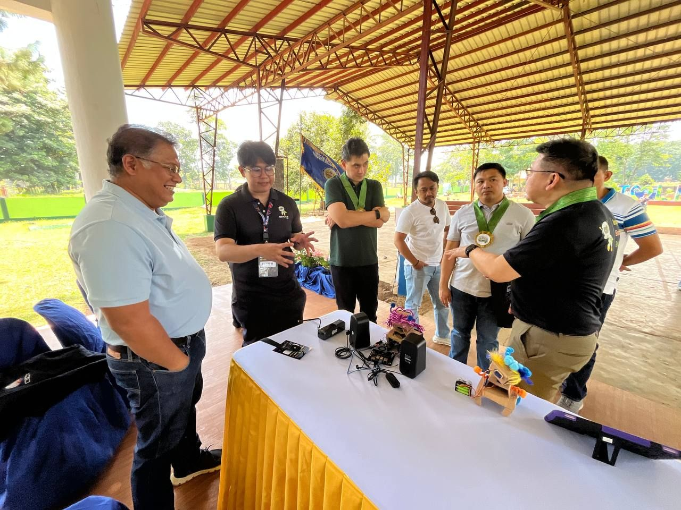
DEVCON attendees and officials viewing the Kai booth setup at the Mindanao showcase, August 2026.

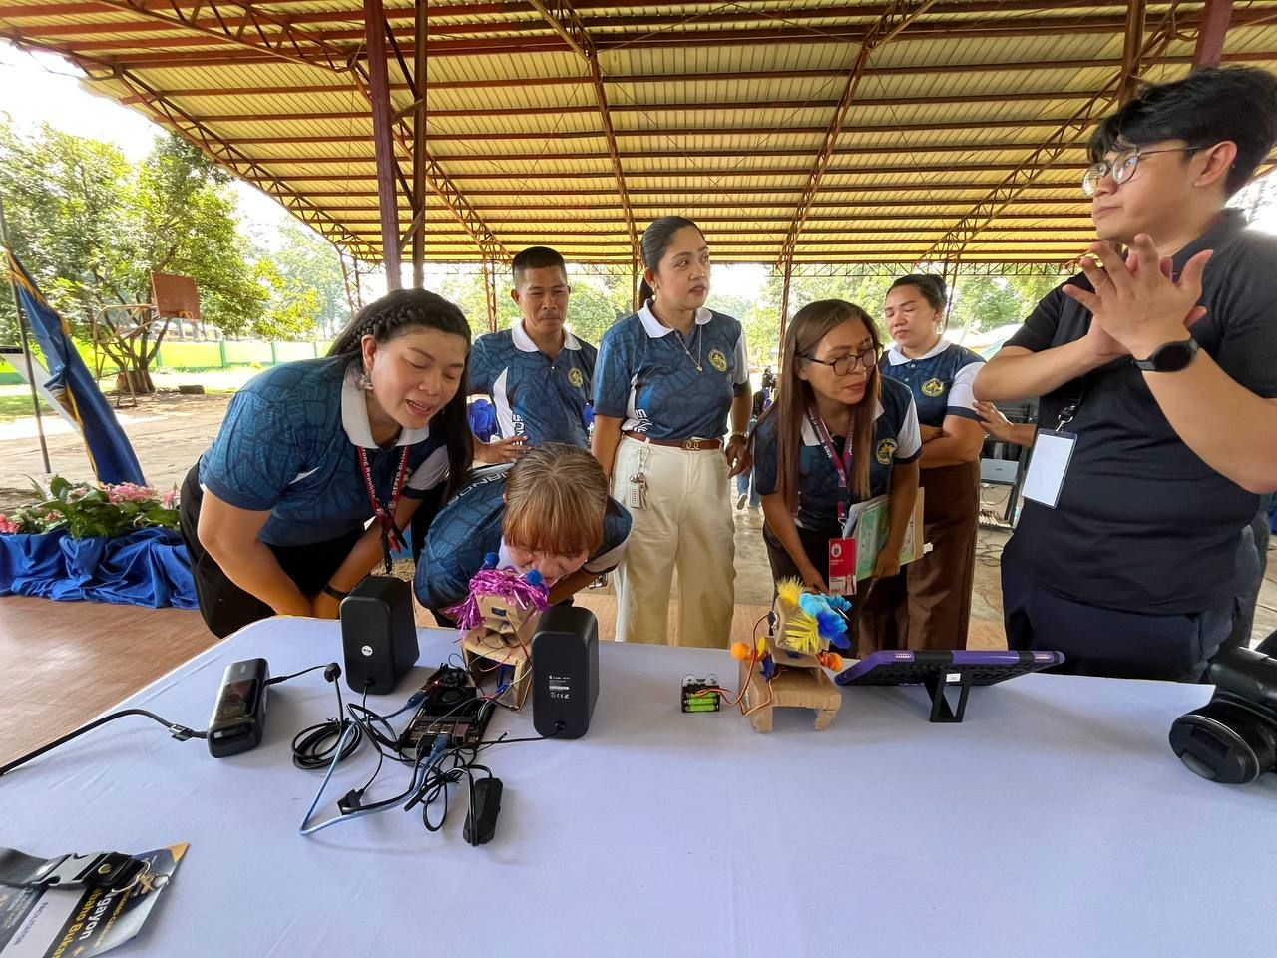
Visitors leaning in to see Kai's face-tracking demo running live on the booth table.

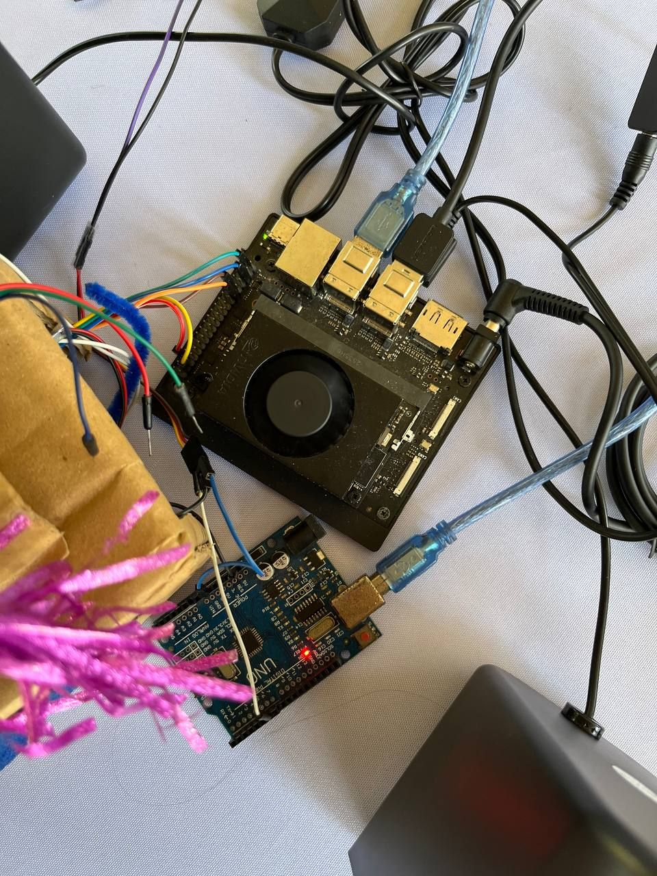
Jetson Orin Nano and Arduino Uno on the bench, wired for the USB serial servo link.

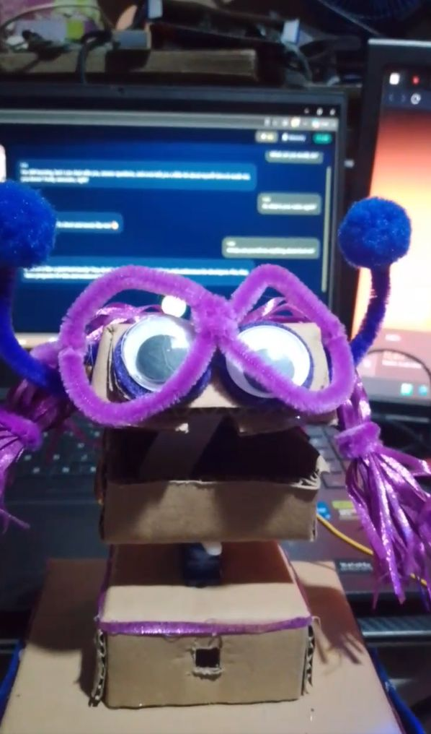
Kai's cardboard head with pipe-cleaner glasses and googly eyes, connected for a bench test.

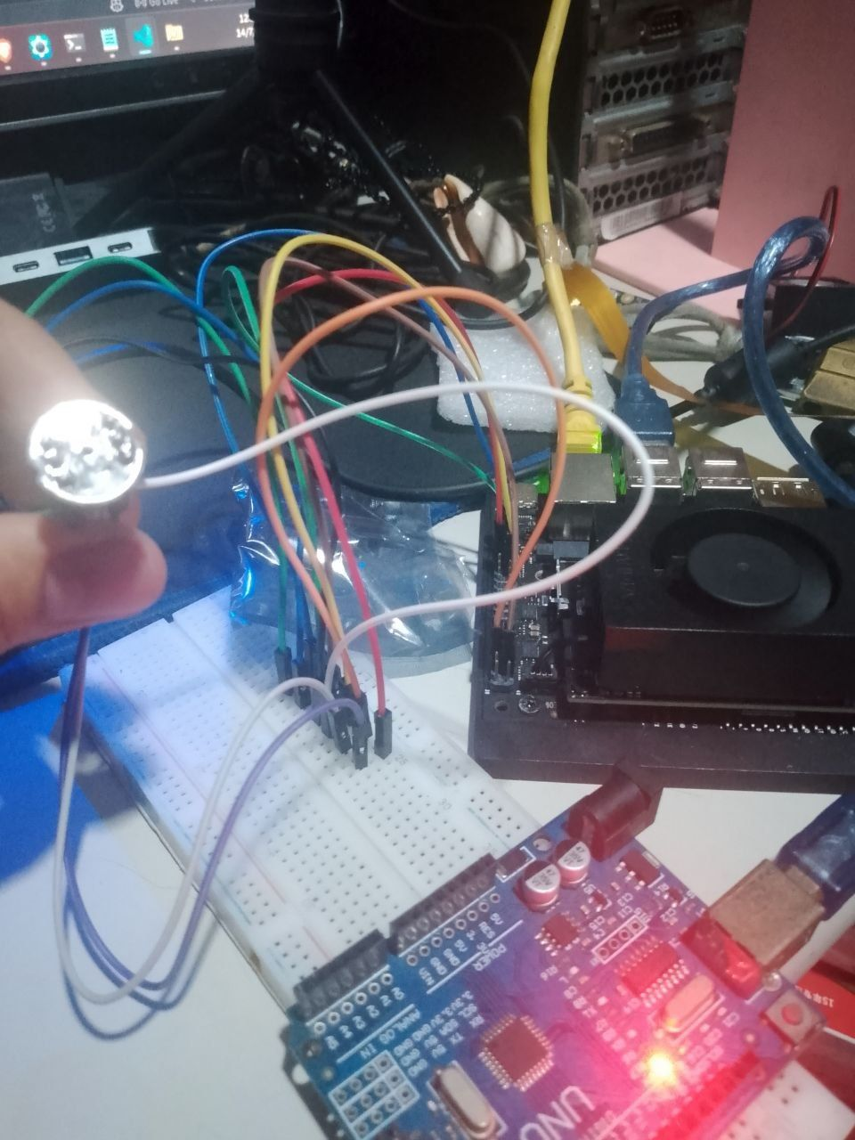
INMP441 microphone wiring on a breadboard beside the Jetson during hardware bring-up.

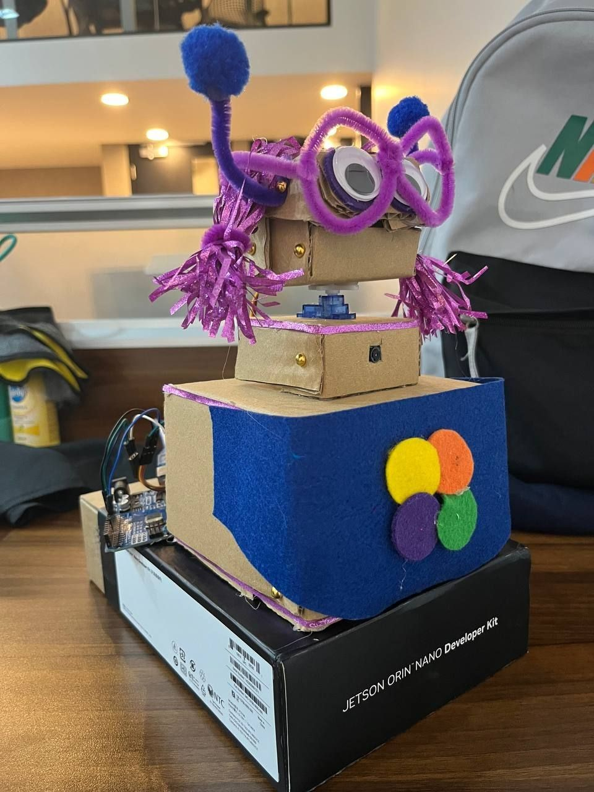
The assembled head and body, with felt trim, resting on the Jetson Orin Nano box.

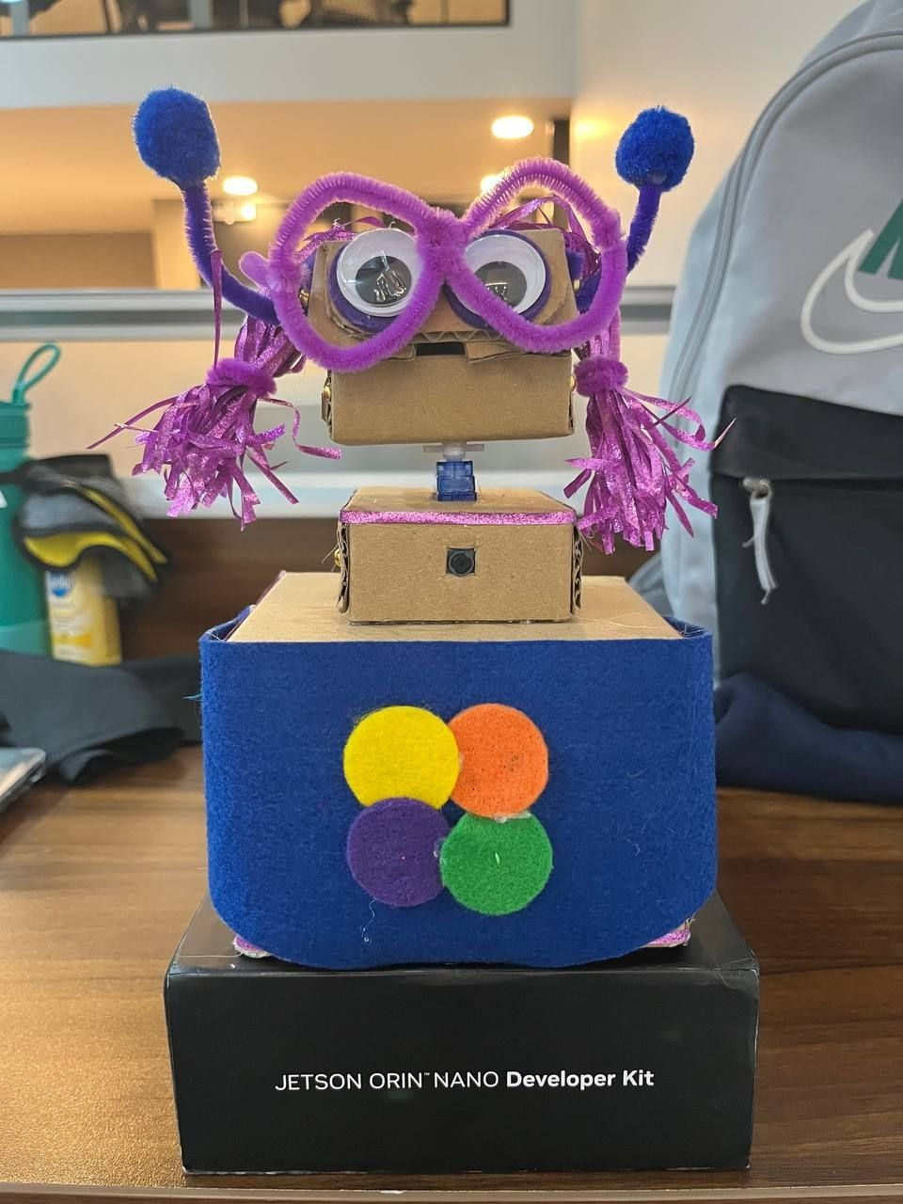
Front view of the finished cardboard chassis on the Jetson Orin Nano box.

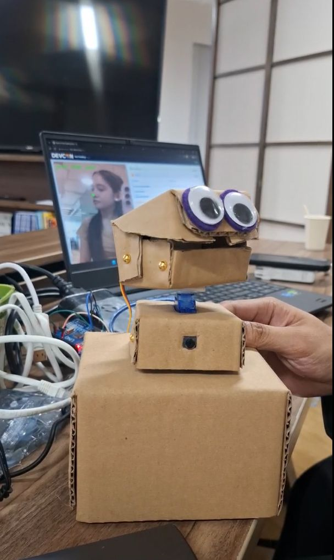
An earlier prototype head with the camera mounted in the lower jaw box.

Approval Log
Name | Role / Title | Approval Date | Signature | Status
TBD | Product Owner |  |  | Pending

