Lab 1

Kai Richardson

Checkpoint 1

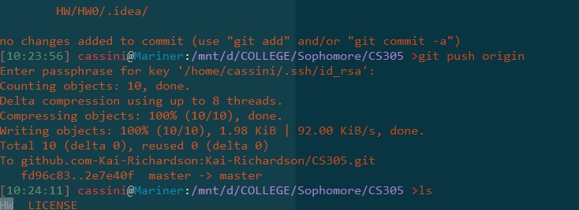

Checkpoint 2

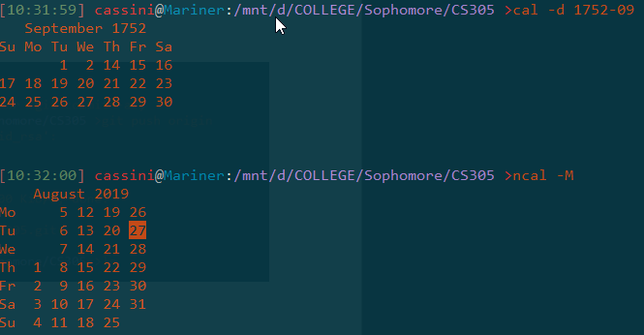

Checkpoint 3

3 things in usr directory:

1. .bash_profile
2. .npm
3. .bashrc

Checkpoint 4

Checked off.

Checkpoint 5

1.

Lab1

|

--------------------------------------------------------------

| | | |

Cs376 cs305 finearts math

| | | |

Test.java foo.h paint.png discrete.txt

2. see above

3a. intended to remove folder cs376, but was in wrong dir

3b. intended to remove folder cs376, but was in wrong dir

4. cp copies, mv moves

5. I ran rm -rf

6. the file node, from my install of node.js, it’s 35,002,089 bytes.