Adaptive Coding System Prototype: State of Developer Ecosystem Report 2025
Reahlyn Ermita, Jay Mark Labial, Jim Margaja, Jake Quejada, Jude Rabaya

Introduction
The goal of this activity is to design an adaptive coding system that changes its hints, feedback, debugging help, code completion and AI assistance according to different types of users. The system uses a user model built from real survey data, so each user gets the kind of help their group actually needs.

Investigation
We used the publicly available JetBrains State of Developer Ecosystem 2025 raw dataset (developer_ecosystem_2025_external.csv), with 24,534 developer responses collected from April to June 2025.

Data source
Item | Details
Dataset | JetBrains State of Developer Ecosystem 2025, anonymized raw data
Collected | April to June 2025
Respondents | 24,534 developers from 194 countries and regions
Raw size | 4,740 columns (one per question or answer option)
Personal data | None; the dataset is anonymized

Characteristics investigated. From the 4,740 columns, 23 were kept:
Area | Columns | What it measures
Programming experience | code_yrs, employment_status | Years of professional coding; whether the respondent is a student
Development environment | ide_main, main_lang | Main IDE or editor; main programming language
AI-assisted programming | ai_tool_* (6 tools), uses_ai_tools | Which AI tools they regularly use (ChatGPT, GitHub Copilot, JetBrains AI Assistant, Cursor, Claude, Gemini)
AI-assisted programming | ai_task_freq: * (6 tasks) | How often they use AI for code completion, generating code, explaining code, debugging, explaining bugs and learning
Feature importance | ai_importance: * (4 features) | How important completion quality, chat answer quality, an easy interface and IDE integration are

Data cleaning. The text was loaded as UTF-8 so answers such as "3–5 years" display correctly. code_yrs was grouped into three levels: Beginner (0–2 years, 5,836 people), Intermediate (3–10 years, 10,482) and Experienced (11+ years, 8,216). AI tool columns were converted to Yes/No. No rows were deleted; blank answers were excluded question by question, because several AI questions were shown only to AI users (about 7,000 people).

Data Analysis
We compared the three experience groups on every measure and kept the ones with a clear difference between Beginners and Experienced developers. Percentages are the share of each group; the last column is Beginner minus Experienced, in percentage points.
Measure | Beginner | Intermediate | Experienced | Difference
Use AI often to explain code | 59% | 45% | 34% | +25
Use AI often to explain bugs and fixes | 64% | 52% | 39% | +25
Use AI often for debugging | 50% | 39% | 27% | +23
Use AI often to learn about coding | 62% | 54% | 45% | +17
Use ChatGPT (AI users) | 63% | 52% | 44% | +19
Main editor is VS Code | 32% | 20% | 14% | +18
Main language is Python | 27% | 18% | 13% | +14
Use AI code completion often | 75% | 79% | 82% | −7
Rate completion quality "Very important" | 63% | 71% | 76% | −13
Use GitHub Copilot (AI users) | 31% | 38% | 44% | −13
Use JetBrains AI Assistant (AI users) | 11% | 20% | 28% | −17
Use AI often to generate code | 74%

Key findings
The groups differ most in why they use AI, not in whether they use it. About 80% of every group uses at least one AI tool.
- There is a clear difference between beginners (0–2 years) and experienced developers (11+ years) in why they use AI.
- Beginners use AI to understand code: 59% often use it to explain code (vs 34% of experienced developers), 64% to explain bugs (vs 39%) and 50% to debug (vs 27%).
- Experienced developers use AI for speed: 82% often use AI code completion (vs 75%), and 76% rate completion quality "Very important" (vs 63%).
- Beginners prefer chat tools like ChatGPT (63% vs 44%); Experienced developers prefer AI inside the IDE, like GitHub Copilot (44% vs 31%) and JetBrains AI Assistant (28% vs 11%).
- Beginners use lighter editors (VS Code 32% vs 14%) and more often use AI to learn (62% vs 45%).
- Most developers already use AI tools: about 80% of every group uses at least one.

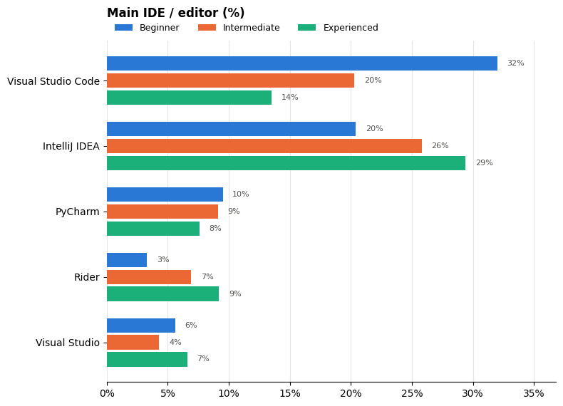

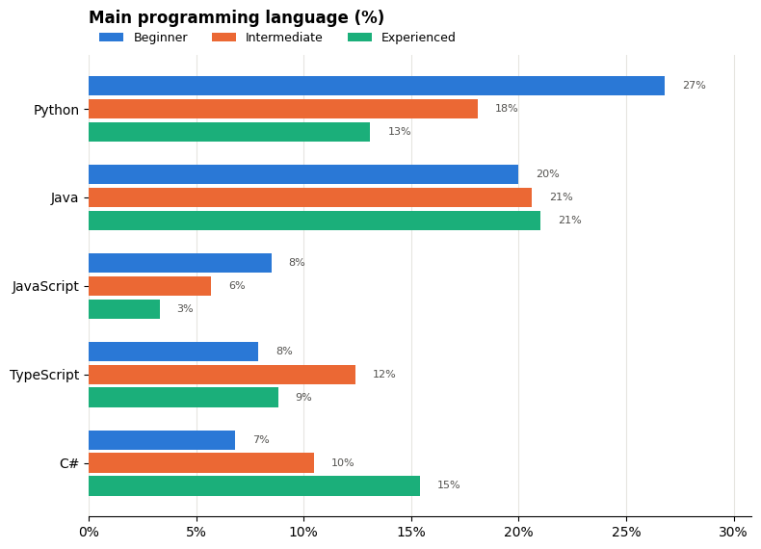

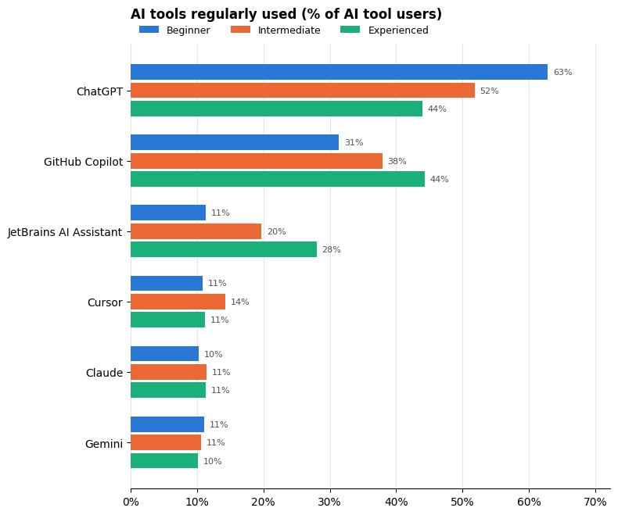
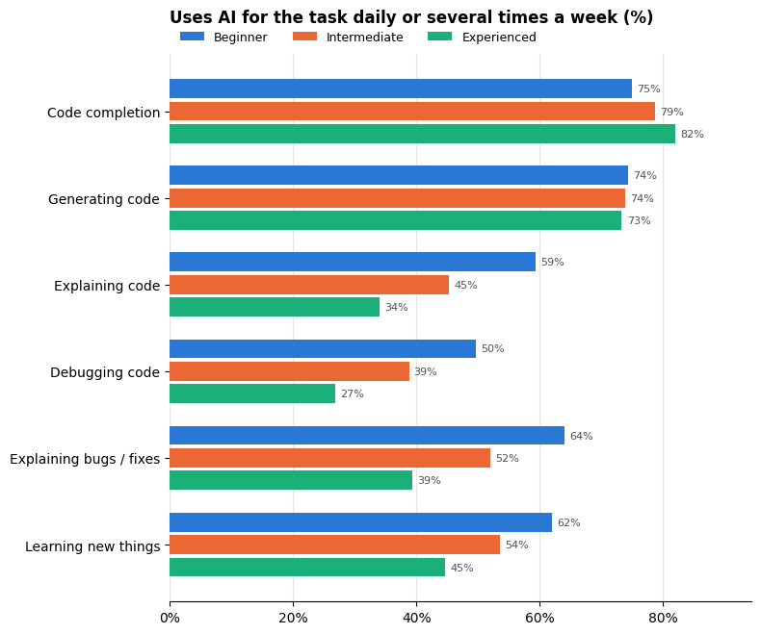
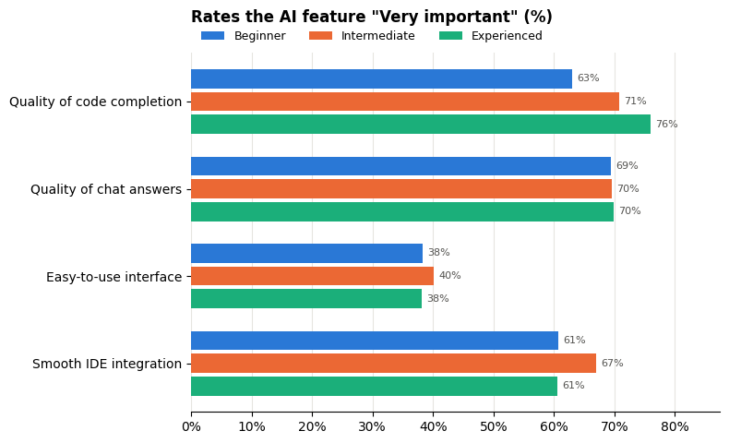

Analysis and User Profiles
The analysis compared the three experience groups on every measure and kept the measures with a clear gap between Beginners and Experienced developers. The table below shows those gaps; the last column is Beginner minus Experienced, in percentage points.
Measure | Beginner | Intermediate | Experienced | Gap
Use AI often to explain code | 59% | 45% | 34% | +25
Use AI often to explain bugs and suggest fixes | 64% | 52% | 39% | +25
Use AI often for debugging | 50% | 39% | 27% | +23
Use AI often to learn about coding | 62% | 54% | 45% | +17
Use ChatGPT (AI users) | 63% | 52% | 44% | +19
Main editor is VS Code | 32% | 20% | 14% | +18
Main language is Python | 27% | 18% | 13% | +14
Use AI code completion often | 75% | 79% | 82% | −7
Rate completion quality "Very important" | 63% | 71% | 76% | −13
Use GitHub Copilot (AI users) | 31% | 38% | 44% | −13
Use JetBrains AI Assistant (AI users) | 11% | 20% | 28% | −17
Use AI often to generate code | 74% | 74% | 73% | +1

Positive gaps describe what Beginners need more: explanation, debugging help and learning support, delivered through a chat. Negative gaps describe what Experienced developers need more: fast, high-quality completion inside the IDE. Intermediate developers fall between the two on every measure, so the lab focuses on the two ends as Profile A and Profile B.

Profile A: Beginner Learner
- Low programming experience (0–2 years); 36% are students
- Codes mainly in Python, in a lightweight editor such as VS Code
- Needs high support: step-by-step hints, detailed error explanations and guided debugging
- Uses AI mainly to explain code, fix bugs and learn concepts, through a chat tool

Profile B: Experienced Professional
- High experience (11+ years)
- Codes mainly in Java or C#, in a full IDE such as IntelliJ IDEA or Rider
- Prefers minimal traditional assistance: no hints, short error messages, quick fixes
- Uses AI mainly for fast code completion, built into the editor

User model
The system uses the following attributes:
Attribute | Profile A: Beginner | Profile B: Experienced
Experience Level | Beginner | Experienced
Years Coding | 0-2 years | 11+ years
Preferred Language | Python | Java/C#
Editor Style | Lightweight(VS CODE) | Full IDE (IntelliJ)
Guidance Level | HIGH | LOW
Error Details | DETAILED | COMPACT
Debugging Assistance | HIGH | LOW
Code Completion | MODERATE | HIGH
AI Assistance | CHAT TUTOR | INLINE(inside the editor)
Learning Support | ON | OFF

Prototype Implementation
The prototype is a Google Colab notebook (CS412_Lab2_Adaptive_Coding.ipynb) written in Python, with an interactive page built in HTML, CSS and JavaScript and shown inside Colab.
Notebook structure
Part | What it does
Part 1 – Investigate | Loads the cleaned Excel file and groups users into Beginner, Intermediate and Experienced
Part 2 – Analyze | Builds 6 comparison tables and 5 charts (pandas, matplotlib)
Part 3 – User model | Stores the user models as Python dictionaries (USER_MODELS)
Part 4 – Adaptation rules | Stores the rules and the adapt() function, with evidence for each rule
Part 5 – Python feedback demo | Checks the same buggy code with Python's real compiler and prints different feedback per model
Interactive prototype | The Adaptive Coding System Prototype page (HTML shown with IPython.display)
The interactive prototype includes:
- Profile switcher: Profile A · Beginner and Profile B · Experienced buttons
- Task panel: the coding task and step-by-step hints (Beginner only)
- Code editor: line numbers, with error lines highlighted in red
- Toolbar: Check code, Generate code (AI) and Reset
- Suggestion bar: keyword or full-line AI suggestions, depending on the profile
- Problems area: detailed error cards or one-line errors, with the matching fix buttons
- Active User Model panel: shows all 9 attributes of the selected profile
- AI Assistant: Chat Tutor (Beginner) or Inline AI (Experienced), both simulated
- Micro-Learning Concept: a short lesson (Beginner only)
- Adaptation Evidence & Signals: 8 cards with bars showing the survey percentages behind each rule
How it works: when a profile is selected, the page reads that profile's user model and applies the rules above. Check code scans every line of the code for a missing colon and unclosed brackets. Both profiles start from the same starter code with 2 bugs (a missing : on line 1 and a missing ) on line 8), so their results can be compared directly.

Demonstration
Both profiles were tested with the same code and the same steps: select the profile, press Check code, then fix the errors.
Test 1 – Profile A (Beginner)
- Who is this user? A Beginner with 0–2 years of experience who codes in Python in a lightweight editor and uses a chat AI to understand code.
- What does the user model contain? Guidance High, Error detail Detailed, Debugging High, Completion Moderate, AI mode Chat tutor, Learning On.
- How does the system adapt?
What happened:
  - All 4 hints are shown as steps.
  - Both bugs are shown as detailed red cards (Line 1: Missing Colon, Line 8: Bracket Never Closed) with "What happened" and "How to fix".
  - Each card has debug steps and a "Still stuck? Show the fixed line" button, then "Apply this fix".
  - The AI Tutor opens automatically: "I found 2 problems… Try fixing the first one yourself!"
  - A micro-lesson on functions is shown.
  - After both fixes: "No errors. Great job! Output: Average: 85.0".
- Why does it adapt this way? Beginners use AI far more to explain code (59%), explain bugs (64%), debug (50%) and learn (62%), mostly through ChatGPT (63%).
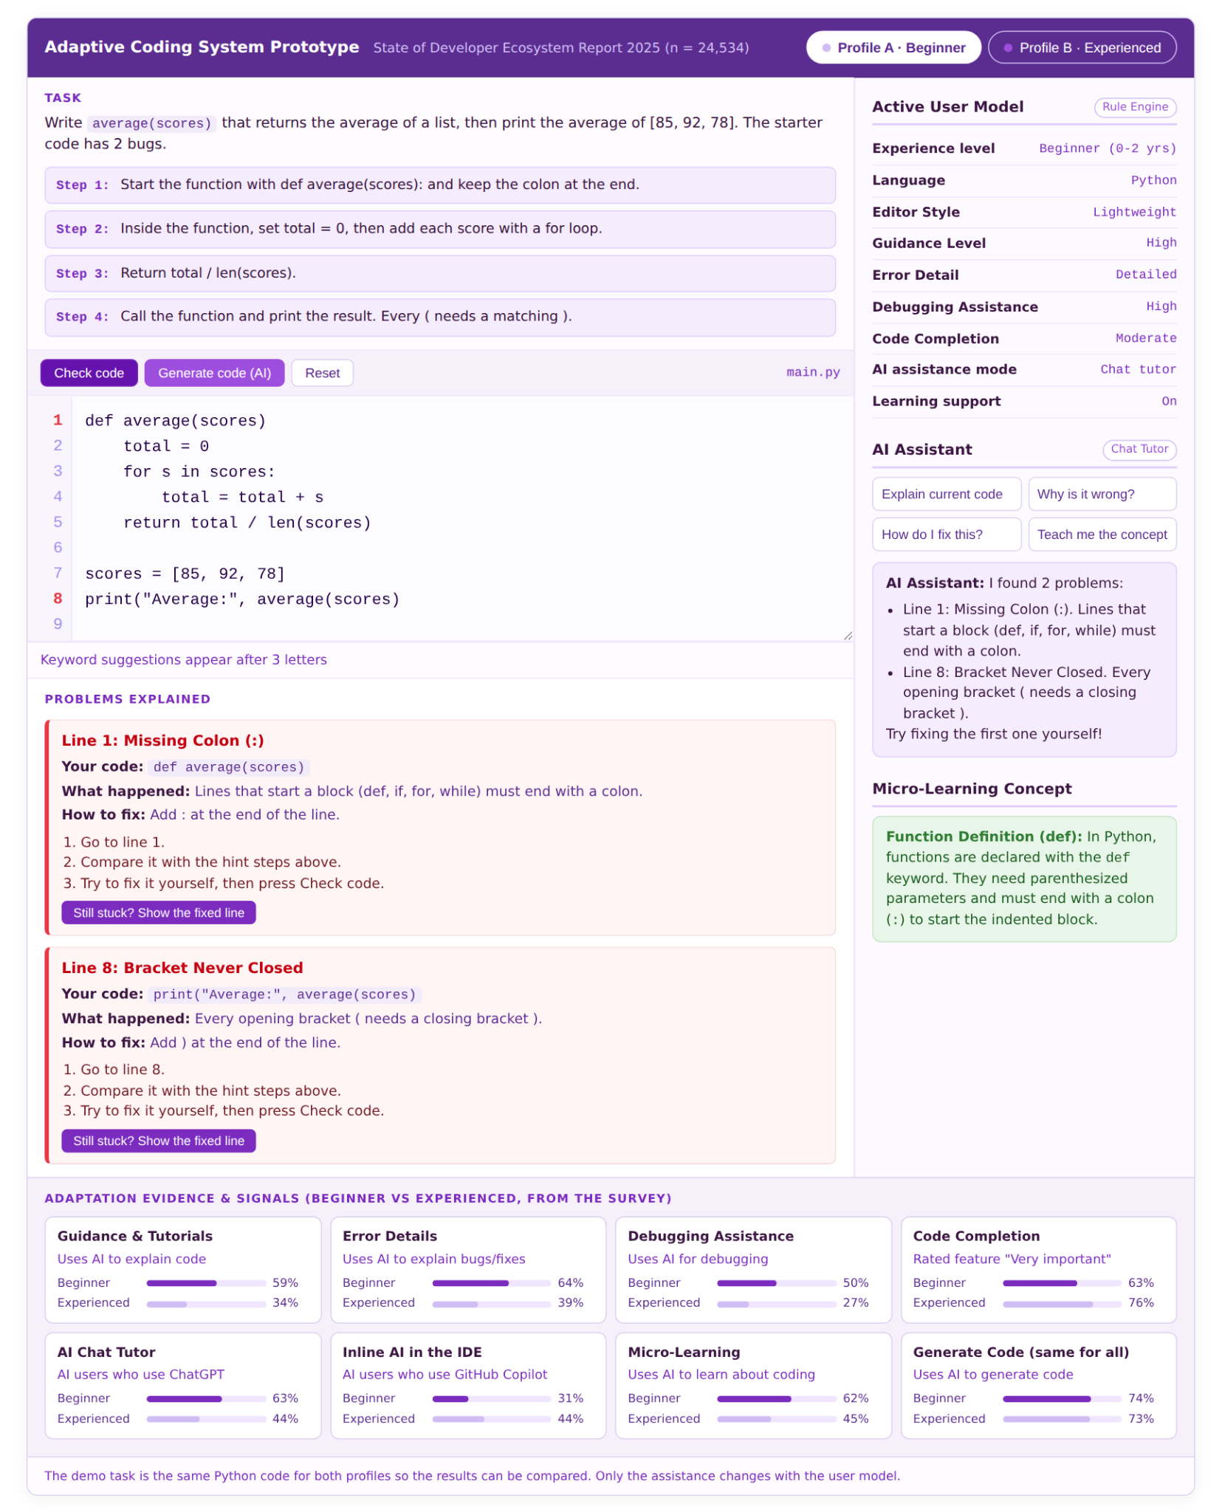
Test 2 – Profile B (Experienced)
- Who is this user? an Experienced Professional with 11+ years of experience who works in a full IDE and uses AI inside the editor to code faster.
- What does the user model contain? Guidance Low, Error detail Compact, Debugging Low, Completion High, AI mode Inline, Learning Off.
- How does the system adapt?
What happened:
  - No hints, no chat tutor and no lesson are shown.
  - Errors are one line each: 1:20 SyntaxError: expected ':' and 8:6 SyntaxError: '(' was never closed.
  - Each error has a one-click Quick fix and an inline AI suggestion of the corrected line.
  - Typing on line 1 shows a full-line AI suggestion: def average(scores):.
  - After the fixes: "0 problems · Average: 85.0".
- Why does it adapt this way? experienced developers rarely use AI to explain code (34%) or debug (27%), but they value fast code completion (76% "Very important") and use AI inside the IDE (Copilot 44%).
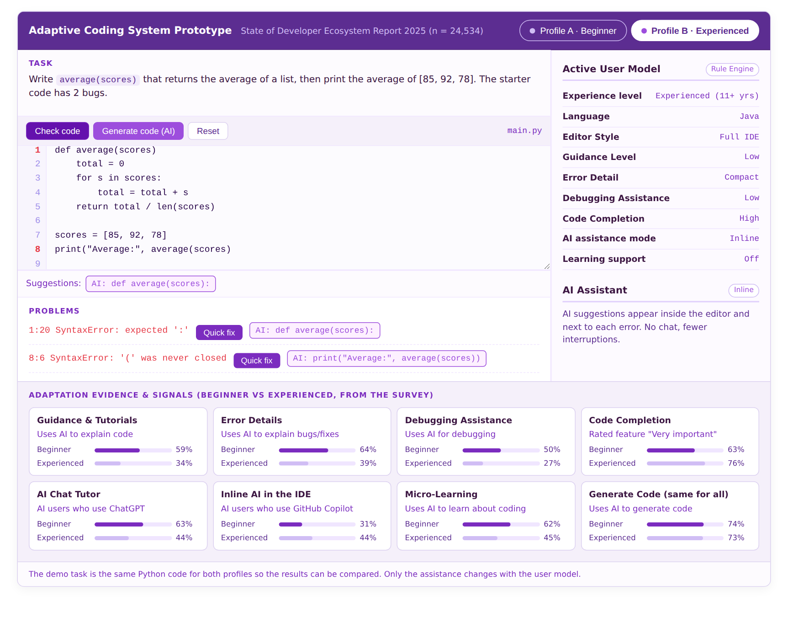
Result: both users fix the same code and get the same output (Average: 85.0), but the system gives each one different help. This clearly shows that the system does not behave the same way for every user.

Reflection
Which user characteristics did you model, and why did you select them?
We modeled nine attributes: experience level, preferred language, editor style, guidance level, error detail, debugging assistance, code completion, AI assistance mode and learning support. We selected them because they showed the largest differences between Beginners and Experienced developers in the survey (up to 25 percentage points), and because each one can directly change what a coding tool shows. Characteristics with no difference, such as using AI to generate code (74% vs 73%), were not modeled as adaptive and stayed the same for everyone.
What patterns in the data supported your user model?
- Explaining code (59% vs 34%), explaining bugs (64% vs 39%), debugging (50% vs 27%) and learning (62% vs 45%) all go down as experience goes up, so Beginners get high guidance, detailed errors, guided debugging and lessons.
- Code completion goes up with experience (75% vs 82% use it often; 63% vs 76% rate it "Very important"), so Experienced developers get eager, full-line completion.
- Beginners prefer chat tools (ChatGPT 63% vs 44%), while Experienced developers prefer AI inside the IDE (GitHub Copilot 31% vs 44%, JetBrains AI 11% vs 28%), which gave us the Chat tutor vs Inline AI modes.
- Beginners use lighter editors (VS Code 32% vs 14%) and more often use Python (27% vs 13%), which shaped the editor style and language values.
How did the user model influence the behavior of your system?
The same code and task produce two different experiences. For the Beginner model, the system shows 4 hints, detailed error cards, step-by-step debugging, an AI Chat Tutor and a micro-lesson. For the Experienced model, it hides the hints, tutor and lesson, shows one-line errors with a Quick fix, and gives inline AI and full-line completion. Every one of these differences comes from a single attribute in the user model, so changing one value changes only that behavior.
What limitations does your user model have?
- The survey is self-reported, so it shows what developers say they do, not what they actually do.
- Most respondents are professionals; students are only 36% of the Beginner group, so USTeP students may differ.
- Several AI questions were answered by only about 7,000 AI users, and the dataset cannot separate non-AI users from people who skipped the question.
- Users are grouped by years of experience only, and the model is static: it does not change as a beginner improves.
- The dataset had no questions on formatting or syntax highlighting, so those features were not adapted.
- The AI assistant in the prototype is simulated, not a real AI.
What additional information could make the user model more useful?
- Real usage data from USTeP, such as the errors a student makes, how many hints they open and how long they take to fix a bug, so the model can update itself over time.
- A short survey of USTeP students about their own preferences, including formatting, syntax highlighting and how much AI help they want.
- The type and difficulty of each task, since even a skilled student may want hints on a new topic.

Conclusion
The prototype successfully demonstrates an adaptive coding environment. Using survey data from 24,534 developers, we found that beginners use AI mainly to understand code, while experienced developers use it mainly for speed. We turned this difference into two user models and seven adaptation rules, so the same coding task gives beginners guidance and explanations and gives experienced developers fast, minimal help.

