**Report (Data science Internship)**

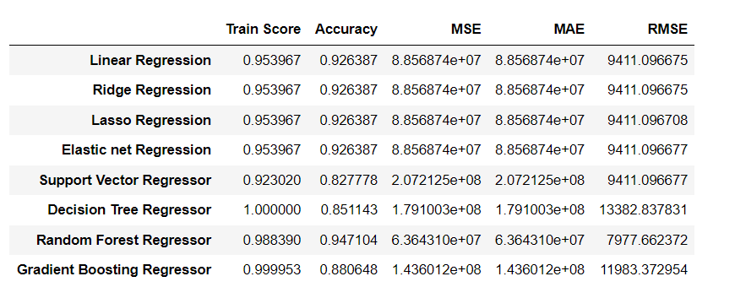

**Insights:**

* **Linear Regression, Ridge Regression, Lasso Regression, and Elastic Net Regression:** These algorithms exhibit similar performance, with high accuracy scores around 0.93. They achieve relatively low Mean Squared Error (MSE), Mean Absolute Error (MAE), and Root Mean Squared Error (RMSE), indicating good predictive capability and model fit.
* **Support Vector Regressor (SVR):** Although SVR demonstrates a lower accuracy score of 0.83 compared to other algorithms, it still provides acceptable performance. However, it has notably higher error metrics, indicating less precise predictions.
* **Decision Tree Regressor:** Despite achieving a perfect training score, Decision Tree Regressor shows lower accuracy and higher error metrics compared to other algorithms, suggesting overfitting and less generalization capability.
* **Random Forest Regressor:** With a high accuracy score of 0.95, Random Forest Regressor outperforms other algorithms in terms of predictive accuracy. It also exhibits the lowest error metrics among all algorithms, indicating superior performance and robustness.

**Conclusion:**

Based on the performance evaluation, Linear Regression, Ridge Regression, Lasso Regression, and Elastic Net Regression are suitable for tasks requiring high accuracy and efficiency. However, for optimal predictive performance and robustness, Random Forest Regressor stands out as the top-performing algorithm. Its ability to handle complex datasets and provide accurate predictions makes it a preferred choice for regression tasks.