COMP3004 Group Project

December 13, 2023

Guled Mohamed  
Maya Cassis  
Mohammad Raza 101199686  
Kai Duquet

**Use Cases for AED Simulation Software**

**Use Case 1: Analyzing Heart Rhythm**

**Primary** **Actor**: User (student or trainee)

**Goal**: To accurately determine if the patient’s heart rhythm is shockable.

**Preconditions:**

- The AED simulation software is installed and functional.

- The simulation environment is set up properly.

- The user has basic knowledge of operating the AED simulation

**Post Conditions:**

- The software accurately determines and displays whether the heart rhythm is shockable or not.

- Electrode placement confirmation is validated.

- The result of the heart rhythm analysis is available for further action by the user.

Steps:

1. User starts the AED simulation.

2. User selects the option to analyze heart rhythm.

3. Software prompts user to ’place’ electrodes (simulated action).

4. User confirms electrode placement.

5. Software analyzes the simulated patient’s heart rhythm and displays whether it’s shockable or not.

**Use Case 2: Delivering a Shock**

**Primary Actor:** User

**Goal:** To safely deliver an electric shock in case of a shockable rhythm.

**Preconditions:**

- A shockable heart rhythm has been accurately diagnosed by the software.

- The user has received prior instructions/training on delivering a shock via the simulation.

**Post Conditions:**

- The simulated shock is delivered safely.

- The patient's response to the shock is displayed or simulated.

- The software prompts further actions based on the response received.

**Steps:**

1. Following a shockable rhythm diagnosis, the software prompts the user to deliver a shock

2. User is instructed to ensure no one is touching the patient (simulated).

3. User presses the ‘shock’ button in the simulation.

4. Software simulates the delivery of an electric shock and shows the patient’s response.

**Use Case 3: Providing CPR Guidance**

**Primary Actor:** User

**Goal:** To guide the user through CPR procedure.

**Preconditions:**

- The heart rhythm is identified as non-shockable or post-shock by the software.

- The user is familiar with CPR procedures.

**Post Conditions:**

- Real-time feedback on the quality of CPR performed by the user is provided.

-The software assists in maintaining the correct rate and depth of chest compressions during CPR simulation.

**Steps:**

1. If the heart rhythm is non-shockable or post-shock, the software prompts CPR.

2. User starts CPR in the simulation.

3. Software provides real-time feedback on the rate and depth of chest compressions.

**Use Case 4: Conducting a Comprehensive Emergency Response Simulation**

**Primary Actor:** User (student or trainee)

**Goal:** To navigate through a complete simulated cardiac emergency, applying all AED functions.

**Preconditions:**

- The software can present complex emergency scenarios.

- User familiarity with AED functions and emergency response procedures.

**Post Conditions:**

- The user receives a summary report detailing their actions during the simulation.

- Suggestions for improvement or areas of strength are provided based on the user's performance.

- The patient's status within the simulation reflects the user's actions and responses accurately.

**Steps:**

1. Software presents a complex emergency scenario, including a patient with varying symptoms.

2. User assesses the patient’s condition (e.g., responsiveness, breathing).

3. User decides to use the AED and turns it on.

4. User follows on-screen instructions to ’place’ electrodes on the patient.

5. Software simulates heart rhythm analysis and informs the user of the result (shockable or non-shockable rhythm).

6. If shockable, the user is guided to deliver a shock; if non-shockable, the user is prompted to perform CPR.

7. During CPR, software provides detailed feedback on compression rate and depth.

8. Software dynamically changes the patient’s status based on user actions, requiring the user to reassess and respond accordingly.

9. The scenario concludes with the software providing a summary of the user’s actions and suggestions for improvement

**Use Case 5: Advanced ECG Interpretation and Response Training**

**Primary Actor:** User

**Goal:** To enhance the user’s skills in ECG interpretation and appropriate response in various cardiac situations.

**Preconditions:**

- Access to the advanced ECG interpretation module is available.

- The user has prior knowledge of basic ECG interpretation and response protocols.

**Post Conditions:**

- Immediate feedback on the correctness of the user's diagnosis and response is provided.

- Enhanced skills in ECG interpretation and appropriate response in various cardiac situations are expected after completing the module.

**Steps:**

1. User accesses the advanced ECG interpretation module.

2. Software presents a series of ECG readings representing different cardiac conditions (e.g., ventricular fibrillation, ventricular tachycardia, asystole).

3. For each reading, the user is asked to diagnose the condition and select the appropriate response (e.g., deliver a shock, start CPR, monitor only).

4. After the user’s selection, the software provides immediate feedback, explaining the correct diagnosis and response.

5. In some scenarios, the software may present complications (e.g., changing rhythms, unresponsive patient) to challenge the user’s decision-making skills.

6. The module concludes with a comprehensive review of the user’s performance, highlighting areas of strength and opportunities for learning.

UML Diagram

**Analyzing Heart Rhythm:**

Sequence Diagram:

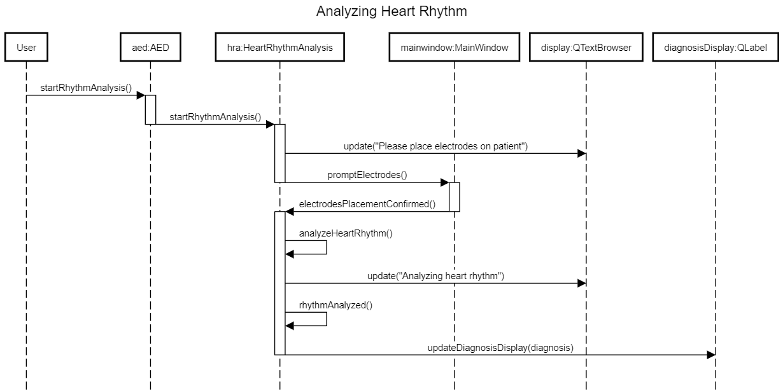

In this sequence diagram, the user starts the AED simulation, and selects the option to analyze the heart rhythm. Once an option has been selected the software prompts the user to "place" the electrodes, which then the user must confirm the placement. The software analyzes the simulated patient's heart rhythm and displays whether it is shockable or not.

State Diagram:

**Delivering a Shock**

Sequence Diagram:

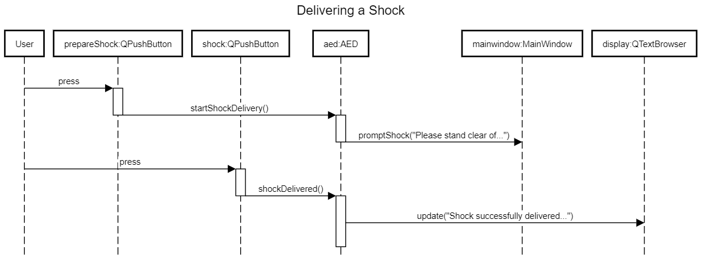

In this sequence diagram, after the shockable rhythm diagnosis, the software prompts the user to deliver a shock. The user presses the 'shock' in the simulation. The software then simulates the electric shock and displays the patient's response.

State Diagram:

**Providing CPR Guidance**

Sequence Diagram:

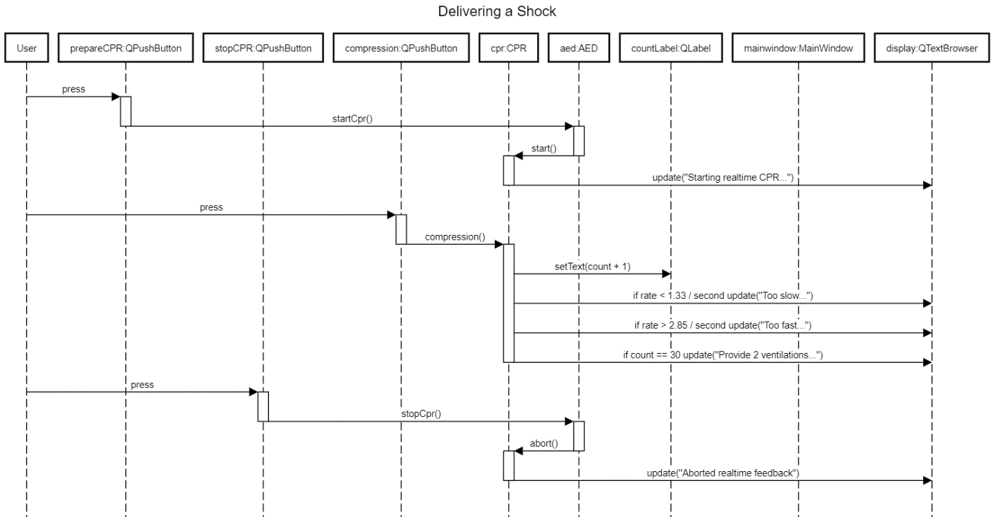

In this sequence diagram, if the patient's heart rhythm is not shockable or in post-shock, the AED prompts CPR. The user begins the CPR in the simulation, and the AED provides real-time feedback on the rate, depth of the chest compressions, and updates the patient’s response to the display.

State Diagram:

**Conducting a Comprehensive Emergency Response Simulation**

Sequence Diagram:

In this sequence diagram the software creates an emergency scenario, including a patient with varying symptoms. The user assesses the patient’s conditions and turns on the AED. On-screen instructions are followed to place electrodes on the patient. The AED simulates heart rhythm analysis and informs the user of a shockable or non-shockable rhythm. If shockable the user is guided to deliver a shock, if non-shockable the user is prompted to perform CPR. The AED provides feedback on compression rate and depth. The AED updates the patient’s response and summary, displaying it.

State Diagram:

**Advanced ECG Interpretation and Response Training**

In this sequence diagram, the user starts the ECG training. The software generates a series of ECG readings representing different cardiac conditions. The user is then asked to diagnose the condition and select the appropriate response (e.g., deliver a shock, CPR...). After user selection, immediate feedback is provided. The AED concludes with a detailed performance review that is shown on display.

**Traceability Matrix**

|  |  |  |  |  |  |  |
| --- | --- | --- | --- | --- | --- | --- |
| ID | Related Use Case | Implemented  By | Fulfilled  By | Test | Tested  By | Description |
| 1 | Use Case 1: Analyzing Heart Rhythm | UI, Hearth Rhythm Analyzer | User | Heart Rhythm Analysis Test | User | Verify the system allows the user to start the AED simulation and analyze heart rhythm |
| 2 | Use Case 1: Analyzing Heart Rhythm | UI, Electrode system | User | Electrode Placement Test | User | Confirm the system prompts for electrode placement and accepts confirmation |
| 3 | Use Case 1: Analyzing Heart Rhythm | Hearth Rhythm Analyzer, Display | User | Rhythm Result Display Test | User | Ensure the system analyzes and displays the heart rhythm as shockable or not |
| 4 | Use Case 2: Delivering a Shock | UI, Shock Delivery system | User | Shock Delivery Test | User | Validate the system prompts for shock delivery and simulates the shock when initiated |
| 5 | Use Case 2: Delivering a Shock | UI, Patient | User | Patient Response Test | User | Confirm the system shows the patient's response to the delivered shock |
| 6 | Use Case 3: Providing CPR Guidance | UI, CPR Feedback System | User | CPR Guidance Test | User | Verify the system prompts CPR and provides real-time feedback. |
| 7 | Use Case 4: Comprehensive Emergency Response | UI, Emergency Scenario | User | Emergency Response Test | User | Verify the software guides the user through a complete emergency scenario, applying all AED functions |
| 8 | Use Case 4: Comprehensive Emergency Response | UI, Dynamic Response | User | Dynamic Status Update Test | User | Verify the software updates the patient's status dynamically based on user actions |
| 9 | Use Case 5: Advanced ECG Interpretation | UI, ECG Interpretation System | User | Advanced ECG Interpretation Test | User | Verify user can access and utilize the advanced ECG interpretation and Response training effectively |
| 10 | Use Case 5: Advanced ECG Interpretation | UI, Performance Review System | User | Performance Review Test | User | Confirm the system provides a comprehensive review of the user's performance post-training |