**Avian Vocalisation as a Language**

**Sophie Dobbie**

**Abstract**

This review provides insight into instances of complex language among species of the Avian class. Complex language is taken to indicate the presence of these three linguistic elements: phenomes, morphemes, and compositional syntax. While these elements have been studied within bird species, the field is young. The first instance of compositional language outside of the human species was only found in 2016. Nonetheless, these are important findings that signify the beginning of a growing field.

**Keywords:** Bird vocalisation, syntax, phonology, communication

1. **Introduction**

The complexity of language is a defining aspect of the human species, where infinite meanings can be conveyed through combinations of a finite set of words. Naturally, other animals’ linguistic ability is questioned to not only establish inter-species comparisons, but also to provide insight into the natural evolution of communication across sentient life. Particularly interesting is the discovery of high-level language in a distinctly non-mammalian class: Aves. While research into bird vocalisation is dated to the 1600’s, its perception as a language has only developed with 1958’s implementation of equipment capable of sound recording and visualisation (Slater, 2003). As such, study of the linguistic properties in bird song or call attached to meaning is a relatively young field. This means that behaviours accompanied by song may be well-documented, but the specifics of the structure of these songs are not. This is the reason for this meta-analysis, as the complexity of their language is not completely defined.

Determining linguistic complexity requires a brief cover of linguistic background followed by the mention of studies of phonological and syntax in relation to referential communication. It is important to note that this review only concerns the naturally occurring linguistic capability of untrained, wild birds. More importantly, this review cannot cover all bird species, much less one species in depth. This is due to the immense amount of research required, and conversely the lack of thorough study of any single species. Therefore, conclusions drawn from this review may only provide insight into the possibilities of language present in the Aves class, and the animal kingdom in its entirety.

1. **Linguistic Background**

For this review, the complexity of a language possesses two hierarchical levels: phonology and compositional syntax. The first criterion is met when phenomes (meaningless sounds/gestures) are combined to form a morpheme (meaningful word). The attachment of meaning here is called “referential communication” and is necessary in communication. Examples of isolated phenomes can be seen in figure 1 below, and examples of phenomes within song can be seen in figure 2 (appendix). The second is met when morphemes are combined to convey an increasingly complex meaning, the order of which being determined by the language’s syntax (de Boer, Sandler & Kirby, 2012). As this compositional structure is the indicator of a complex language, the following studies assess the presence of this element within avian vocalisations.

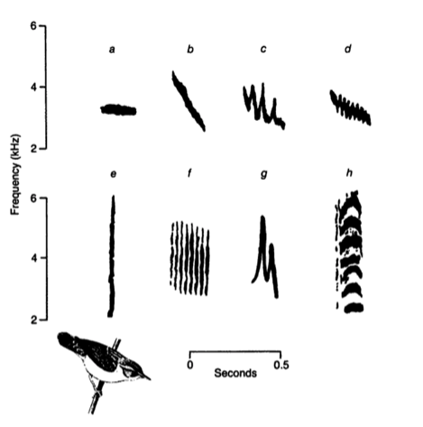

*Figure 1. Sonogram of phenome (syllable) repertoire of a male sedge warbler (Catchpole & Slater, 1996).*

* 1. **Evidence of Phonology and Syntax**

The first criterion of complex language necessitates evidence of deliberate communication. Supporting previous work by Templeton (2005), and Freeberg and Lucas (2002), a 2008 study by Mahurin and Freeberg indicates that varying composition of notes (morphemes) within a call incited different recruitment outcomes. Their study observed and recorded Carolina chickadees (*Poecile carolinensis)* upon their discovery of a planted bird seed station. Specifically, the scientists found the number of D-notes in a call to decrease with each chickadee that arrived at the newly detected food source. Additionally, the time between chickadee arrivals were longer with this D-note decrease. As C-note composition was found to be constant between calls, it follows that D-note composition served as a recruitment function. This result is analogous to the distinction between a nonsensical shout and an articulate specification of those need arriving, where both would recruit beings, but only one is considered speech. In this case, these birds were found to use speech, as they incorporate various phenomes corresponding to various recruitment outcomes.

However, it is necessary to note that this finding contradicted Freeberg and Lucas’ 2002 study of the same species, which stated that higher C-note composition incited recruitment. As Mahurin and Freeberg wrote, the two studies involve chickadees from Indiana and Tennessee, raising the possibility of dialects between distinct populations. This hypothesis was later confirmed by Freeberg in 2012, where similarity between phenomes and significant structural differences existed between populations. These structural differences attached to identical meaning imply not only the existence of syntax within Aves, but also the variation of syntax observed within a species, a feature of complex language. The observation of syntax differences as dialects is supported by Lachlan’s study (2013) highlighting the syntax degradation of 12 island and continental colonies of chaffinches *(Fingilla coelleb).* Again, the phenomes between populations remained consistent, while syntax varied largely with the island colonies. This variation found mainland European chaffinch songs to have fixed sequences of phenomes within song, contrary to the lack of sequential requirement in the island populations (see figure 3 below).

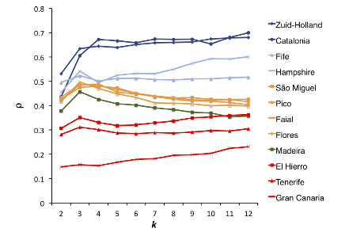

*Figure 3. Syntactical Structure in 12 chaffinch populations. ρ represents the syntactical structure as calculated from a first-order Markov chain redundancy, which tests for fixed sequencing of a phenome category. Higher ρ values represent increased structure. k represents the number of phenome categories used by this algorithm (Lachlan et al., 2013).*

While the above studies do evidence a presence of phonology and syntax, it does not conclusively prove the existence of compositional syntax, that is, morpheme structure affecting meaning.

* 1. **Evidence of Compositional Syntax**

A 2016 study held the first experimental study of compositional syntax within a species of bird, in this instance, the Japanese tit (Parus minor) (Suzuki et al., 2016). The first section of the experiment established the meaning of individual morphemes while the second established meaning of combined morphemes. Both sections incorporate the playback method, where scientists sounded phenome recordings through speakers and observed the subsequent behaviours. The noted phenomes include a succession of ABC notes signalling ‘scan for danger’, and D notes signalling ‘approach the caller’. In response to an ABC-D call, the Japanese tits were found to possess a new behaviour as a simultaneous combination of ABC and D. However, that is not to say that syntax has no effect. A playback of D-ABC elicited no response in the Japanese tits, meaning that the close temporal proximity is not responsible for the ABC-D response. With ABC, D, and ABC-D songs all eliciting different responses, the study provides significant evidence that compositional syntax is present outside of human language.

1. **Conclusion**

Phenomes, morphemes, and compositional syntax have all been observed in avian populations. The most significant evidence for complex language in Aves was only found in 2016, in the Japanese tit. While interesting, this is the first and only instance of avian compositional syntax recorded. At this time, there is still a significant lack of research in this field, in turn amounting to a lack of conclusive study on the language of any one species. Nonetheless these instances of interpretation hint at a well of linguistic ability mirroring the human language. Further investigation can not only give insight into the language of birds, but also model how language across all sentient life may evolve and develop.

1. **References:**

* Baker, M. C. (2001). Bird song research: the past 100 years. *Bird Behavior*, *14*(1), 3-50.
* Catchpole, C. (1980). Sexual Selection and the Evolution of Complex Songs Among European Warblers of the Genus Acr Ocephal Us. *Behaviour*, *74*(1), 149-165. http://dx.doi.org/10.1163/156853980x00366
* Catchpole, C., & Slater, P. (1996). Bird Song: Biological Themes and Variations. *Choice Reviews Online*, *33*(05), 15. <http://dx.doi.org/10.5860/choice.33-2735>
* Freeberg, T., & Lucas, J. (2002). Receivers respond differently to chick-a-dee calls varying in note composition in Carolina chickadees, Poecile carolinensis. *Animal Behaviour*, *63*(5), 837-845. http://dx.doi.org/10.1006/anbe.2001.1981
* Freeberg, T. (2012). Geographic Variation in Note Composition and Use of chick-a-dee Calls of Carolina Chickadees (Poecile carolinensis). *Ethology*, *118*(6), 555-565. <http://dx.doi.org/10.1111/j.1439-0310.2012.02042.x>
* Lachlan, R., Verzijden, M., Bernard, C., Jonker, P., Koese, B., & Jaarsma, S. et al. (2013). The Progressive Loss of Syntactical Structure in Bird Song along an Island Colonization Chain. *Current Biology*, *23*(19), 1896-1901. http://dx.doi.org/10.1016/j.cub.2013.07.057
* Mahurin, E., & Freeberg, T. (2008). Chick-a-dee call variation in Carolina chickadees and recruiting flockmates to food. *Behavioral Ecology*, *20*(1), 111-116. http://dx.doi.org/10.1093/beheco/arn121
* Slater, P. (2003). Fifty years of bird song research: a case study in animal behaviour. *Animal Behaviour*, *65*(4), 633-639. http://dx.doi.org/10.1006/anbe.2003.2051
* Suzuki, T., Wheatcroft, D., & Griesser, M. (2016). Experimental evidence for compositional syntax in bird calls. *Nature Communications*, *7*, 10986. <http://dx.doi.org/10.1038/ncomms10986>
* Templeton, C. (2005). Allometry of Alarm Calls: Black-Capped Chickadees Encode Information About Predator Size. *Science*, *308*(5730), 1934-1937. http://dx.doi.org/10.1126/science.1108841

1. **Appendix**

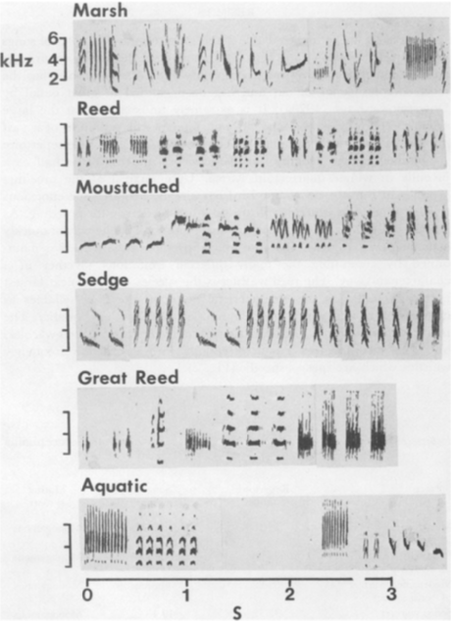

*Figure 2. Sonograms of songs of six European warblers composed of phenomes listed with time on the x-axis and accompanying pitch (kHz) on the y-axis (Catchpole, 1980).*