**STUDENT-LED PROJECT APPLICATION FORM**

**Please submit this form by email to the project committee ([MSP-projects@maastrichtuniversity.nl](mailto:MSP-projects@maastrichtuniversity.nl)) by 12:00 noon on Monday 25th September 2017. Your supervisor must have also submitted the supervisor’s form by the same time. Projects will not be offered in the vote, if either form is submitted late.**

|  |  |  |  |  |  |  |
| --- | --- | --- | --- | --- | --- | --- |
| Project Title | Pattern Recognition as a Methods of Automated Bird Recognition | | | | | |
| Student Leader(s): | **Kai Hendriks**  **Sophie Dobbie** | **Supervisor(s):** | | | | Bart van Grinsven |
| Primary Location: | **Chemelot**/MSP**/**Other:……………………. | | **Max. Group Size:** | | | 6 |
| Resource Requirements (preliminary) | | | | | | |
|  | Description | | | Approx. Cost | | |
| Equipment Requirements | **None** | | | 0 | | |
| Consumables Requirements | **None** | | | 0 | | |
| Health and Safety considerations: | None. Computer based. | | | | | |
| Are other students interested in this project? | **Yes**/No/Don’t know* | If so, who?  Hugo Maathuis, Artur Dorzee, Sephanie Mendez, Claudia Chinea | | |  | |

Please fill in the template on the next page with your project description. Use the formatting in the template. Note that the project description is limited to **one** side of A4.

**Phoneme pattern recognition as a method of automated bird identification**

Student Leaders: *Sophie Dobbie (*[*s.dobbie@student.maastrichtuniversity.nl*](mailto:s.dobbie@student.maastrichtuniversity.nl)*)*

*Kai Hendriks (*[*ksp.hendriks@student.maastrichtuniversity.nl)*](mailto:ksp.hendriks@student.maastrichtuniversity.nl))

Supervisor(s): *Bart van Grinsven (bart.vangrinsven@maastrichtuniversity.nl)*

Level: 3000Max. no. students: 6

Bird identification is a necessary first step in any ornithological study. As of now, it is a wholly manual and human dependant process, which has room for improvement concerning human error and time consumption. A program capable of automatically identifying bird vocalisations would be a viable solution to this problem [1].

Bird vocalisations have two forms: songs and calls. Meaningful words are constructed using meaningless elements: phonemes [2]. No matter the dialect, two birds of the same species will sing with the same phonemes [3]. By analysing multiple recordings of a species, it is possible to collect a representative database of phonemes.

Thisproject is an extension of a previous assignment created in MATLAB, where birds were identified through pitch analysis of their vocalisations. Now, the next step is to involve pattern recognition to discern between similar pitched species. This will focus on the automated mathematical identification of phonemes within a song or call. Through compiling these species-dependant phonemes into a database, a program can be made to compare database phonemes to those within an unknown bird’s vocalisation. Therefore, the aim of this project is to develop a generalised phoneme pattern recognition program.

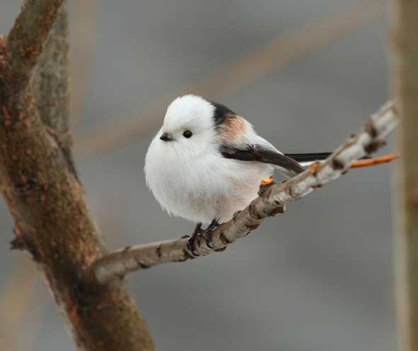

This project is suitable for students with sufficient programming skills. Programming will be done in MATLAB. Experience in signal analysis, pattern recognition, and machine learning is useful, but not required. Beware that this project strictly concerns the signals birds produce, and as such there is very little application of biology to this research.

**References**

* 1. Scott Brandes T. Automated sound recording and analysis techniques for bird surveys and conservation. Bird Conservation International. 2008;18(S1).
* 2. Phillips S, Wilson W. Commentary: Experimental evidence for compositional syntax in bird calls. Frontiers in Psychology. 2016;7.
* 3. Lachlan R, Verzijden M, Bernard C, Jonker P, Koese B, Jaarsma S et al. The Progressive Loss of Syntactical Structure in Bird Song along an Island Colonization Chain. Current Biology. 2013;23(19):1896-1901.
* 4. Long-tailed tit [Internet]. 2017 [cited 22 September 2017]. Available from: https://lostplaygrounds.files.wordpress.com/2016/01/2270341269_f8425fd1e7_b.jpg

**Please write not more than 500 words explaining why you think you would make a good leader for a student led project (if two project leaders not more than 750 words for both combined):**

**Why we will make good student project leaders**

At this point we have done one 1000, 2000, and 3000 level together. In each project, we were told from both the members of the group and the supervisor that we both played leading roles in the projects’ overall success. As evidenced from the projects as well as the many courses we have done together, we work well with each other. We feel that while pushing the project forward, we still make sure to encourage input from other teammates.

I (Sophie) have leadership skills from highschool symphonic band and jazz band, where I was the trumpet section leader for three years. I had to direct, correct, and teach my section in practices four days a week, not counting concerts. During my gap year I was an assistant teacher in band, where I individually taught children from age 10 to 16 often in groups of 12. Relating this to skills needed as a student project leader, this taught me how to lead, convey information in a digestible manner, as well as keep the students’ focus on the work at hand.

I (Kai) have done numerous things involving leadership roles; an example is the multiple committees I have been part of at MSP. In the events committee, I have shown to be motivated in successfully organising parties and other events. Next to this, with 2 fellow students, I set up the MSP Charity Committee last February of which I am co-chair now. We organise weekly events and have so far raised a significant amount of money for charity. Finally, in secondary school, I was co-founder of the Greenteam, where we organised activities to make our school more sustainable. This included placing solar panels on the roof and organising a warm sweater day. From all this I have learnt to be able to set up events in a structured way and to be a good a respectful leader.

We are very motivated for this project and are determined to have a successful result. We have already started part of this project in period 5 of 2016-17. We have a good idea of what needs to be done to create this pattern recognition software, including knowledge of different pattern methods we would like to try. We have also done the preliminary research on the biological side of this– that concerning the language structure birds have.

From previous project experience, we feel that four people is enough to do this project. Especially in the programming projects, there is just not enough for 5+ people to do. For optimal efficiency and performance, we really stress that this project needs 4 people maximum.