%Kai Jin

%1

%Rolling sevens is more probable because the combination for one and one

%is only 1, however, there are more than one combination for seven.

%(1/36)/(6/36) = 1/6

%2

%P(0)=0

%P(1)=P(1)*P(0)=0

%P(2)=P(1)*P(1)=1/36

%P(3)=P(1)*P(2)+P(2)*P(1)=2/36=1/18

%P(4)=P(1)*P(3)+P(2)*P(2)+P(3)*P(1)=3/36=1/12

%P(5)=P(1)*P(4)+P(2)*P(3)+P(3)*p(2)+P(4)*P(1)=4/36=1/9

%P(6)=P(1)*P(5)+P(2)*P(4)+P(3)*P(3)+P(4)*P(2)+P(5)*P(1)=5/36

%P(7)=P(1)*P(6)+P(2)*P(5)+P(3)*P(4)+P(4)*P(3)+P(5)*P(2)+P(6)*P(1)=6/36=1/6

%P(8)=P(2)*P(6)+P(3)*P(5)+P(4)*P(4)+P(5)*P(3)+P(6)*P(2)=5/36

%P(9)=P(3)*P(6)+P(4)*P(5)+P(5)*P(4)+P(6)*P(3)=4/36=1/9

%P(10)=P(4)*P(6)+P(5)*P(5)+P(6)*P(4)=3/36=1/12

%P(11)=P(5)*P(6)+P(6)*P(5)=2/36=1/18

%P(12)=P(6)*P(6)=1/36

%Calculate probability for every combination of two dices

size = 1;

result = zeros(36,1);

for x = 1:12

for c = 1:6

if (x-c)<=0

else if (x-c)>6

else

result(size,1) = x;

size = size + 1;

end

end

end

end

figure()

histogram(result,'Normalization','Probability')

xlabel('Sum of two dices')

ylabel('Probability')

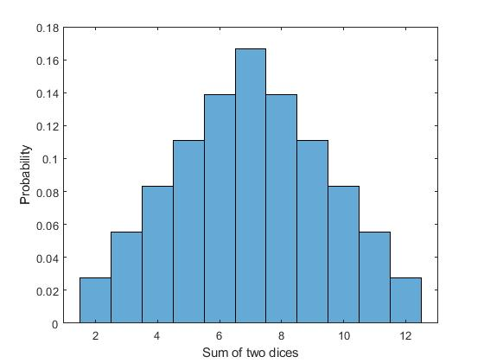

%3

result2 = zeros(1,11);

for x = 2:12

for c = 1:6

if (x-c)<=0

else if (x-c)>6

else

result2(1,x-1) = result2(1,x-1) + 1/36;

end

end

end

end

ave = 0;

for c = 1:length(result2)

ave = ave+(c+1)*result2(1,c);

end

ave =

7

variance = 0;

for c = 1:length(result2)

variance = variance+sqrt(((c+1)-ave)^2*result2(1,c));

end

variance =

7.3630

%4

dice10 = zeros(1,10);

for c = 1:10

dice1 = randi(6,1);

dice2 = randi(6,1);

total = dice1+dice2;

dice10(1,c) = total*result2(1,total-1);

end

figure()

subplot(1,2,1)

histogram(dice10,'Normalization','Probability')

xlabel('Average')

ylabel('Ptobability')

subplot(1,2,2)

histogram(dice10)

set(gca,'YScale','log')

xlabel('Average')

ylabel('Log of Probability')

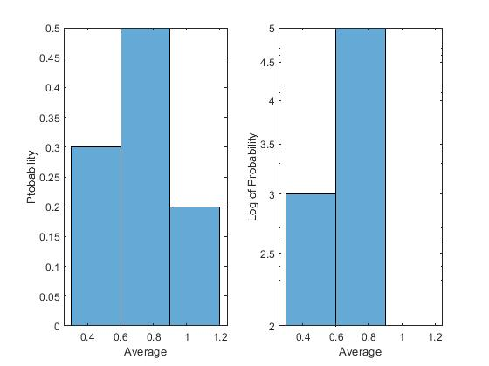

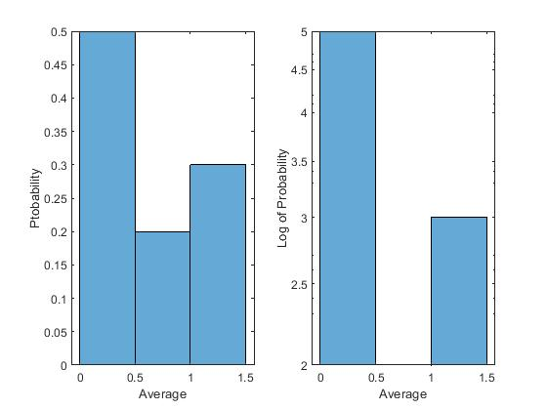

%I run several times simulation. Based on the graph, it looks like Gaussian

%distribution sometimes, however, sometimes it is not.

%5

x = linspace(-10,10,1000);

std0 = 5;

mean0 = 3;

%get 1000 random num from Gaussian distribution which mean is 3 and std is

%5

gaus1_data = sort(std0.*randn(1000,1) + mean0);

std0 = 2;

mean0 = 0;

%get 1000 random num from Gaussian distribution which mean is 0 and std is

%2

gaus2_data = sort(std0.*randn(1000,1) + mean0);

%get average of two distributions above

ave_data = sort((gaus1_data+gaus2_data)*0.5);

%build these three distribution

gaus1 = fitdist(gaus1_data, 'Normal');

gaus2 = fitdist(gaus2_data, 'Normal');

ave = fitdist(ave_data, 'normal');

figure()

subplot(1,3,1)

plot(x,pdf(gaus1,x),"LineWidth",4)

title('Gaussian distribution 1')

subplot(1,3,2)

plot(x,pdf(gaus2,x),"LineWidth",4)

title('Gaussian distribution 2')

subplot(1,3,3)

plot(x,pdf(ave,x),"LineWidth",4)

title('Ave of distribution 1 and 2')

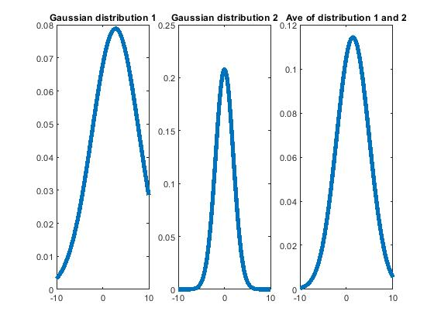

stats1 = [mean(gaus1_data) std(gaus1_data) var(gaus1_data)];

stats2 = [mean(gaus2_data) std(gaus2_data) var(gaus2_data)];

stats3 = [mean(ave_data) std(ave_data) var(ave_data)];

stats1 =

3.0179 4.9256 24.2617

stats2 =

0.1088 2.0274 4.1103

stats3 =

1.5633 3.4757 12.0805

%Based on the graphs and calculations, we can find that the average of two

%Gaussian distributions is also a Gaussian distribution, and its mean and

%std are very closed to the average of two original Gaussian distributions. Therefore,

%if we get a Gaussian distribution data set from lab, we may also consider

%it can be combined by some other sub Gaussian distributions