
School of Information Technology
Diploma in AI and Analytics

Data Processing on Big Data
(IT3383)
ASSIGNMENT REPORT

Prepared for:
Mr. Heng

Prepared by:
Khor Kai Xuan (234201R)

Contents
1.0 Introduction & Problem Statement 3
2.0 Dataset Overview 3
3.0 System Architecture – Medallion Architecture 4
3.1 Rationale for Medallion Architecture 4
4.0 Data Processing & Transformation 4
4.1 Bronze Layer – Raw Data Ingestion 4
4.2 Silver Layer – Cleaned & Enriched Data 6
4.3 Gold Layer – Business-Ready Analytics 9
5.0 Developed Data Product – Streamlit Dashboard 16
5.1 Dashboard Overview 16
5.2 Executive Overview 16
5.3 Skills Premium 17
5.4 Market Segments 18
5.5 Salary Scenario Explorer 18
6.0 Predictive Modeling & Evaluation 19
7.0 Analysis & Key Insights 20
8.0 Limitations & Drawbacks 20
9.0 Enhancements & Areas for Improvement 21
10.0 Recommendations 21
11.0 Conclusion 21

Data Science Salary Intelligence Using Snowflake Medallion Architecture

1.0 Introduction & Problem Statement
Glassdoor hosts a vast number of job postings across various industries, offering valuable insights into the data science job market. However, raw job posting data is often unstructured, noisy, and difficult to analyze directly due to inconsistent salary estimates, missing values, and heterogeneous job descriptions. Without proper data engineering and analytical design, meaningful insights remain inaccessible to job seekers, recruiters, and organizations.
This project aims to design and implement a scalable data analytics solution to analyze and model the factors influencing salary estimations for data science roles. The solution leverages a Snowflake Medallion Architecture (Bronze → Silver → Gold) to clean, transform, and aggregate Glassdoor job postings into analytics-ready datasets. An interactive Streamlit dashboard is then developed to present key insights, trends, and exploratory salary scenarios.
The ultimate goal of this project is to provide actionable insights that help users better understand the data science job landscape, identify high-impact skills, and make informed career or hiring decisions.

2.0 Dataset Overview
The dataset used in this project was scraped from Glassdoor and contains 672 job postings related to data science and analytics roles. Each record includes information such as job title, estimated salary range, company size, company rating, industry, location, and required technical skills (e.g., Python, SQL, AWS, Tableau).
As the dataset was collected through web scraping, it presents several challenges:
- Inconsistent salary formats and missing salary values
- Unstructured categorical fields
- High variability in salary estimates across similar roles
- Data sparsity when filtering by multiple dimensions
These challenges necessitate robust preprocessing and thoughtful aggregation to ensure reliable analysis.

3.0 System Architecture – Medallion Architecture

3.1 Rationale for Medallion Architecture
A Medallion Architecture was adopted to ensure scalability, maintainability, and clear separation of concerns. This architectural pattern is widely used in modern data platforms as it supports data lineage, reprocessing, and incremental enhancement without disrupting downstream consumers.
The architecture consists of three layers:
- Bronze: Raw data ingestion and historical preservation
- Silver: Cleaned, enriched, and structured data
- Gold: Business-ready analytical aggregates

4.0 Data Processing & Transformation

4.1 Bronze Layer – Raw Data Ingestion
Create file format:
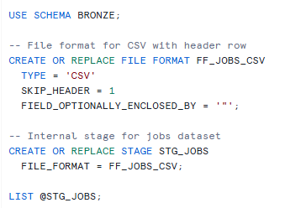
Create Bronze Layer
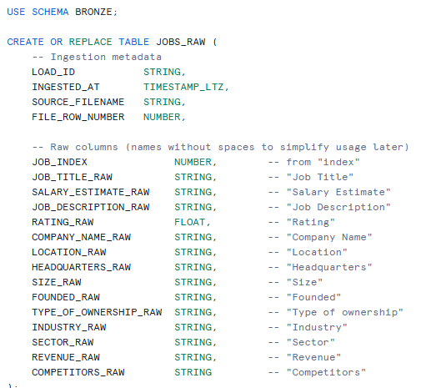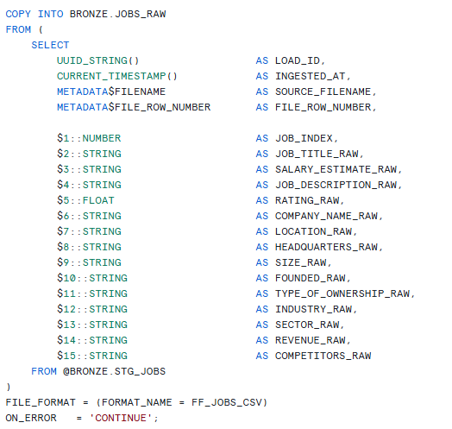

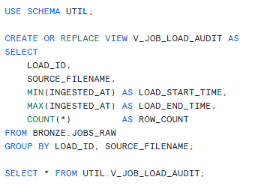
- A dedicated Snowflake database, warehouse, and schemas are created to support a Medallion Architecture design (Bronze, Silver, Gold).
- The Bronze layer is designed to store raw job posting data exactly as received from the source without any transformation.
- A CSV file format is defined to correctly handle header rows and quoted fields in the Glassdoor dataset.
- An internal Snowflake stage is created to temporarily store the uploaded raw CSV files prior to ingestion.
- The BRONZE.JOBS_RAW table is created to hold both:
- Original raw dataset columns (job title, salary estimate, company attributes, etc.)
- Ingestion metadata such as load ID, ingestion timestamp, source filename, and file row number.
- Data is ingested using the COPY INTO command, enabling scalable and reliable bulk loading.
- No data cleansing or transformation is performed at this stage to preserve data fidelity.
- Raw data history is maintained to support auditability, lineage tracking, and future reprocessing.
- A load audit view is created to summarize each ingestion event, including load time and row count, for validation and monitoring purposes.

4.2 Silver Layer – Cleaned & Enriched Data
Clean data
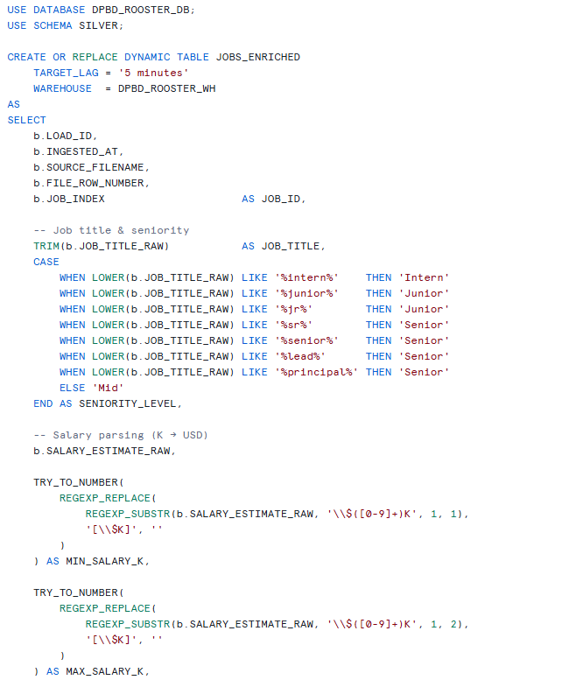
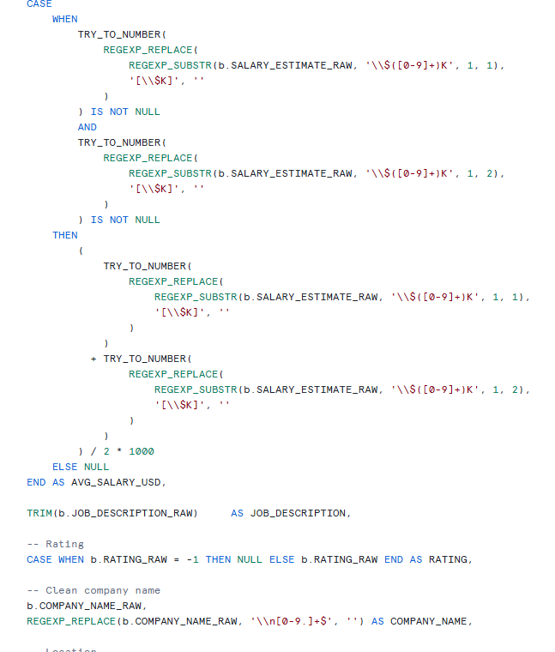
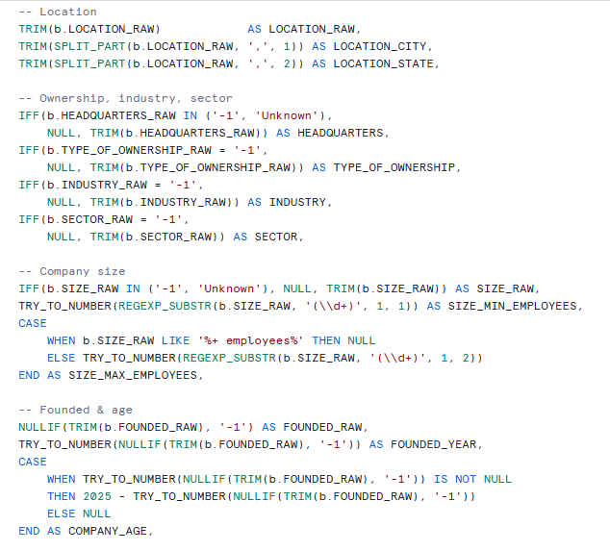
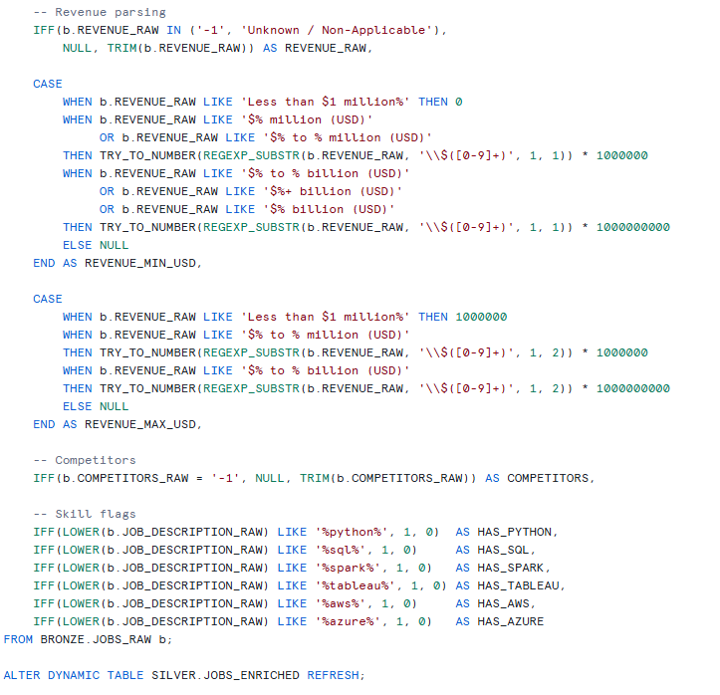
- The Silver layer transforms raw Bronze data into a cleaned, structured, and analytics-ready dataset.
- Raw text fields such as job title, location, company size, revenue, and salary estimates are standardized and normalized.
- Salary estimates are parsed and converted into numeric fields (e.g. average salary in USD) to enable quantitative analysis.
- Missing, invalid, or placeholder values are handled to improve data quality and consistency.
- Job seniority levels are derived from job titles to enable experience-based analysis.
- Binary skill indicators (e.g. HAS_PYTHON, HAS_SQL, HAS_AWS) are engineered from job descriptions to capture technical requirements.
- Company attributes such as size, rating, industry, and sector are standardized into consistent categorical formats.
- The Silver layer serves as the single source of truth for exploration and modeling, balancing data cleanliness with sufficient granularity.
- This layer supports both:
- Flexible ad-hoc analysis (used in the Streamlit scenario explorer)
- Downstream aggregations in the Gold layer

4.3 Gold Layer – Business-Ready Analytics
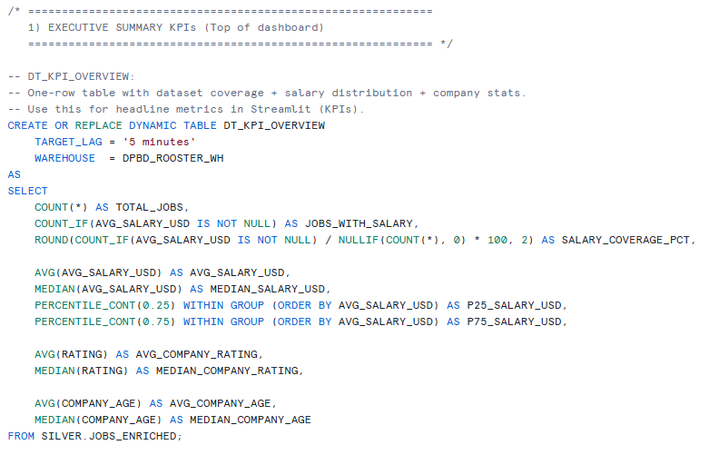
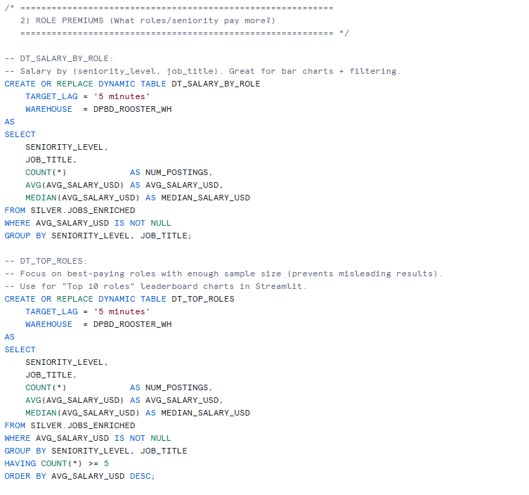

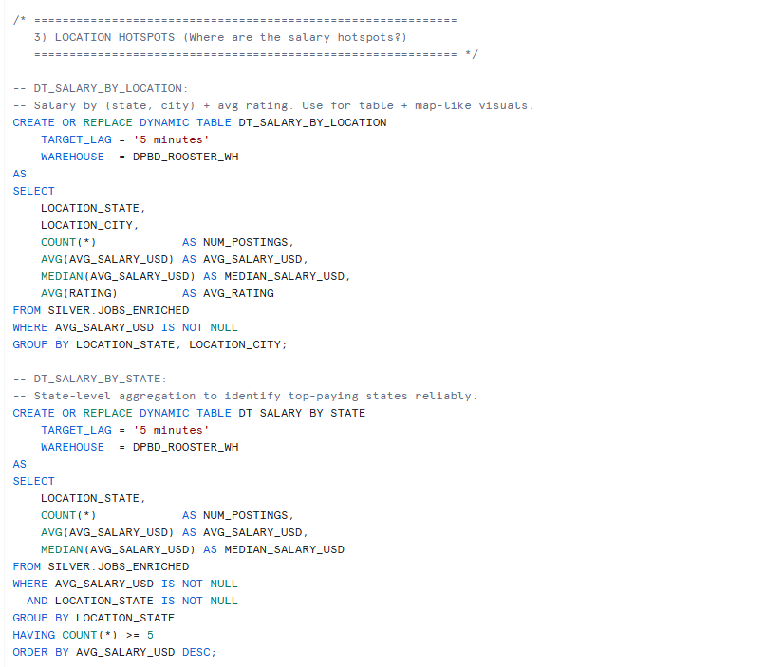
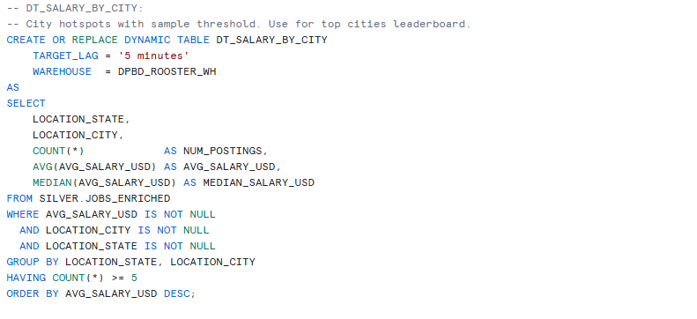

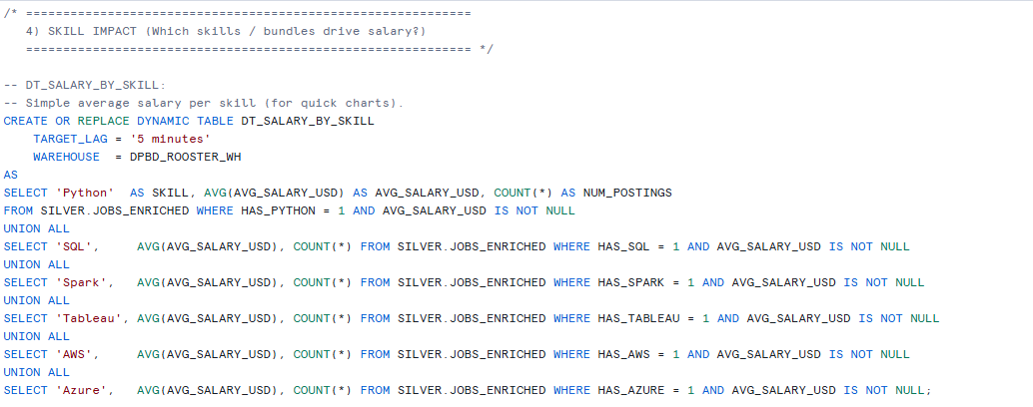
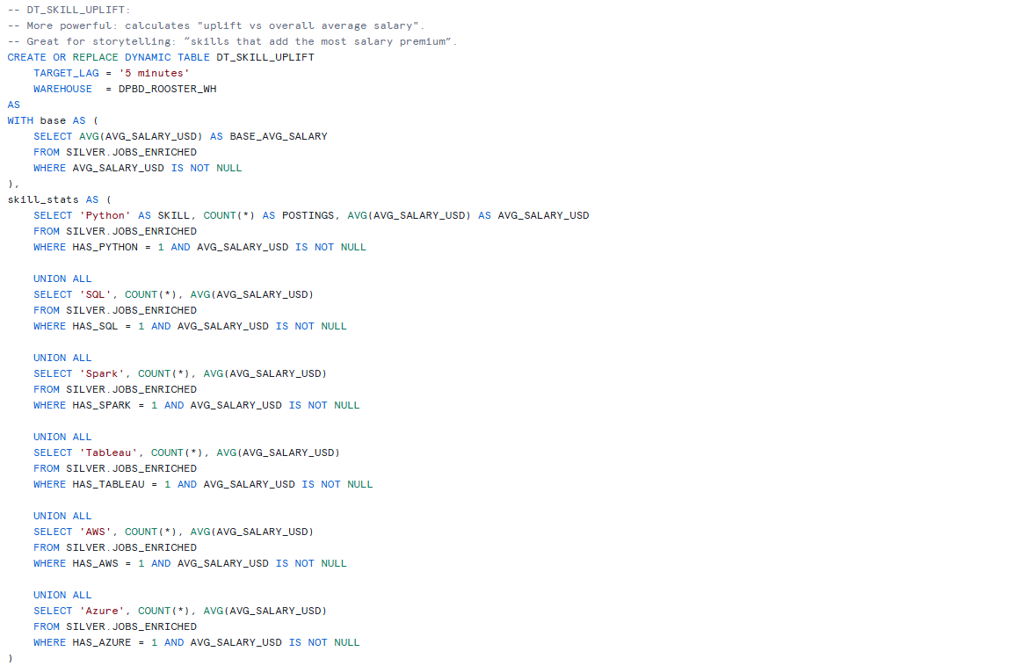
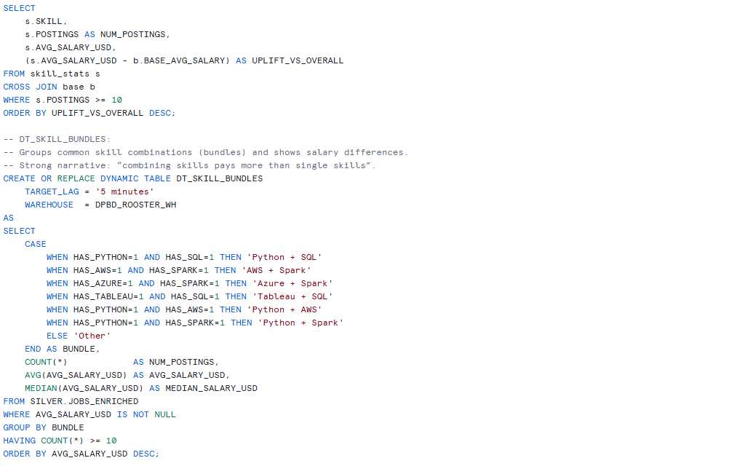
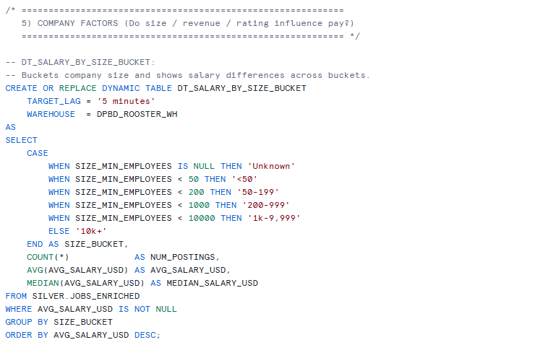
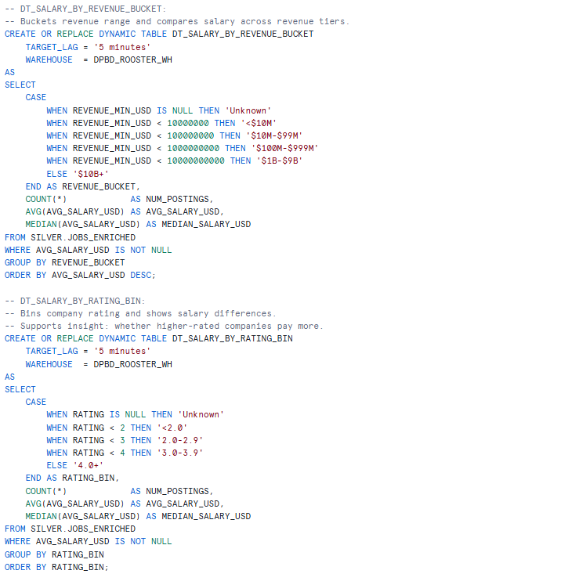

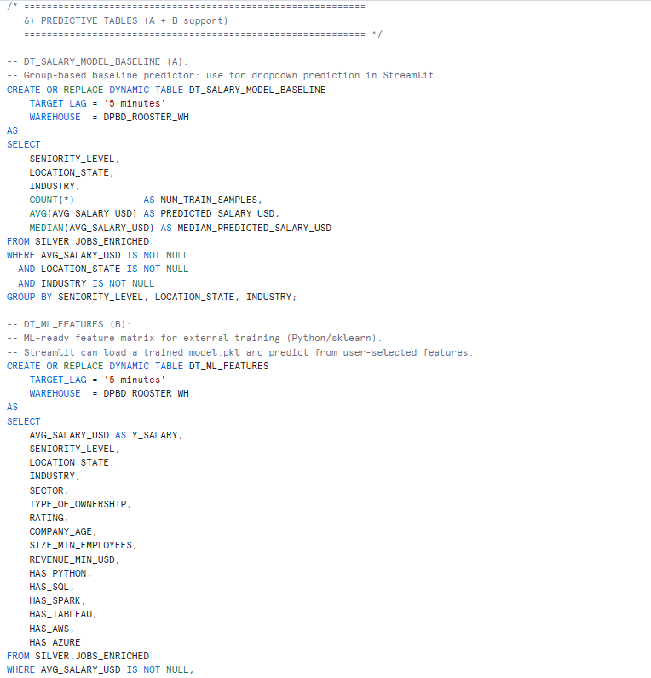

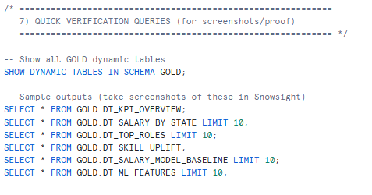
- The Gold layer contains aggregated, business-focused datasets designed for reporting, visualization, and decision support.
- Snowflake Dynamic Tables are used to automatically maintain up-to-date aggregations with minimal operational overhead.
- Gold tables are optimized for performance and scalability, reducing the need to repeatedly query large Silver datasets.
- Key analytical outputs include:
  - Salary trends by job role and seniority
  - Salary distribution by location (state/city)
  - Skill-based salary uplift analysis
  - Salary segmentation by company size, revenue, and rating
  - Baseline salary reference tables for scenario exploration
- Aggregations are intentionally designed to support interpretability rather than over-precise prediction, reflecting real-world data variability.
- The Gold layer acts as the primary data source for the Streamlit dashboard, enabling fast, consistent, and reproducible insights.
- By separating analytical logic from raw data processing, the Gold layer improves maintainability and supports future expansion of the system.

The Silver layer prioritizes data quality and feature enrichment, while the Gold layer prioritizes analytical usability and performance, aligning with industry best practices for modern data platforms.

5.0 Developed Data Product – Streamlit Dashboard

5.1 Dashboard Overview
An interactive Streamlit dashboard was implemented directly within Snowflake, leveraging native integration for secure and low-latency access to the Gold and Silver layers. Global slicers allow users to dynamically filter results by seniority, location, industry, and required skills.
The dashboard is structured into four main sections:
- Executive Overview
- Skills Premium
- Market Segments
- Salary Scenario Explorer

5.2 Executive Overview
The Executive Overview provides a high-level snapshot of the data science job market. Key performance indicators include:
- Total number of job postings
- Salary coverage
- Median salary
- Interquartile salary range
These metrics provide immediate context on overall market conditions and data reliability.

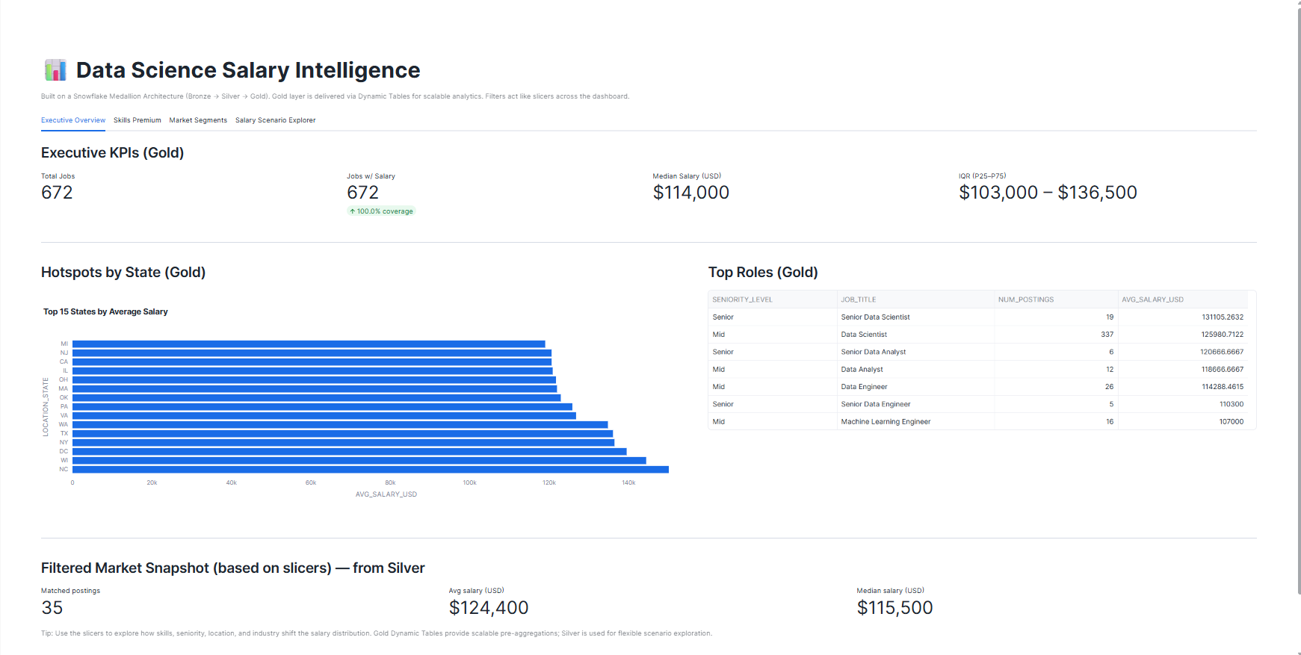

5.3 Skills Premium
The Skills Premium section analyzes how specific technical skills influence salary relative to the overall average. Results show that certain skills, particularly cloud platforms and data engineering tools, are associated with positive salary uplift, while others demonstrate marginal or neutral effects.
This analysis highlights the importance of skill specialization over job titles alone.

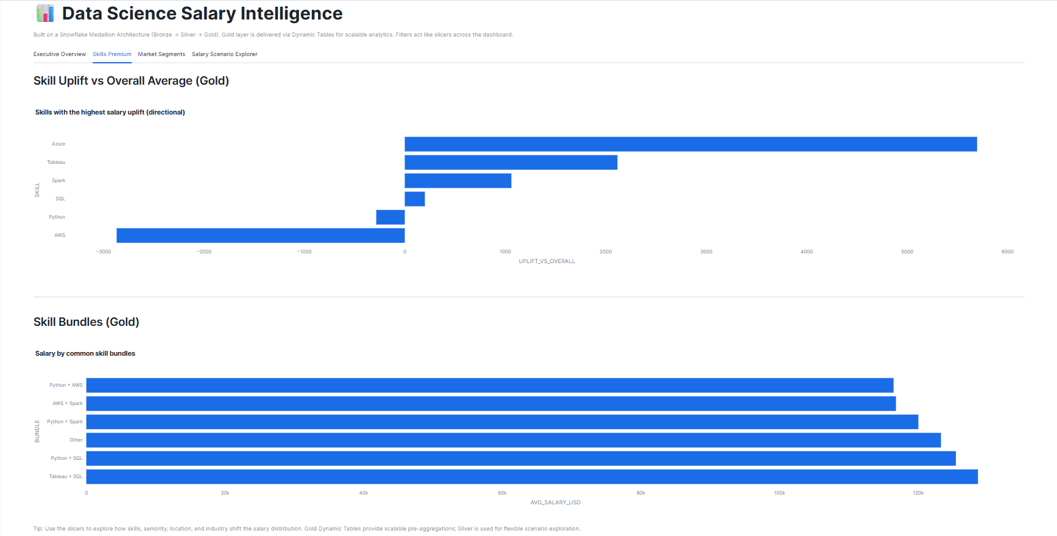

5.4 Market Segments
This section explores salary trends across company size, revenue, and rating. The results indicate that salary differences exist across company attributes, but the relationship is not strictly linear. This suggests that role requirements and skill composition may outweigh company scale in determining compensation.

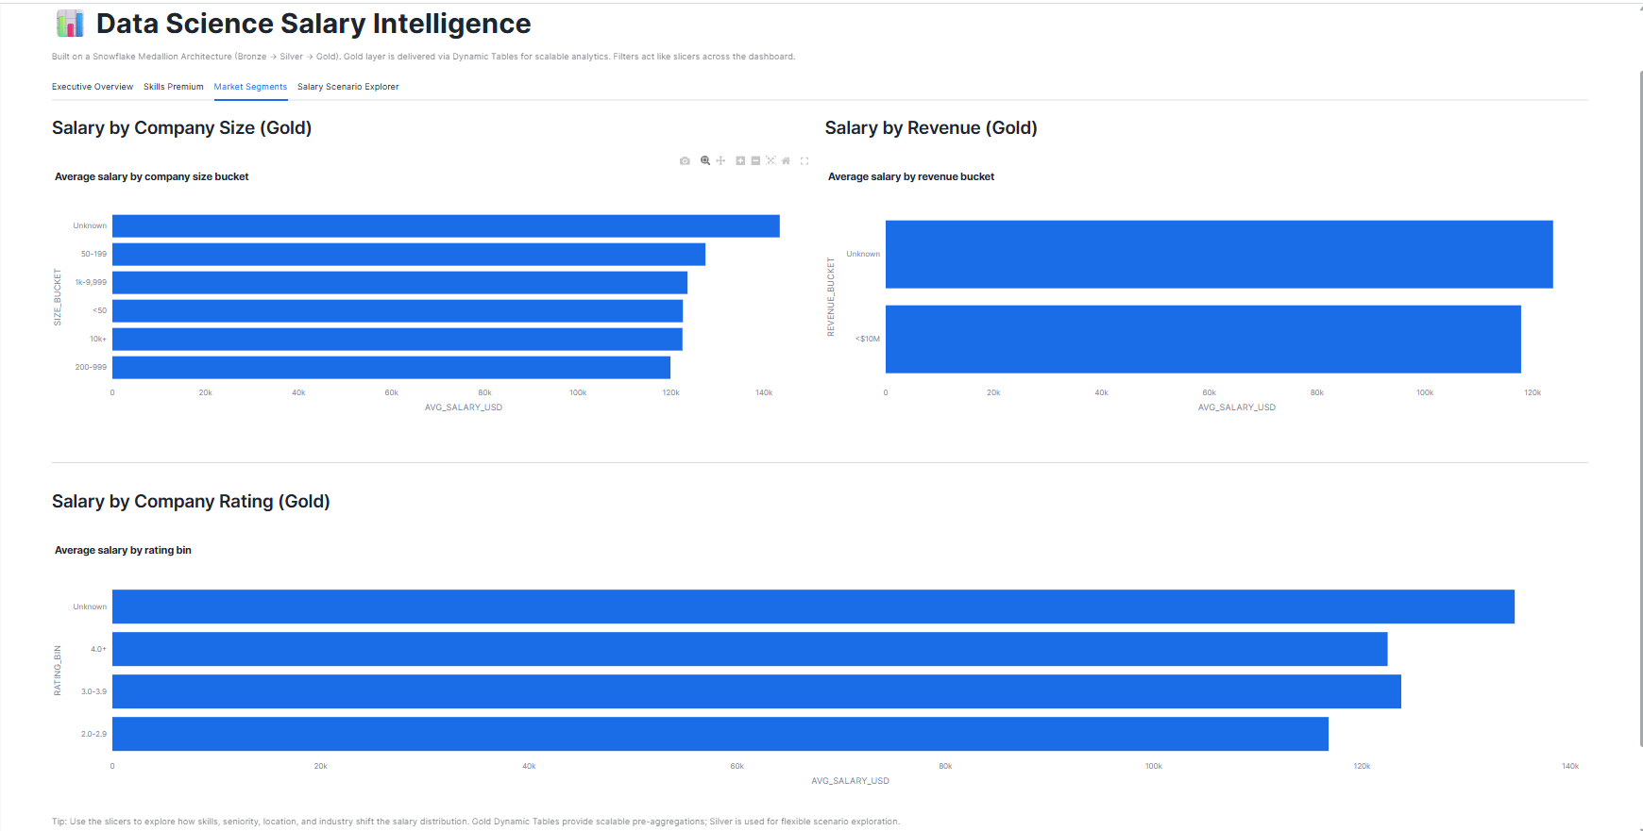

5.5 Salary Scenario Explorer
The Salary Scenario Explorer provides an exploratory view rather than a deterministic salary prediction. A baseline salary reference is derived from historical averages in the Gold layer, while a distribution of similar job postings from the Silver layer illustrates the realistic range of outcomes.
This design prioritizes transparency and interpretability, acknowledging the inherent variability of salary data.

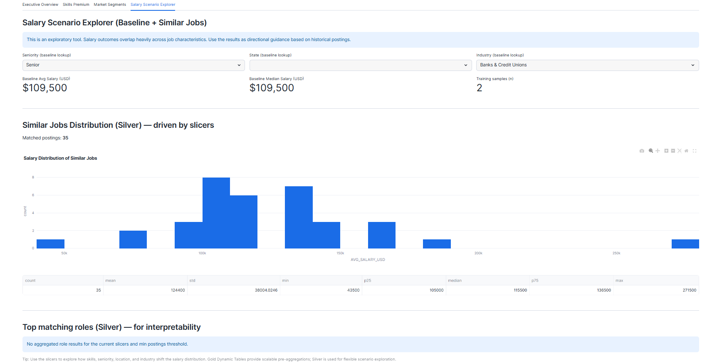

6.0 Predictive Modeling & Evaluation
Gradient Boosting models were evaluated for both regression and salary band classification. Despite experimenting with different modeling approaches, predictive performance remained limited, with low R² scores and weak classification accuracy.
These results indicate that:
- Salary outcomes overlap heavily across job characteristics
- The dataset contains high noise and limited signal for individual-level prediction
- Salary determination is influenced by complex, interacting factors
As a result, predictive models were retained for exploratory purposes but not positioned as authoritative predictors.
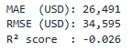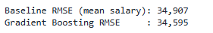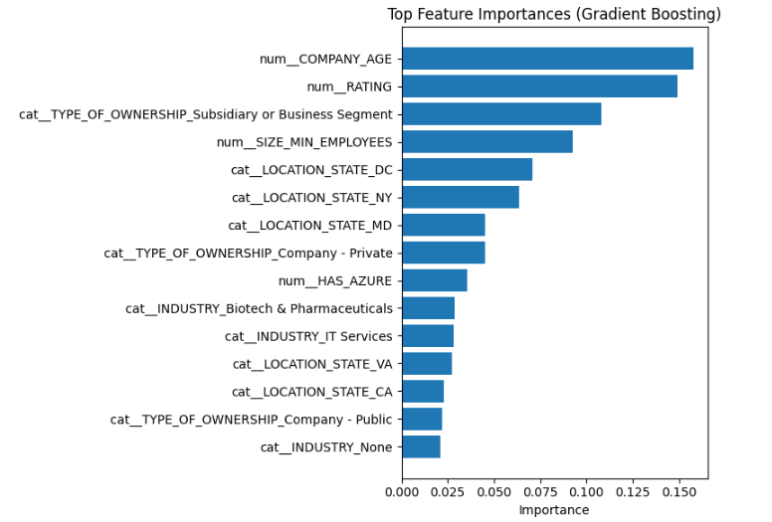

7.0 Analysis & Key Insights
Several key insights emerge from the analysis:
- Salary distributions are wide, even for similar roles, indicating high market variability.
- Skills have stronger influence than job titles, particularly specialized technical skills.
- Location remains a significant driver, reflecting regional demand and cost-of-living differences.
- Company attributes matter, but do not dominate salary outcomes.
These findings directly address the project’s objective of understanding factors influencing data science salaries.

8.0 Limitations & Drawbacks
This project has several limitations:
- A relatively small dataset limits predictive modeling performance
- Data sparsity occurs for highly specific filter combinations
- Salary estimates are self-reported or inferred and may contain bias
Rather than extrapolating unreliable predictions, the system transparently communicates data availability, preserving analytical integrity.

9.0 Enhancements & Areas for Improvement
Several enhancements were implemented to improve the robustness, scalability, and interpretability of the system beyond a basic analytics pipeline.

1. Adoption of a Medallion Architecture for Maintainability and Scalability
Instead of performing all transformations in a single step, the system was redesigned using a Bronze–Silver–Gold Medallion Architecture. This separation of concerns improves maintainability by isolating raw ingestion, data cleansing, and business analytics into distinct layers. The presence of raw data history in the Bronze layer also enables reprocessing and auditing, which would not be possible in a flat pipeline design.

2. Preservation of Raw Data History with Ingestion Metadata
The Bronze layer was enhanced to include ingestion metadata such as load identifiers, ingestion timestamps, source filenames, and row numbers. This allows each record to be traced back to its source and ingestion event. An audit view was also created to validate load completeness and monitor ingestion consistency. These features improve data governance and reliability.

3. Feature Engineering to Improve Analytical Depth
In the Silver layer, raw textual data was enriched with engineered features such as seniority level and binary indicators for in-demand technical skills (e.g., Python, SQL, AWS). This enhancement enables more granular analysis of how specific skills and experience levels influence salary trends, which would not be possible using raw text fields alone.

4. Use of Dynamic Tables for Automated Gold-Layer Aggregation
Instead of static tables or manual refresh processes, Snowflake Dynamic Tables were used in the Gold layer. This enhancement ensures that business metrics and aggregates remain automatically up-to-date when upstream data changes, reducing operational overhead and improving scalability. It also aligns the system with modern, production-grade analytics practices.

5. Shift from Point Prediction to Scenario-Based Salary Exploration
Initial attempts at salary regression and classification revealed limited predictive performance due to data sparsity and overlapping salary distributions. Rather than presenting unreliable predictions, the system was improved by repositioning salary estimation as a scenario-based exploration using aggregated baselines and historical distributions. This enhancement improves interpretability and avoids misleading outputs.

6. Integration of Streamlit Directly within Snowflake
The Streamlit dashboard was implemented natively within Snowflake instead of as an external application. This enhancement eliminates the need for separate authentication, reduces data movement, and ensures secure, low-latency access to Gold and Silver datasets. It also simplifies deployment and improves user experience.

7. Explicit Handling of Data Sparsity
The dashboard was intentionally designed to surface scenarios where insufficient historical data exists. Instead of extrapolating or generating synthetic predictions, the system transparently communicates data availability. This design choice enhances analytical integrity and aligns with responsible data practice.

10.0 Recommendations
For Job Seekers
- Focus on acquiring high-impact technical skills identified in the Skills Premium analysis
- Use salary distributions rather than point estimates to set realistic expectations
For Recruiters
- Benchmark compensation using skill combinations rather than job titles alone
For System Development
- Combine descriptive analytics with cautious predictive modeling to support decision-making
- Implementing Snowpipe or streaming ingestion for near real-time updates
- Expanding the dataset with additional job boards or historical records
- Applying natural language processing to extract richer signals from job descriptions
- Reintroducing predictive models once sufficient data volume is available

11.0 Conclusion
This project demonstrates how a Snowflake Medallion Architecture can transform raw Glassdoor job postings into a scalable and insightful analytics platform. While predictive modeling faced limitations due to data complexity, the resulting dashboard provides transparent, interpretable, and actionable insights into the data science job market. The solution reflects industry-aligned architecture, analytical maturity, and ethical data practice.

