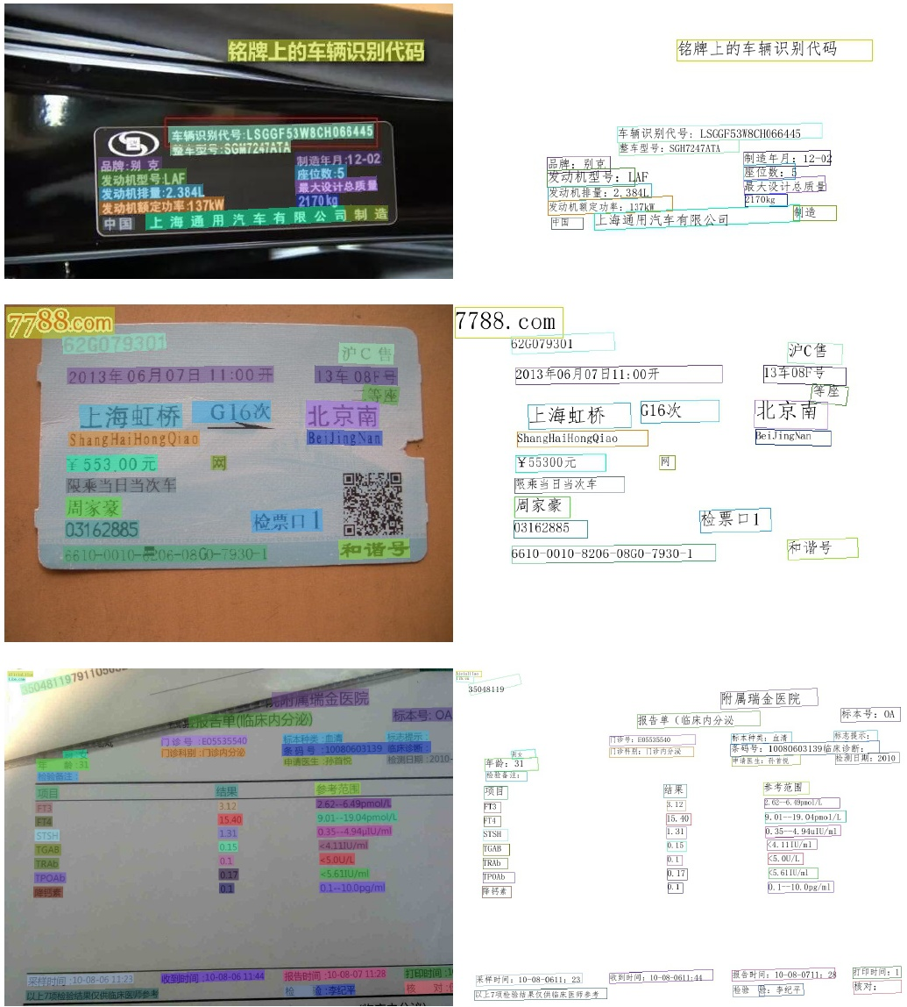

DeVries, T.; and Taylor, G. W. 2017. Improved regulariza- tion of convolutional neural networks with cutout. arXiv preprint arXiv:1708.04552 .2.2

Gupta, A.; Vedaldi, A.; and Zisserman, A. 2016. Synthetic data for text localisation in natural images. In Proceedings of the IEEE conference on computer vision and pattern recog nition, 2315-2324.3.1

He, M.; and Yang, Z. 2018. ICPR 2018 contest on robust reading for multi-type web images (MTWI). https://tianchi. aliyun.com/competition/entrance/231651/information3.1

He, T.; Zhang, Z.;, Zhang, H.;, Zhang, Z., Xie, J., and Li, M 2019a. Bag of tricks for image classification with convolu- tional neural networks. In Proceedings of the IEEE Confer- ence on Computer Vision and Pattern Recognition, 558-567. 2.1

oriented and multi-lingual scene text detection with direct regression. IEEE Transactions on Image Processing 27(11): 5406-5419. [3.1]

He, Y.; Liu, P.; Wang, Z.; Hu, Z., and Yang, Y. 2019b. Filter pruning via geometric median for deep convolutional neural. networks acceleration. In Proceedings of the IEEE Confer- ence on Computer Vision and Pattern Recognition, 4340 4349.92.1

Howard, A.; Sandler, M.; Chu, G.; Chen, L.-C.; Chen, B.;. Tan, M.; Wang, W.; Zhu, Y.; Pang, R.; Vasudevan, V.; et al. 2019. Searching for mobilenetv3. In Proceedings of the IEEE International Conference on Computer Vision, 1314 1324.12

Hu, J.; Shen, L.; and Sun, G. 2018. Squeeze-and-excitation networks. In Proceedings of the IEEE conference on com-. puter vision and pattern recognition, 7132-7141.2.1