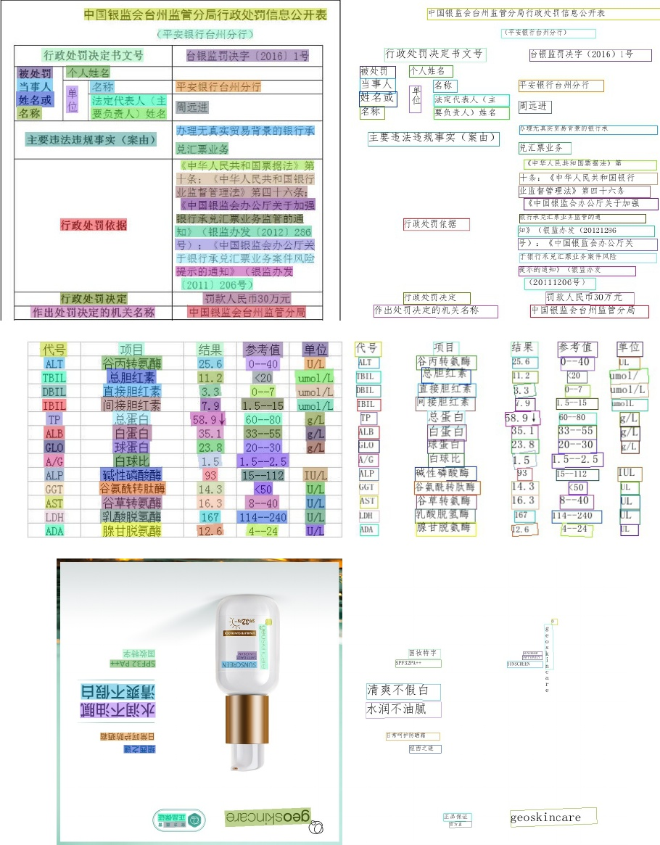

Figure 14: Some image results of the proposed PP-OCR system for Chinese and English recognition.

Huang, Z., Chen, K.; He, J.; Bai, X.;, Karatzas, D.; Lu, S., and Jawahar, C. 2019. Icdar2019 competition on scanned receipt ocr and information extraction. In 2019 Interna- tional Conference on Document Analysis and Recognition (ICDAR), 1516-1520. IEEE.3.1

Karatzas, D.; Mestre, S. R.; Mas, J.; Nourbakhsh, F.; and. Roy, P. P. 2011. ICDAR 2011 robust reading competition- challenge 1: reading text in born-digital images (web and email). In 2011 International Conference on Document Analysis and Recognition, 1485-1490. IEEE.3.1

Li, H.; Kadav, A.; Durdanovic, I.; Samet, H.;, and Graf, H. P. 2016. Pruning filters for efficient convnets. arXiv preprint arXiv:1608.08710 :2.1

Real-Time Scene Text Detection with Differentiable Bina- rization. In AAAI, 11474-11481.

Lin, T.-Y.; Dollar, P., Girshick, R.; He, K.; Hariharan, B., and Belongie, S. 2017. Feature pyramid networks for ob- ject detection. In Proceedings of the IEEE conference on computer vision and pattern recognition, 2117-2125.2.1

Luo, C.; Zhu, Y.; Jin, L.; and Wang, Y. 2020. Learn to Augment: Joint Data Augmentation and Network Optimiza- tion for Text Recognition. In Proceedings of the IEEE/CVF Conference on Computer Vision and Pattern Recognition, 1374613755.2.3][11

Nayef, N.;, Patel, Y.; Busta, M.; Chowdhury, P. N.; Karatzas, D.;, Khlif, W.;, Matas, J.;, Pal, U.;, Burie, J.-C.;, Liu, C.-1., et al. 2019. ICDAR2019 robust reading challenge on multi- lingual scene text detection and recognition-RRC-MLT-