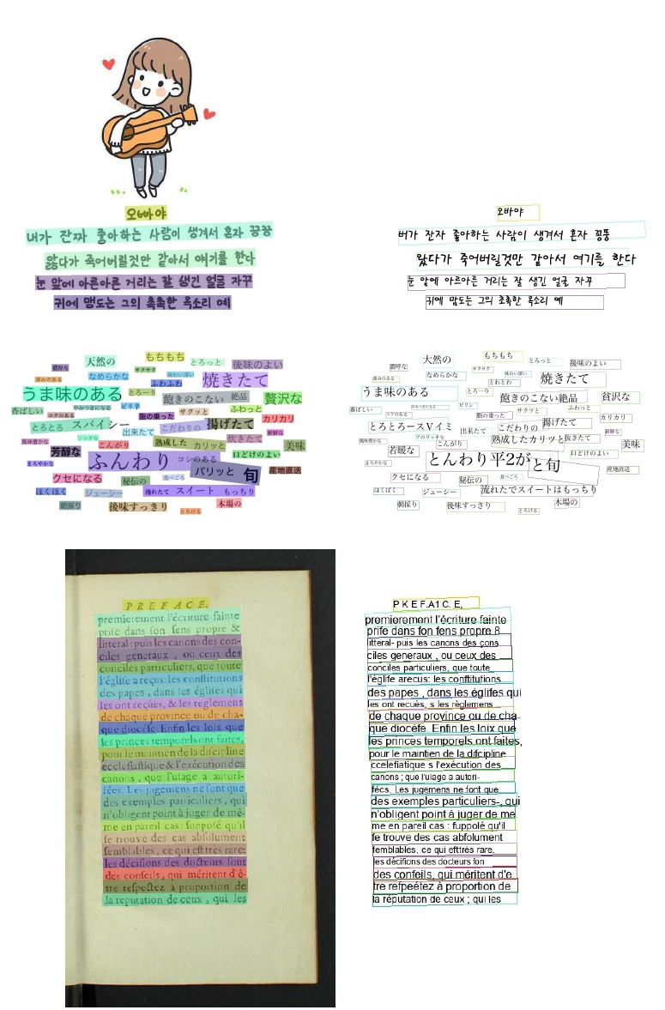

Figure 15: Some image results of the proposed PP-OCR system for multilingual recognition

2019. In 2019 International Conference on Document Anal- ysis and Recognition (ICDAR), 1582-1587. IEEE.3.1

Sanster. 2018. Generate text images for training deep learn- ing ocr model. https://github.com/Sanster/text renderer3.1 Shi, B.; Bai, X.; and Yao, C. 2016. An end-to-end trainable neural network for image-based sequence recognition and its application to scene text recognition. IEEE transactions on pattern analysis and machine intelligence 39(11): 2298- 2304.110 Shi, B.;, Yao, C.;, Liao, M.; Yang, M.;, Xu, P.;, Cui, L.;, Be- longie, S.; Lu, S.; and Bai, X. 2017. ICDAR2017 competi-

Shi, B.;, Yao, C.;, Liao, M.; Yang, M.;, Xu, P.;, Cui, L.;, Be- longie, S.; Lu, S.; and Bai, X. 2017. ICDAR2017 competi- tion on reading chinese text in the wild (RCTW-17). In 2017 14th IAPR International Conference on Document Analysis and Recognition (ICDAR), volume 1, 1429-1434. IEEE.3.1

network to be meticulous for weakly-supervised object and action localization. In 2017 IEEE international conference on computer vision (ICCV), 3544-3553. IEEE.2.2

Sun, Y.; Liu, J.; Liu, W.;, Han, J.;, Ding, E., and Liu, J. 2019. Chinese street view text: Large-scale chinese text reading with partially supervised learning. In Proceedings of the IEEE International Conference on Computer Vision, 9086-- 9095.3.1

Xu, Z.; Yang, W.; Meng, A.; Lu, N.; Huang, H.; Ying, C.; and Huang, L. 2018. Towards end-to-end license plate de- tection and recognition: A large dataset and baseline. In Proceedings of the European conference on computer vision (ECCV), 255-271. 3.1

Yao, C.; Bai, X.; Liu, W.; Ma, Y.; and Tu, Z. 2012. Detect- ing texts of arbitrary orientations in natural images. In 2012