# PP-OCR: A Practical Ultra Lightweight OCR System

# Yuning Du, Chenxia Li, Ruoyu Guo, Xiaoting Yin, Weiwei Liu,

Baidu Inc.

Baidu Inc. {duyuning, yangyehua} @baidu.com

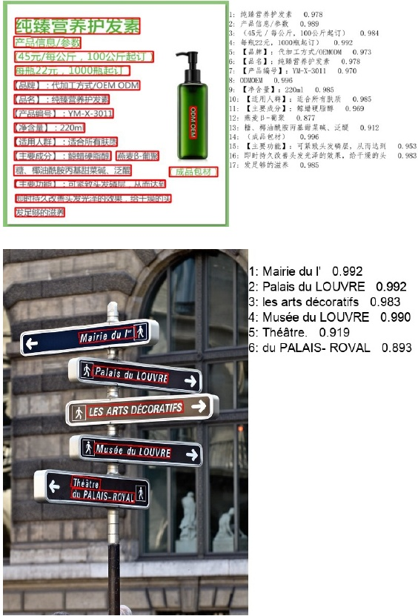

# Abstract

The Optical Character Recognition (OCR) systems have been widely used in various of application scenarios, such as of- fice automation (OA) systems, factory automations, online educations, map productions etc. However, OCR is still a challenging task due to the various of text appearances and the demand of computational efficiency. In this paper, we propose a practical ultra lightweight OCR system, i.e., PP- OCR. The overall model size of the PP-OCR is only 3.5M for recognizing 6622 Chinese characters and 2.8M for rec- ognizing 63 alphanumeric symbols, respectively. We intro duce a bag of strategies to either enhance the model ability or reduce the model size. The corresponding ablation exper iments with the real data are also provided. Meanwhile, sev- eral pre-trained models for the Chinese and English recog- nition are released, including a text detector (97K images are used), a direction classifier (600K images are used) as well as a text recognizer (17.9M images are used). Besides, the proposed PP-OCR are also verified in several other lan- guage recognition tasks, including French, Korean, Japanese and German. All of the above mentioned models are open- sourced and the codes are available in the GitHub repository, i.e., https://github.com/PaddlePaddle/PaddleOCR.

# 1Introduction

OCR (Optical Character Recognition), a technology which targets at recognizing text in images automatically as shown in Figure1 has a long research history and a wide range of application scenarios, such as document electronization, identity authentication, digital financial system, and vehicle. license plate recognition. Moreover, in factory, products can be more conveniently managed by extracting the text infor-. mation of products automatically. Students' offline home- work or test paper can be electronized with an OCR system to make the communication between teachers and students more efficient. OCR can also be used for labeling the point of interests (POI) of a street view image, benefiting the map production efficiency. Rich application scenarios en-. dow OCR technology with great commercial value, mean- while, a lot of challenges..

while, a lot of challenges.. Various of Text Appearances Text in image can be gen erally divided into two categories: scene text and document text. Scene text refers to the text in natural scene as shown in

Copyright O 2021, All rights reserved.

Figure 1: Some image results of the proposed PP-OCR sys- tem.

Figure[3] which usually changes dramatically for the factors such as perspective, scaling, bending, clutter, fonts, multi- lingual, blur, illumination, etc. Document text, as shown in Figure[4] is more often encountered in practical application. Different problems caused by the high density and long text need to be solved. Otherwise, document image text recogni- tion often comes with the need to structure the results, which introduced a new hard task.

Computational Efficiency In practical, the images that need to be processed are usually massive, which makes high computational efficiency an important criterion for design- ing an OCR system. CPU is preferred to be used than GPU