# PP-OCR: A Practical Ultra Lightweight OCR System

# Yuning Du, Chenxia Li, Ruoyu Guo, Xiaoting Yin, Weiwei Liu,

Baidu Inc.

Baidu Inc. {duyuning, yangyehua} @baidu.com

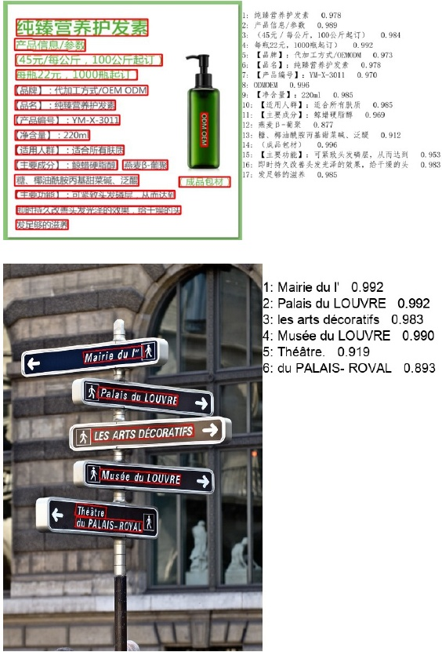

# Abstract

The Optical Character Recognition (OCR) systems have been widely used in various of application scenarios, such as of- fice automation (OA) systems, factory automations, online educations, map productions etc. However, OCR is still a challenging task due to the various of text appearances and the demand of computational efficiency. In this paper, we propose a practical ultra lightweight OCR system, i.e., PP- OCR. The overall model size of the PP-OCR is only 3.5M for recognizing 6622 Chinese characters and 2.8M for rec- ognizing 63 alphanumeric symbols, respectively. We intro duce a bag of strategies to either enhance the model ability or reduce the model size. The corresponding ablation exper iments with the real data are also provided. Meanwhile, sev- eral pre-trained models for the Chinese and English recog- nition are released, including a text detector (97K images are used), a direction classifier (600K images are used) as well as a text recognizer (17.9M images are used). Besides, the proposed PP-OCR are also verified in several other lan- guage recognition tasks, including French, Korean, Japanese and German. All of the above mentioned models are open- sourced and the codes are available in the GitHub repository, i.e., https://github.com/PaddlePaddle/PaddleOCR.

# 1Introduction

OCR (Optical Character Recognition), a technology which targets at recognizing text in images automatically as shown in Figure1 has a long research history and a wide range of application scenarios, such as document electronization, identity authentication, digital financial system, and vehicle. license plate recognition. Moreover, in factory, products can be more conveniently managed by extracting the text infor-. mation of products automatically. Students' offline home- work or test paper can be electronized with an OCR system to make the communication between teachers and students more efficient. OCR can also be used for labeling the point of interests (POI) of a street view image, benefiting the map production efficiency. Rich application scenarios en-. dow OCR technology with great commercial value, mean- while, a lot of challenges..

while, a lot of challenges.. Various of Text Appearances Text in image can be gen erally divided into two categories: scene text and document text. Scene text refers to the text in natural scene as shown in

Copyright O 2021, All rights reserved.

Figure 1: Some image results of the proposed PP-OCR sys- tem.

Figure[3] which usually changes dramatically for the factors such as perspective, scaling, bending, clutter, fonts, multi- lingual, blur, illumination, etc. Document text, as shown in Figure[4] is more often encountered in practical application. Different problems caused by the high density and long text need to be solved. Otherwise, document image text recogni- tion often comes with the need to structure the results, which introduced a new hard task.

Computational Efficiency In practical, the images that need to be processed are usually massive, which makes high computational efficiency an important criterion for design- ing an OCR system. CPU is preferred to be used than GPU

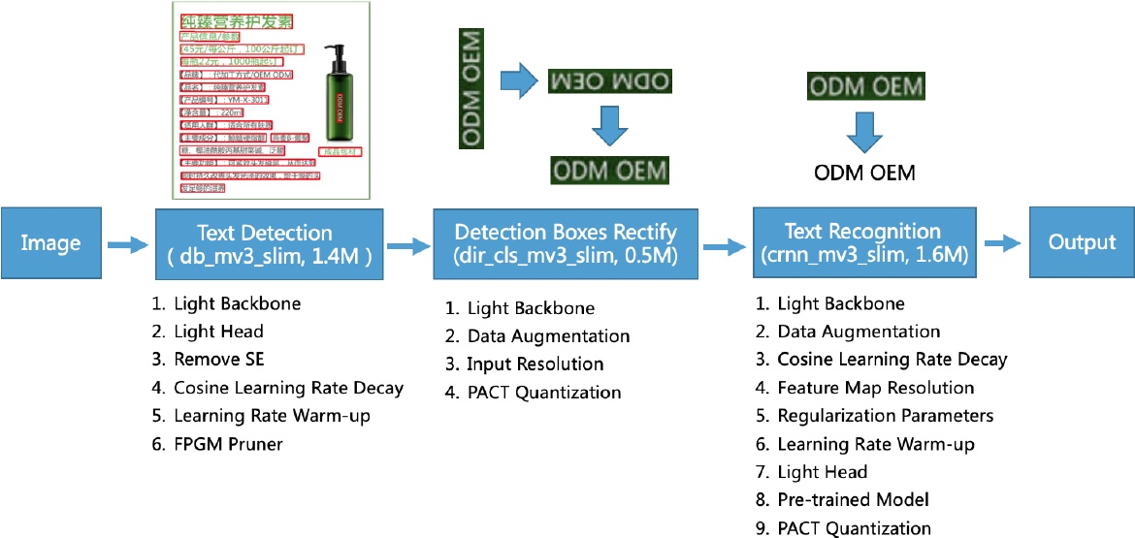

Figure 2: The framework of the proposed PP-OCR. The model size in the figure is about Chinese and English characters recognition. For alphanumeric symbols recognition, the model size of text recognition is from 1.6M to 0.9M. The rest of the models are the same size.

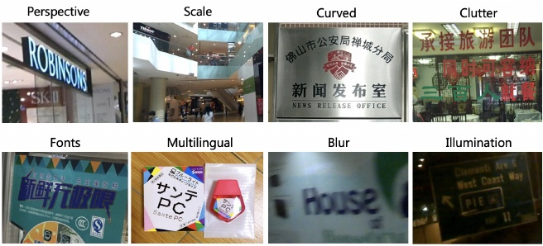

considering the cost. In particular, the OCR system need to be run on embedded devices in many scenarios, such as cell phones, which makes it necessary to consider the model size. Trade off model size and performance is difficult but of great value. In this paper, we propose a practical ultra lightweight OCR system, named as PP-OCR, which consists of three parts, text detection, detected boxes rectification and text. recognition as shown in Figure2

Text Detection The purpose of text detection is to locate the text area in the image. In PP-OCR, we use Differentiable Binarization (DB) (Liao et al. 2020) as text detector which is based on a simple segmentation network. The simple post processing of DB makes it very efficient. In order to further improve its effectiveness and efficiency, the following six strategies are used: light backbone, light head, remove SE module, cosine learning rate decay, learning rate warm-up, and FPGM pruner. Finally, the model size of the text detector is reduced to 1.4M.

is reduced to 1.4M. Detection Boxes Rectify Before recognizing the detected text, the text box needs to be transformed into a horizon- tal rectangle box for subsequent text recognition, which is

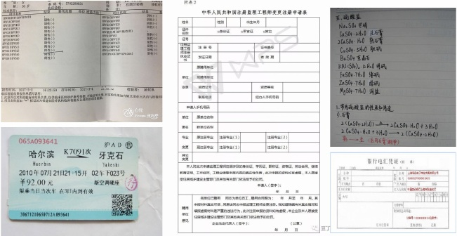

Figure 4: Some images contained document text..

easy to be achieved by geometric transformation as the de- tection frame is composed of four points. However, the rec- tified boxes may be reversed. Thus, a classifier is needed to determine the text direction. If a box is determined re- versed, further flipping is required. Training a text direction classifier is a simple image classification task. We adopt the following four strategies to enhance the model ability and reduce the model size: light backbone, data augmentation, input resolution and PACT quantization. Finally, the model. size of the text direction classifier is 50oKB.

Text Recognition In PP-OCR, we use CRNN (Shi, Bai, and Yao 2016) as text recognizer, which is widely used and practical for text recognition. CRNN integrates feature ex- traction and sequence modeling. It adopts the Connection-. ist Temporal Classification(CTC) loss to avoid the inconsis. tency between prediction and label. To enhance the model ability and reduce the model size of a text recognizer, the. following nine strategies are used: light backbone, data aug- mentation, cosine learning rate decay, feature map resolu-.

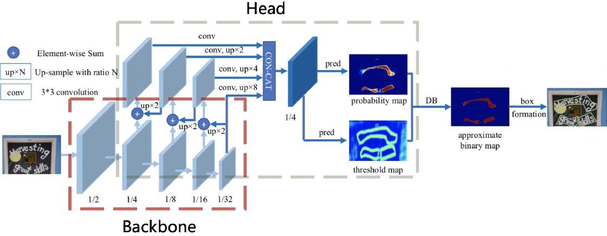

Figure 5: Architecture of the text detector DB. This figure comes from the paper of DB (Liao et al. 2020). The red and gray rectangles show the backbone and head of the text detector separately.

tion, regularization parameters, learning rate warm-up, light head, pre-trained model and PACT quantization. Finally, the model size of the text recognizer is only 1.6M for Chinese and English recognition and 900KB for alphanumeric sym- bols recognition.

bols recognition. In order to implement a practical OCR system, we con- struct a large-scale dataset for Chinese and English recog. nition as an example. Specifically, text detection dataset has 97K images. Direction classification dataset has 600k im ages. Text recognition dataset has 17.9M images. A small amount of the data are selected to conduct ablation exper- iments quickly and choose the appropriate strategies. We make a lot of ablation experiments to show the effects of different strategies in Figure2 Besides, we also verify the proposed PP-OCR system for other languages recognition which including alphanumeric symbols, French, Korean, Japanese and German.

Japanese and German. The rest of the paper is organized as follows. In section 2, we present the bag of model enhancement or slimming strategies. Experimental results are discussed in section 3 and conclusion is conducted in section 4.

# 2Enhancement or Slimming Strategies

In this section, the details of six strategies for enhancing the model ability or reducing the model size of a text detector will be introduced. Figure 5 shows the architecture of the text detector DB.

text detector DB. Light Backbone The size of backbone has dominant effect on the model size of a text detector. Therefore, light backbones should be selected for building the ultra lightweight models. With the development of image clas. sification, MobileNetV1, MobileNetV2, MobileNetV3 and ShuffleNetV2 series are often used as the light backbones. Each series has different scale. Thanks to the inference time on CPU and accuracy of more than 20 kinds of back bones are provided by PaddleClas as shown in Figure6

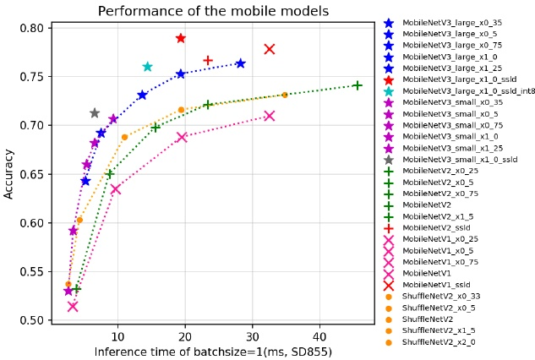

Figure 6: The performance of some light backbones on the ImageNet 1000 classification, including MobileNetV1, Mo- bileNetV2, MobileNetV3 and ShuffleNetV2 series. The in- ference time is tested on Snapdragon 855 (SD855) with the batch size set as 1.

MobileNetV3 can achieve higher accuracy when the pre dict time are same. As for the choice of scale, we adopt MobileNetV3_large_x0.5 to balance accuracy and efficiency empirically. Incidentally, PaddleClas provides a total of up to 24 series of image classification network structures and training configurations, 122 models' pretrained weights and their evaluation metrics, such as ResNet, ResNet_vd, SERes- NeXt, Res2Net, Res2Net_vd, DPN, DenseNet, EfficientNet, Xception, HRNet, etc.

Xception, HRNet, etc. Light Head The head of the text detector is similar as the FPN (Lin et al.2017) architecture in object detection and fuse the feature maps of the different scales to im- prove the effect for the small text regions detection. For con- venience of merging the different resolution feature maps, 1 1 convolution is often used to reduce the feature maps to the same number of channel (we use inner channels for

Figure 7: Architecture of the SE block. This figure comes from the paper (Hu, Shen, and Sun|2018)

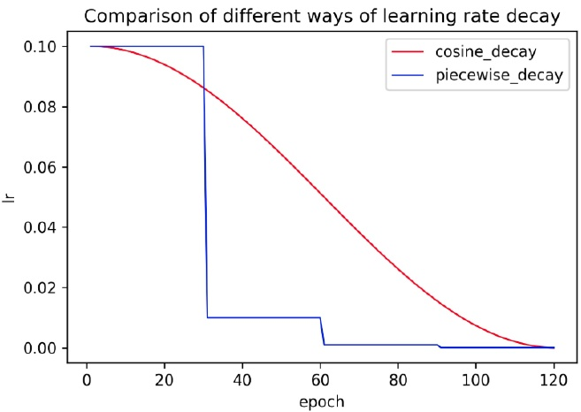

Figure 8: Comparison of different ways of learning rate de- cay.

short). The probability map and the threshold map are gen- erated from the fused feature map with convolutions which are also associated with the above inner channels. Thus in- ner channels has a great influence on the model size. When inner channels is reduced from 256 to 96, the model size is reduced from 7M to 4.1M, but the accuracy declines slightly

reduced from 7M to 4.1M, but the accuracy declines slightly Remove SE SE is the short for squeeze-and-excitation (Hu, Shen, and Sun 2018). As shown in Figure7 SE blocks model inter-dependencies between channels explicitly and re-calibrate channel-wise feature responses adaptively. Be- cause SE blocks can improve the accuracy of the vision tasks obviously, the search space of MobileNetV3 contains them and numerous of SE blocks are in MobileNetV3 architec- ture. However, when the input resolution is large, such as 640 640, it is hard to estimate the channel-wise feature responses with the SE block. The accuracy improvement is limited, but the time cost is very high. When the SE blocks are removed from the backbone, the model size is reduced from 4.1M to 2.5M, but the accuracy has no effect.

from 4.1M to 2.5M, but the accuracy has no effect. Cosine Learning Rate Decay The learning rate is the hyperparameter to control the learning speed. The lower the learning rate, the slower the change of the loss value Though using a low learning rate can ensure that you will not miss any local minimum, but it also means that the con- vergence speed is slow. In the early stage of training, the weights are in random initialization state, so we can set a relatively large learning rate for faster convergence. In the late stage of training, the weights are close to the optimal values, so a relatively smaller learning rate should be used. Cosine learning rate decay has become the preferred learn-

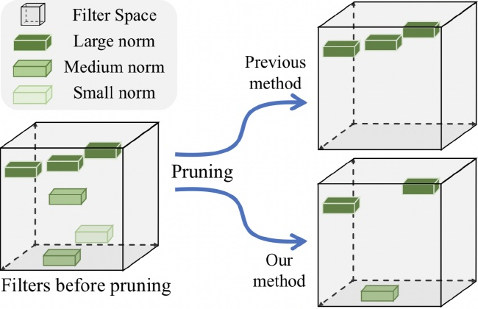

Figure 9: Illustration of FPGM Pruner. This figure comes from the paper (He et al. 2019b)

ing rate reduction strategy for improving model accuracy During the entire training process, cosine learning rate de cay keeps a relatively large learning rate, so its convergence is slower, but the final convergence accuracy is better. Figure 8compares the different ways of learning rate decay.

8compares the different ways of learning rate decay. Learning Rate Warm-up The paper (He et al.2019a) shows that using learning rate warm-up operation can help to improve the accuracy in the image classification. At the beginning of the training process, using a too large learning rate may result in numerical instability, a small learning rate is recommended to be used. When the training process is sta- ble, the initial learning rate is to be used. For text detection, the experiments show that this strategy also is effective.

the experiments show that this strategy also is effective. FPGM Pruner Pruning is another method to improve the inference efficiency of neural network model. In order to avoid the model performance degradation caused by the model pruning, we use FPGM (He et al. 2019b) to find the unimportant sub-network in original models. FPGM uses geometric median as the criterion and the each filter in a con- volution layer is considered as a point in Euclidean space. Then calculate the geometric median of these points and re. move the filters with the similar values, as shown in Figure The compress ratio of each layer is also important for prun- ing a model. Pruning every layer uniformly usually leads to significant performance degradation. In PP-OCR, the prun- ing sensitivity of each layer is calculated according to the method in (Li et al. 2016) and then used to evaluate the re- dundancy of each layer.

# 2.2Direction Classification

In this section, the details of four strategies for enhancing the model ability or reducing the model size of a direction classifier will be introduced.

Light Backbone We also adopt MobileNetV3 as the backbone of the direction classifier which is the same as the text detector. Because this task is relatively simple, we use MobileNetV3_small_x0.35 to balance accuracy and effi- ciency empirically. When using larger backbones, the accu- racy doesn't improve more.

some image processing operations to train a text recog- nizer, such as rotation, perspective distortion, motion blur and Gaussian noise. Those processes are referred to as BDA (Base Data Augmentation) for short. They are randomly added to the training images. The experiment shows that BDA also is useful for the direction classifier training. Be- sides BDA, some new data augmentation operations are proposed recently for improving the effect of image clas- sification, for example, AutoAugment (Cubuk et al.2019) RandAugment (Cubuk et al.2020), CutOut DeVries and Taylor2017), RandErasing (Zhong et al.2020), HideAnd- Seek (Singh and Lee[2017), GridMask (Chen 2020), Mixup (Zhang et al.|2017) and Cutmix (Yun et al.|2019). But the experiments show that most of them don't work for the direction classifier training except for RandAugment and RandErasing. RandAugment works best. Eventually, we add BDA and RandAugment to the training images of the direc- tion classification.

tion classification. Input Resolution In general, when the input resolution of a normalized image is increased, accuracy will also be improved. Since the backbone of the direction classifier is very light, increasing the resolution properly will not lead to the computation time raise obviously. In the most of the previous text recognition methods, the height and width of a normalized image is set as 32 and 100, respectively. How- ever, in PP-OCR, the height and width is set as 48 and 192, respectively, to improve the accuracy of the direction classi- fer. PACT Quantization Quantization allows the neural net

PACT Quantization Quantization allows the neural net work model to have lower latency, smaller volume and lower computational power consumption. At present, quantiza- tion is mainly divided into two categories: offline quanti- zation and online quantization. Offline quantization refers to a fixed-point quantization method that uses methods such as KL divergence and moving average to determine quan- tization parameters and does not require retraining. Online quantization is to determine quantization parameters dur ing the training process, which can provide less quantization loss than offline quantization mode. PACT (PArameterized Clipping acTivation) (Choi et al.

loss than offline quantization mode. PACT (PArameterized Clipping acTivation) (Choi et al. 2018) is a new online quantification method that removes some outliers from the activations in advance. After remov- ing the outliers, the model can learn more appropriate quan- titative scales. The formula for PACT to preprocess the acti- vations is as follows:

The preprocessing of the activation value of the ordinary PACT method is based on the ReLU function. All activation values greater than a certain threshold are truncated. How- ever, the activation functions in MobileNetV3 are not only ReLU, but also hard swish. Using ordinary PACT quantiza- tion leads to a higher quantization loss. Therefore, we mod- ify the formula of the activations preprocessing as follows to reduce the quantization loss.

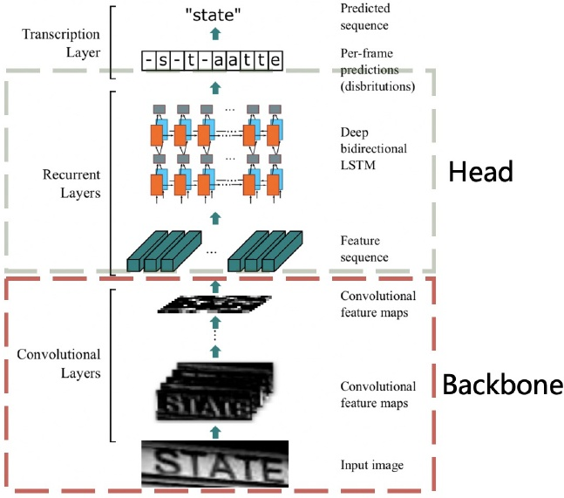

Figure 10: Architecture of the text recognizer CRNN. This figure comes from the paper (Shi, Bai, and Yao 2016). The red and gray rectangles show the backbone and head of the text recognizer separately.

We used the improved PACT quantification method to quantify the direction classifier model. In addition, L2 reg. ularization with a coefficient of O.001 is added to the PACT parameters to improve the model robustness. The implementation of the above FPGM Pruner and

parameters to improve the model robustness. The implementation of the above FPGM Pruner and PACT quantization is based on PaddleSlim PaddleSlim is a toolkit for model compression. It contains a collection of compression strategies, such as pruning, fixed point quan- tization, knowledge distillation, hyperparameter searching neural architecture search.

# 2.3Text Recognition

In this section, the details of nine strategies for enhancing the model ability or reducing the model size of a text recognizer will be introduced. Figure10shows the architecture of the text recognizer CRNN.

text recognizer CRNN. Light Backbone We also adopt MobileNetV3 as the backbone of the text recognizer which is the same as the text detection. MobileNetV3_small_x0.5 is selected to bal- ance accuracy and efficiency empirically. If you're not that sensitive to the model size, MobileNetV3_small_x1.0 is also a good choice. The model size is just increased by 2M, the accuracy is improved obviously Data Augmentation Besides BDA (Base Data Augmen-

Data Augmentation Besides BDA (Base Data Augmen- tation) which is often used in text recognition as mentioned earlier, TIA (Luo et al. 2020) also is an effective data aug- mentation method for text recognition. As shown in Figure

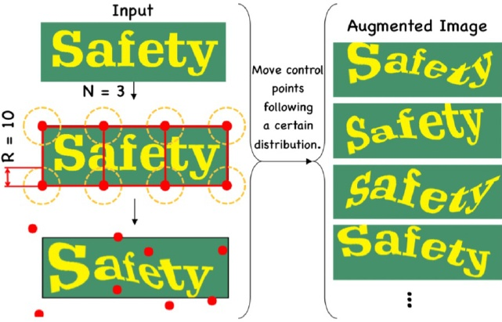

Figure 11: Illustration of data augmentation, TIA. This fig- ure comes from the paper (Luo et al. 2020)

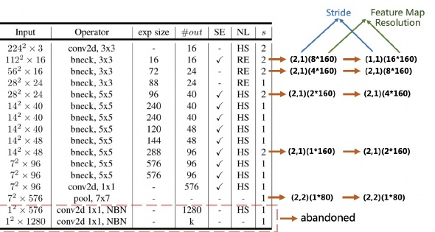

Figure 12: Illustration of the modify of the feature map reso- lution. The table comes from the paper (Howard et al. 2019)

11] at first, a set of fiducial points are initialized on the im age. Then move the points randomly to generate a new im age with the geometric transformation. In PP-OCR, we add BDA and TIA to the training images of the text recognition.

BDA and TIA to the training images of the text recognition. Cosine Learning Rate Decay As mentioned in text de- tection, cosine learning rate decay has become the preferred learning rate reduction method. The experiments show that cosine learning rate decay strategy is also effective to en- hance the model ability for text recognition.

Feature Map Resolution In order to adapt to multilin- gual recognition, particularly in Chinese recognition, in PP- OCR the height and width of the CRNN input are set as 32 and 320. Then, the strides of the original MobileNetV3 is not appropriate for text recognition. As shown in Figure[12 for the sake of keeping more the horizontal information, we modify the stride of the down sampling feature map except the first one from (2,2) to (2,1). In order to keep more verti. cal information, we further modify the stride of the second down sampling feature map from (2,1) to (1,1). Thus, the stride of the second down sampling feature map s2 affects the resolution of the whole feature map and the accuracy of the text recognizer dramaticly. In PP-OCR, s2 is set as (1,1) to achieve the better performance empirically.

to achieve the better performance empirically. Regularization Parameters Overfitting is a common term in machine learning. A simple understanding is that

the model performs well on the training data, but it performs poorly on the test data. To avoid overfitting, many regular ways have been proposed. Among them, weight_decay is one of the widely used ways to avoid overfitting. After the final loss function, L2 regularization (L2_decay) is added to the loss function. With the help of L2 regularization, the weight of the network tend to choose a smaller value, and finally the parameters in the entire network tends to O, and the generalization performance of the model is improved ac- cordingly. For text recognition, L2_decay has a great influ- ence on the accuracy.

ence on the accuracy. Learning Rate Warm-up Similar as the text detection, learning rate warm-up is also helping the text recognition. For text recognition, the experiments show that using this strategy is also effective.

strategy is also effective. Light Head A full connection layer is used to encode the sequence features to the predicted characters in the ordinary. The dimension of the sequence features have an impact on the model size of a text recognizer, especially for Chinese recognition whose characters are more than 6 thousands. Meanwhile, it is not that the higher of the dimension, the stronger of the ability of the sequence features representa- tion. In PP-OCR, the dimension of the sequence features is set to 48 empirically.

set to 48 empirically. Pre-trained Model If the training data is fewer, fine tune the existing networks, which are trained on a large data set such as ImageNet, to achieve fast convergence and better accuracy. The transfer learning in image classification and object detection show the above strategy is effective. In real scenes, the data used for text recognition is often limited. If the models are trained with tens of millions samples, even if they are synthesized ones, the accuracy can be significantly improved with the above models. We demonstrate the effec- tiveness of this strategy through experiments.

PACT Quantization We adopt the similar quantization scheme of the direction classification to reduce the model size of a text recognizer except for skipping the LSTM lay- ers. Those layers will not be quantified at present since the complexity of LSTM quantization.

# 3Experiments

# 3.1Experimental Setup

DataSetsAs shown in Table1 in order to implement a practical OCR system, we construct a large-scale dataset for Chinese and English recognition as an example. For text detection, there are 97k training images and 500

For text detection, there are 97k training images and 500 validation images. Among the training images, 68K im- ages are real scene images, which come from some public datasets and Baidu image search. The public datasets used include LSVT (Sun et al.[2019), RCTW-17 (Shi et al.[2017) MTWI 2018 (He and Yang|2018), CASIA-10K (He et al. 2018), SROIE (Huang et al.2019), MLT 2019 (Nayef et al. 2019), BD1 (Karatzas et al.2011), MSRA-TD500 (Yao et al. 2012) and CCPD 2019 (Xu et al.2018). Most the training images from Baidu image search are document text images. The remaining 29K synthetic images mainly focus on the scenarios for long text, multi direction text and table text. All the validation images come from the real scenes.

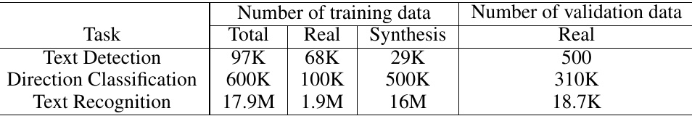

Table 1: Statistics of dataset for Chinese and English Recognition.

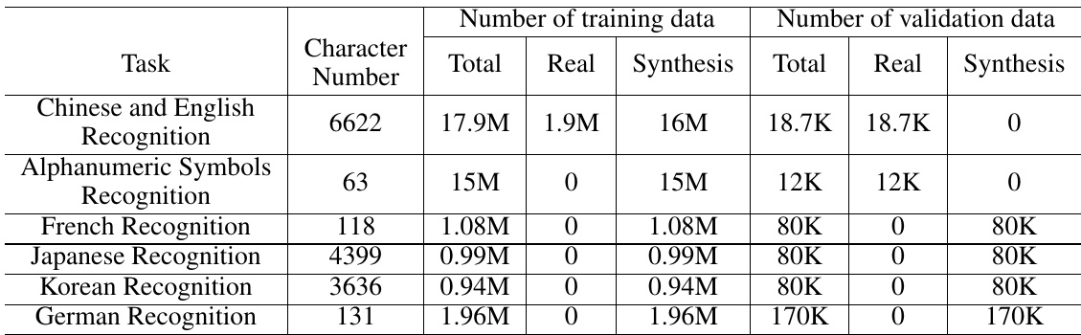

For direction classification, there are 600k training images and 310K validation images. Among the training images, 100K images are real scene images, which come from the public datasets (LSVT, RCTW-17, MTWI 2018). They are horizontal text which rectify and crop the ground truth of the images. The remaining 500K synthetic images mainly focus on the reversed text. We use the vertical fonts to synthesize some text images and then rotate them horizontally. All the validation images come from the real scenes.

validation images come from the real scenes. For text recognition, there are 17.9M training images and 18.7K validation images. Among the training images, 1.9M images are real scene images, which come from some pub- lic datasets and Baidu image search. The public datasets used include LSVT, RCTW-17, MTWI 2018 and CCPD 2019. The remaining 16M synthetic images mainly focus on the scenarios for different backgrounds, translation, rotation, perspective transformation, line disturb, noise, vertical text and so on. The corpus of synthetic images come from the real scene images. All the validation images also come from the real scenes. In order to conduct ablation experiments quickly and

In order to conduct ablation experiments quickly and choose the appropriate strategies, we select 4k images from the real scene training images for text detection, and 300k ones from the real scene training images for text recogni- tion.

In addition, we collected 300 images for different real ap. plication scenarios to evaluate the overall OCR system, in- cluding contract samples, license plates, nameplates, train tickets, test sheets, forms, certificates, street view images, business cards, digital meter, etc. Figure[3and Figure4show some images of the test set.

Furthermore, to verify the proposed PP-OCR for other languages, we also collect some corpus for alphanumeric symbols recognition, French recognition, Korean recogni- tion, Japanese recognition and German recognition. Then

Table 2: Statistics of dataset for multilingual recognition.

synthesize the text line images for text recognition. Some images for alphanumeric symbols recognition come from the public datasets, ST (Gupta, Vedaldi, and Zisserman 2016) and SRN (Yu et al. 2020). Table2shows the statistics. Since MLT 2019 for text detection includes multilingual im- ages, the text detector for Chinese and English recognition also can support multi language text detection. Due to the limited data, we haven't found the proper data to train the direction classifier for multilingual.

direction classifier for multilingual. The data synthesis tool used in text detection and text recognition is modified from text render (Sanster[2018).

Implementation Details We use Adam optimizer to train all the models and adopt cosine learning rate decay as the learning rate schedule. The initial learning rate, batch size and the number of epochs for different tasks can be found in Table When we obtain the trained models, FPGM pruner and PACT quantization can be used to reduce the model size further with the above models as the pre-trained ones. The training processes of FPGM pruner and PACT quantization are similar as previous.

In the inference period, HMean is used to evaluate the per- formance of a text detector. Accuracy is used to evaluate the performance of a direction classifier or a text recognizer. F- score is used to evaluate the performance of an OCR system. In order to calculate F-score, a correct text recognition result should be the accurate location and the same text. GPU in- ference time is tested on a single T4 GPU. CPU inference time is tested on a Intel(R) Xeon(R) Gold 6148. We use the Snapdragon 855 (SD 855) to evaluate the inference time of the quantification models.

# 3.2Text Detection

Table 5] compares the performance of the different back- bones for text detection. HMean, the model size and the in-

|  |  |  |  |  |  |  |  |  |
| --- | --- | --- | --- | --- | --- | --- | --- | --- |
| of the head 256 96 96 96 96 | SE V | Learning Rate Decay | Warm-up | 0.6821 0.6677 0.6952 0.7034 0.7349 | 0.5560 0.5524 0.5413 0.5404 0.5420 | HMean 0.6127 0.6046 0.6087 0.6112 0.6239 | Size (M) 7 4.1 2.6 2.6 2.6 | (CPU, ms) 406 213 173 173 173 |
|  |  |  |  |  |  |  |  |  |
|  |  |  |  |  |  |  |  |  |
|  |  |  |  |  |  |  |  |  |
|  |  |  |  |  |  |  |  |  |
|  |  |  |  |  |  |  |  |  |

Table 3: Ablation study of inner_channel of the head, SE, cosine learning rate decay, learning rate warm-up for text detection.

|  |  |  |  |  |
| --- | --- | --- | --- | --- |
| Task Text Detection Direction | Initial Learning Rate 0.001 0.001 | Batch Size 16 512 | Ablation Total Data Data | |
| 400 100 | 60 100 |
| Classification Text Recognition | 0.001 | 1024 | 500 | 100 |
|  |  |  |  |  |
|  |  |  |  |  |

Table 4: Implementation details of the model training..

|  |  |  |  |
| --- | --- | --- | --- |
| Backbone MobileNetV3_ large_x1 | HMean 0.6463 | Model Size (M) 16 | Inference Time (CPU, ms) 447 |
| MobileNetV3_ large_x0.5 MobileNetV3_ large_x0.35 | 0.6127 0.5935 | 7 5.4 | 406 367 |
| MobileNetV3_ small_x1 | 0.5919 | 7.5 | 380 |
|  |  |  |  |
|  |  |  |  |

Table 5: Compare the performance of the different back bones for text detection.

ference time of the different scales of MobileNetV3 change greatly. In PP-OCR, we choose MobileNetV3_large_x0.5 to balance accuracy and efficiency.

balance accuracy and efficiency. Tabel 3]shows the ablation study of inner channel of the head, SE, cosine learning rate decay, learning rate warm-up for text detection. Firstly, by reducing the internal channels of the detector head from 256 to 96, the model size was re- duced by 41%, and the inference time was accelerated by nearly 50% with HMean only dropped slightly. Therefore, reducing the inner channel is an effective way to lighten the detector. Then, when remove the SE block of the de. tector backbone, the model size is reduced 36.6% and the inference time has accelerated 18.8% further. Meanwhile, HMean will not be affected. Therefore, for text detection, the accuracy improvement of SE blocks is limited, but the time cost is very high. Finally, using both cosine learning rate decay instead of the fix learning rate and learning rate

|  |  |  |  |
| --- | --- | --- | --- |
| Pruner V | HMean 0.6239 0.6169 | Size (M) 2.6 1.4 | (SD 855, ms) 164 133 |
|  |  |  |  |
|  |  |  |  |

Table 6: Ablation study of FPGM pruner for text detection.

|  |  |  |  |
| --- | --- | --- | --- |
| Backbone MobileNetV3_ small_x0.5 MobileNetV3 | Accuracy 0.9494 0.9403 | Model Size (M) 1.34 0.85 | Inference Time (CPU, ms) 3.22 3.21 |
| small_x0.35 ShuffleNetV2_ x0.5 | 0.9017 | 1.72 | 3.41 |
|  |  |  |  |
|  |  |  |  |

Table 7: Compares the performance of the different back- bones for direction classification.

warm-up, HMean will be improved obviously. At the same time, the model size and the inference time will not be af- fected. Cosine learning rate decay and learning rate warm- up are effective strategies for text detection.

up are effective strategies for text detection. Table6shows the ablation study of FPGM pruner for text detection. Using FPGM pruner, the model size is reduced 46.2% and the inference time has accelerated 18.9% on SD 855 device with HMean slightly dropped. Therefore, FPGM pruner can prune the text detection model effectively.

# 3.3Direction Classification

Table 7compares the performance of different backbones for direction classification. The accuracy of MobileNetV3 with difference scales (0.35, 0.5) are close. The model size and the inference time of MobileNetV3_small_x0.35 are much better. Besides, ShuffleNetV2 is used to train a di- rection classifier in some previous work. From the table, whether it's accuracy or the model size or the inference time, ShuffleNetV2 is not a good choice.

ShuffleNetV2 is not a good choice. Tabel9 shows the ablation study of data augmentation for direction classification. The baseline accuracy of text di- rector classify without data augmentation is only 88.79%. When we adopt BDA (base data augmentation), the accu- racy can boost 2.55%. We also verified that RandomErasing

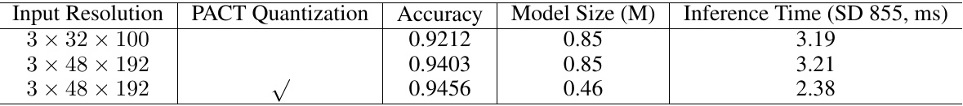

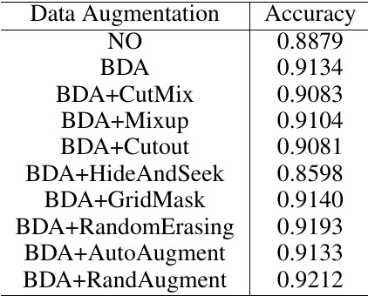

Table 9: Ablation study of data augmentation for direction classification.

|  |  |  |  |
| --- | --- | --- | --- |
| Backbone MobileNetV3 small_x0.35 MobileNetV3_ small_x0.5 | Accuracy 0.6288 0.6556 | Model Size (M) 22 23 | Inference Time (CPU, ms) 17 17.27 |
| MobileNetV3_ small_x1 | 0.6933 | 28 | 19.15 |
|  |  |  |  |
|  |  |  |  |

Table 10: Compares the performance of the different back. bones for text recognition. The number of channel in the head is 256.

and RandAugment are useful for text direction classifica- tion. Therefore, in PP-OCR, we use BDA (base data aug- mentation) and RandAugment to train a direction classifier. Table [8|shows the ablation study of input resolution and

mentation) and RandAugment to train a direction classifier. Table [8|shows the ablation study of input resolution and PACT quantization for direction classification. When the in- put resolution is adjusted from 3 32 100 to 3 48 192 The classification accuracy has improved but the prediction speed is basically unchanged. Furthermore, we also verified quantization strategy is effective in accelerating the predic. tion speed of the text direction classifier. The model size is reduced 45.9% and the inference time has accelerated 25.86%. Accuracy is slight promotion.

# 3.4Text Recognition

Table [10] compares the performance of the different back. bones for text recognition. The accuracy, the model size and the inference time of the different scales of Mo- bileNetV3 change greatly. In PP-OCR, we choose Mo- bileNetV3_small_x0.5 to balance accuracy and efficiency.

Table 8: Ablation study of input resolution and PACT quantization for direction classification.

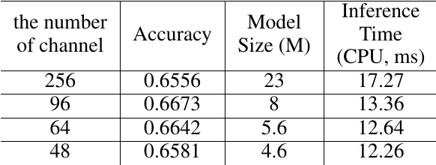

Table 11: Ablation study of the number of channel in the head for text recognition. The data augmentation is only used BDA.

Table [11compares the number of channel in the CRNN head for text recognition. Reduce the number of channe. from 256 to 48, the model size is reduced from 23M to 4.6M and the inference time has accelerated nearly 30%. However, the accuracy will not be affected. We can see the number of. channel in the head has a great influence on the model size of a lightweight text recognizer.

of a lightweight text recognizer. Tabel12 shows the ablation study of data augmentation, cosine learning rate decay, the stride of the second down sampling feature map, regularization parameters L2_decay and learning rate warm-up for text recognition. To verify the advantages of each strategy, the setting of

To verify the advantages of each strategy, the setting of the basic experimental is the strategy S1. When using BDA, the accuracy will be improved 3.12%. Data augmentation is very necessary for text recognition. When we adopt the cosine learning rate decay further, the accuracy will be im- proved 1.47%. The cosine learning rate is an effective strat- egy for text recognition. Next, when we increase the fea- ture map resolution and reduce the stride of the second down sampling feature map from (2,1) to (1,1), the accuracy will be improved 5.27%. Then, when we adjust the regulariza- tion parameters L2_decay from 0 to 1e - 5 further, the accu racy will be improved 3.4%. The feature map resolution and L2.decay have a great influence on the performance. Final. using learning rate warm-up, the accuracy will be improved 0.62%. Using TIA data augmentation, the accuracy will be improved 0.91%. Learning rate warm-up and TIA also are effective strategies for text recognition.

effective strategies for text recognition. Tabel13]shows the ablation study of PACT quantization for text recognition. When we use PACT quantization, the model size is reduced 67.39% and the inference time has ac- celerated 8.3%. Since there was no quantification on LSTM, The acceleration is not obvious. However, accuracy achieves a significant improvement. Therefore, PACT quantization also is an effective strategy for reducing the model size of. a text recognizer.

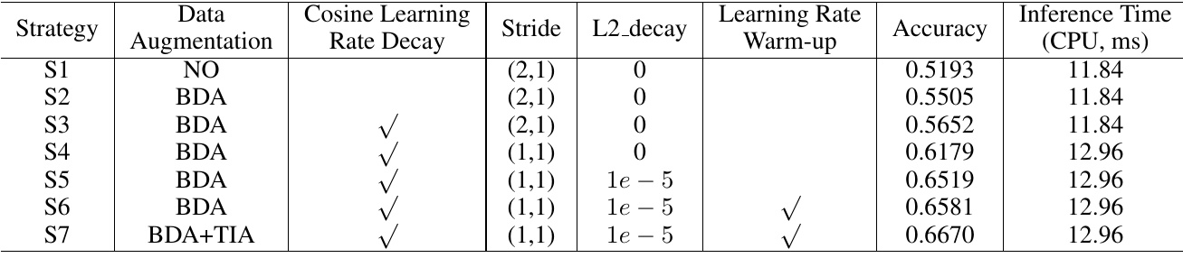

Table 12: Ablation study of data augmentation, cosine learning rate decay, the stride of the second down sampling feature map, regularization parameters L2_decay and learning rate warm-up for text recognition. Backbone is MobileNetV3_small_x0.5. The. number of channel in the head is 48..

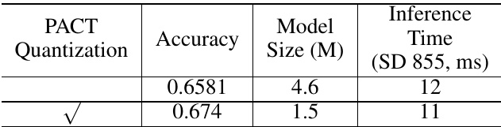

Table 13: Ablation study of PACT quantization for text recognition.

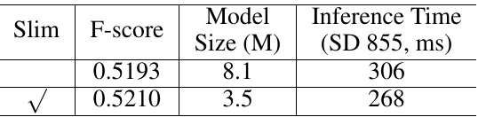

Table 14: Ablation study of the prunner or quantization for the OCR system.

model. We utilize 17.9M training images to learn a text rec- ognizer. Then, use this model as the pre-trained model to fine-tuning the samples for the ablation experiments. When using above pre-trained model, the accuracy will go from 65.81% to 69% and the effect is very obvious.

# 3.5System Performance

Table14shows the ablation study of the prunner or quantiza-. tion for the OCR system. When we use the slim approaches, the model size is reduced 55.7% and the inference time has. accelerated 12.42%. F-score has no impact. The inference time includes pre-process and post-process of each parts of the system. Therefore, FPGM pruner and PACT quantization also are effective strategies for reducing the model size.

also are effective strategies for reducing the model size. To compare the gap between the proposed ultra lightweight OCR system and large-scale OCR system, we also train a large-scale OCR system and use Res18_vd as the text detector backbone and Res34_vd as the text recognizer backbone. Table [15] shows the comparison. F-score of the large-scale OCR system is higher than the ultra lightweight. OCR system, but the model size and the inference time of the ultra lightweight system are better obviously..

the ultra lightweight system are better obviously.. Figure13and Figure[14 show some image results of the proposed PP-OCR system for Chinese and English recog-

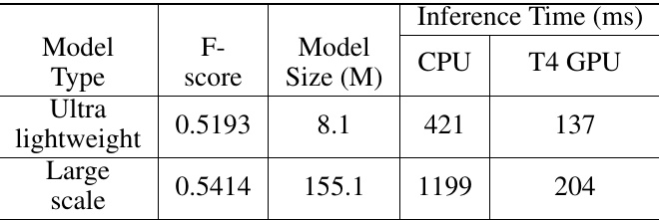

Table 15: Compare between the ultra lightweight OCR sys- tem and the large scale one..

nition. Figure[15 show some image results of the proposed PP-OCR system for multilingual recognition.

# 4Conclusions

In this paper, we propose a practical ultra lightweight OCR system, PP-OCR, which the overall model size is only 3.5M for recognizing 6622 Chinese characters and 2.8M for rec- ognizing 63 alphanumeric symbols. We introduce a bag of strategies to either enhance the model ability or light the model. The corresponding ablation experiments are also provided. Meanwhile, some practical ultra lightweight OCR models are released with a large-scale dataset..

# References

# Chen, P. 2020. GridMask data augmentation. arXiv preprint

Choi, J.; Wang, Z.;, Venkataramani, S.; Chuang, P. I.-J.; Srinivasan, V.; and Gopalakrishnan, K. 2018. Pact: Param- eterized clipping activation for quantized neural networks. arXiv preprint arXiv:1805.06085 .2.2

Cubuk, E. D.; Zoph, B.; Mane, D.;, Vasudevan, V.;, and Le, Q. V. 2019. Autoaugment: Learning augmentation strate- gies from data. In Proceedings of the IEEE conference on computer vision and pattern recognition, 113-123.2.2

Cubuk, E. D.;, Zoph, B.; Shlens, J.;, and Le, Q. V. 2020. Ran- daugment: Practical automated data augmentation with a re- duced search space. In Proceedings of the IEEE/CVF Con- ference on Computer Vision and Pattern Recognition Work- shops, 702-703.2.2

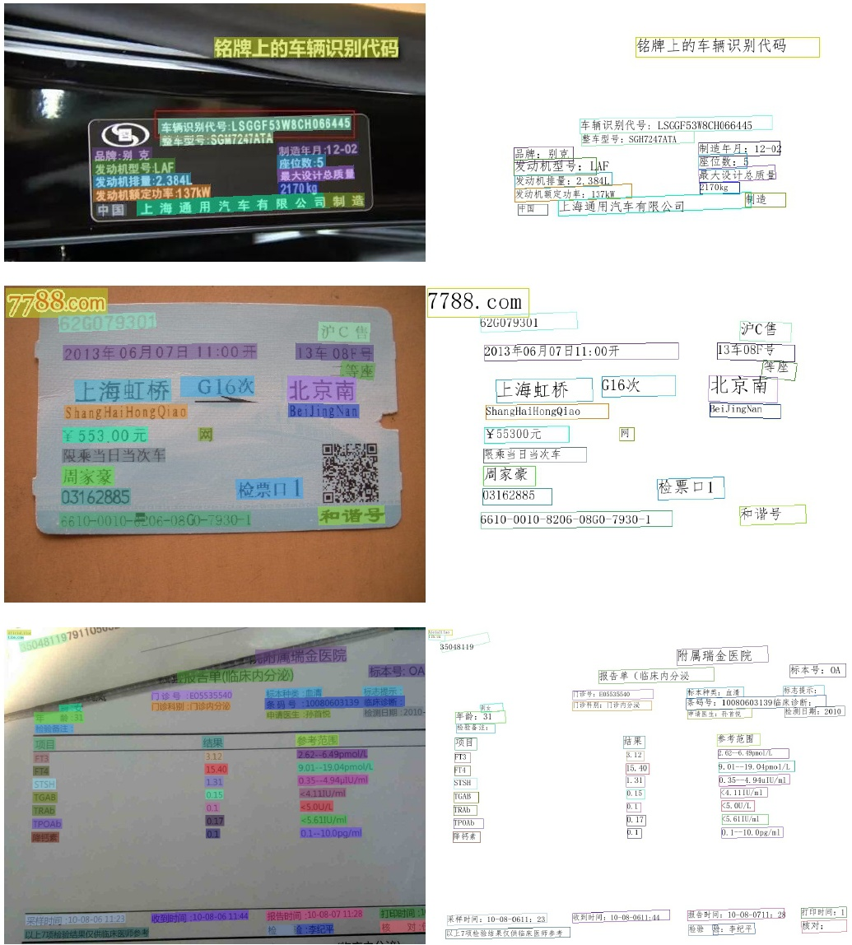

DeVries, T.; and Taylor, G. W. 2017. Improved regulariza- tion of convolutional neural networks with cutout. arXiv preprint arXiv:1708.04552 .2.2

Gupta, A.; Vedaldi, A.; and Zisserman, A. 2016. Synthetic data for text localisation in natural images. In Proceedings of the IEEE conference on computer vision and pattern recog nition, 2315-2324.3.1

He, M.; and Yang, Z. 2018. ICPR 2018 contest on robust reading for multi-type web images (MTWI). https://tianchi. aliyun.com/competition/entrance/231651/information3.1

He, T.; Zhang, Z.;, Zhang, H.;, Zhang, Z., Xie, J., and Li, M 2019a. Bag of tricks for image classification with convolu- tional neural networks. In Proceedings of the IEEE Confer- ence on Computer Vision and Pattern Recognition, 558-567. 2.1

oriented and multi-lingual scene text detection with direct regression. IEEE Transactions on Image Processing 27(11): 5406-5419. [3.1]

He, Y.; Liu, P.; Wang, Z.; Hu, Z., and Yang, Y. 2019b. Filter pruning via geometric median for deep convolutional neural. networks acceleration. In Proceedings of the IEEE Confer- ence on Computer Vision and Pattern Recognition, 4340 4349.92.1

Howard, A.; Sandler, M.; Chu, G.; Chen, L.-C.; Chen, B.;. Tan, M.; Wang, W.; Zhu, Y.; Pang, R.; Vasudevan, V.; et al. 2019. Searching for mobilenetv3. In Proceedings of the IEEE International Conference on Computer Vision, 1314 1324.12

Hu, J.; Shen, L.; and Sun, G. 2018. Squeeze-and-excitation networks. In Proceedings of the IEEE conference on com-. puter vision and pattern recognition, 7132-7141.2.1

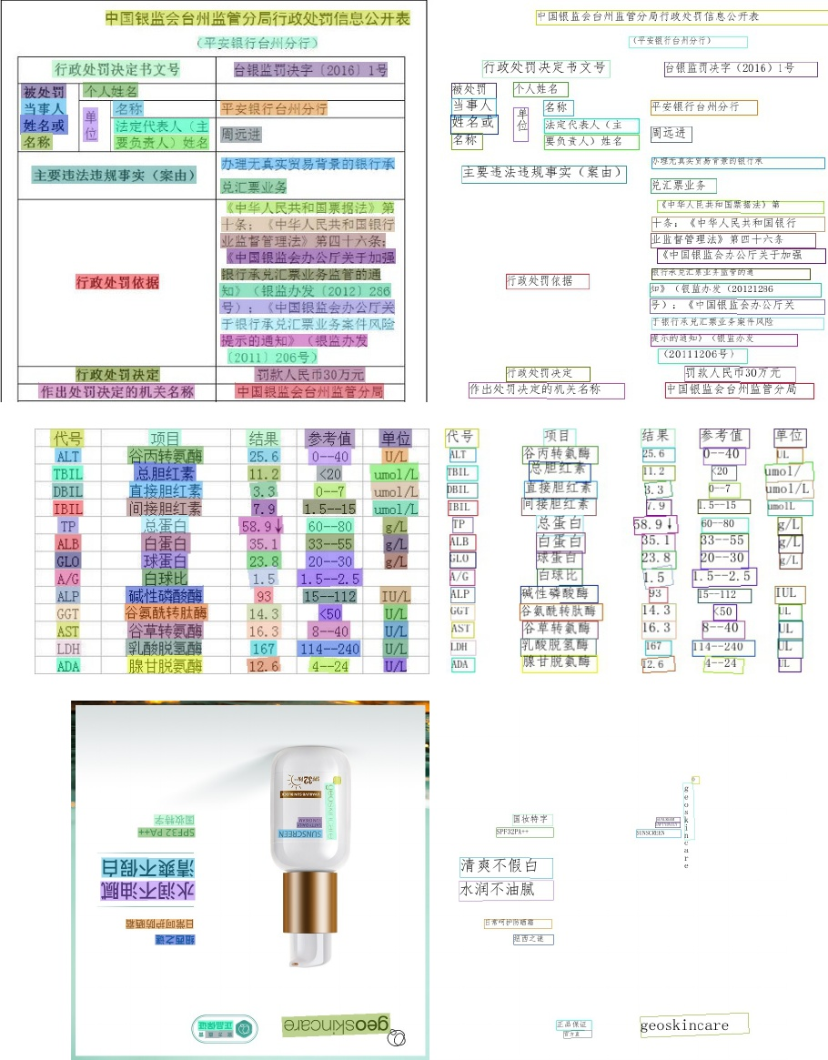

Figure 14: Some image results of the proposed PP-OCR system for Chinese and English recognition.

Huang, Z., Chen, K.; He, J.; Bai, X.;, Karatzas, D.; Lu, S., and Jawahar, C. 2019. Icdar2019 competition on scanned receipt ocr and information extraction. In 2019 Interna- tional Conference on Document Analysis and Recognition (ICDAR), 1516-1520. IEEE.3.1

Karatzas, D.; Mestre, S. R.; Mas, J.; Nourbakhsh, F.; and. Roy, P. P. 2011. ICDAR 2011 robust reading competition- challenge 1: reading text in born-digital images (web and email). In 2011 International Conference on Document Analysis and Recognition, 1485-1490. IEEE.3.1

Li, H.; Kadav, A.; Durdanovic, I.; Samet, H.;, and Graf, H. P. 2016. Pruning filters for efficient convnets. arXiv preprint arXiv:1608.08710 :2.1

Real-Time Scene Text Detection with Differentiable Bina- rization. In AAAI, 11474-11481.

Lin, T.-Y.; Dollar, P., Girshick, R.; He, K.; Hariharan, B., and Belongie, S. 2017. Feature pyramid networks for ob- ject detection. In Proceedings of the IEEE conference on computer vision and pattern recognition, 2117-2125.2.1

Luo, C.; Zhu, Y.; Jin, L.; and Wang, Y. 2020. Learn to Augment: Joint Data Augmentation and Network Optimiza- tion for Text Recognition. In Proceedings of the IEEE/CVF Conference on Computer Vision and Pattern Recognition, 1374613755.2.3][11

Nayef, N.;, Patel, Y.; Busta, M.; Chowdhury, P. N.; Karatzas, D.;, Khlif, W.;, Matas, J.;, Pal, U.;, Burie, J.-C.;, Liu, C.-1., et al. 2019. ICDAR2019 robust reading challenge on multi- lingual scene text detection and recognition-RRC-MLT-

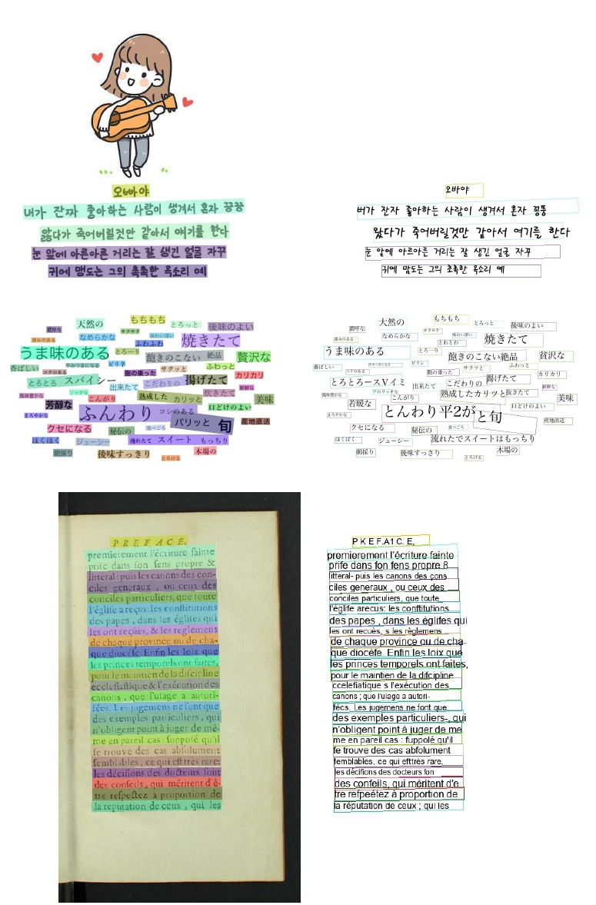

Figure 15: Some image results of the proposed PP-OCR system for multilingual recognition

2019. In 2019 International Conference on Document Anal- ysis and Recognition (ICDAR), 1582-1587. IEEE.3.1

Sanster. 2018. Generate text images for training deep learn- ing ocr model. https://github.com/Sanster/text renderer3.1 Shi, B.; Bai, X.; and Yao, C. 2016. An end-to-end trainable neural network for image-based sequence recognition and its application to scene text recognition. IEEE transactions on pattern analysis and machine intelligence 39(11): 2298- 2304.110 Shi, B.;, Yao, C.;, Liao, M.; Yang, M.;, Xu, P.;, Cui, L.;, Be- longie, S.; Lu, S.; and Bai, X. 2017. ICDAR2017 competi-

Shi, B.;, Yao, C.;, Liao, M.; Yang, M.;, Xu, P.;, Cui, L.;, Be- longie, S.; Lu, S.; and Bai, X. 2017. ICDAR2017 competi- tion on reading chinese text in the wild (RCTW-17). In 2017 14th IAPR International Conference on Document Analysis and Recognition (ICDAR), volume 1, 1429-1434. IEEE.3.1

network to be meticulous for weakly-supervised object and action localization. In 2017 IEEE international conference on computer vision (ICCV), 3544-3553. IEEE.2.2

Sun, Y.; Liu, J.; Liu, W.;, Han, J.;, Ding, E., and Liu, J. 2019. Chinese street view text: Large-scale chinese text reading with partially supervised learning. In Proceedings of the IEEE International Conference on Computer Vision, 9086-- 9095.3.1

Xu, Z.; Yang, W.; Meng, A.; Lu, N.; Huang, H.; Ying, C.; and Huang, L. 2018. Towards end-to-end license plate de- tection and recognition: A large dataset and baseline. In Proceedings of the European conference on computer vision (ECCV), 255-271. 3.1

Yao, C.; Bai, X.; Liu, W.; Ma, Y.; and Tu, Z. 2012. Detect- ing texts of arbitrary orientations in natural images. In 2012

# IEEE conference on computer vision and pattern recogni-

Yu, D.; Li, X.; Zhang, C.; Liu, T.; Han, J.; Liu, J.; and Ding, E. 2020. Towards accurate scene text recognition with semantic reasoning networks. In Proceedings of the IEEE/CVF Conference on Computer Vision and Pattern Recognition, 12113-12122.2.2]3.1

Yun, S.; Han, D.; Oh, S. J.;, Chun, S.; Choe, J.;, and Yoo, Y. 2019. Cutmix: Regularization strategy to train strong clas- sifiers with localizable features. In Proceedings of the IEEE International Conference on Computer Vision, 6023-6032. 2.2

Zhang, H.; Cisse, M.; Dauphin, Y. N.;, and Lopez-Paz, D 2017. mixup: Beyond empirical risk minimization. arXiv preprint arXiv:1710.09412 .2.2

Zhong, Z.; Zheng, L.; Kang, G.; Li, S.; and Yang, Y. 2020. Random Erasing Data Augmentation. In AAAI, 13001- 13008.2.2