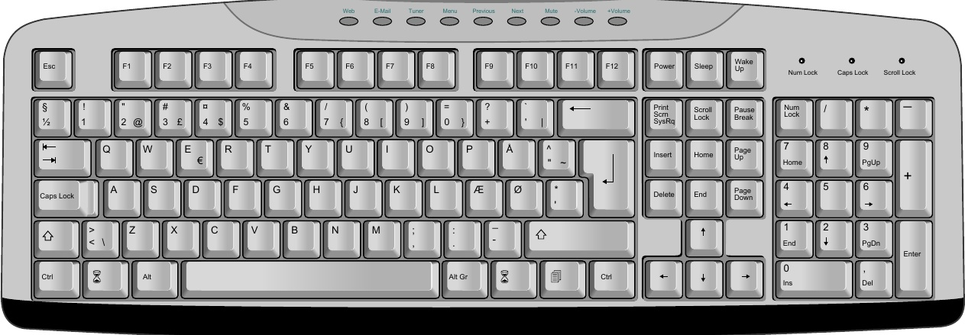

Figure 2: This figure floats to the top of the page, spanning both columns.

# 3.1 HTML5

This template uses HTML5 elements to aid in rep- resenting the document structure. The section element is used to split the text into sections, and the header element holds the headlines. The figure element is used to include figures and their corrensponding captions live inside the fig- caption element. The cite element holds all ref- erences.

A small microformat, based on a convention of class names, is used to encode the name and affili- ation of the authors.

# 3.2 CSS

A css style sheet describes how to format the HTML document into a PDF file. CsS is a declar- ative language which attaches property values to HTML elements and documents. Many aspects of cSS is used to achieve the presentation of USENIX papers, including:

multi-column layout . footnotes page and column floats : multi-level counters

Some commonly used features are absent from the above list: page numbers and running headers should not be specifed by USENIX authors, these are added by those who compile the Proceedings.

# 3.3 JavaScript

This template uses JavaScript to process refer- ences. References are added at the point where they appear, and a script is later used to move the

references to the end of the paper, leaving behind a numeric marker.

# 3.4 PDF

(This section has been added by Hakon Wium Lie)

In order to convert the document to PDF, a for- matter is needed. Common browsers support HTML and CSS, but they do not support all the CSS functionality for page-based formatting. For ex- ample, browsers do not support footnotes or page floats. This paper has been formatted with Prince,[a] a purpose-built program for converting HTML and XML documents into PDF by way of CSs. Prince is a commercial product, but can be downloaded and used for free for non-commercial purposes. In order for Prince to process the script includ-

In order for Prince to process the script includ- ed in this template, a command line option must be specified:

$ prince --javascript example.html

# 4 Tables

The table below lists recipients of the UsENIx Life. time Achievement Award in the 1900s. Notice how notes inside the table are moved to the end of the table.

|  |  |
| --- | --- |
| Year 1999 1998 | Recipient X Window System* Tim Berners-Lee |
| 1997 | Brian W. Kernighan |
|  |  |
|  |  |

[a] www.princexml.com