Final Project Proposal

Year: 2017 Semester: Fall Team: 3 Project: Virtual Sport

Creation Date: August 20, 2017 Last Modified: August 25, 2017

Team Members (#1 is Team Leader):

Member 1: Chia-Hua Peng Email: [peng81@purdue.edu](mailto:peng81@purdue.edu)

Member 2: Hengyi Lin Email: [lin483@purdue.edu](mailto:lin483@purdue.edu)

Member 3: Lingke Yu Email: [yu412@purdue.edu](mailto:yu412@purdue.edu)

Member 4: Yutao Hu Email: [CEO@purdue.edu](mailto:CEO@purdue.edu) (Login: hu298)

1.0 Project Description:

Virtual Sport is a VR appliance that enables users to play sports from the comfort of their own living room. The project features a Kendo sport VR app and a haptic embedded device. The goal is to help users interact with digital data and improve sports experience in virtual reality. The haptic embedded device will track the user’s hand orientation using an accelerometer and transmit the data to a VR application over a wireless connection. A VR headset will visualize the movement of a sword in a 3-dimensional virtual environment. The device also provides tactile feedback when the user spars with digital opponents. There is a unique sliding contact handle, which uses torque cues to simulate the shear and friction forces. The sliding contact handle mechanism is demonstrated in Figure 1 in Page 4.

2.0 Roles and Responsibilities:

1. Chia-Hua has leadership experience from various course projects and teaching assistant work at Purdue. He has experience designing and developing Mixed Reality applications for Microsoft HoloLens and learned the project management skills from an Agile Software Development team as a software intern at Noblis. He also has an outstanding academy performance in the firmware courses such as ECE362 and ECE 337 at Purdue. His strong background in both the software and hardware ends qualifies him the Software Engineer and Team Leader positions. He will primarily focus on designing the VR app and building a prototype for testing the wireless communication between the VR software and the microcontroller. He will also assist the team in microcontroller coding, firmware peripheral testing, as well as assembling the hardware and mechanical components.
2. Hengyi is actively involved in the Haptics Interface Research Lab at Purdue. He worked with haptic devices and tested users’ feelings and emotions while providing various vibration frequency inputs. Meanwhile he also received outstanding grades in ECE 362 and ECE 337 and was involved significantly in his ECE 362 mini project. With his background of the research lab, his extraordinary academic performance in ECE courses and his assistance in the previous projects, he will serve as a Haptic Designer for the Virtual Sport project and design various haptic mechanisms for the embedded hardware. He will primarily focus on writing the software program for the haptic feedback mechanism, designing the mechanical components, and building a prototype for testing the tactile and friction force simulation. He will also assist the team in testing the hardware peripherals, soldering the PCB, and packaging the final product.
3. Linke has experience in PCB design from ECE362 and he will serve as a hardware engineer for the Virtual Sport project. He will work on the overall schematic and choosing the resister, capacitor, and other electrical components required for the embedded device. He will also attend the PCB training sessions, design the PCB layout, and handle the PCB fabrication.
4. Yutao will take the role in System Engineer and is in charge of designing the functional blocks and component layout for the Virtual Sport project. He will also assist the team in designing the PCB, programming the microcontroller, building the mechanical component, and investigating various tools and resources that can be useful for the project.

2.1 Homework Assignment Responsibilities

Responsibilities for each team member and the homework assignment they should complete are detailed below in figure 1.

|  |  |  |  |
| --- | --- | --- | --- |
| *Design Component Homework* | | *Professional Component Homework* | |
| 3-Software Overview | CP | 9-Legal Analysis | YH |
| 5-Electrical Overview | HL | 10-Reliability and Safety Analysis | LY |
| 7-Mechanical Overview | HL | 11-Ethical/Environmental Analysis | YH |
| 8-Software Formalization | CP | 12-User Manual | LY |

CP: Chia-Hua Peng HL: Hengyi Lin LY: Linke Yu YH: Yutao Hu

**Figure 1. Homework Assignment Responsibilities**

3.0 Estimated Budget

|  |  |
| --- | --- |
| **Mechanical** | **Estimated Cost** |
| VR Headset | $20.00 |
| Customized Plastic Box, Contact Handle and 3D Printing | $70.00 |
| Screw/ T-Nut/ Stabilizing Components | $10.00 |
| **Electrical** |  |
| **Microcontrollers (x 3)** | $60.00 |
| Miscellaneous Circuit Components | $40.00 |
| PCB | $100.00 |
| Accelerometer | $10.00 |
| Bluetooth LE (x 2) | $20.00 |
| Vibration Motors (x 3) | $15.00 |
| Linear Actuators (x 3) | $20.00 |
| **Other** |  |
| Shipping | $80.00 |
| **Total Cost** | $445.00 |

**Figure 2. Estimated Budget**

The total estimated price for our project is $445.00. This will be paid for by the $300 provided by Purdue University. This will pay for the physical mechanical pieces needed for the design and the several electrical components needed for this complex design.

4.0 Project Specific Success Criteria

1. An ability to track the user’s hand orientation and log the data on a VR application
2. An ability to visualize the movement of digital objects on a VR headset using the hand orientation data
3. An ability to receive and respond to commands from a VR application
4. An ability to indicate the presence of digital object collision by providing vibration feedback
5. An ability to apply torque cues on a sliding contact handle upon shear and friction feedbacks

Note: The torque cues described in PSSC 5 is demonstrated by Tactical Haptics in the Figure below [1]. The torque cues created by the contact handle movement will mimic the shear and friction forces experienced by a user.

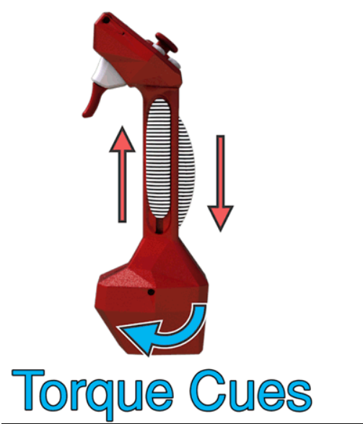

Figure Torque Cue and Friction Force Simulation

5.0 Sources Cited:

[1] Tactical Haptics, *Red controller* [Online image], 2014. Available from:   
<http://tacticalhaptics.com/files/IQT_Quarterly_Fall2014_Provancher.pdf> [Accessed 8/23/2017]