Functional Specification

Year: 2017 Semester: Fall Team: 3 Project: Virtual Sport

Creation Date: August 20, 2017 Last Modified: September 1, 2017

Team Members (#1 is Team Leader):

Member 1: Chia-Hua Peng Email: peng81@purdue.edu

Member 2: Hengyi Lin Email: lin483@purdue.edu

Member 3: Lingke Yu Email: yu412@purdue.edu

Member 4: Yutao Hu Email: hu298@purdue.edu

Assignment Evaluation:

|  |  |  |  |  |
| --- | --- | --- | --- | --- |
| **Item** | **Score (0-5)** | **Weight** | **Points** | **Notes** |
| **Assignment-Specific Items** | | | | |
| **Functional Description** | 5 | x3 | 15 |  |
| **Theory of Operation** | 5 | x3 | 15 |  |
| **Expected Usage Case** | 5 | x3 | 15 |  |
| **Design Constraints** | 5 | x3 | 15 |  |
| **Writing-Specific Items** | | | | |
| **Spelling and Grammar** | 4 | x2 | 8 |  |
| **Formatting and Citations** | 5 | x1 | 5 |  |
| **Figures and Graphs** | 5 | x2 | 10 |  |
| **Technical Writing Style** | 5 | x3 | 15 |  |
| **Total Score** | 98 | | |  |

5: Excellent 4: Good 3: Acceptable 2: Poor 1: Very Poor 0: Not attempted

General Comments:

Well done in general.

1.0 Functional Description

Virtual Sport is a haptic VR appliance that allows user to feel the touch feedback and to interact with digital data. The ultimate goal is to enhance the user’s VR experience in sports. Kendo, an Asian style fencing, is the primary sport scenario chosen for implementation. The controller will be able to track the user’s hand orientation, transmit the data to a VR app over a wireless connection, and have the headset display the visual feedback in a 3-dimensional virtual environment. The VR software will track the virtual collision events when user draws contacts with digital objects. The haptic VR hardware will provide vibration feedback to virtual contacts and the vibration intensity will be determined by a physical property that is tracked by the physics engine in the VR application. The device will also apply torque cues on the controller handle to simulate shear and friction forces.

2.0 Theory of Operation

The project features a haptic controller and a VR headset. The haptic controller detects the user’s hand orientation and provides touch feedback. It consists a microcontroller that governs the sensors and motors. The VR headset is a typical headset for mobile devices (i.e. Google Cardboard). User may run the VR app on a smart phone, put the mobile device in the headset, and view the virtual environment from a 3-dimensional perspective. The two devices are connected in a wireless connection over a Bluetooth module.

A microcontroller embedded in the haptic device will govern the firmware peripherals. A 3-axis accelerometer will track the user’s hand orientation, or the tilt angle data of the hand. The microcontroller will read the data from the accelerometer chip through an I2C protocol, and transmit the data to a Bluetooth module over a serial communication. The hand orientation tracking concept is described in Figure 1.

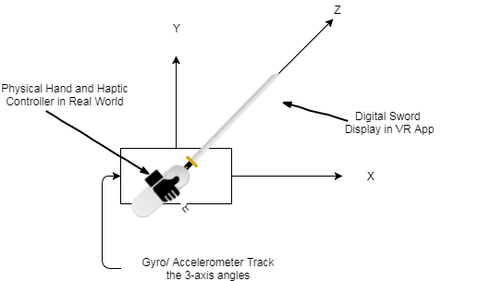

Figure 1 Use gyro/accelerometer to track the hand tilting   
angles and visualize the digital sword in a virtual environment

The VR app that is running on the mobile device will be designed in Unity3D, a game engine for VR and AR development. The Bluetooth controller group in the app will scan the Bluetooth device using the device name and service UUID. Once it found the Bluetooth module, the Bluetooth controller group will ping and parse the accelerometer data at a constant rate. The other groups in the VR software will compute some vector math, perform calibration, and visualize the digital sword movement using the accelerometer data.

A haptic manager group in the application will log the physical properties (i.e. relative velocity, force, impact, etc.) from a physics engine when digital objects collides in the virtual environment. The Bluetooth controller group will send a haptic feedback instruction to the microcontroller. There will be various haptic command for different types of collision. The microcontroller will receive and respond to commands sent from the VR application.

The microcontroller in the haptic device will use the PWM peripherals to create vibration feedback waves. There will be various type of waveform for different commands triggered by the VR application. The microcontroller will also govern the analog circuitry for providing the shear and friction feedback. The haptic feedback mechanism is described in Figure 2. By sliding the controller handle surface in opposite directions, a torque cue is applied to the user’s hand and this simulates the sense of shear and frictional forces. According to an article published by the Tactical Haptic, the motion of such sliding contactors is capable of demonstrating the sword and shield interaction feedback [1], which is the most critical haptic component for the kendo sport scenario. Linear actuators will be utilized for sliding the controller contact handle and the speed/ direction of the sliding motion will be controlled by the microcontroller over an analog circuitry.

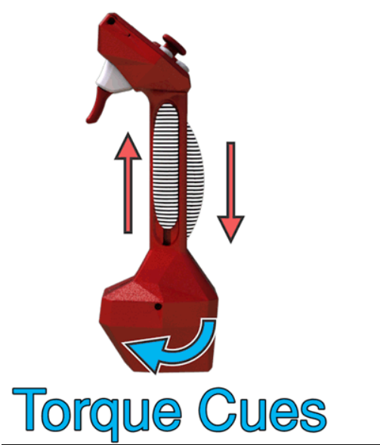

Figure 2 Use Torque Cues to Simulate Shear and Friction Forces [2]

3.0 Expected Usage Case

It is expected that the user will use the device in an indoor environment where he/she can freely move his/her hand around while standing or sitting at a constant place. The expected user will own an iPhone with Virtual Reality and Bluetooth capabilities enabled. User will run the VR application on a phone and insert the mobile device into a VR headset. The overall weight of the headset is estimated to be about 500 g. User must not wear glasses while using the headset. The haptic controller can be hold with either a right hand or a left hand. User must hold the controller in an orientation indicated on the device. After the user checks his/her hand can be moved freely without hitting a physical object, he or she may wear on the headset. As soon as the controller is powered on and the VR application finds the haptic controller device, the user may tilt the controller to interact with the digital objects in the virtual environment. The haptic controller will vibrate and the contact handle will slide up and down while the user is interacting with digital objects. The vibration intensity is varied between no vibration and a typical mobile device vibration intensity. The friction force created by the sliding contact handle is estimated to be in between 1.0 N to 2.5 N. The value will be adjusted during the prototype stage to ensure that the user can feel comfortable holding the device. The overall weight of the haptic controller is estimated to be the weight of an Xbox controller. A single simulation session will likely last up to about 10 minutes before the user feels tired viewing the virtual scenario, wearing the headset, or holding the controller. The user needs a basic understanding about how to open an iPhone app, how to wear on a headset, and how to hold a game controller to use the product.

4.0 Design Constraints

4.1 Computational Constraints

The project requires the VR application to visualize the movement of a kendo sword using the hand orientation data provided by the accelerometer. The data also needs to go through an Euler angle conversion and a rotation vector calculation before visualization. In order to reduce the latency between the action and feedback, the entire visualizing procedure needs to be completed in a short amount of time. A mapping algorithm will be used for converting the raw accelerometer data to the Euler angle format adopted by the VR Engine. The rotation algorithm and the calibration work will be performed in the mobile application, as the VR Engine is more capable of computing 3-dimensional vector math.

Similar to the computational constraints for the visual feedback algorithms, the motors also need to respond to the digital object collisions at low latency. After a collision event is triggered, the VR software will send a haptic command to the microcontroller, and the microcontroller will decode the command and initiate a haptic feedback. There is the need to use a table lookup method to decide which type of touch feedback needs to be execute for the given command.

4.2 Electronics Constraints

The electrical components include an accelerometer, a Bluetooth, 2-4 vibration motors, 2 linear actuators, and pushbuttons. The project requires 4-6 PWM pins, one UART, one I2C, and about five GPIO pins on the microcontroller. The orientation and position of the accelerometer is crucial for this project. It is anticipated that the accelerometer chip will be placed at the bottom of the controller and wired to the PCB over jumper cables so the orientation can be easily adjusted. The Bluetooth module will not be soldered directly on the PCB but through a socket so it can be easily replaced. The number of vibration motors required for the final product as well as the maximum vibration intensity will be determined in the prototype stage to ensure the users will feel comfortable using the device. It is estimated that about five GPIO pins will be required as pushbutton inputs and LED outputs (for debugging purpose).

4.3 Thermal/Power Constraints

The wireless haptic controller will no doubt need to be battery-powered. To satisfy general users, the battery life needs to be longer. The minimum battery life is set to be 10 hours. Power consumption and heat dissipations are also important factors in this project. Although the microcontroller, accelerometer, and motor devices should be able to operate at higher temperature, it is important to prevent the device from getting hot and unconformable for the player. The project, however, require a significant amount of power to effectively drive the current drawing haptic devices. The target maximum operating temperature for the device is set to be 40 degree Celsius and the target power consumption is set to be around 10 watts. The power consumption for a typical 6 mm vibration motor is 420 microwatt [3]. It is estimated that the project will use 2 to 4 of similar devices. The power consumed by the vibration motors should not be a great concern. The linear actuators, however, are likely going to drive a more significant amount of power. A sample datasheet for a micro linear actuator with about the size that is suitable for the project shows a power consumption of around 2.45 W [4]. It is anticipated that the project will use two linear actuators.

4.4 Mechanical Constraints

The project requires vibrating the controller and sliding the contact handle. The mechanical components need to be robust and solid. The shape and material of the handle also need to be carefully chosen to ensure the user will feel comfortable using the device. The weight of the controller also needs to be lower. The target weight of the device is the weight of a typical game controller, such as Xbox or Wii Remote. It is anticipated that a 3D printer will be used for creating a light and robust sliding contact handle.

4.5 Economic Constraints

The reactive grip haptic controller made by the Tactical Haptics is sold at a price of $180 [5]. It has a similar handle slider feature for simulating the shear and friction forces. The Virtual Sport project, however, is not a product that is manufactured in bulk production, and the cost is expected to be higher due to the money spend on 3D printing, PCB, software development tools, and equipment shipping. The estimated price will be in the $300 to $450 range.

4.6 Other Constraints

The Bluetooth choice is limited by the peripherals of the hardware that is running the VR application. A lot of mobile or VR devices, such as iPhone, does not support Bluetooth 2.0 anymore. A Bluetooth Low Energy module will be used instead. The connection strength, the length of data per transmission, the transmission baud rate, as well as the frequency a command can be send from the VR app are also limited by the Bluetooth module and the Bluetooth plugin used in the VR application.

5.0 Sources Cited:

[1] Provancher, William (2014). *Creating Greater VR Immersion By Emulating Force Feedback*   
*With Ungrounded Tactile Feedback.* Available: <http://tacticalhaptics.com/wp-content/uploads/2013/10/IQT_Quarterly_Fall_2014_Provancher-Final.pdf>

[2] Tactical Haptics, *Red controller* [Online image], 2014. Available from:   
<http://tacticalhaptics.com/files/IQT_Quarterly_Fall2014_Provancher.pdf> [Accessed 8/23/2017]

[3] PrecisionMicrodrives (2017). *Vibration Motor*. [Online] Available: <https://www.precisionmicrodrives.com/sites/default/files/datasheet-for-the-306-101-vibration-motor.original.pdf>

[4] Haydon (2017). *Size 8 Stepper Motor Linear Actuator*. [Online] Available: <http://www.haydonkerk.com/LinearActuatorProducts/StepperMotorLinearActuators/LinearActuatorsHybrid/Size8LinearActuator/tabid/74/Default.aspx>

[5] Lang, Ben (2013). *Reactive Grip Haptic VR Controller Kickstarter Is Live*. Available:

<https://www.roadtovr.com/reactive-grip-kickstarter-tactical-haptics-haptic-feedback-vr-controller/>

**Appendix 1: Functional Block Diagram**

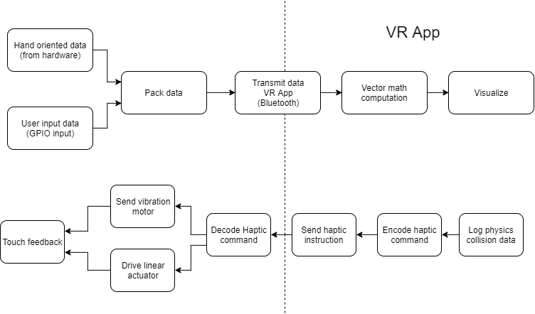

Functional Block Diagram