Mechanical Overview

Year: 2017 Semester: Fall Team: 3 Project: Virtual Sports

Creation Date: September 16, 2017 Last Modified: December 7, 2017

Author: Lingke Yu Email: yu412@purdue.edu

Assignment Evaluation:

|  |  |  |  |  |
| --- | --- | --- | --- | --- |
| **Item** | **Score (0-5)** | **Weight** | **Points** | **Notes** |
| **Assignment-Specific Items** | | | | |
| **Commercial Packaging Analysis 1** | 5 | x2 | 10 |  |
| **Commercial Packaging Analysis 2** | 5 | x2 | 10 |  |
| **CAD Model Illustrations** | 5 | x4 | 20 |  |
| **Project Packaging Specifications** | 5 | x2 | 10 |  |
| **PCB Footprint Layout** | 5 | x2 | 10 |  |
| **Writing-Specific Items** | | | | |
| **Spelling and Grammar** | 4 | x2 | 8 |  |
| **Formatting and Citations** | 5 | x1 | 5 |  |
| **Figures and Graphs** | 5 | x2 | 10 |  |
| **Technical Writing Style** | 5 | x3 | 15 |  |
| **Total Score** | 98 | | |  |

5: Excellent 4: Good 3: Acceptable 2: Poor 1: Very Poor 0: Not attempted

Comments:

*Well written in general. Good work on the PCBs.*

1. Commercial Product Packaging
   1. Product #1

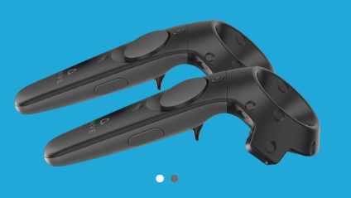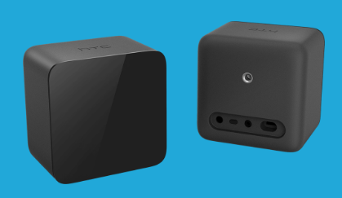

The first commercial product that is similar to our product is HTC VIVE controller. This controller sale with a headset and two base stations. The controller itself contains multiple sensors that can detect the pointing direction and vertical angle of the controller. In addition, there are some vibration motors in the controller, which can provide feedbacks to players. While playing the game, the user would put on the VR headset and the headset would provide the user with HD VR feedback. The two base stations are auxiliary equipment to the controller. The base stations can track the player’s position by tracking the position of the controller. When the relative position of the controller changed, the position of the character would also change in the VR game. However, because of the range of detection for the base station is limited, the player can only move in the restricted area near the base station. If the player transcends the restricted area, the base station would lose track of the controller and the game would be forced to stop. Unlike the VIVE controller, our product uses the camera on the headset to track the position of the controller. In this way, as long as the controller is in front of the player, the headset would never lose track of the player and the player would have unlimited moving space (the player should check the surrounding before starting the game).

Apart from the restricted moving space, the VIVE controller has only one kind of haptic feedback – vibration feedback. Vibration is a good haptic feedback for collision, but sometimes it is not enough. To improve the haptic feedback, our product adds torque cues to simulate the shear and friction forces. While the player swings the sword, the torque cues would move to the opposite direction to which the player’s hand move. This would let the player feels the weight of the sword and movement of the sword. With the torque cues, our product would have better haptic feedback than VIVE controller would.

* 1. 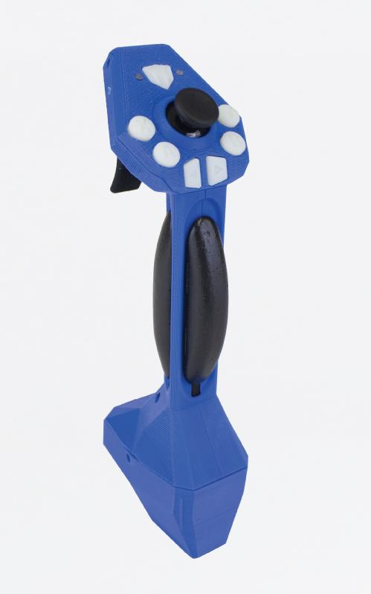Product #2

The second commercial product that is similar to our product is Reactive Grip Motion Controller. This product has a tactile feedback device with sliding contactor plates placed around the handle. Those contactor plates are similar to the torque cues on our product, which can provide haptic feedback to player. However, unlike our product, this product has four torque cues on each side of the handle. Although more torque cues can enhance the haptic feedback, the width of the handle and weight of the controller would largely increase. The wide handle would make player feel uncomfortable and the heavy weighted controller may largely reduce the playtime. In order to prevent these problems, we reduced the number of the torque cue to one, but increased the move range of the torque for our product.

In addition, the Reactive Grip Motion Controller does not have any position detection sensor and is usually used as an add-on handle to other controllers like VIVE controller. Besides, the Reactive Grip Motion Controller is a wired controller and requires a high performance PC to drive. Those property makes this controller hard to setup and difficult to popularize. Unlike this controller, our product can use a normal smart phone like iPhone 5 to drive. Compared to the Reactive Grip Motion Controller, our product is much easier to setup. Since our controller is small and portable. Our customer can play it everywhere with their smart phone and this would make our product easier to popularize. Besides, our controller is using Bluetooth connection instead of wired connection, which can enhance user experience.

3.0 Sources Cited

1. Tacticalhaptics.com. (2017). *Tactical Haptics*. [online] Available at: [http://tacticalhaptics.com/products/](http://tacticalhaptics.com/products/%20) [Accessed 22 Sep. 2017].
2. Vive.com. (2017). Controller. [online] Available at: [https://www.vive.com/us/accessory/controller/](https://www.vive.com/us/accessory/controller/%20) [Accessed 22 Sep. 2017].

Appendix 1: CAD Model Illustrations

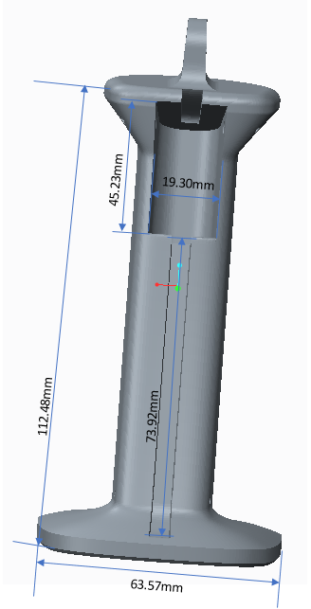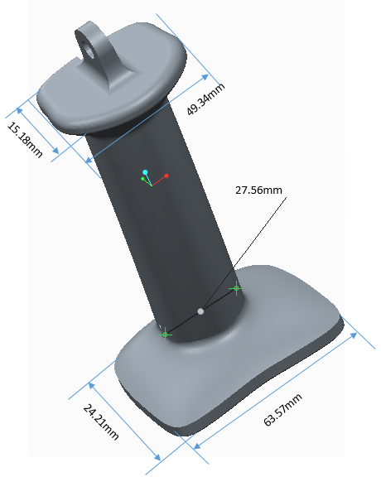

Major Dimension:

Height = 130 mm, Length = 25 mm, Width = 64 mm

Height = 5.11 inch, Length = 0.98 inch, Width = 2.51 inch

The main PCB will be located at the top of the controller.

A small box of size of 10 cm * 10 cm * 5 cm would contain the main PCB.

The PCB for Accelerometer will be located at the bottom of the controller.Appendix 2: Project Packaging Specifications

|  |  |  |  |
| --- | --- | --- | --- |
| Material | Tools Required | Weight/Quantity | Cost |
| (ABS)  3D printing material | 3D printer | 400g | $80 |
| Sewing thread | Sewing needle | 10g/1 pack | $5 |
| 3MM springs | N/A | 5g/5 Pcs | $3 |
| Battery box | Glue | 80g/5 Pcs | $15 |
| Screws | Screw drivers | 20g/20 Pcs | $2 |
| Total (5 products) | | 515g | $105 |
| Estimated per product | | 103g | $21 |

Appendix 3: PCB Footprint Layout

Overall PCB foot print

6-pins PWM to program

STM32F4

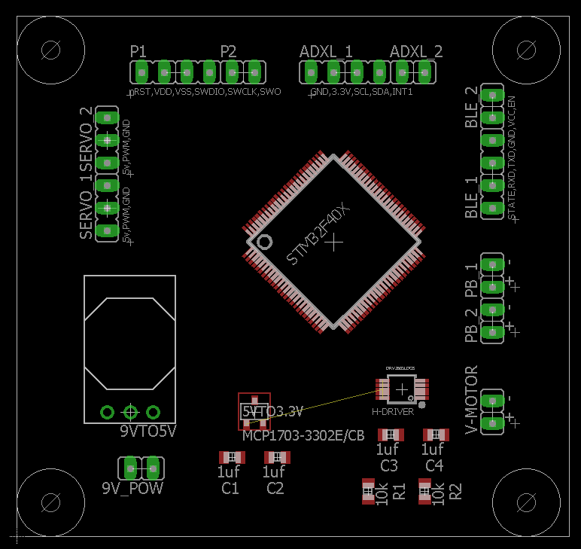

Servo * 2

3-pin3 each

9V to 5V

Converter

OKI-78SR

9V Power

Input

5V to 3.3V

Converter

MCP1703

2-pins to

Vibration motor

Push bottom * 2

Bluetooth

6-pins

To Accelerometer PCB

ADXL345 6-pins

Haptic Driver

DRV2605LDGS

Dimension: 2.44 * 2.30 inch (6.1976 * 5.842 cm)

Area: 5.612 square inch (36.20 cm2)

PCB for ADXL 345 Accelerometer 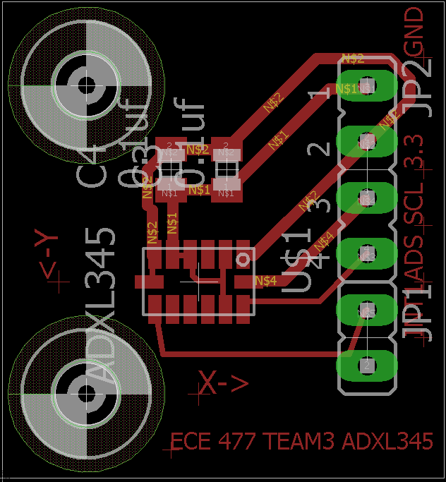

Dimension: 0.79 * 0.85 inch (2.00 * 2.15 cm)

Area: 0.6715 square inch (4.30 cm2)