Legal Analysis

Year: 2017 Semester: Fall Team: 3 Project: Virtual Sport

Creation Date: October 16, 2017 Last Modified: December 7, 2017

Author: Chia-Hua Peng Email: peng81@purdue.edu

Assignment Evaluation:

|  |  |  |  |  |
| --- | --- | --- | --- | --- |
| **Item** | **Score (0-5)** | **Weight** | **Points** | **Notes** |
| **Assignment-Specific Items** | | | | |
| **Regulatory Analysis** | 5 | x3 | 15 |  |
| **Analysis of Patent 1** | 5 | x3 | 15 |  |
| **Analysis of Patent 2** | 5 | x3 | 15 |  |
| **Analysis of Patent 3** | 5 | x3 | 15 |  |
| **Writing-Specific Items** | | | | |
| **Spelling and Grammar** | 5 | x2 | 10 |  |
| **Formatting and Citations** | 5 | x1 | 5 |  |
| **Figures and Graphs** | 5 | x2 | 10 |  |
| **Technical Writing Style** | 5 | x3 | 15 |  |
| **Total Score** | 100 | | |  |

5: Excellent 4: Good 3: Acceptable 2: Poor 1: Very Poor 0: Not attempted

Comments:

*This document is very comprehensive and well written. Good job guys!*

1.0 Regulatory Analysis

In order to market the product to the United States and the European area, it is important to ensure that the device receives an FCC certification and complies with the RoHS regulations.

The Virtual Sport project uses the HM-10 Bluetooth LE module to communicate the embedded device with a VR application. Therefore, it is categorized as an intentional radiator by the FCC Part 15 rules [1]. This means that the device is intentionally using the radio spectrum and has to be regulated by the FCC to prevent radio frequency pollution. According to the HM-10 User Guide [2] in the FCC ID database, the module has been tested and found to comply with the FCC Part 15 regulations. Thus, the embedded device can be certified without including the HM-10 module as long as its FCC ID is labeled in a visible area on the final end product.

The Virtual Sport project still needs to be tested for additional compliance requirements in order to receive the FCC certification. The device uses a microprocessor that operates at 168 MHz and an I2C clock running at 100 MHz. Because the device is operating at a rate over 9000 pulses per second, the product is categorized as an unintentional radiator when the Bluetooth module is not considered. In order to sell the product in the United States, our team needs to send the equipment to an FCC certified testing lab. If the lab verifies that the design complies with the FCC regulation, then it can be moved forward for certification. After an FCC certification is obtained, the manufacturer must label the FCC ID on the product as well as on the user manual before it can be shipped to the market.

To comply with the RoHS standards, the lead level of the final product must be less than 1000 ppm [3]. This means our design should avoid the use of lead-base solder. It is also required to verify that the mechanical and electrical components used in the Virtual Sport project do not contain the restricted materials listed in the RoHS guide [3]. The prototype product did not use any of the restricted materials. The final product should comply with the RoHS regulation.

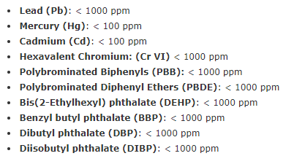

Figure 1 List of Restricted Substances by RoHS [3]

2.1 Analysis of Hand-Held Controllers for Virtual Reality System

* US Patent Publication Number: US 20160357249 A1
* Patent Holder: OCULUS VR
* Filing Date: April 14, 2016
* Abstract:

This patent [4] covers a handheld controller for a virtual reality system. The controller contains a user-input surface, which allows the player to interact with digital objects from a joystick and pushbuttons. It also includes a plurality of LEDs on the cage-like outer surface. A VR application may use an external device to detect the user’s hand motion by tracking the illuminating sources on the controller. An example of such external device is a camera mounted on the VR headset.

* Key Patent Claims:
* A virtual reality handheld controller comprising a user-input surface, a grip coupled to the user-input surface, and a cage that contains a plurality of LEDs
* A user-input surface comprising a first user-input key and a plurality of user-input keys which include a thumb stick, a button, a trigger, and a directional pad
* At least a portion of the LED sources on the handheld controller are positioned to be visible to a forward-looking camera on a head-mounted display worn by a user
* Analysis of Patent Liability:

The Virtual Sport project also contains a handheld controller for a virtual reality system. This controller also includes a handle and a user-input surface as specified in the patent. The major difference is that the controller does not have a surface with a plurality of LEDs. Another difference is that the user-input surface described in the patent is comprised of multiple input keys such as thumb sticks and buttons, whereas the Virtual Sport project only uses a group of membrane switches to manipulate player settings in the virtual reality system. Because the mechanical component of the Virtual Sport project is different, there should not be a potential of infringement against this patent.

Another key patent claim the Oculus VR handheld controller had is that the product contains LEDs on its outer surface. This enables an external device to track the illuminating sources and to detect the user’s hand motion. The Virtual Sport product uses a very different implementation to achieve a similar purpose. It detects the hand tilting angle data from an accelerometer module embedded inside the handheld controller. The performance may not be as good as what the Oculus VR handheld controller can achieve, but the user does not need to install an external device in order to use the product. Since the hand-motion tracker information is completely different, there should be nothing against the claim listed in this patent.

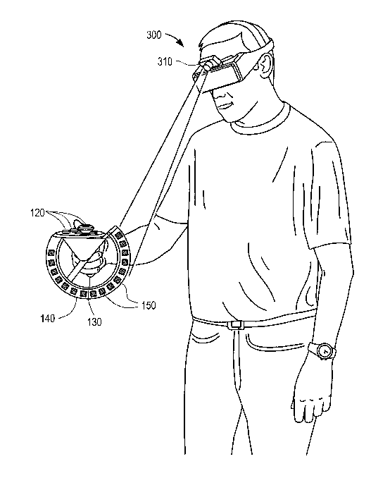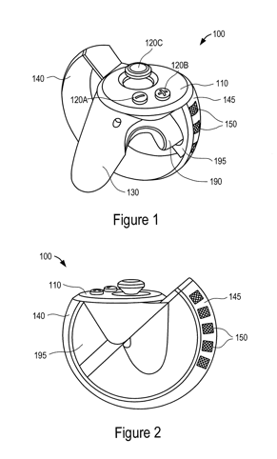

Figure 2 Illustration of Hand-Held Controllers for Virtual Reality System [4]

2.2 Analysis of Electronic Device and Method of Controlling the Same

* US Patent Publication Number: US 20170185160 A1
* Patent Holder: SAMESUNG ELECTRONICS
* Filing Date: December 23, 2016
* Abstract:

This patent [5] introduces a method about how to detect the user’s hand coordinate from the magnetic field. It uses a portable electronic device to generate magnetic field and a motion detector to obtain the coordinate of the electronic device using the generated magnetic field. Based on the change of the location of a source, a virtual reality providing device will configure the coordinate of the user’s hand.

* Key Patent Claims:
* A source configured to generate magnetic field
* A motion detector configured to detect the user’s hand coordinate based on the generated magnetic field
* A VR providing device that reflects the coordination change based on input received from the motion detector
* A motion detector containing a communication interface that transmits motion data to VR application
* Analysis of Patent Liability:

The Virtual Sport project uses a similar approach as described in the patent owned by Samsung Electronics. Both ideas use a module in an electronic device to detect the hand motion and a communication interface to transmit the information to a virtual reality system. The patent detects the hand coordination change by using a combination of a magnetic field generator and a magnetic field sensor. The Virtual Sport project measures the changes in hand tilting angles using an accelerometer. Because the Virtual Sport project uses a very different implementation to achieve the similar purpose, it should not have any potential of infringement against this patent.

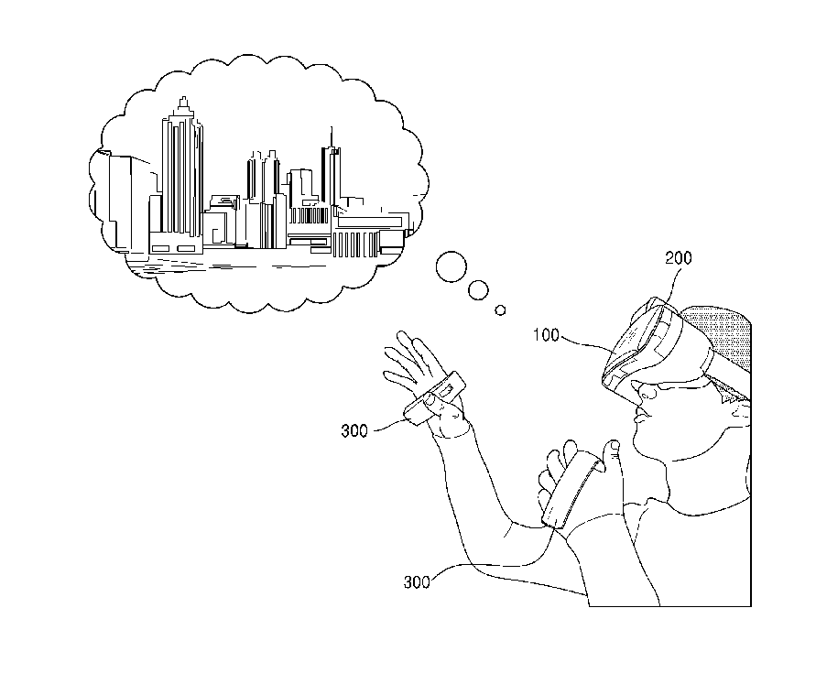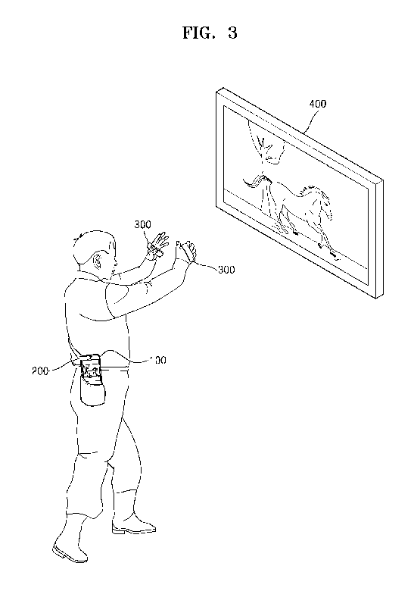

Figure 3 Illustration of Electronic Device and Method of Controlling the Same [5]

2.3 Analysis of Reactive Grip Motion Controller

* Prior Art Holder: TACTICAL HAPTICS, INC
* Release Date: Fall 2014
* Abstract:

This prior art [6] is a haptic device that interfaces with commercial VR controllers. It is compatible with major VR platforms such as Oculus Rift and HTC Vive. The device places multiple sliding contactor plates around its handle. It portrays a torque cue by moving the sliding plates in opposite directions. This simulates the shear and friction forces.

* Similar Features:
* A method to simulate shear and friction forces by sliding contactor plates
* A method to simulate a variety of virtual forces by adjusting the speed and magnitude of the contactor
* A system development kit that utilizes a physics engine to calculate virtual forces and sends information to the haptic device
* Analysis of Prior Art Liability:

This product interfaces with commercial VR platforms such as Oculus and Vive. The Virtual Sport project, on the other hand, is targeting for a less expensive and student-affordable VR platform – the Google Cardboard.

The Virtual Sport project contains a sliding handle that is similar to the contactor feature in the Reactive Grip Motion Controller. Both devices recreate the sensation of actually holding an object to enhance user experience in virtual reality. The Reactive Grip Motion Controller uses multiple sliding plates to generate a variety of haptic forces. The Virtual Sport project uses a large sliding handle to create a similar effect. A similar contactor is pulled up and down by a linear servo. The sliding speed and magnitude can also be adjusted by updating the PWM duty cycle.

Similar to the Reactive Grip Motion Controller, the Virtual Sport project also uses a physics engine to track the virtual collision events. The Reactive Grip Motion Controller has its own system development kit to receive and respond to forces in a virtual environment. The Virtual Sport project also contains a customized Unity package. This package enables developers to detect collision events from the Unity physics engine and to send haptic instructions to the haptic device over a Bluetooth protocol.

There is no pending or issued patent found on the Reactive Grip Motion Controller product. Thus, there should not be any legal issue if the Virtual Sport project uses a similar feature.

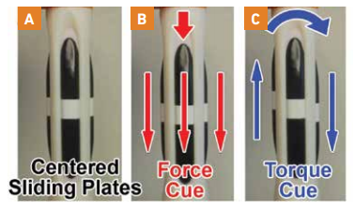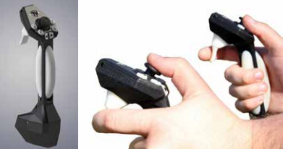

Figure 4 Illustration of Reactive Grip Motion Controller [6]

1. Sources Cited:
2. Bureau Veritas Consumer Products Services. (2010). *Federal Communications Commission Frequently Asked Questions*. [Online]. Available: <http://www.bureauveritas.com/wps/wcm/connect/31b53f004edb713e8d5fcd600bbc220bFCC_Frequently_Asked_Questions_Aug10.pdf?MOD=AJPERES>
3. Jinan Huamao Technology Co., Ltd. *User guide*. [Online]. Available: <https://fccid.io/2AB6YHM-1011V1/User-Manual/User-manual-2657650.pdf>
4. RoHSGuide. (October 22, 2017). *Is your facility RoHS compliant for 2017*. [Online]. Available: <http://www.rohsguide.com/>
5. James S. Webb, Benjamin E. Rogoza, Peter W. Bristol, Jason A. Higgins, Sharvil S. Talati, Yi-Yaun Chen, Neil W. Konzen, “Hand-held controllers for virtual reality system,” U.S. Patent 20160357249 A1, June 3, 2015
6. Yong-jin Cho, Sung-Yeon Lee, Ki-Hwan Kim, Jong-yoon Kim, Moon-ki Yeo, Dae-kyu Lee, “Electronic device and method of controlling the same,” U.S. Patent 20170185160 A1, December 23, 2016
7. Tactical Haptics, Inc. (2014). *Creating Greater VR Immersion by Emulating Force Feedback with Ungrounded Tactile Feedback* [Online]. Available: <http://tacticalhaptics.com/files/IQT_Quarterly_Fall2014_Provancher.pdf>