Reliability and Safety Analysis

Year: 2017 Semester: FALL Team: 3 Project: Virtual Sport

Creation Date: November 3, 2017 Last Modified: December 7, 2017

Author: Lingke Yu Email: yu412@purdue.edu

Assignment Evaluation:

|  |  |  |  |  |
| --- | --- | --- | --- | --- |
| **Item** | **Score (0-5)** | **Weight** | **Points** | **Notes** |
| **Assignment-Specific Items** | | | | |
| **Reliability Analysis** | 5 | x2 | 10 |  |
| **MTTF Tables** | 5 | x3 | 15 |  |
| **FMECA Analysis** | 5 | x2 | 10 |  |
| **Schematic of Functional Blocks (Appendix A)** | 5 | x2 | 10 |  |
| **FMECA Worksheet (Appendix B)** | 5 | x3 | 15 |  |
| **Writing-Specific Items** | | | | |
| **Spelling and Grammar** | 4 | x2 | 8 |  |
| **Formatting and Citations** | 5 | x1 | 5 |  |
| **Figures and Graphs** | 5 | x2 | 10 |  |
| **Technical Writing Style** | 5 | x3 | 15 |  |
| **Total Score** | 98 | | |  |

5: Excellent 4: Good 3: Acceptable 2: Poor 1: Very Poor 0: Not attempted

Comments:

*Good job overall, despite some minor grammatical issues.*

1. Reliability Analysis

STM32F407VG

The STM32F407VG [2] is used to control the entire system. It was chosen for the reliability analysis because it is complex and critical for our system. The failure per 10^6 hours (λp) and mean time to failure (MTTF) was calculated based on the formulas outlined in MIL-HDBK-217F [1]. I choose the model of digital CMOS IC microprocessor for this microcontroller. λp= (C1 * πt + C2 * πe) * πl * πq. The MTTF and λp is in the expected range. The failure of this microcontroller would not directly cause harm to the users.

Table 1, microcontroller analysis

|  |  |  |  |
| --- | --- | --- | --- |
| Parameter name | Description | Value | Comments |
| C1 | Die complexity | 0.56 | Complexity model for a 32 bit microcontroller |
| πt | Temperature coeff | 0.13 | 30°C operating temperature |
| C2 | Pin/Package Constant | 0.04 | 100 no-hermetic pins |
| πe | Environmental Constant | 0.5 | GB |
| πl | Learning Factor | 1 | The IC is more than two years in production |
| πq | Quality Factor | 10 | Commercial components |
| Entire design | | | |
| λp | | 0.928 | |
| MTTF | | 1.077 million hours =  1077586 hours = 123 years | |

MCP1703

The MCP1703 [3] voltage regulator is used to provide power to the 3.3V(Vin) for the main part of the circuit. If this voltage regulator fails to operate normally, the microprocessor, Bluetooth module, accelerometer and haptic driver would get unstable or incorrect voltage input and they would malfunction.

The failure per 10^6 hours (λp) and mean time to failure (MTTF) was calculated based on the formulas outlined in MIL-HDBK-217F [2]. I choose the model of digital CMOS Switch-Mode Regulator for this voltage regulator. λp= (C1 * πt + C2 * πe) * πl * πq. The MTTF and λp is in the expected range. The failure of this voltage regulator would not directly cause harm to the users.

Table 2, voltage regulator analysis

|  |  |  |  |
| --- | --- | --- | --- |
| Parameter name | Description | Value | Comments |
| C1 | Die complexity | 0.01 | 1 to 100 bipolar transistors is used |
| πt | Temperature coeff | 0.13 | 30°C operating temperature |
| C2 | Pin/Package Constant | 0.0012 | 3 pin SMT |
| πe | Environmental Constant | 0.5 | GB |
| πl | Learning Factor | 1 | The IC is more than two years in production |
| πq | Quality Factor | 10 | Commercial components |
| Entire design | | | |
| λp | | 0.019 | |
| MTTF | | 52.632 million hours =  52632000 hours = 6008 years | |

ADXL345

The ADXL [4] accelerometer is used to measure the angle and movement of the entire product. It provides the current accelerate data for the microprocessor so that the microprocessor can calculate the angle change for the entire product. If the accelerometer fails, the product cannot sensor the movement or rotation of the handle and in this case, most of the feedback would no-longer working correctly.

The failure per 10^6 hours (λp) and mean time to failure (MTTF) was calculated based on the formulas outlined in MIL-HDBK-217F [2]. I choose the model of digital CMOS IC microprocessor for this accelerometer. λp= (C1 * πt + C2 * πe) * πl * πq. The MTTF and λp is in the expected range. The failure of this accelerometer would not directly cause harm to the users.

Table 3, voltage regulator accelerometer

|  |  |  |  |
| --- | --- | --- | --- |
| Parameter name | Description | Value | Comments |
| C1 | Die complexity | 0.56 | Complexity model for a 30 bits microcontroller (10 bits for each axis) |
| πt | Temperature coeff | 0.13 | 30°C operating temperature |
| C2 | Pin/Package Constant | 0.0062 | 14 non-hermetic pins |
| πe | Environmental Constant | 0.5 | GB |
| πl | Learning Factor | 1 | The IC is more than two years in production |
| πq | Quality Factor | 10 | Commercial components |
| Entire design | | | |
| λp | | 0.759 | |
| MTTF | | 1.3175 million hours =  1317523 hours = 150 years | |

SUMMARY

The MTTF of all three components is more than half million hours which are long enough for our product. The possible methods to improve the reliability of our design is to use simpler microcontroller. Since the current draw for our circuit is very small and powered by 9V battery, the operation temperature would not be too high, so there is no need for external cooling system to reduce the temperature coefficient. The only suggestion is adding more impact buffer between our circuit and the package, because the user would need to wave the product and may cause fallen of the product. More impact buffer would prevent the circuit damage for collision.

1. Failure Mode, Effects, and Criticality Analysis (FMECA)

There were two criticality levels for this project, low and high. High refers to failures which cause injury to users, such as hurt user’s hands. Low refers to negligible failure which only cause the system to shut down and does not do any damage to users. An acceptable rate of occurrence for failures of low levels is λP = 10-6. And acceptable rate of occurrence for high level is λP = 10-9.

In general, our circuit works under low current and has low probability to overheat, therefore our product has very low probability hurting users.

3.0 Sources Cited:

1. “Military Handbook Reliability Prediction of Electronic Equipment”, Department of Defense. Washington DC. MIL-HDBK-217F, Dec. 2, 1991.
2. STMicroelectronics (2017). *STM32F407VG* [Online]. Available:

<http://www.st.com/en/microcontrollers/stm32f407vg.html>

1. MICROCHIP (2017). MCP1703[Online]. Available:

<http://ww1.microchip.com/downloads/en/DeviceDoc/22049e.pdf>

1. Analog Devices. *3-Axis Digital Accelerometer ADXL345 datasheet* [Online]. Available:

<http://www.analog.com/media/en/technical-documentation/data-sheets/ADXL345.pdf>

1. Tower-Pro (2017). SG90 9g Micro Servo. Available:

<http://akizukidenshi.com/download/ds/towerpro/SG90.pdf>

1. Jinlong Machinery and Electronics. Cylindrical Core SMT Motor Product Specification

[Online]. Available:

[http://www.vibration](http://www.vibrationmotor.com/products/download/Z30C1T8219731.pdf)

[motor.com/products/download/Z30C1T8219731.pdf](http://www.vibrationmotor.com/products/download/Z30C1T8219731.pdf)

1. JNHuaMao Technology. *Bluetooth 4.0 BLE module datasheet* [Online]. Available:

<http://fab.cba.mit.edu/classes/863.15/doc/tutorials/programming/bluetooth/bluetooth40_en.pdf>

Appendix A: Schematic Functional Blocks

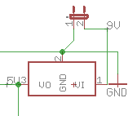 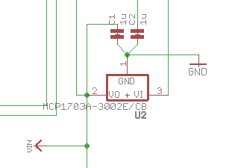

Figure 1, power source circuit. Figure 2, voltage regulator circuit.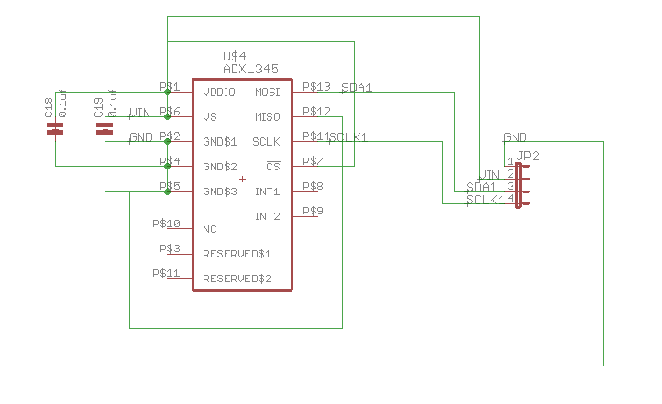 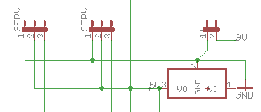

Figure 3, accelerometer circuit. Figure 4, servos output circuit. [5]

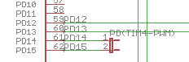 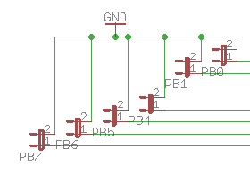 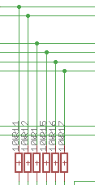

Figure 5, vibration motor output circuit. [6] Figure 6, push button output circuit.

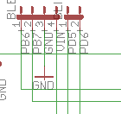 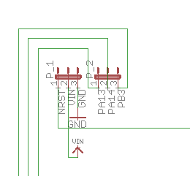

Figure 7, Bluetooth output circuit [7] Figure 8, in circuit programming circuit.

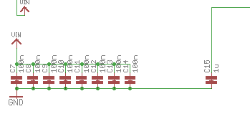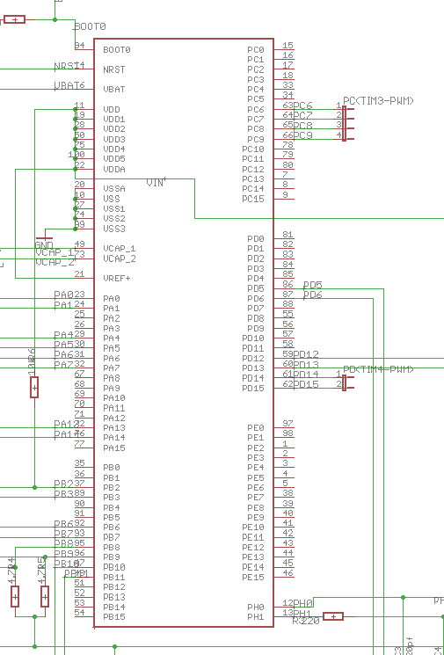

Figure 9, microcontroller circuit.Appendix B: FMECA Worksheet

Subsystem A: power source

|  |  |  |  |  |  |  |
| --- | --- | --- | --- | --- | --- | --- |
| **Failure No.** | **Failure Mode** | **Possible Causes** | **Failure Effects** | **Method of Detection** | **Criticality** | **Remarks** |
| A1 | No 9V input on input pins | 9V battery run, bad connection from the battery to input pins. | Entire circuit not working. | Bluetooth model not power on, servo do not reset | Low | No harm but product would not work |
| A2 | No 5V output from OKI-78SR | OKI-78SR broken, bad connection for the OKI-78SR to the main pcb | Entire circuit not working. | Bluetooth model not power on, servo do not reset | Low | No harm but product would not work |

Subsystem B: voltage regulator

|  |  |  |  |  |  |  |
| --- | --- | --- | --- | --- | --- | --- |
| **Failure No.** | **Failure Mode** | **Possible Causes** | **Failure Effects** | **Method of Detection** | **Criticality** | **Remarks** |
| B1 | No 5V input on input pins | Bad connection for the MCP1703 to the main pcb | Entire circuit not working. | Bluetooth model not power on, servo do not reset | Low | No harm but product would not work |
| B2 | No 3.3V output from MCP1703 or output less than 3.3V | MCP1703 broken, bad connection for the MCP1703 to the main pcb, decoupling capacitor shorts. | Entire circuit not working. | Bluetooth model not power on, servo do not reset | Low | No harm but product would not work, may not cause permanent damage to the entire circuit since the Vin is less than 3.3V |

Subsystem C: accelerometer

|  |  |  |  |  |  |  |
| --- | --- | --- | --- | --- | --- | --- |
| **Failure No.** | **Failure Mode** | **Possible Causes** | **Failure Effects** | **Method of Detection** | **Criticality** | **Remarks** |
| C1 | Failure to send acceleration data | Bad connection for the ADXL345 to the accelerometer pcb, decoupling capacitor shorts. | Sword not move in the VR app. | Bluetooth successfully send data, but data does not change | Low | No harm but the VR game is not playable. |
| C2 | Accelerometer send data of wrong direction. | Accelerometer pcb point to wrong direction. | Sword pointing to wrong direction in the VR app | Bluetooth successfully send data, but data was wrong | Low | No harm but the VR game is not playable. |

Subsystem D: servos output

|  |  |  |  |  |  |  |
| --- | --- | --- | --- | --- | --- | --- |
| **Failure No.** | **Failure Mode** | **Possible Causes** | **Failure Effects** | **Method of Detection** | **Criticality** | **Remarks** |
| D1 | Servo does not rotate. | Trace or jump wire connect to servo broken | No Torque feedback | Other feedbacks work normally but no torque feedback | Low | No harm, game playable but player experience bad. |
| D2 | Servo does not rotate as excepted or instable. | Trace or jump wire connect to servo broken, microprocessor internal problem | Torque feedback does not work as excepted | Other feedbacks work normally but torque feedback does not work as excepted | Low | No harm, game playable but player experience bad. |

Subsystem E: vibration motor

|  |  |  |  |  |  |  |
| --- | --- | --- | --- | --- | --- | --- |
| **Failure No.** | **Failure Mode** | **Possible Causes** | **Failure Effects** | **Method of Detection** | **Criticality** | **Remarks** |
| E1 | Motor overheat | Run for extremely long | Motor get hot and may burn the user’s hand | Vibration motor running continuously | High | May harm user and permanently damage the product. |
| E2 | Motor does not vibrate | Trace or jump wire connect to vibration motor broken, microprocessor internal problem | No haptic feedback | Other feedbacks work normally but no haptic feedback | Low | No harm, game playable but player experience bad. |

Subsystem F: push button

|  |  |  |  |  |  |  |
| --- | --- | --- | --- | --- | --- | --- |
| **Failure No.** | **Failure Mode** | **Possible Causes** | **Failure Effects** | **Method of Detection** | **Criticality** | **Remarks** |
| F1 | No push button input | Trace or jump wire connect to push button broken, microprocessor internal problem | No response while using the push button | Other feedbacks work normally but push button no response | Low | No harm, game playable but player experience bad. |
| F2 | No push button input not stable | Trace or jump wire connect to push button broken, microprocessor internal problem | Push button not work as excepted | Other feedbacks work normally but push button no work as excepted | Low | No harm, game playable but player experience bad. |

Subsystem G: bluthooth

|  |  |  |  |  |  |  |
| --- | --- | --- | --- | --- | --- | --- |
| **Failure No.** | **Failure Mode** | **Possible Causes** | **Failure Effects** | **Method of Detection** | **Criticality** | **Remarks** |
| G1 | Bluetooth model failure | Bluetooth model broken, Trace or jump wire connect to Bluetooth broken, | Bluetooth model does not power on | LED on Bluetooth model does not turn on | Low | No harm, game not playable. |
| G2 | Bluetooth setup failure | Incorrect VR app setup | Cannot connect to Bluetooth model | LED on Bluetooth model is on, but cannot connect to app | Low | No harm, game not playable. |
| G3 | Bluetooth signal unstable | Bluetooth model broken, range between Bluetooth model and phone is too far | Bluetooth connection unstable | LED on Bluetooth model is on, but connect unstable | Low | No harm, game playable but player experience bad. |

Subsystem H: in circuit programming

|  |  |  |  |  |  |  |
| --- | --- | --- | --- | --- | --- | --- |
| **Failure No.** | **Failure Mode** | **Possible Causes** | **Failure Effects** | **Method of Detection** | **Criticality** | **Remarks** |
| H1 | No voltage supplies  to in-circuit  programmer | Shortage on Vcaps | Cannot program the microprocessor | Cannot found device when program the microprocessor | Low | No harm |
| H2 | No data received  from in-circuit  programmer | Damaged  programming cable, | Cannot program the microprocessor | Error appear when program the microprocessor | Low | No harm |

Subsystem I: microprocessor

|  |  |  |  |  |  |  |
| --- | --- | --- | --- | --- | --- | --- |
| **Failure No.** | **Failure Mode** | **Possible Causes** | **Failure Effects** | **Method of Detection** | **Criticality** | **Remarks** |
| I1 | No signal comes  out of the  microcontroller | Damaged capacitor  on VDD/VCORE pin | Unpredictable | Every  component does  not function | Low | No harm |
| I2 | No supply voltage  goes into VDD  pin | Shorted bypass  capacitors | Unpredictable | Every  component does  not function | Low | No harm |