User Manual

Year: 2017 Semester: Fall Team: 03 Project: Virtual Sport

Creation Date: ­11/11/2017 Last Modified: November 16, 2017

Author: Yutao Hu Email: hu298@purdue.edu

Assignment Evaluation:

|  |  |  |  |  |
| --- | --- | --- | --- | --- |
| **Item** | **Score (0-5)** | **Weight** | **Points** | **Notes** |
| **Assignment-Specific Items** | | | | |
| **Product Description** |  | x1 |  |  |
| **Product Illustration** |  | x2 |  |  |
| **Setup Instructions** |  | x3 |  |  |
| **Usage Instructions** |  | x3 |  |  |
| **Troubleshooting Instructions** |  | x3 |  |  |
| **Writing-Specific Items** | | | | |
| **Spelling and Grammar** |  | x2 |  |  |
| **Formatting and Citations** |  | x1 |  |  |
| **Figures and Graphs** |  | x2 |  |  |
| **Technical Writing Style** |  | x3 |  |  |
| **Total Score** |  | | |  |

5: Excellent 4: Good 3: Acceptable 2: Poor 1: Very Poor 0: Not attempted

Comments:

*Comments from the grader will be inserted here.*

1. Product Description

Virtual Sport is a VR appliance that enables users to play sports from the comfort of a limited space. The project features a Kendo sport mobile VR app and a haptic handheld controller. Users may enjoy playing the Kendo sport in a virtual environment and perceive the touch feelings recreated by the haptic embedded device. The handheld controller tracks the user’s hand orientation and transmits the data to the VR app over a wireless connection. A VR headset visualizes the movement of a sword in a 3-dimensional virtual environment. The device also provides tactile feedback when the user spars with digital opponents. There is a unique sliding contact handle, which uses torque cues to simulate the shear and friction forces.

1. Product Illustrations

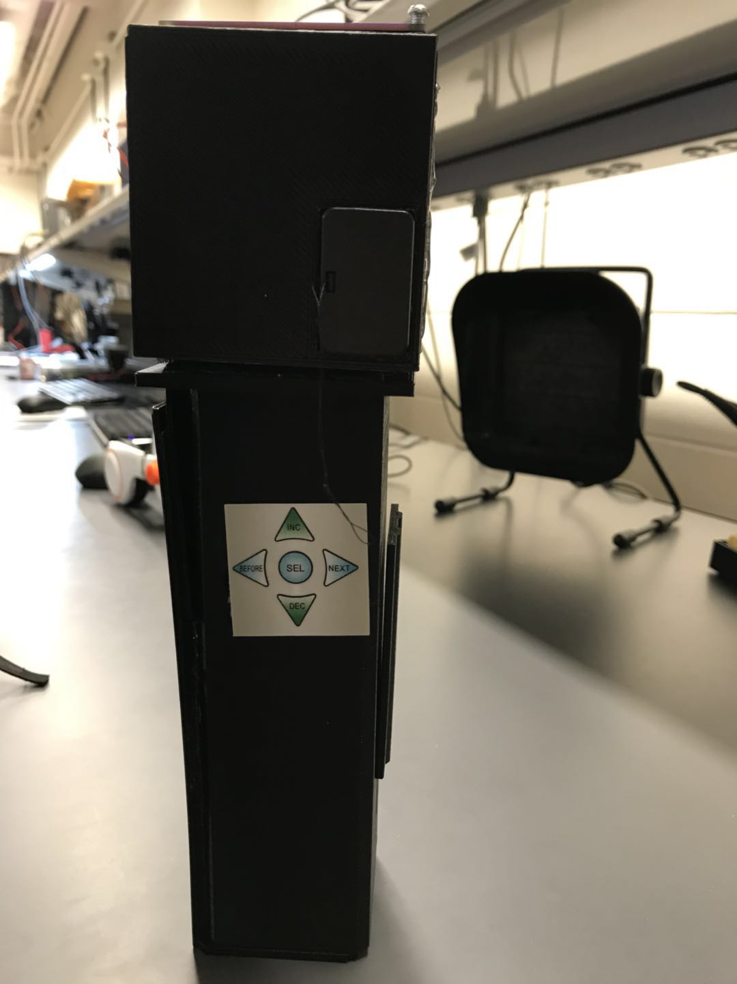

Figure 1 Haptic handheld controller

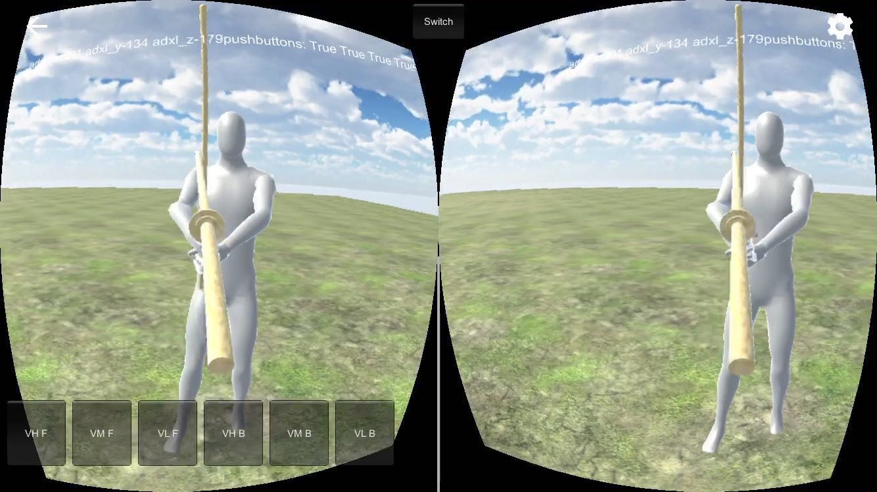

Figure 2 Mobile VR App

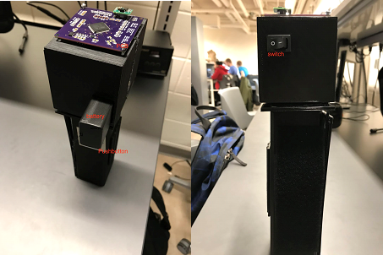

Figure 3 Side View of the Haptic Handheld Controller

1. Setup Instructions

* Battery Installment

1. Turn off the power switch.
2. Pull out the battery case.
3. Slide the lid and pop the battery out from the case.
4. Put the 9V battery in the case.
5. Slide the battery to fasten it.
6. Install the lid and push back in.
7. Turn on the device.

* App Deployment

1. Download Xcode on a Mac OS X device.
2. Open the “Kendo VR” Xcode project.
3. Connect your iPhone and the Mac OS X device over the Apple lightning cable.
4. Run the Xcode project.
5. On your phone, open Setting > General > Device Management, and tap Trust “VR Haptics”. You should be able to run our VR app on your iOS device.
6. Usage Instructions

* Pair the haptic handheld controller with the mobile device

1. Turn on the Bluetooth setting on your iPhone.
2. Open the mobile VR app. It will scan through the available haptic handheld devices in the current environment and automatically pair with the one with the strongest connection.

* Start the VR experience

1. Place the app in the landscape orientation when the app is opened. Insert your mobile device into a VR headset.
2. Turn on the haptic handheld device and wear on the headset.
3. Swing the haptic controller toward a digital object. The device should provide vibration and frictional feedback when the user draws contacts with virtual items.

* Change the scene.

1. Press the membrane buttons on the handheld device or the GUI switch buttons on the VR app to manipulate the scenarios.
2. Troubleshooting Instructions
3. Device not found

|  |  |
| --- | --- |
| **Possible Causes** | **Solution** |
| The device is running out of battery. | Change the battery. See the instruction above. |
| Bluetooth connection failed. | Restart haptic devices and reconnect the Bluetooth. |
| If none of the above solve this issue | Contact our support team through email. |

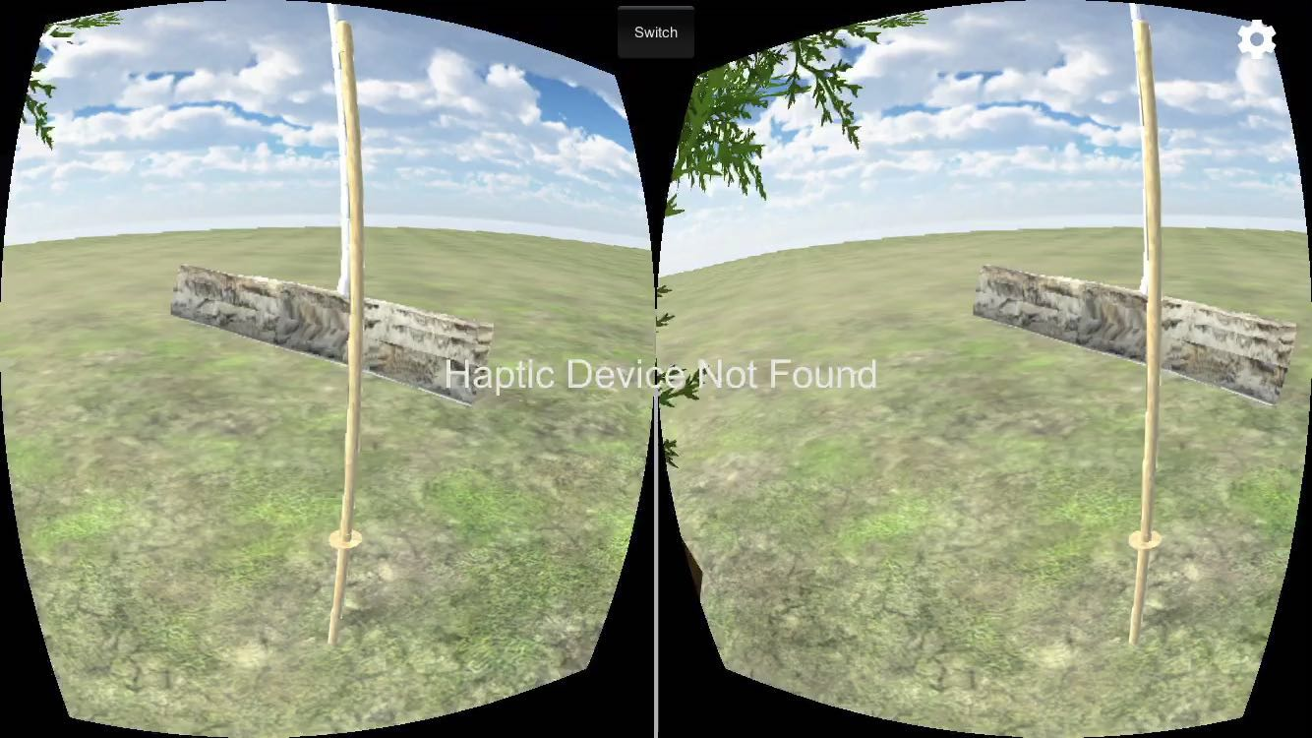

1. The APP is not running.

|  |  |
| --- | --- |
| **Possible Causes** | **Solution** |
| iOS kills the app if the memory is full | Close other APP that is running and reboot your phone to clear the memory usage |
| If none of the above solve this issue | Try re-deploy the app or contact our support team through email |