Final Project Documenontation
Mini Social Networking Web Application

Bondly


Carl Andre Curato
Johnmar Dumopol
Gian Sodecta Fabre
James Roy Arnaiz
Deither Sabanal
John Taub

Introduction
In an era where digital connectivity is the cornerstone of human interaction, Bondly emerges as a streamlined, high-performance mini social networking platform. Designed with the core philosophy of "Connecting Your Social Circle," Bondly provides a familiar yet refined experience similar to industry giants like Facebook, but with a focus on speed, simplicity, and modern aesthetics.
Bondly is built on a robust Model-View-Controller (MVC) architecture, ensuring that the user interface remains fluid while the back-end processes data securely and efficiently. The platform serves as a digital bridge, allowing users to transcend geographical boundaries to share thoughts, life updates, and visual media in real-time.

The Core Concept
Just like Facebook, Bondly revolves around the concept of a "Social Feed." Users are empowered to build a digital identity through personalized profiles and engage with a broader community. Whether it is posting a brief status update, sharing a high-resolution image of a cherished moment, or discovering new friends through a centralized search system, Bondly provides the essential tools for modern social networking without the clutter of traditional platforms.

System Objectives
The primary goal of Bondly is to bridge the physical gap between individuals, proving that distance is no barrier to meaningful relationships. In a world where life often keeps us apart, this platform is engineered to act as a digital glue for social circles.
- To Strengthen Interpersonal Bonds
- To Foster Continuous Connection
- To Promote Discovery within the Community

Authentication System
User registration with validation ,Secure login with password hashing ,Session-based access control ,Logout functionality Password verification with password_hash().
Post Management (CRUD)
Create posts (text + optional image), View all posts in chronological order ,View posts with timestamps , Delete posts (by owner only) ,Image upload with validation , Post title support
Interactions
Like/Heart posts, Unlike posts, Add comments to posts , View comments on posts , Delete comments, Comment author information Like count tracking , Comment count tracking.
User Profiles
User profile page with avatar, User bio/description , User statistics (posts, engagements) ,User's post history ,Join date display , Profile picture upload . Profile editing.
Profile Management
Edit full name, Edit bio , Update profile picture, View profile statistics, View post history

Search & Discovery
Search users by username, Search users by full name, View search results, Navigate to user profiles from search.

Screenshots of all pages
Log in
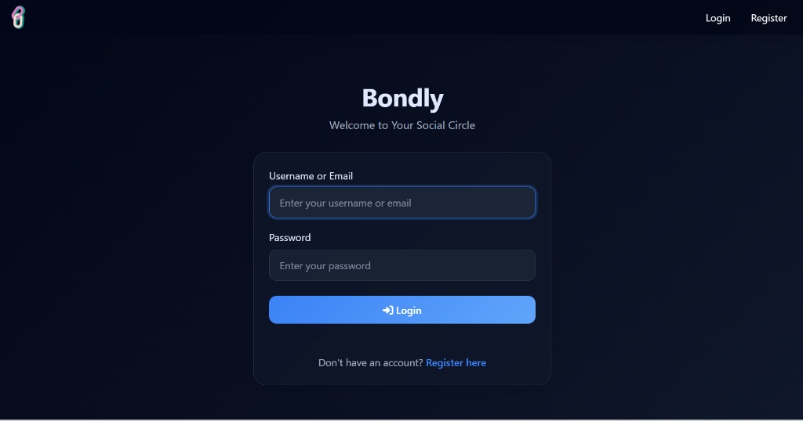

Registration/Sign Up
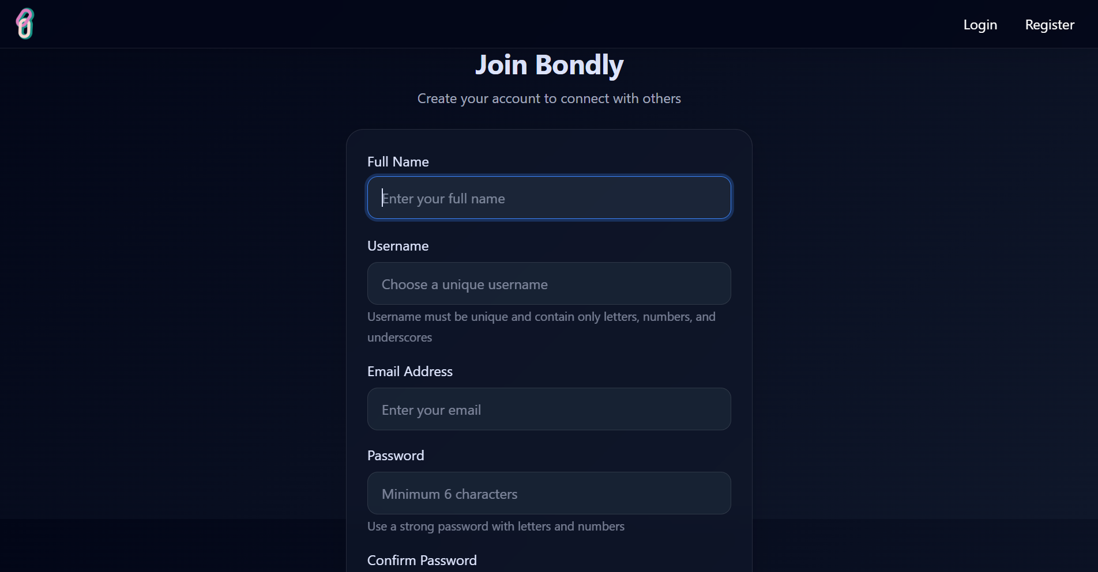

Home Page
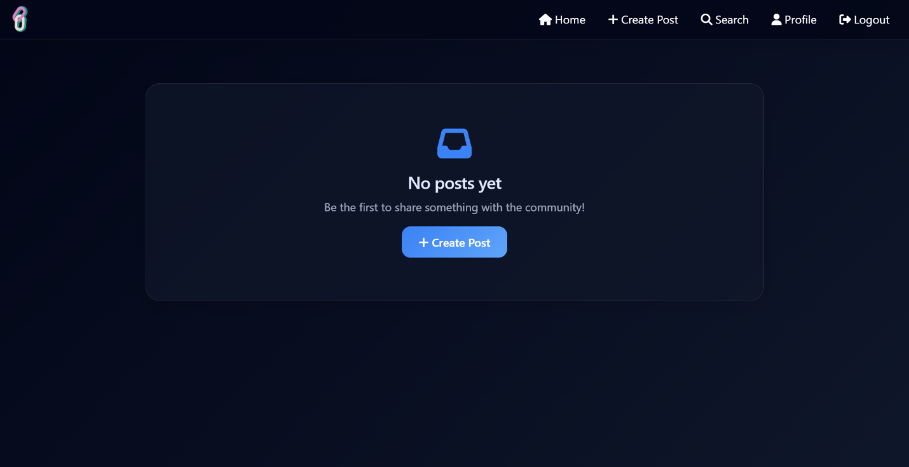

Create Post
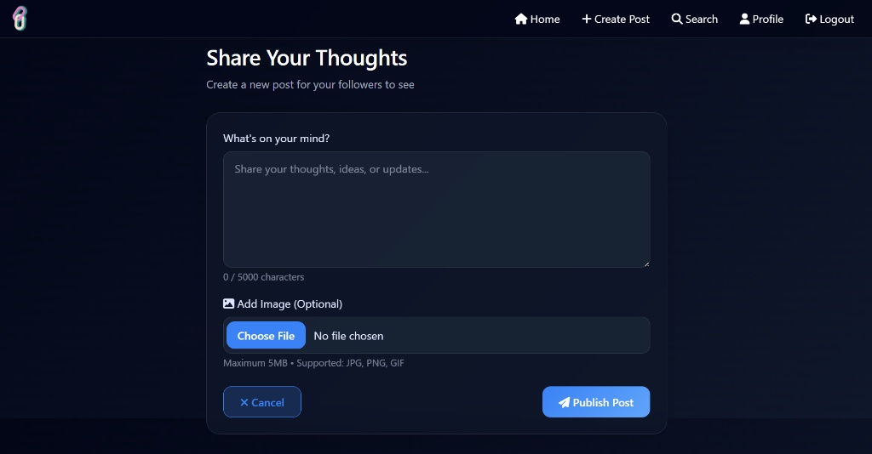

Search Page
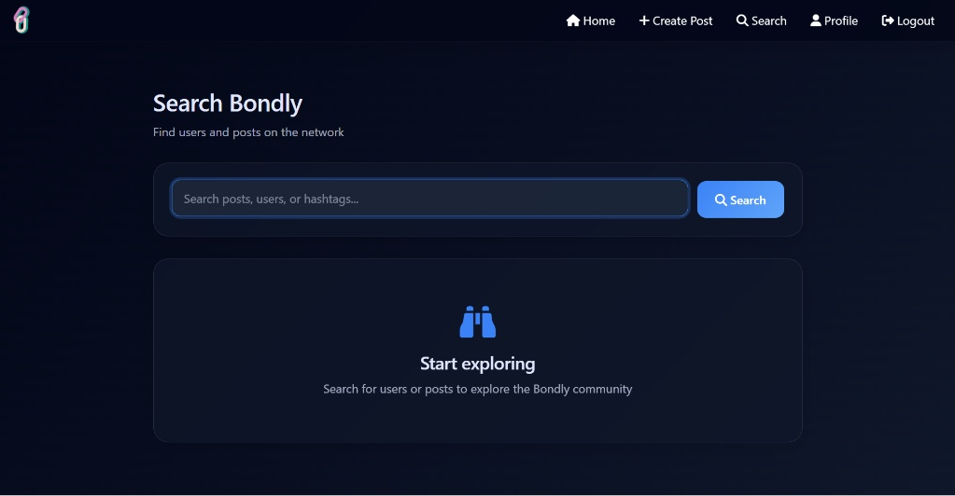

Profile Page
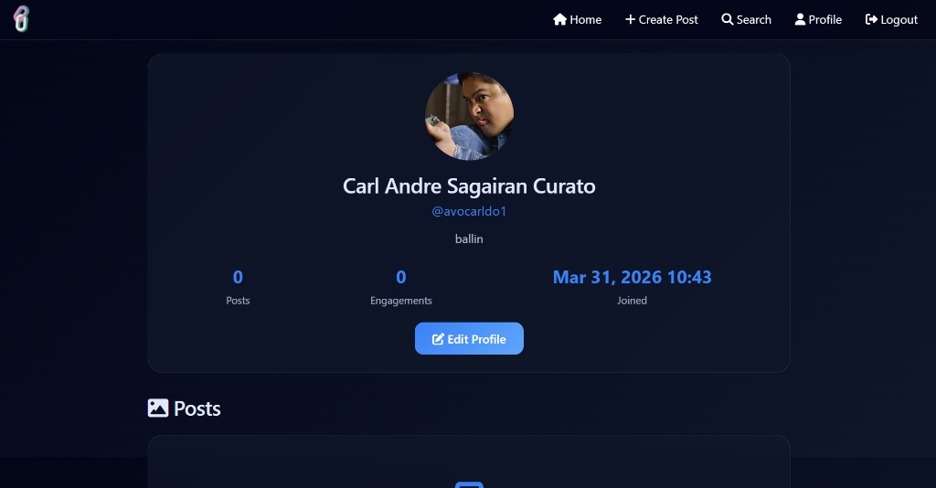

User Guide
Registration & Login
- Click "Register" to create a new account
- Enter Full Name, Username, Email, and Password (min 6 characters)
- Click "Login" to log in with your credentials
Creating Posts
- Click "Create Post" in the navigation
- Add a title (optional) and content
- Upload an image (optional)
- Click "Publish Post"
Interacting with Posts
- Like: Click the heart icon (limit 1 per user)
- Comment: Enter text in comment box and press send
- Delete: Only post owners can delete their own posts
Profile Management
- Click "Profile" to view your profile
- Click "Edit Profile" to update:
  - Full Name
  - Bio
  - Profile Picture
- View your post statistics and all published posts

Searching Users
- Click "Search" in navigation
- Enter username or full name
- Click on user card to view their profile

