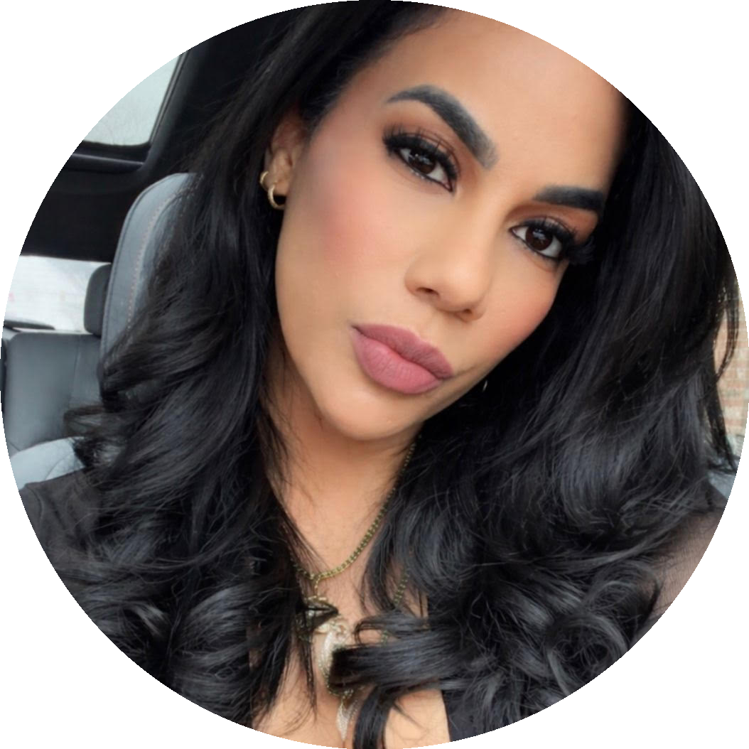  SUGEY CRUCETT  PCM Skills Trainer  CONTACT  Lawrence, MA  978-305-5071  sugeycrucett@live.com  LANGUAGES  - English — Fluent  - Spanish (Español) — Fluent  CORE COMPETENCIES  - PCA Program & MassHealth Knowledge  - Consumer Eligibility Assessment  - Skills Training & Orientation  - Case Documentation & Management  - Database & Records Management  - Employer/Employee Coaching  - Peer Support & Advocacy  - Information & Referral Services  - Microsoft Office / Excel  - Patient Care & ADL Support  - Quality Compliance & SOPs  CERTIFICATIONS  - CPR & AED Certified  - BLS — Basic Life Support First Aid Certified  - CNA Certification (In Progress)  - Cosmetology Cert. — DR 2004  EDUCATION  - Gateway Community College | New Haven, CT | 2006–2008  - Nursing Program (2 Years)  - International Health Training Ctr Lawrence, MA | Currently Enrolled CNA Certification Program |  | PROFESSIONAL SUMMARY  Bilingual (English/Spanish) healthcare professional with direct, hands-on experience delivering Personal Care Attendant services through the Tempus Unlimited/MassHealth PCA Program. Demonstrates deep understanding of PCA consumer needs, employer/employee dynamics, and care plan management. Skilled at assessing individual capacity, guiding paperwork completion, and communicating effectively with individuals with disabilities, families, and agency staff. Combines a background in medical compliance, patient advocacy, and quality documentation to bring immediate value to a PCM Skills Trainer role.  PROFESSIONAL EXPERIENCE  Tempus Unlimited | Personal Care Assistant (PCA) | Stoughton, MA | 2023 – Present  - Deliver patient-centered care under the MassHealth PCA Program, developing firsthand knowledge of consumer eligibility, service agreements, and the role of Fiscal Intermediaries  - Assist consumers with activities of daily living (ADLs) including bathing, dressing, and meal preparation while following individualized care plans and safety protocols  - Monitor and report changes in consumer condition to supervisors, family members, and healthcare staff — mirroring the case-monitoring function of a Skills Trainer  - Communicate effectively with consumers, surrogates, and program staff to troubleshoot service concerns and resolve day-to-day program issues  - Follow MassHealth PCA program guidelines, EVV documentation procedures, and established SOPs with consistent accuracy  - Support consumers and surrogates in understanding their rights, responsibilities, and available community resources  Techprint Inc. | Medical Device Assembler | Lawrence, MA | 2018 – Present  - Maintain meticulous documentation of production and quality records, reflecting the database and case-file management skills required for this role  - Operate within strict ISO standards and SOPs in a regulated environment — demonstrating the attention to compliance critical in a MassHealth-funded program  - Collaborate across teams to resolve issues and meet daily operational goals, reinforcing strong organizational and communication skills  - Train on and follow detailed work instructions, demonstrating the capacity to absorb, apply, and eventually teach procedural knowledge  Parlex Corporation | Medical Component Assembler Lawrence, MA | 2010 – 2017  - Assembled small, high-precision medical components in a controlled cleanroom environment, ensuring adherence to strict safety and quality standards  - Followed detailed work instructions, SOPs, and technical specifications to maintain consistency and product accuracy  - Performed quality inspections using visual and measurement tools to ensure compliance with regulatory and production standards  - Maintained thorough documentation of production processes, supporting traceability and quality control requirements  - Utilized core manufacturing technologies and equipment relevant to medical device production  - Collaborated effectively within a cross-functional team to meet daily production targets and resolve issues  - Mentored and trained new hires, improving onboarding efficiency and maintaining team performance standards  - Demonstrated strong attention to detail, discipline, and compliance in a regulated manufacturing environment  WHY I AM THE RIGHT FIT  Direct PCA Program Experience: Already working within the Tempus Unlimited / MassHealth PCA ecosystem — I understand the program from the consumer's perspective and can speak to it authentically.  Bilingual English/Spanish: Fluent in both languages — a strongly preferred qualification that enables effective communication with a diverse consumer base in the Lawrence/Merrimack Valley area.  Consumer Advocacy & Support: Experienced in guiding individuals with disabilities through complex care and paperwork processes — a core function of the Skills Trainer role.  Compliance & Documentation: Seven-plus years maintaining accurate records and following regulated procedures at Techprint Inc., directly transferable to PCM database management.

