# CPRG-352 - Web Application Programming

## Lab 3

## Topic: Simple Servlet

**Submission reminder:** Create a public repository in your GitHub account and push your code there.

## Part 1

Create a Java web application called **"Calculators"**, with a servlet called AgeCalculatorServlet.java and a JSP file called agecalculator.jsp. In web.xml, map URL /age to AgeCalculatorServlet. When executed, this application navigates to /age and should show the following HTML form:

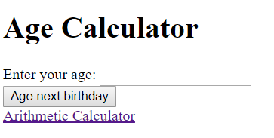

If the user clicks on the "**Age next birthday**" button without filling in a value in the text box then the user should see the message "***You must give your current age***" below this form, e.g.

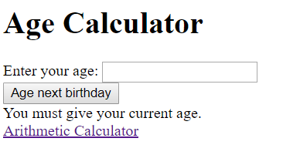

If the user enters an invalid entry (e.g. text), display an error message “You must enter a number.”

If the user does fill in a value, e.g. ***19***, and submits then the application should show the following:

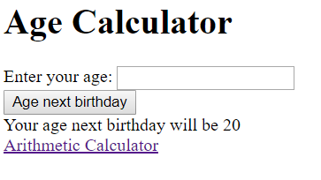

## Part 2

Add a link with the text “Arithmetic Calculator” to agecalculator.jsp that navigates to “arithmetic”.

Create another servlet (ArithmeticCalculatorServlet.java), another JSP (arithmeticcalculator.jsp). Map /arithmetic to ArithmeticCalculatorServlet.

Navigating to /arithmetic produces the following screen:

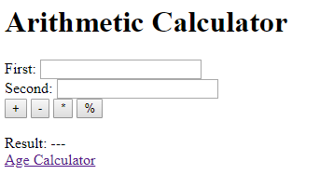

The user can enter two integer values in the text boxes provided, and then click on one of the buttons to tell the application which operation they want to perform on the values.

If no calculation has been performed, then the result should show as "**---**".

If a user enters an invalid input (blank textbox or text), then the result should show “invalid”.

Ensure the textboxes stay populated with the values they had previous entered.

Add a link to “Age Calculator” to allow the user to navigate back to the first calculator.

**Example 1: adding 1 and 3**

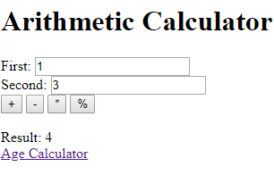

**Example 2: Multiplying 3 and 7**

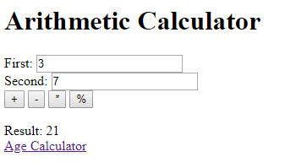

**Example 3: clicking on a button without providing either or both values or entering text**

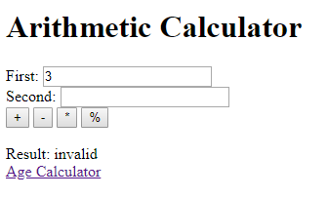

**Example 4: entering invalid input**

