|  |  |
| --- | --- |
| Diploma in Computer Engineering  Intelligent Automation (INAUTO) |  |

**INAuto Project Proposal Form**

|  |  |  |
| --- | --- | --- |
| Team Name: | **What is INAuto?** | Class: PE01 |
| Team Members: | Chuang Kai Siang (2200589F) | |
| Joshua Lim Jing Lin (2202465G) | |
|  | |

Pls tick on the boxes:

Applications Used

✓

✓

MS Office App 1 ◻ ___MS Word____ MS Office App 2 ◻ ____Excel_____ MS Office App 3 ◻ ___MS Teams___ MS Office App 4 ◻ __MS Outlook__

✓

✓

Web Application 1 ◻ __Glints.com__ Web Application 2 ◻ ____________

Web Application 3 ◻ ____________ Web Application 4 ◻ ____________

✓

✓

Email ◻ PDF ◻

✓

Others, please indicate ◻ _ChatGPT_ Others, please indicate ◻ ___ _______

**Signed Declaration**

**Kai Siang:**

**________**

**Joshua:**

**________**



**Brief description of your RPA App:**

|  |
| --- |
| **Description:**  **Problem** – Nowadays students constantly face the tedious and time-consuming internship job application process, particularly, crafting personalized emails that meet the professional and institutional standards of the present day. This may result in hindering a student’s ability to focus on the interview preparations and their chances of getting the internship role.  **Solution** – Addressing the issue of the student internship sector, our RPA (Robotic Process Automation) focuses on optimizing the job application process by automating email creations for students. Specifically, these emails whilst being automated, are designed to replicate, and maintain a professional tone that aligns with the institutional standards for clarity and professionalism. By automating the email creation process, students can save a substantial amount of time. Furthermore, our RPA process efficiently organizes and maintains records of the students’ applications, allowing them to keep transcripts of all their applied jobs whilst in search of other potential internship offers.  **Steps:**   1. User inputs name and job topic 2. Job topic is searched on the **Glints.com** website 3. Details of the job topic are extracted from **Glints.com** 4. Place extracted data into an **Excel** sheet. 5. The user selects jobs to apply for from the **Excel** sheet 6. Import selected **Excel** sheet details into **ChatGPT**. 7. Utilize **ChatGPT** to generate a detailed application form from the data. 8. Scrap and send the application form as a notification through **Outlook Email**. 9. Save email contents as a **Word document**. 10. Convert **Word document** containing the email summary to **PDF**. 11. Upload **Word documen**t and **PDF** to **MS Teams** as a transcript for a user to record job application history.     **Business impacts and benefits:**   * Increased efficiency:   + Automating repetitive tasks, saving time and effort.   + Sending out multiple emails for job applications in a quick and efficient method. * Improved personalization:   + ChatGPT generates detailed application forms, leading to more targeted emails. * Improved error handling:   + ChatGPT's error-checking capabilities assist in minimizing factual errors and stylistic inconsistencies within application forms. * Enhanced record keeping:   + Word and PDF transcripts in MS Teams will serve as receipts for email. * Reduced costs:   + Potentially reduces the reliance of students or job seekers using expensive application forms and resume writing services. * Enhanced Data Insights:   + Transcripts stored in MS Teams provide students with the ability to track their application success rates. This data can help students to refine their approach, identify suitable companies that best align with their skillset and interests.   + Data insights can reveal and set valuable benchmarks for successful applications among students. This can create a more collaborative learning environment where students will be able to share their knowledge and best practices in landing an internship. * Expandability:   + The RPA process can also go beyond the regular internship applications. Its potential can also extend towards other forms of academic and professional settings. For example, being able to generate cover letters alongside with personalized emails offers students a complete application package. Another example would be integrating the RPA with university career services platforms to help students better develop and manage their career. |

**Workflow Design, Flowchart Design Structure**

|  |
| --- |
| **Workflow**    **Flowchart** |

**Development Works:**

* Students are to work in pairs. Your tutor may allocate the grouping or students may be allowed to form their own group. Each student in the group must contribute 50% towards the project implementation. Interviews will be conducted to find out how much each student has contributed. If any student does not contribute enough, he/she will fail the project.
* A workshare table must be submitted to show distribution of effort.

|  |  |
| --- | --- |
| **Work done** | **Action by** |
| Project Description | Kai Siang |
| Workflow | Joshua |
| Flowchart | All |
| Planning & Schedule | Kai Siang |
|  |  |

**Project Planning & Schedule**

|  |  |  |
| --- | --- | --- |
| **Week** | Planned Tasks | Action By |
| **e.g. week 10** | Layout Design | Team member: by Alex |
| 7 | *View Project Description* | Kai Siang |
| 8 | *Brainstorm RPA App Ideas* | All |
| 9 | *Term Test Week (Draft Proposal)* | All |
| 10 | *Term Break (Draft Proposal)* | All |
| 11 | *Term Break (Draft Submission)* | Joshua |
| 12 | *Project Development Flowcharts* | All |
| 13 | *Sequences, DataTable Extraction* | Kai Siang |
| 14 | *Workflow Arguments, DataTable Extraction* | Joshua |
| 15 | *Final Touches* | All |
| 16 |  |  |
| 17 |  |  |

**Approved** ◻**/ Rejected** ◻ **/Re-Submit** ◻

**Objectives**

To empower students in employing the usage of an application automation system powered by ChatGPT and RPA to secure internships with greater efficiency, personal individualization, and record-keeping. This application enables students to land their preferred internship role and employment by keeping records of applications and automatically creating professional emails.

**(*Refer to project brief and diagrams above for an elaboration on the steps of the RPA process.)**

**Functionalities Descriptions (Individual Contributions)**

**Kai Siang’s Contribution:**

* Implemented error handling for the user inputs, created flowchart flow and decision making for the RPA process.
* Troubleshooted and extracted necessary information from the dynamic website for Glints.sg.
* Anchored images for input selection like type into and click
* optimized DataTables by determining variables to store.
* Fine-tuned prompts for ChatGPT and manipulated substrings from its output for email input.
* Developed the logic for creating Word documents in MS Teams to save user's storage space, formatting the content in Word accordingly.
* Implemented logic to save PDF copies to the user's downloads folder for secure, un-editable record-keeping.
* Fixed delays and timing issues in the RPA process to ensure smooth activity execution.
* Added additional YouTube recording of the whole process for easy reviewing at the beginning of the RPA process.

**Joshua’s Contribution:**

* Storyboarded an initial version of the project to understand the entire project flow.
* Implemented project beginning and end statements, mentioning members and scope.
* Added sorting and filtering functionalities in Excel, including creating and clearing sheets, and sorting specific columns.
* Developed DataTables and outlined columns for input from scrapped data.
* Integrated simple arguments for workflow, such as assigning names and job topics, and user details for email generation.
* Explored various methods for sending emails, including manual Outlook interaction and UiPath's send outlook messages activity.
* Implemented logic to determine if there is an existence of an RPA MS Teams group for the user.
* Conducted a fact-check of the original workflow and flowchart to identify areas for improvement.

**Overall Contributions:**

Kai Siang focused on executing and optimizing the technical aspects of the RPA process. Joshua directed his efforts towards conceptualizing the project flow, overseeing data management, and exploring different implementation options. Overall, our collaborative efforts complimented each other effectively, culminating in an efficient and comprehensive RPA process.

**Reflection**

**Introduction:**

As we reflect on the journey through our project, it becomes evident that this learning experience has been both challenging and rewarding. The primary focus was on utilizing UiPath for data scraping from the job listing website, Glints, and automating the process of sending personalized resumes to prospective employers via email. This project not only enhanced technical skills but also provided valuable insights into problem-solving and collaboration.

**Learning Journey:**

The learning journey started with a comprehensive exploration of UiPath, grasping an understanding of how we may manipulate the web scraping tool to extract relevant data from Glints. Understanding the structure of the website, handling dynamic elements, and ensuring data accuracy posed initial challenges. As the module progressed, the integration of ChatGPT into the workflow brought an additional layer of complexity. Learning to leverage ChatGPT for prompting inputs, generating personalized content, and dynamically adapting to varying job descriptions was a key milestone.

**Challenges Faced:**

1. Web Scraping Complexity: Navigating through the dynamic nature of Glints' website proved challenging. Adapting the scraping mechanism to handle updates and changes in the site structure required constant adjustments.
2. ChatGPT Integration: Integrating ChatGPT into the automation process introduced challenges in terms of understanding and formatting the responses generated by the language model. Ensuring coherence and relevance in the content generated proved to be a significant hurdle.
3. Email Automation: Sending emails with personalized content, attaching the generated resume, and handling potential errors in the email sending process demanded a thorough understanding of UiPath's email automation capabilities.

**How We Overcame Challenges:**

1. Iterative Development: We adopted an iterative development approach, regularly testing and refining the web scraping components. This ensured adaptability to changes on the Glints website and improved the overall robustness of the solution.
2. Fine-Tuning ChatGPT Prompts: We invested time in fine-tuning the prompts provided to ChatGPT, ensuring clarity in instructions, and handling various scenarios. Regular testing and adjustments were made to enhance the relevance and coherence of the generated responses.
3. Error Handling and Logging: Robust error handling mechanisms were implemented, especially in the email automation process. Detailed logging helped identify and address issues promptly, ensuring a smoother execution of the automation workflow.

**Conclusion:**

In conclusion, this Intelligent Automation module has been a journey of growth and discovery. Overcoming the challenges posed by web scraping intricacies, ChatGPT integration, and email automation has not only enhanced technical proficiency but has also instilled a sense of resilience and adaptability. The ability to collaborate with different technologies to create a comprehensive, automated solution is a testament to the skills acquired throughout this module. As we submit our final work, we take pride in the evolution from novice to adept automation practitioners, ready to apply these skills in real-world scenarios.

**Personal Reflection**

**Kai Siang:**

The project's completion was initially hindered by several issues. Adapting to UiPath's recent modern update required relearning key activities and restarting the project. Data extraction from Glints.sg proved initially challenging due to dynamic content obscuring critical keywords and phrases for email applications. Constructing effective prompts for ChatGPT, known for format deviations, presented further challenges. These obstacles were tackled by consulting with peers and brainstorming sessions with my project member Joshua, allowing for a pragmatic approach that prioritized simplicity and effectiveness. Notably, mastering UiPath's low-code architecture, with its pre-built components, has significantly enhanced my understanding of code logic by offering alternative perspectives on coding practices. These newly discovered abilities will be advantageous for my future projects.

**Joshua:**

Despite the challenging nature of our project's complexity, I'm pleasantly surprised by the valuable lessons it has taught me in problem-solving. For example, overcoming the obstacle of data scraping the intricate "Glints.com" website required us to devise an alternative approach. Faced with the complexity of the website structure, we decided to save the top five URLs and extract the necessary data by opening each one. I'm grateful for the resourcefulness and support of my teammate, Kai Siang, whose dedication, and continuous improvement motivated me to contribute my best towards our common goal. Overall, the Intelligent Automation module has enhanced my collaboration skills and taught me to be resourceful in resolving challenges.

**Appendix (UiPath Screenshots of Workflow / Output, YouTube Link)**

**YouTube Link:**

<https://youtu.be/TRllt7uCWto?si=teJt5DvYCnEc7v6t>

**Screenshots (See Project Workflow for detailed annotations; limited screenshots selection due to extensive sequences and workflows):**

**Main Workflow**

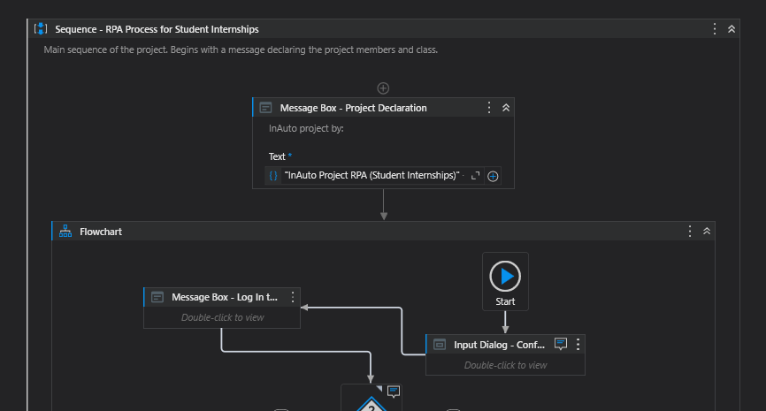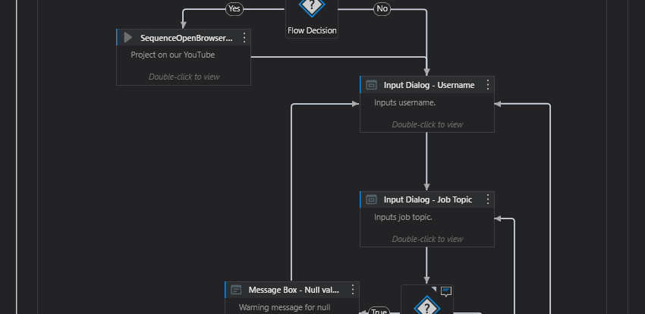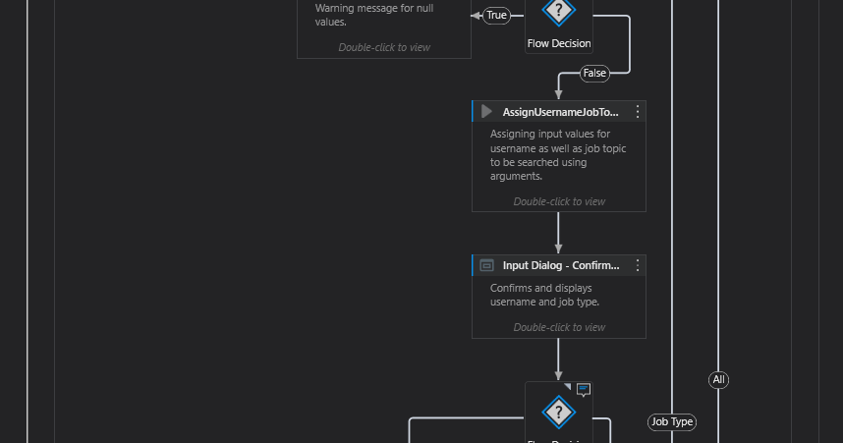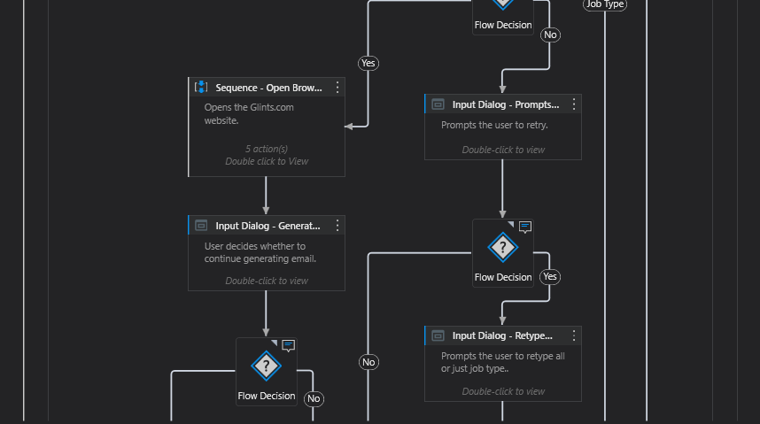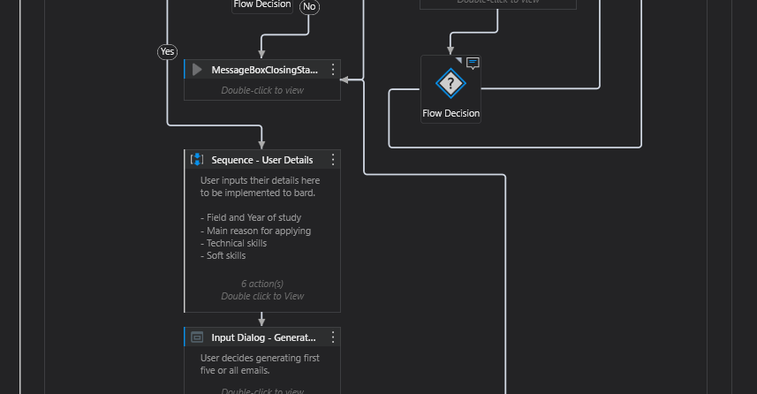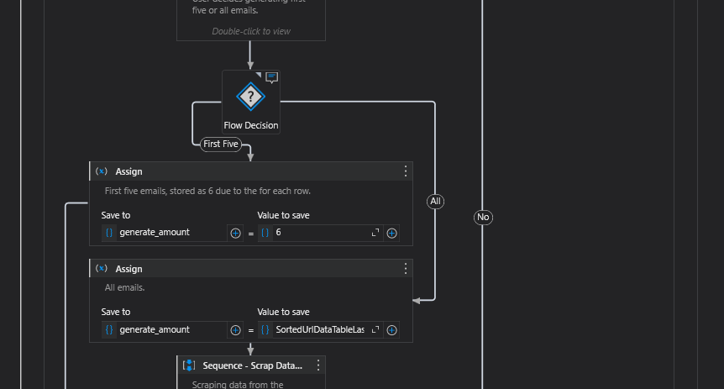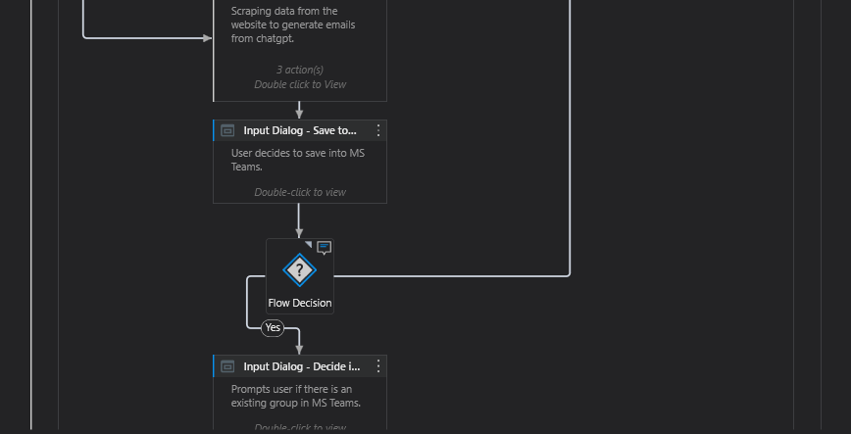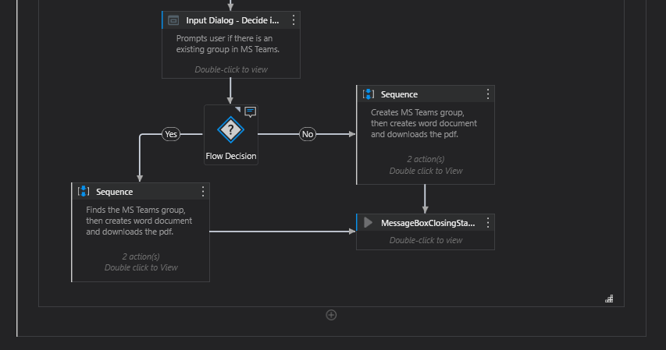

**Sequence (Opens Glints)**

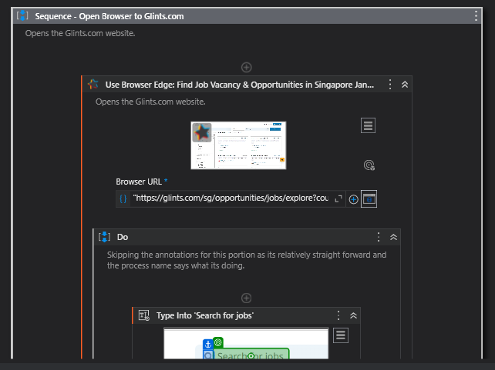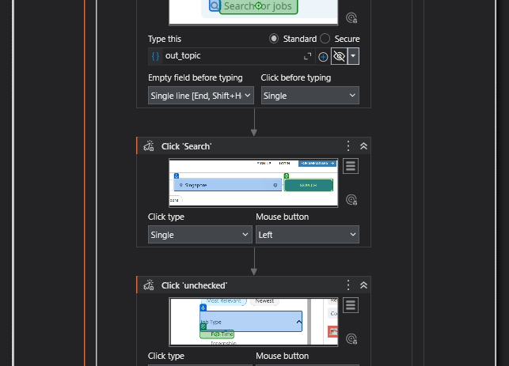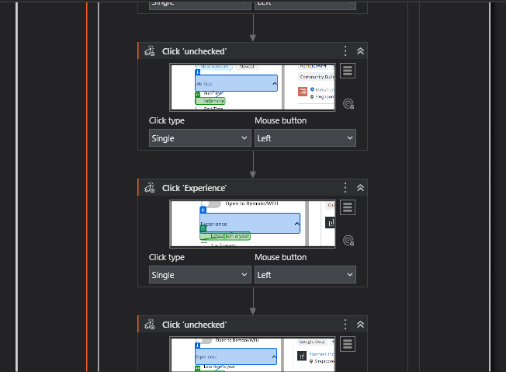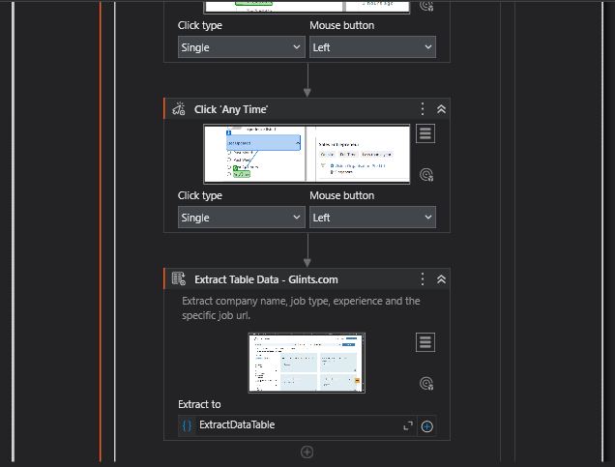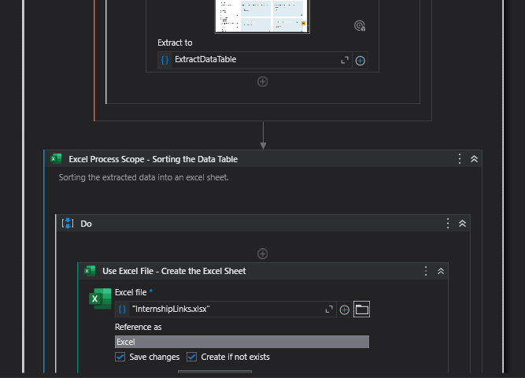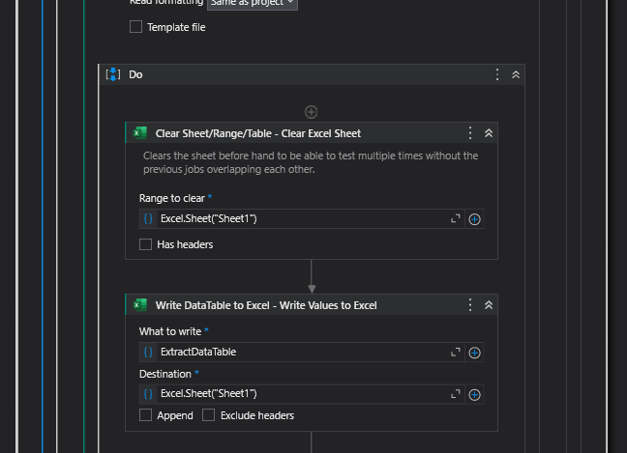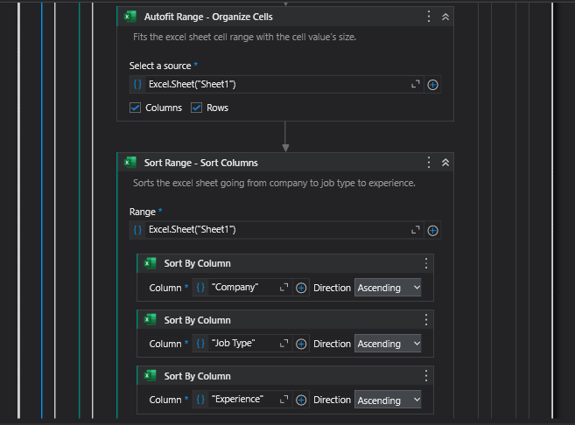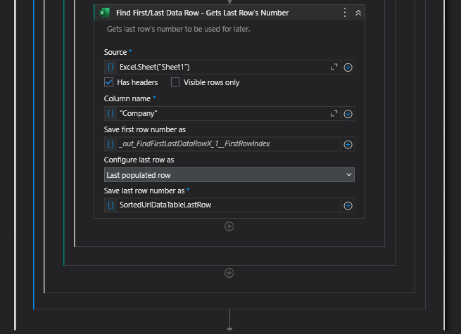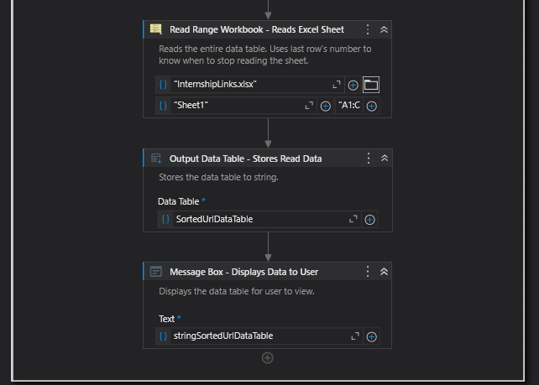

**Sequence (Scrap data to ChatGPT)**

