**CONTROL ROBOTS WITH GESTURES ON LEAP MOTION**

**Components Needed:**

1. Leap Motion Controller (1)
2. Arduino Uno (1)
3. Servo Motors (5)
4. Male-to-Male and Male-to-Female jumper wires
5. Breadboard (1)
6. Power Bank (1)
7. Cardboard
8. Heat sink tubes
9. Fishnet wires

**Software Needed:**

1. Processing IDE
2. Arduino IDE
3. Leap Motion SDK v2.3.1

**Libraries Needed:**

1. Arduino (Firmata) for processing
2. Leap Motion for Processing

**Workshop Skill Break-up:** 60% hardware, 40% software

**Workshop Overview**

The objective of this workshop is to control a robotic hand (servo motors connected to a cardboard cut-out of a hand) through hand gestures on a leap motion controller. The controller is a sensor device that supports hand and finger motions as input. The inputs through the controller is captured via methods in the leap motion for processing library. Processing is an open-source graphical library and integrated development environment (IDE). The processing sketch that we will be running for the workshop will identify which finger is being bent as well as calculate the angle of bend. The corresponding angle is then sent to the Arduino to turn the servo motors. This way we will be able to achieve robotic hand that mimics hand gestures. The cardboard cut-outs of robotic hands will be provided with strings attached to the servo motors.

**Workshop Steps**

1. Software and Library Installations

* Leap Motion SDK
  + Install the leap motion SDK v2.3.1 from the website given below:

<https://developer.leapmotion.com/sdk/v2>

* + Update driver software of leap motion controller: Go to “Device Manager”, right click on “Leap Motion Controller” and update driver.
  + Install Leap motion driver package: Go to Program Files(x86) > Leap Motion > Core Services > Drivers and run dpinst.exe (dpinst64.exe if you have a 64-bit machine)
  + Search for leap motion controller panel and you should be having all green status for your controller once it’s connected.
* Processing IDE
  + Install the latest version of IDE from the website below:

<https://processing.org/download/>

* + Go to Sketch > Import Library > Add Library and download Arduino (Firmata) and Leap Motion for Processing libraries
* Arduino IDE
  + Install Arduino IDE from the website below:

<https://www.arduino.cc/en/main/software>

1. Introducing Leap Motion Controller

* The controller is a USB peripheral device that is designed to be placed on a physical desktop or a mounted onto a virtual reality headset.
* The device is built of two monochromatic IR cameras and three infrared LEDs.

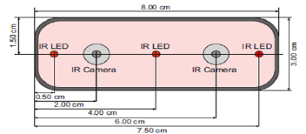

* It observes a roughly hemispherical area, to up to 1m.

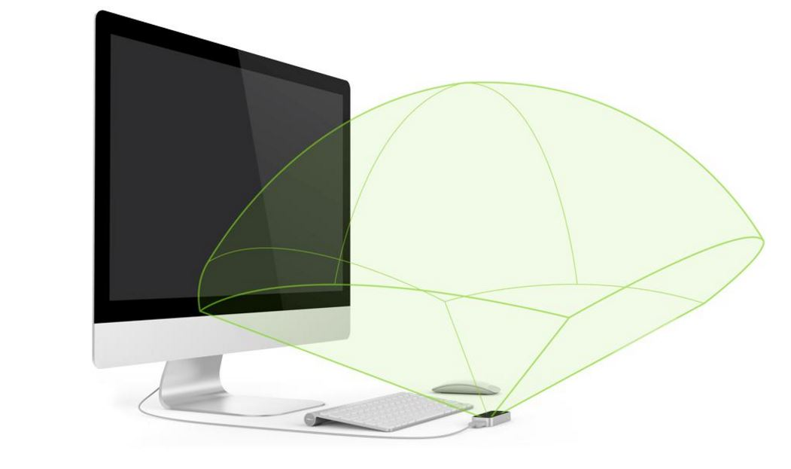

* The LEDs generate a pattern-less IR light and the camera generates almost 200 frames per second of reflected data. This data is sent through USB to a host computer where the Leap Motion Software analyzes it.
* Orion software is the latest SDK released.

1. Connect the Leap Motion Controller.

* When the SDK for Leap Motion is installed, it comes with three different applications.
  + Leap Motion Visualizer: This application displays a variety of tracking data provided by the Leap Motion API and is a good way to get a feel for the data produced by the leap

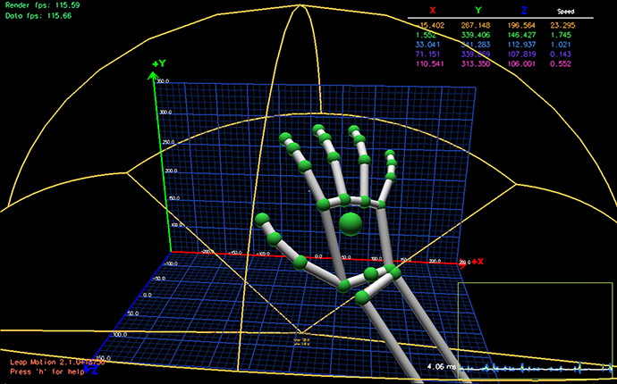

* + Leap Motion App Home: The app home has other cool applications that you can download to play around with the controller
  + Leap Motion Control Panel: You can use this app to set available options for the controller.

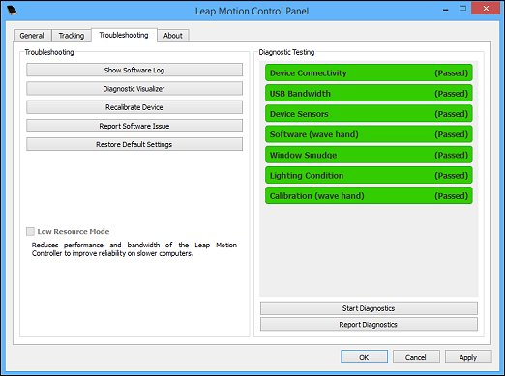

1. Arduino Uno and Servo Motors

* Arduino Uno is a prototyping board based on the ATmega328 microcontroller. We will be using the Arduino to control the servo motors and to communicate with the processing sketch that will be running on the host computer.
* The circuit diagram is given below. The Arduino is connected to the host computer via USB cable. Each motor has a string connected to one of the fingers. The pulse wire (yellow) of the motor is connected to the digital pins on Arduino which has pulse width modulation (pins: 3,5,6,9,10 or 11). The circuit is powered by a 5V power bank.

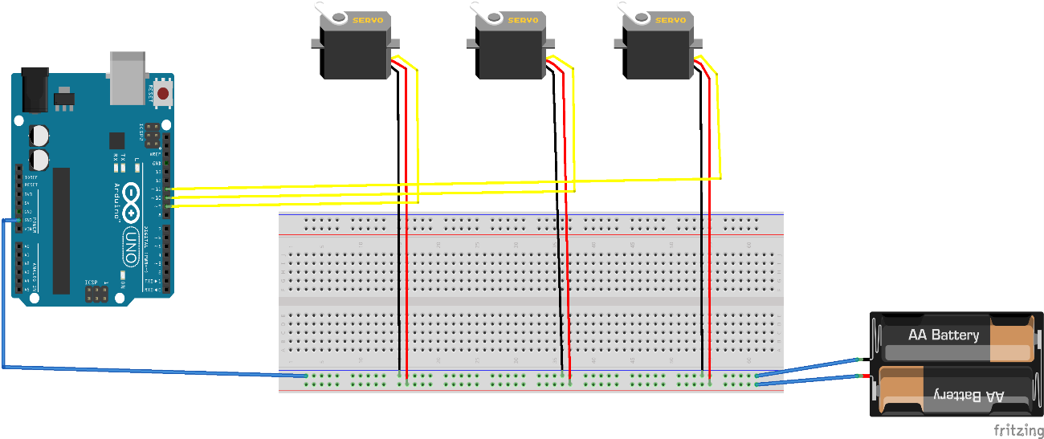

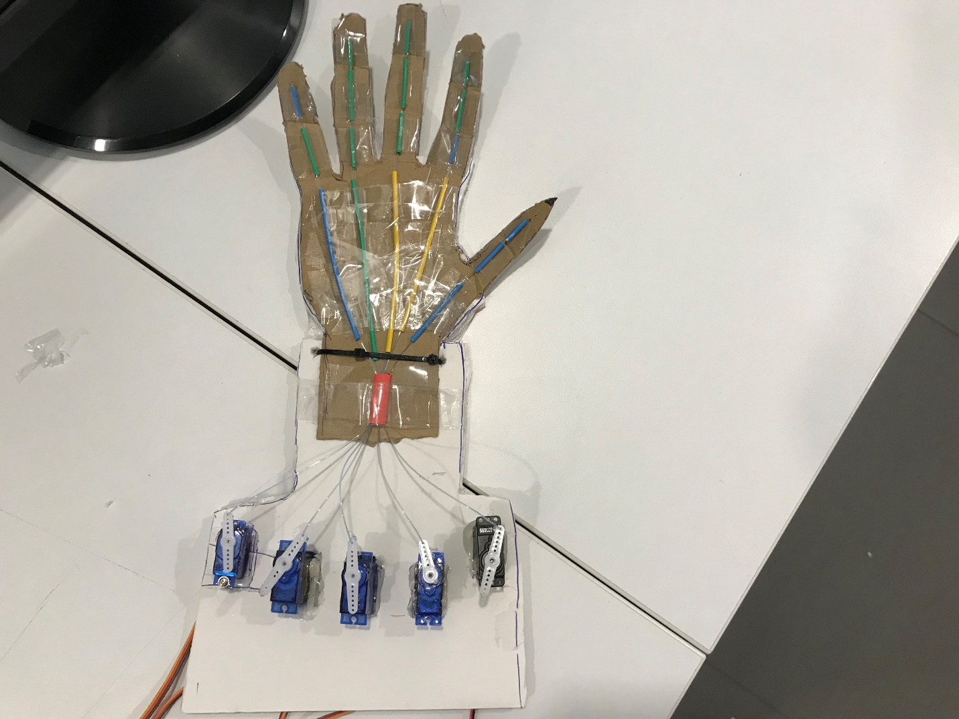

1. Test Arduino and Servo Motors

* Open Arduino IDE, go to File > Examples > Servo > Sweep. Run this code on Arduino.
* From the function **myservo.attach()** change the function parameter to the pin number you want to test (3, 6 or 9)
* Select the port that the Arduino is connected to from the tools menu
* Upload this code on Arduino and check for each digital pin that the motor is connected to
* The servo should go from 0 to 180 degree and back to 0 in small time intervals.

1. Upload Firmata Library on Arduino

* Firmata is a generic protocol for communicating with microcontrollers from software on a host computer. It is intended to work with any host computer software package.
* Go to File > Examples > Firmata > Standard Firmata. Open the file and upload it to Arduino

1. Code for processing

* Coding in the Processing IDE is done in Java programming language.
* Given below is the code snippets for different sections in the main source code along with comments explaining the functionality
* Importing Libraries and creating objects

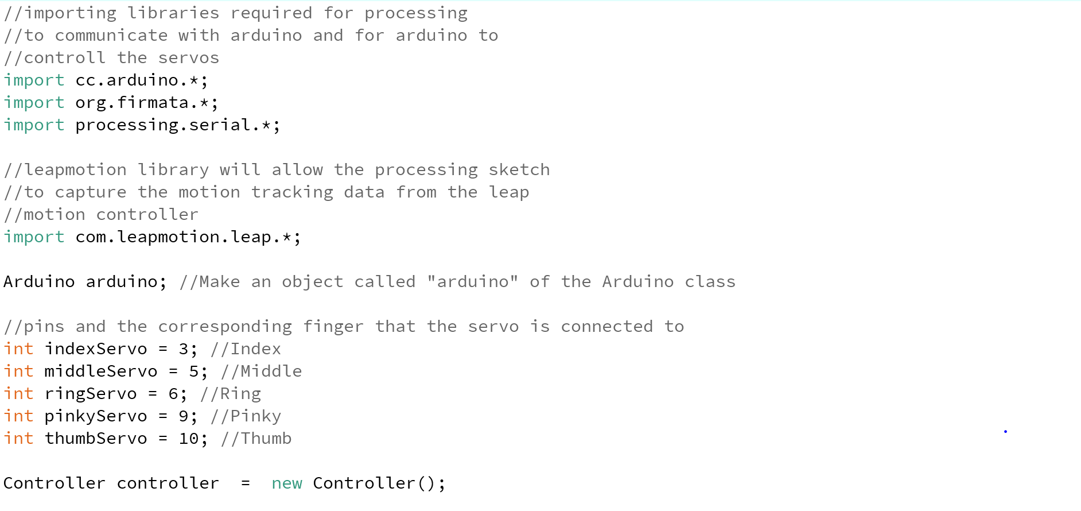

* setup() function

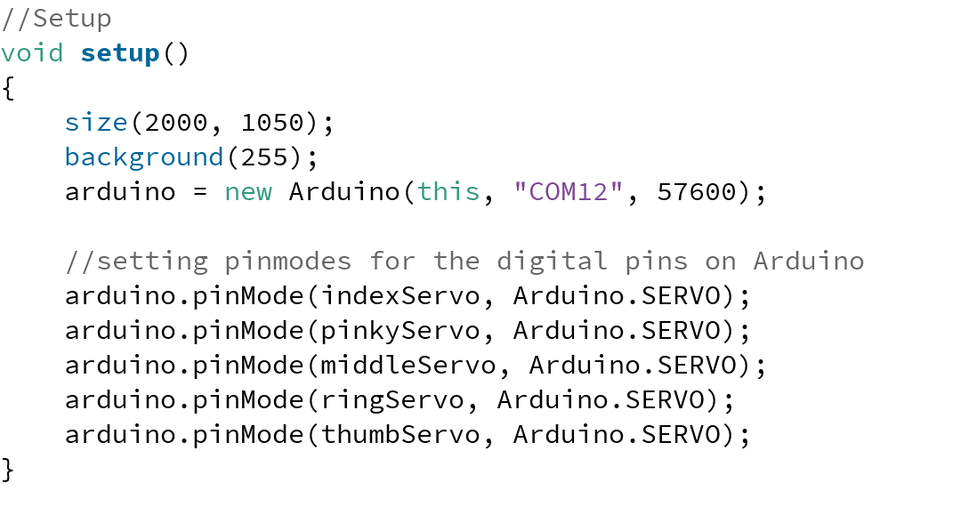

* draw () function

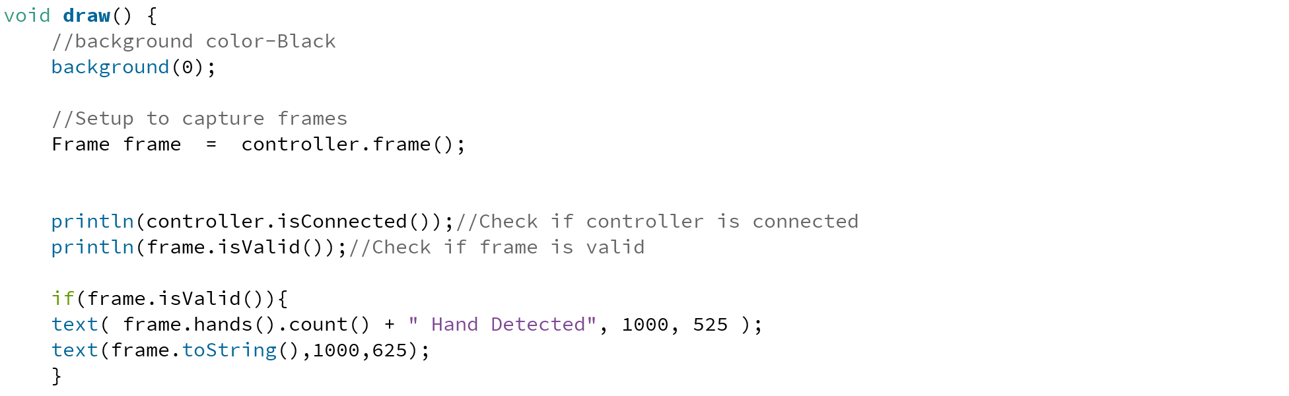

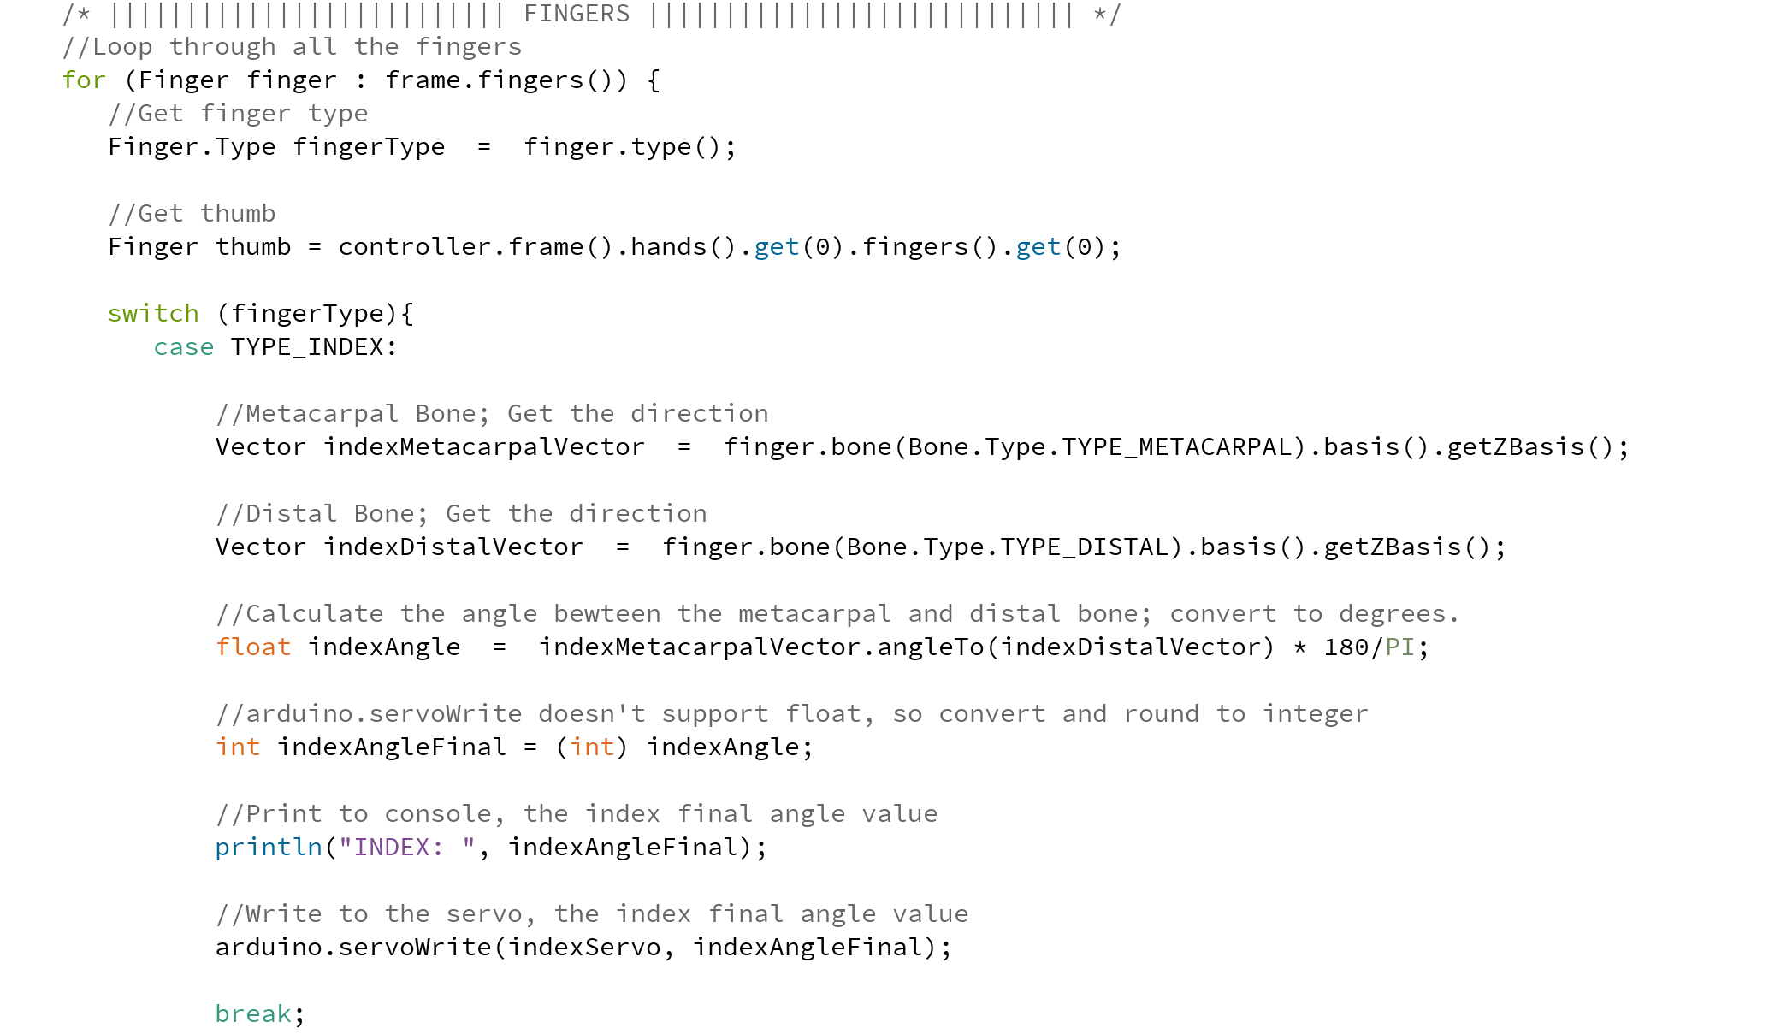

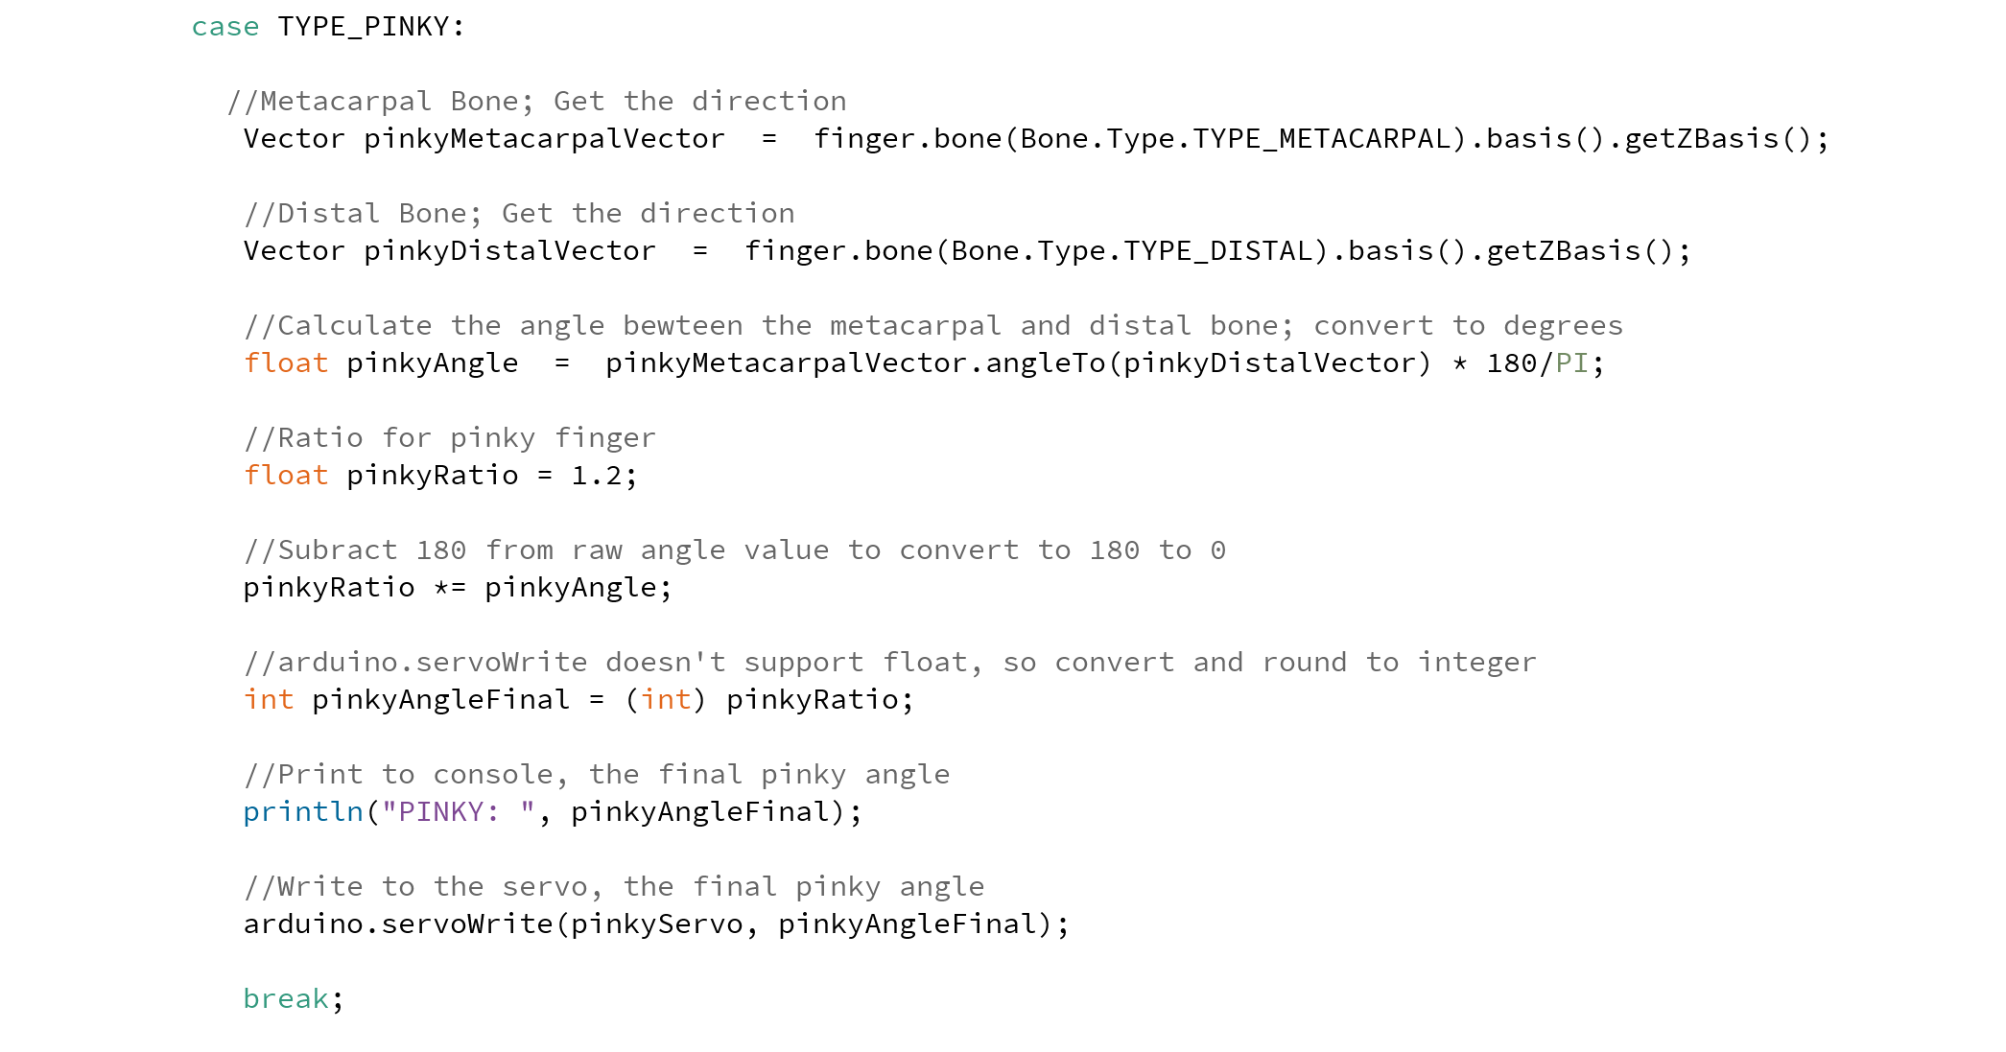

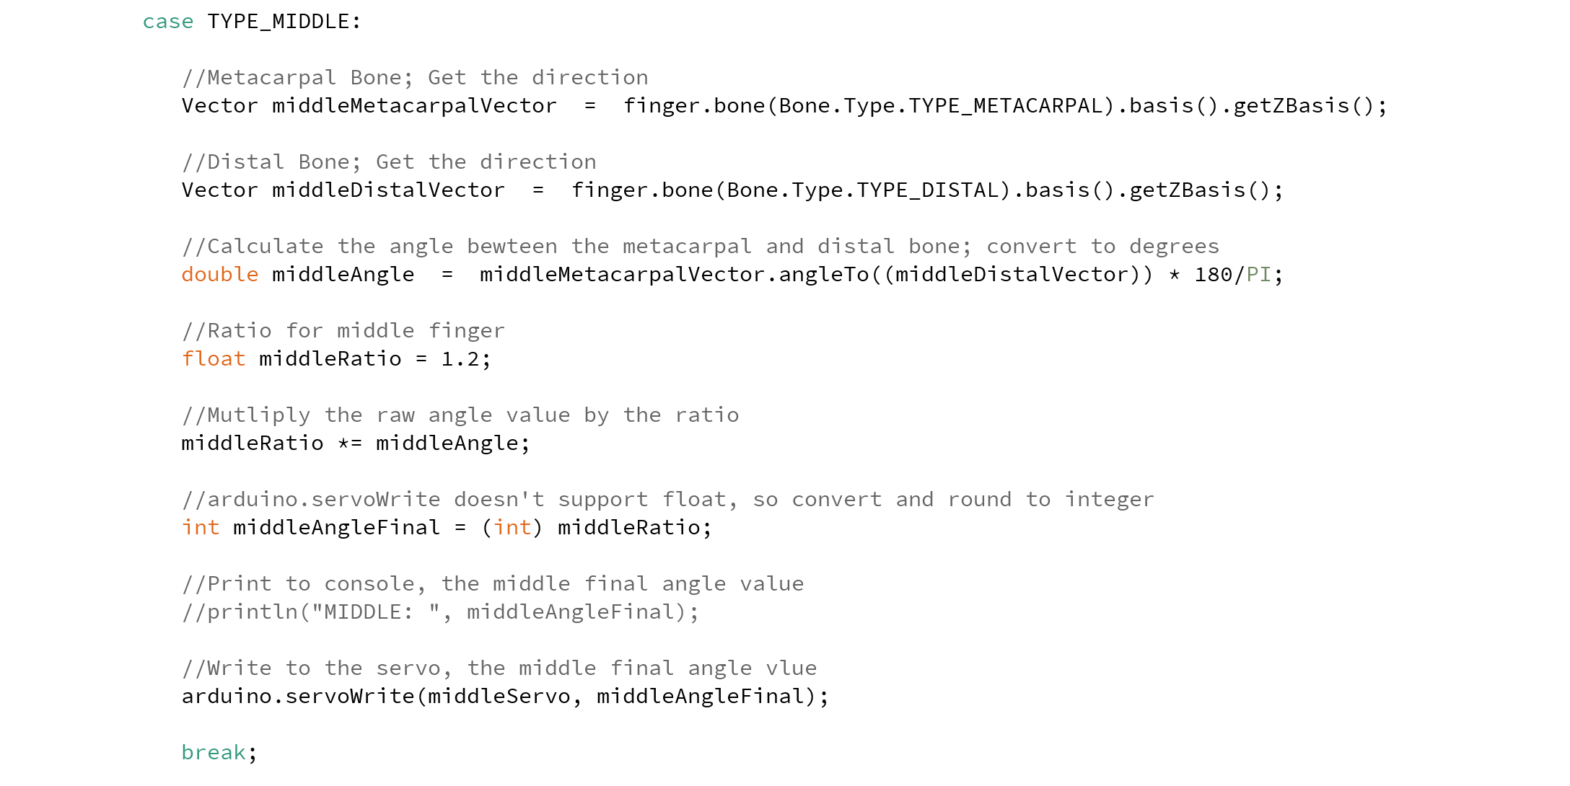

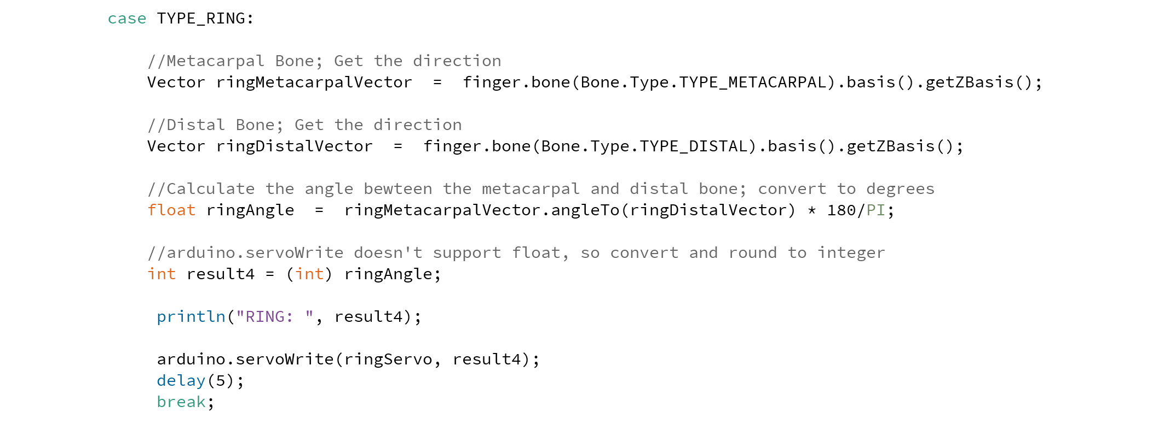

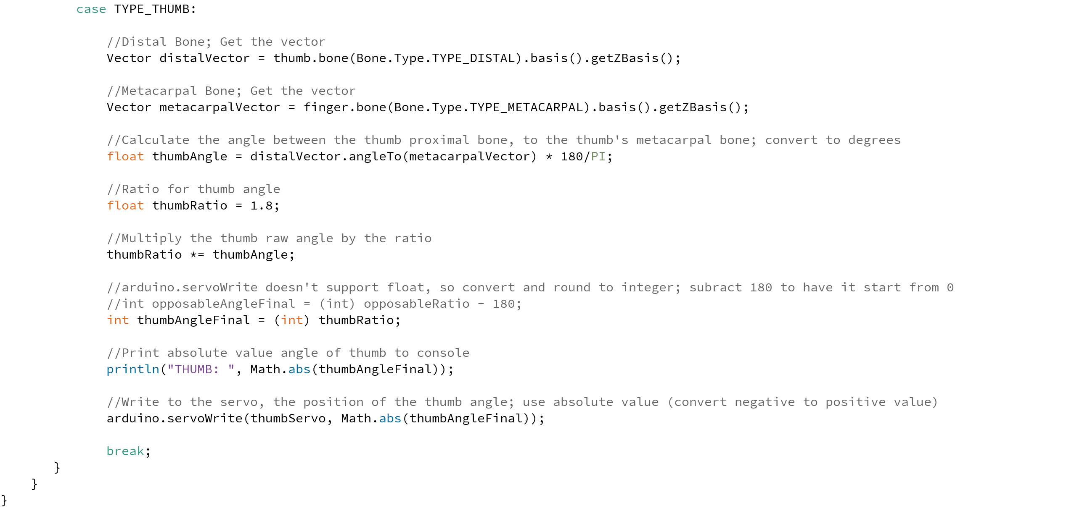

**References and Tutorials**

* <https://en.wikipedia.org/wiki/Leap_Motion>
* <https://developer-archive.leapmotion.com/>