資工所碩一 111522071 張凱東

**1313. Decompress Run-Length Encoded List**

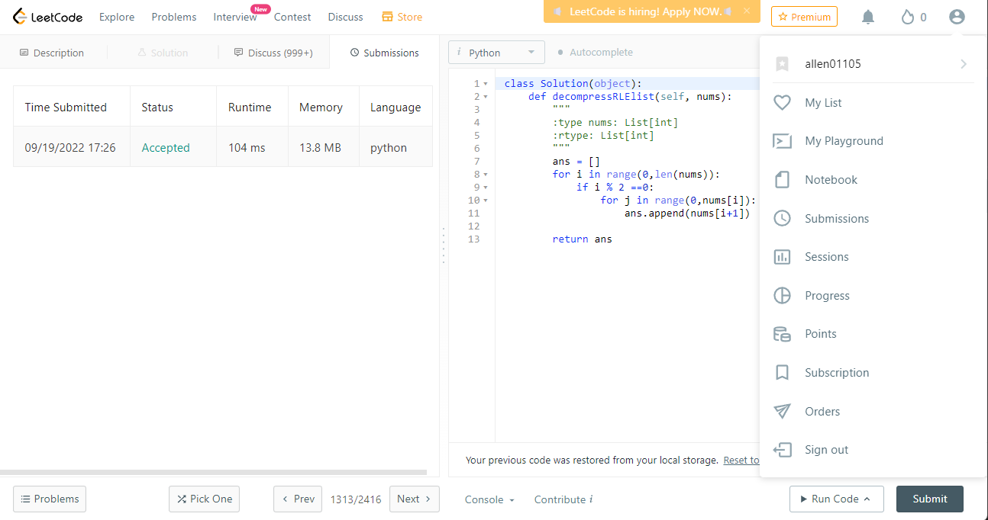

**1431. Kids With the Greatest Number of Candies**

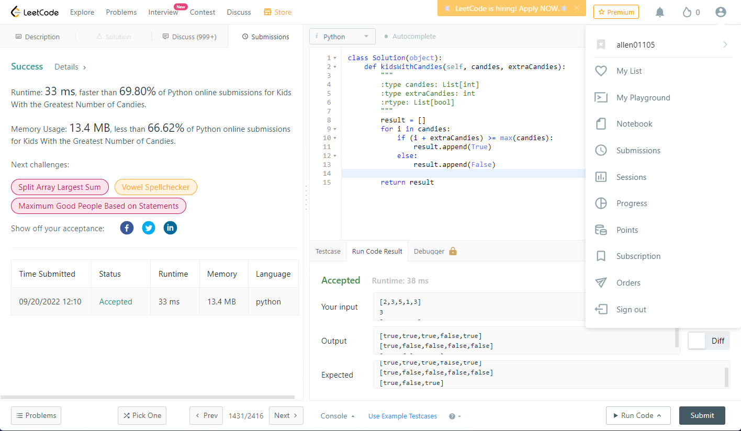

**1480. Running Sum of 1d Array**

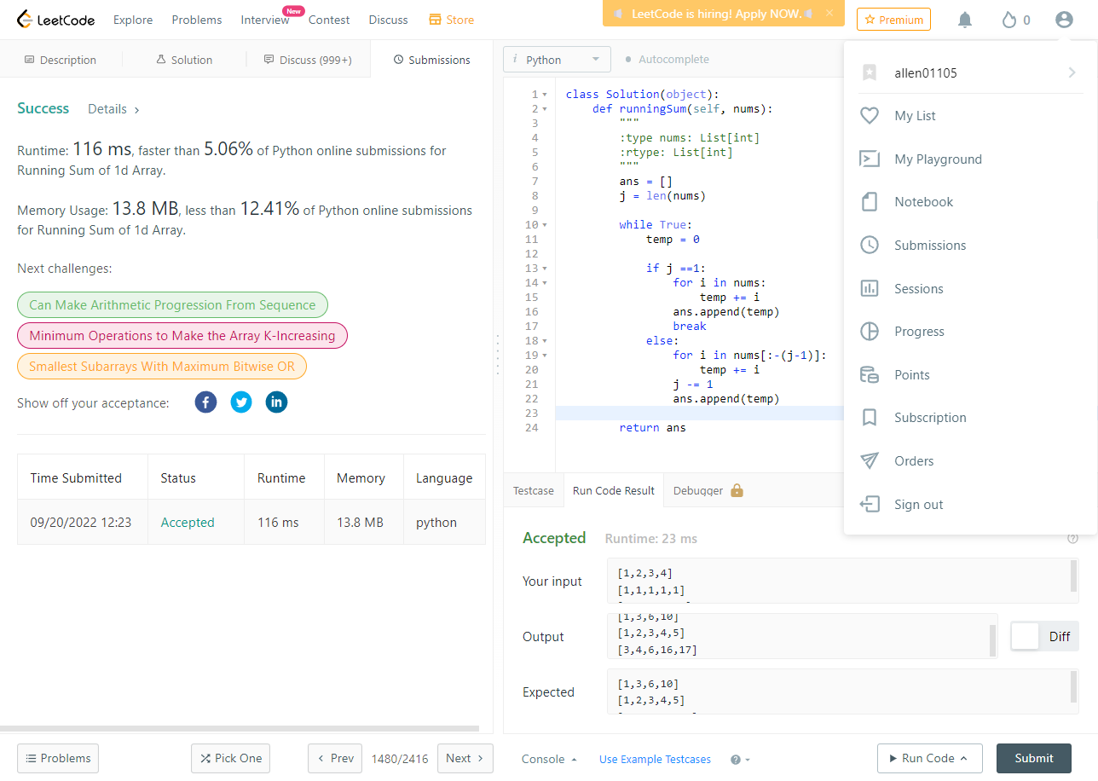

**1528. Shuffle String**

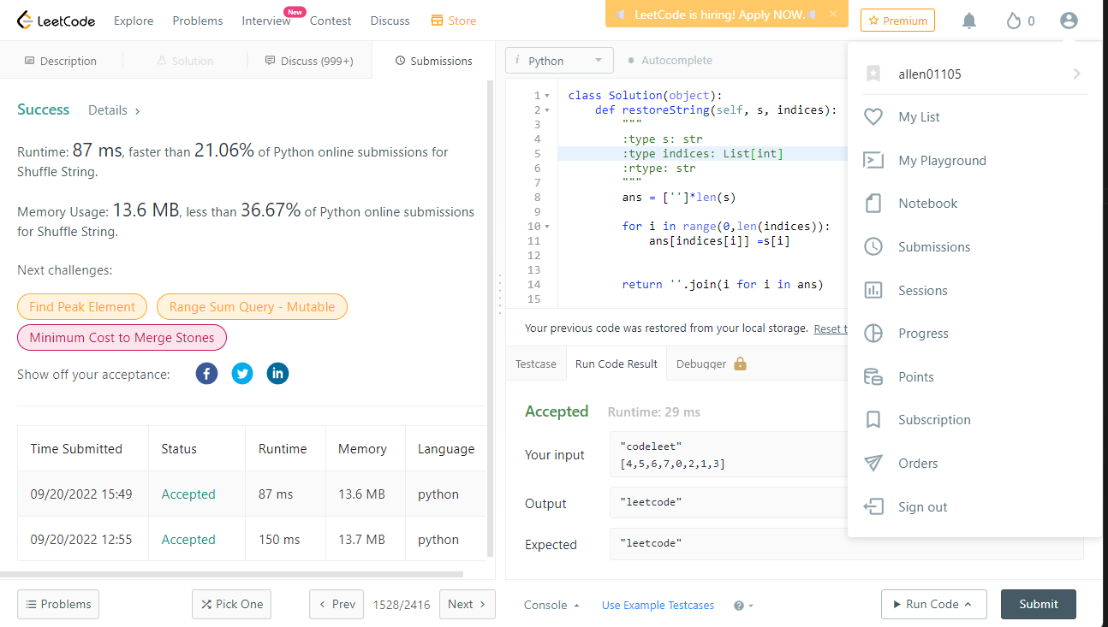

**1672. Richest Customer Wealth**

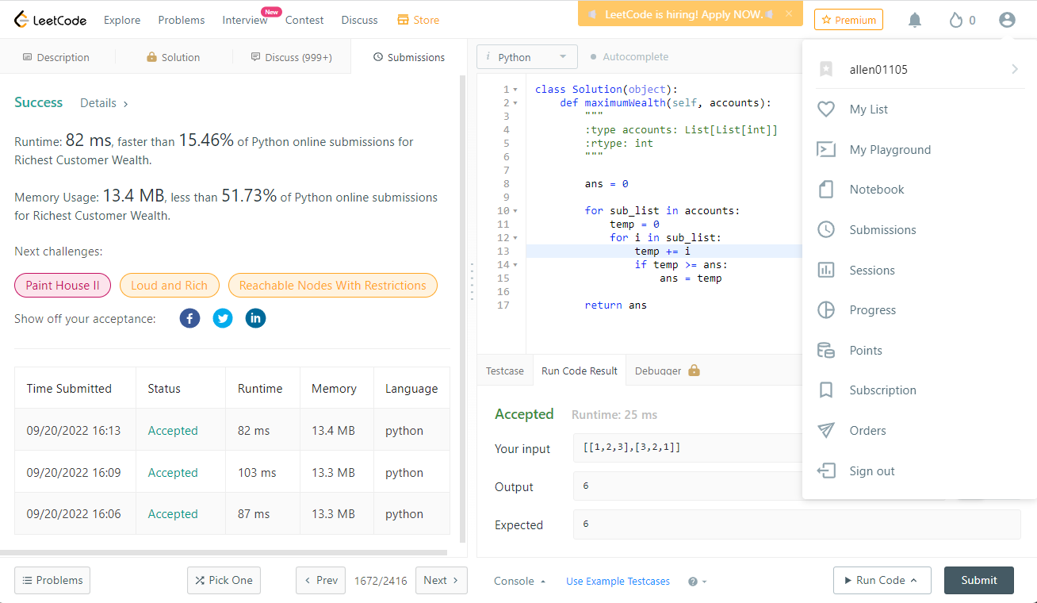

**1512. Number of Good Pairs**

