
网络空间安全实验基础
实验报告

实验名称： 公钥基础设施（PKI）

2025年8月
任务一 任务名称
一、实验内容
（提示：包括讲义要求内容、自行增补内容）

1、构建一个证书颁发机构（CA）
2、创建一个证书签名请求
3、为你的域名生成证书
4、为你的网站添加证书
5、在浏览器中导入证书
6、检验网站是否被浏览器所信任

二、实验过程
（提示：实验所涉及的命令、代码、效果截图等）

1、在虚拟机VM的当前实验目录下创建CA的工作目录
2、创建CA的公私钥并自签证书
3、查看证书文件ca.crt和私钥文件ca.key

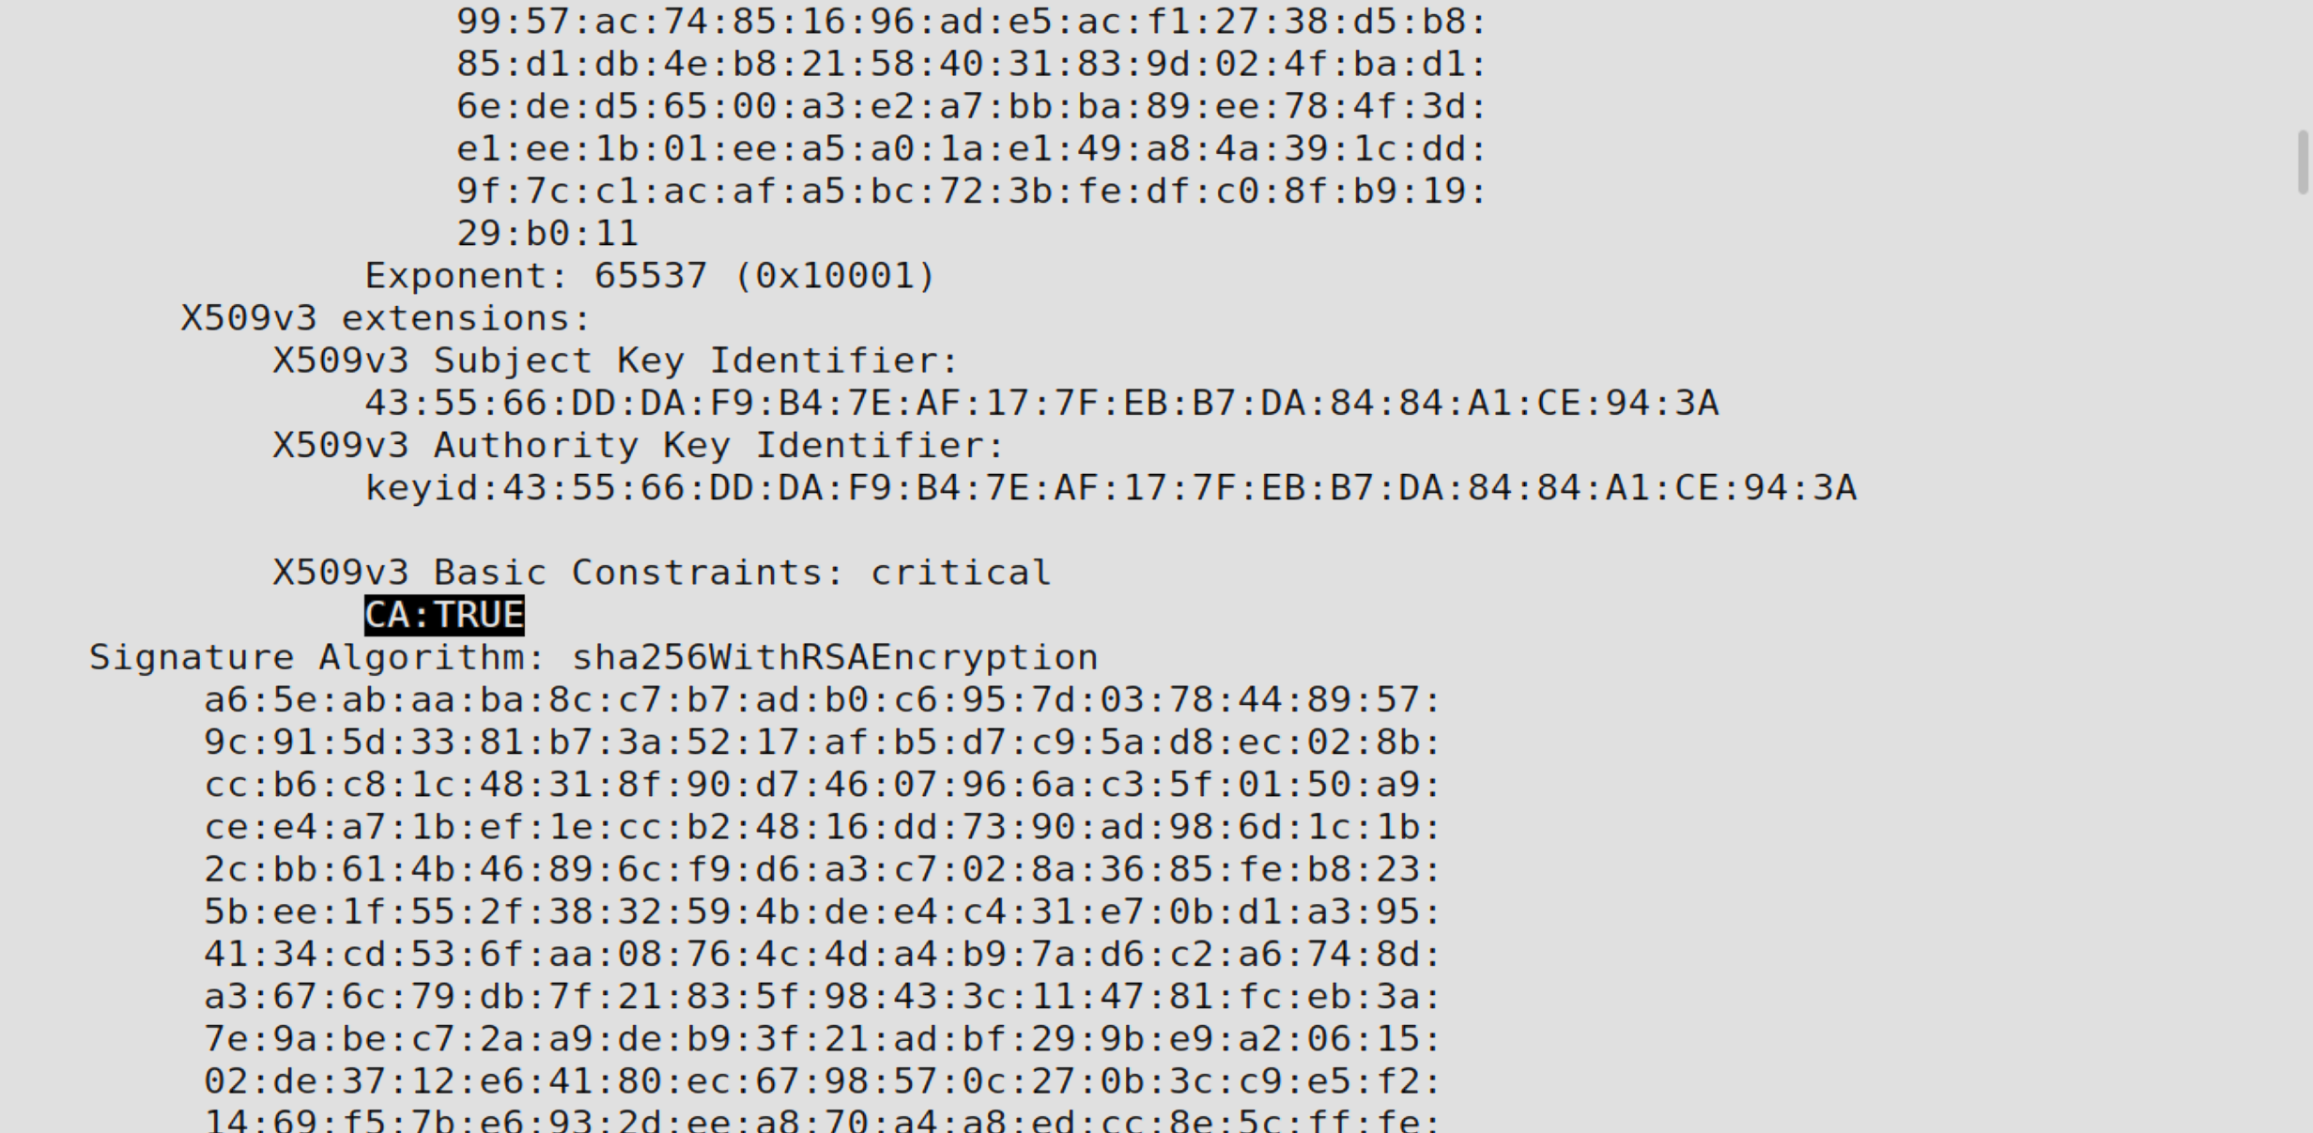
“CA:TRUE”证明这是一个CA 的证书。

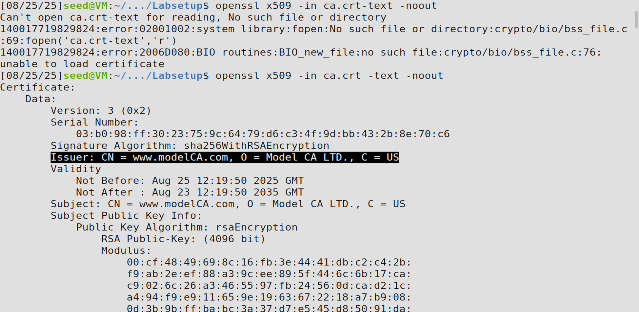
标黑部分说明这是一个自签名证书。

并且通过信息得知：

公开指数e = 65537，

模数n:
00:cf:48:49:69:8c:16:fb:3e:44:41:db:c2:c4:2b:
f9:ab:2e:ef:88:a3:9c:ee:89:5f:44:6c:6b:17:ca:
c9:02:6c:26:a3:46:55:97:fb:24:56:0d:ca:d2:1c:
a4:94:f9:e9:11:65:9e:19:63:67:22:18:a7:b9:08:
0d:3b:9b:ff:ba:bc:3a:37:d7:e5:45:d8:50:91:da:
ec:c4:6d:5b:01:db:0c:f5:00:06:84:f9:16:84:b0:
86:0b:8f:40:63:40:2d:03:12:93:00:99:09:8b:e1:
26:e5:ce:1b:10:52:35:73:6c:0a:9a:5d:a8:fd:55:
b4:57:e6:8b:39:f8:24:5f:ef:46:a1:be:36:38:45:
a5:11:e2:3d:fe:b1:ce:88:f5:e0:27:12:02:92:25:
bd:8a:21:b4:c1:c1:da:6c:11:87:50:84:3f:5a:fd:
82:40:e5:57:7b:98:05:c0:8e:cd:cc:7b:8a:4b:e7:
f1:27:35:c0:86:d2:a2:de:76:07:ec:6e:11:3e:a2:
29:9c:a8:db:57:b1:55:49:15:e8:a9:78:b6:fc:15:
3e:65:07:d6:f6:83:df:8d:8f:f0:c0:92:f5:f5:53:
44:42:19:d5:4c:8c:f2:d1:f4:5f:80:a0:63:d3:ad:
ef:75:5a:83:b7:ca:d1:f1:89:9c:37:b1:b2:b4:5c:
f6:79:c6:76:a4:b2:ae:c2:fb:f3:a5:b1:30:ce:e5:
d4:2e:3f:20:ca:54:b5:34:3e:6e:99:84:5b:27:2c:
b7:25:95:06:70:a3:33:80:35:7d:4e:f7:53:a6:1f:
ab:2f:3a:ea:a2:bc:72:92:71:7f:59:c9:bf:13:a3:
d2:70:ad:9e:8e:cb:30:82:25:96:2b:df:e2:72:6b:
20:f8:2b:46:1e:3c:8a:96:c7:b4:a1:8c:58:d9:2d:
fe:eb:10:9f:59:07:34:c5:05:54:81:97:60:6b:3a:
74:40:c6:f7:0f:b8:49:c8:a2:1f:52:86:f0:1b:85:
79:3d:46:cd:f1:14:47:67:8f:ee:ee:c5:d6:9a:61:
f1:d4:1a:15:1b:2c:d6:5a:eb:0f:57:00:0e:24:f1:
e0:89:83:7c:39:96:bc:c5:87:a6:45:40:45:c1:9c:
aa:1f:e7:bc:d9:0a:30:b5:41:e6:6c:f8:dc:a9:56:
99:57:ac:74:85:16:96:ad:e5:ac:f1:27:38:d5:b8:
85:d1:db:4e:b8:21:58:40:31:83:9d:02:4f:ba:d1:
6e:de:d5:65:00:a3:e2:a7:bb:ba:89:ee:78:4f:3d:
e1:ee:1b:01:ee:a5:a0:1a:e1:49:a8:4a:39:1c:dd:
9f:7c:c1:ac:af:a5:bc:72:3b:fe:df:c0:8f:b9:19:
29:b0:11

私有指数d:
4c:76:1e:d6:77:5d:b6:da:16:35:b1:0a:1c:71:18:
4d:04:28:49:e0:08:b0:99:2d:f2:40:88:14:a3:b2:
18:59:aa:bb:09:e3:e3:07:3a:35:20:2b:53:ec:4a:
ed:c5:6e:2b:03:b0:19:2f:68:c8:d4:0d:72:9c:bc:
bc:e3:63:a7:0f:6d:ee:51:8e:7a:80:3b:e0:41:c0:
9b:08:b7:cc:6c:70:50:23:ed:43:b9:da:8b:a1:ce:
20:8f:7c:31:e0:67:7a:3d:ac:ca:48:a9:93:d6:bf:
11:80:40:cd:79:75:cc:18:eb:a4:5b:ae:4d:9d:02:
c4:75:ff:9f:a7:a0:4b:5f:29:4f:da:a9:87:82:71:
4c:b2:87:29:df:8f:0f:48:9b:a1:ed:eb:d2:db:67:
1a:80:2a:7c:5a:b4:e6:ae:64:9a:d7:dd:c3:03:c6:
bb:87:9e:08:b2:60:54:d2:98:a9:b8:5c:a0:79:73:
a4:82:18:7d:e3:4f:3e:fe:8d:17:b2:d6:5b:a3:57:
f4:38:f9:88:54:9a:e0:35:db:b8:40:16:47:d0:d2:
4e:54:61:00:58:4e:eb:9a:50:35:c9:40:3f:79:b2:
b1:2b:74:5a:23:98:22:c8:a1:3e:02:6c:30:96:75:
c1:75:5d:27:3c:02:cb:b5:76:51:b9:13:f1:a2:65:
2c:86:84:5a:d3:0f:b3:eb:28:f2:a9:52:9e:95:b4:
ad:8d:03:65:f8:42:72:ee:07:fd:51:75:6e:2a:cb:
05:cd:97:fb:3c:2b:96:53:4e:fc:9c:62:dd:d6:ef:
e0:e8:f9:84:1a:54:dc:b9:be:d6:db:d0:25:34:e6:
67:e5:f3:61:b7:9f:91:ba:fd:f4:f5:44:9d:2e:32:
ec:e0:29:f4:e4:7a:c3:df:53:ce:e3:15:c7:9c:60:
07:f3:d7:77:00:c0:2d:f1:7e:9e:83:ec:58:19:05:
c4:31:c5:c3:6c:05:b7:1f:59:3d:ea:56:7f:03:f0:
10:11:6a:b5:74:d7:c8:a9:a1:e5:a4:19:8f:4a:59:
f8:16:d9:b1:e9:34:ec:c4:6c:a0:38:fb:2e:6c:36:
b4:2f:05:36:25:19:84:ae:1b:fe:20:6e:7a:23:ac:
c4:39:bf:1b:3a:98:50:75:5c:a6:b0:e9:28:d0:d2:
c6:0f:88:c2:98:33:71:d6:6a:f7:4e:69:53:39:3c:
3d:ce:7e:30:9f:cc:2d:84:ba:39:3d:6f:6f:bb:16:
2f:53:28:f4:7c:b3:c4:61:12:73:70:62:dc:e6:88:
1a:3e:bc:8b:72:0a:47:d6:3a:a3:48:e0:92:10:73:
c8:09:f8:a8:29:cf:ce:4b:59:bd:00:61:1b:57:e3:
3c:01

质数p:
00:eb:0f:1e:51:f0:dc:14:0d:09:89:01:a0:ef:62:
89:54:e7:90:2a:15:c6:b5:19:f4:62:7b:e8:38:a3:
65:01:ad:50:79:da:84:5d:4d:64:2d:b2:3d:0e:7f:
ea:7a:1e:77:12:42:2d:f6:1c:bf:7d:ef:c2:3c:7e:
db:23:79:18:dc:12:e8:7d:e6:c7:ad:83:6c:06:13:
1a:fb:56:c5:9b:21:73:ed:20:e6:5e:c4:96:e6:86:
ca:a6:5c:5d:b2:a7:4c:a3:fa:9a:46:04:60:7f:c3:
a4:89:88:a1:e4:9e:90:d6:26:0d:46:ee:0e:59:45:
6c:d5:8e:e3:ee:0b:dd:55:e5:cc:ff:a1:c6:5b:c4:
d1:cd:91:60:86:af:ac:37:b9:43:eb:90:3a:7e:e0:
89:49:d9:26:77:2d:39:03:6f:91:4f:6b:ff:c8:26:
8b:bf:3f:60:37:37:e8:67:ac:e9:79:35:ed:d6:cc:
b6:5b:d7:53:c1:ac:e3:1b:db:b7:a2:dc:a5:64:a2:
ee:4c:ec:7f:df:a8:a7:96:a7:52:fe:5e:4b:66:21:
cd:97:b7:80:55:48:b7:64:32:dd:4d:05:f8:26:55:
00:7b:88:5c:dd:89:be:5c:e8:4a:03:da:b4:2a:d9:
6c:82:13:1c:87:21:d6:9f:68:c9:f9:e7:44:c1:98:
81:41

质数q:
00:e1:bf:ad:b1:2f:2d:74:49:5e:7d:e1:ba:b1:6b:
49:ad:f2:ec:8c:a7:cd:58:3f:d7:fa:65:b1:8c:d3:
f7:35:eb:71:20:79:bb:50:3f:40:63:88:55:0b:63:
e1:a3:2c:a1:0a:36:ec:f3:d0:22:34:70:5a:00:74:
3e:80:4b:90:a6:b3:b0:fc:fc:89:3c:7d:18:22:51:
7c:ca:5f:8f:e1:b3:ef:b1:f8:4c:02:d7:f8:98:9c:
02:c4:16:69:93:25:1a:95:15:d5:a0:af:c5:c1:9b:
32:36:71:59:82:08:85:24:36:35:c3:19:df:bd:44:
37:9c:3d:e8:b7:3d:f2:f0:fe:8a:22:21:9a:ae:e5:
11:f6:6c:b3:16:d5:cf:a1:49:a2:ba:e9:52:02:87:
31:34:4b:b5:c0:b6:ee:f3:09:27:b8:ad:82:24:c0:
52:26:0f:c6:ae:50:e7:64:9d:f6:f3:11:3b:c2:43:
59:86:97:22:59:18:7d:c0:65:0e:6c:af:9d:c8:ef:
e9:d9:60:d2:19:ab:a4:95:25:1a:3f:ff:d3:14:de:
ee:c4:c3:b0:99:3b:ab:b1:34:08:8f:35:5a:3e:54:
3c:12:41:94:c2:f9:bd:49:e9:34:4d:ad:52:7b:3e:
86:1c:95:74:36:ed:a0:c7:14:d6:4a:7e:dc:ae:13:
aa:d1

4、创建www.bank32.com的公私钥和CSR，并添加别名
5、查看CSR文件server.csr和私钥文件server.key

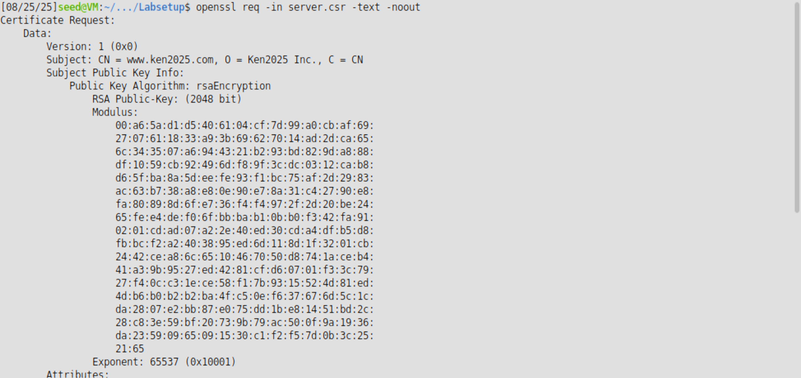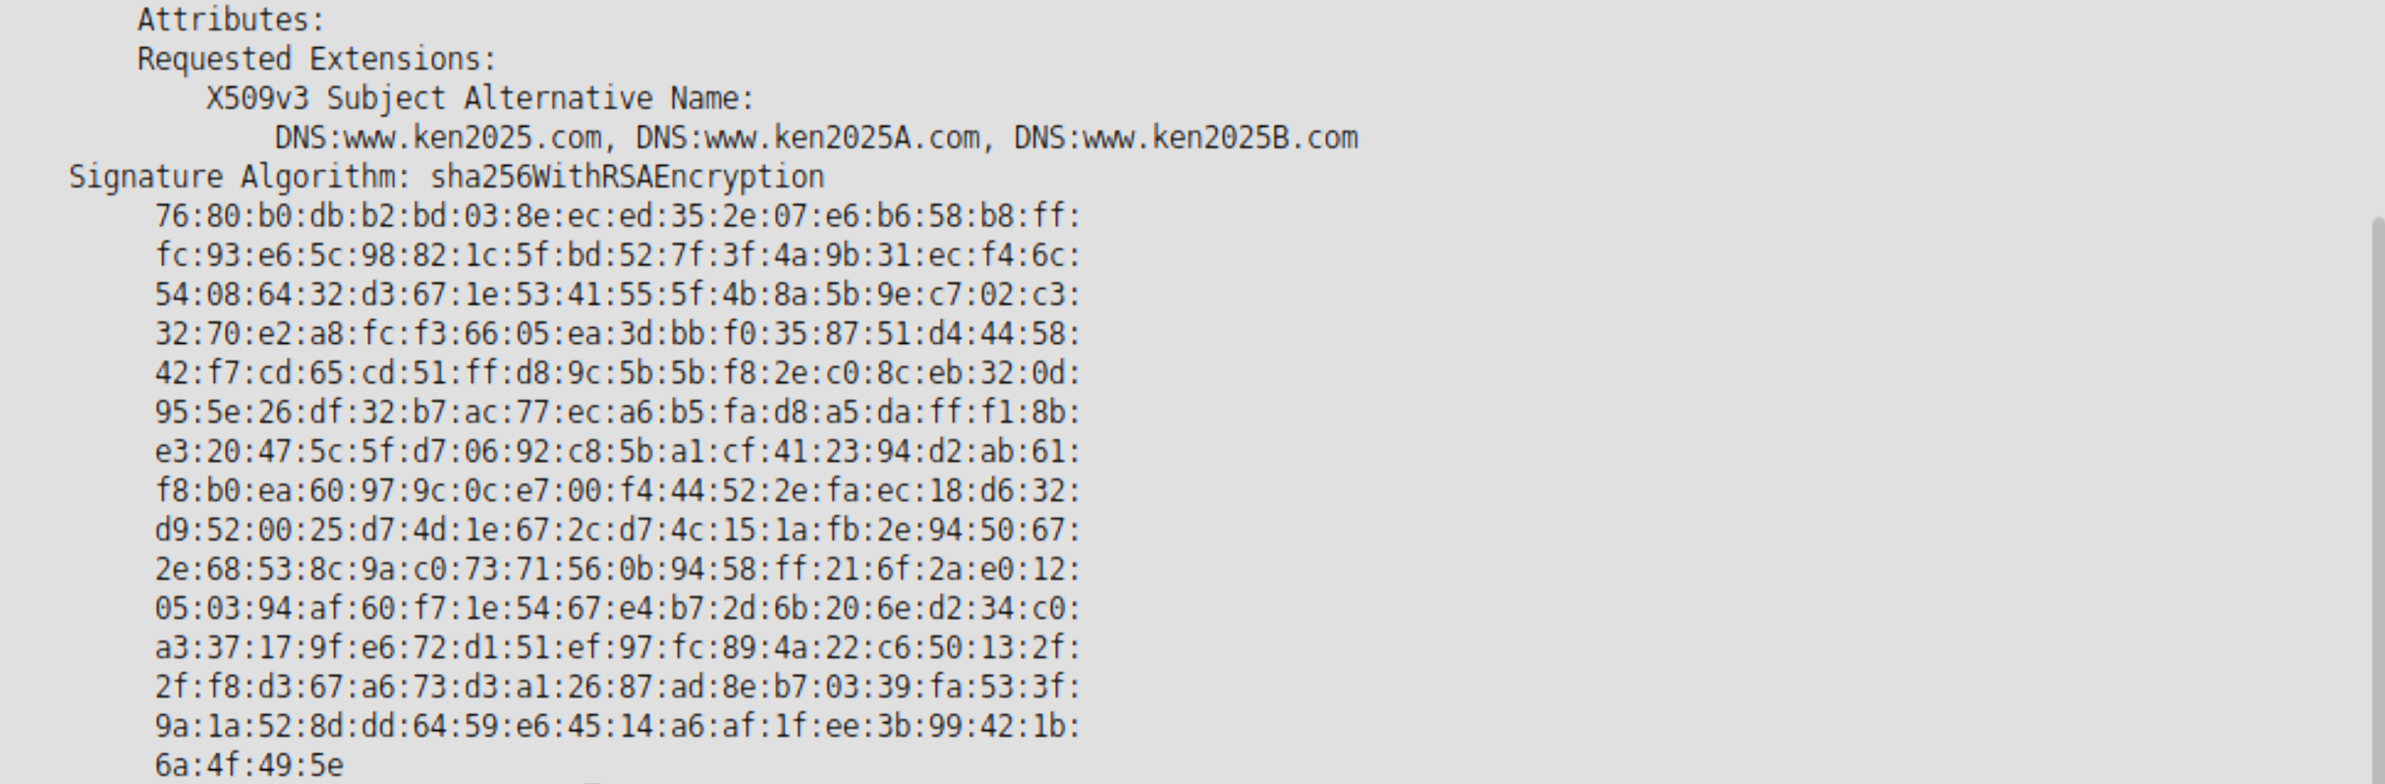
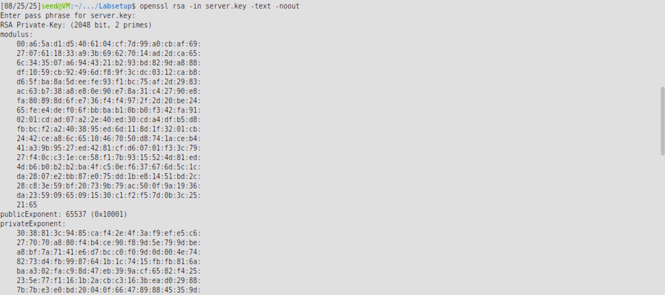
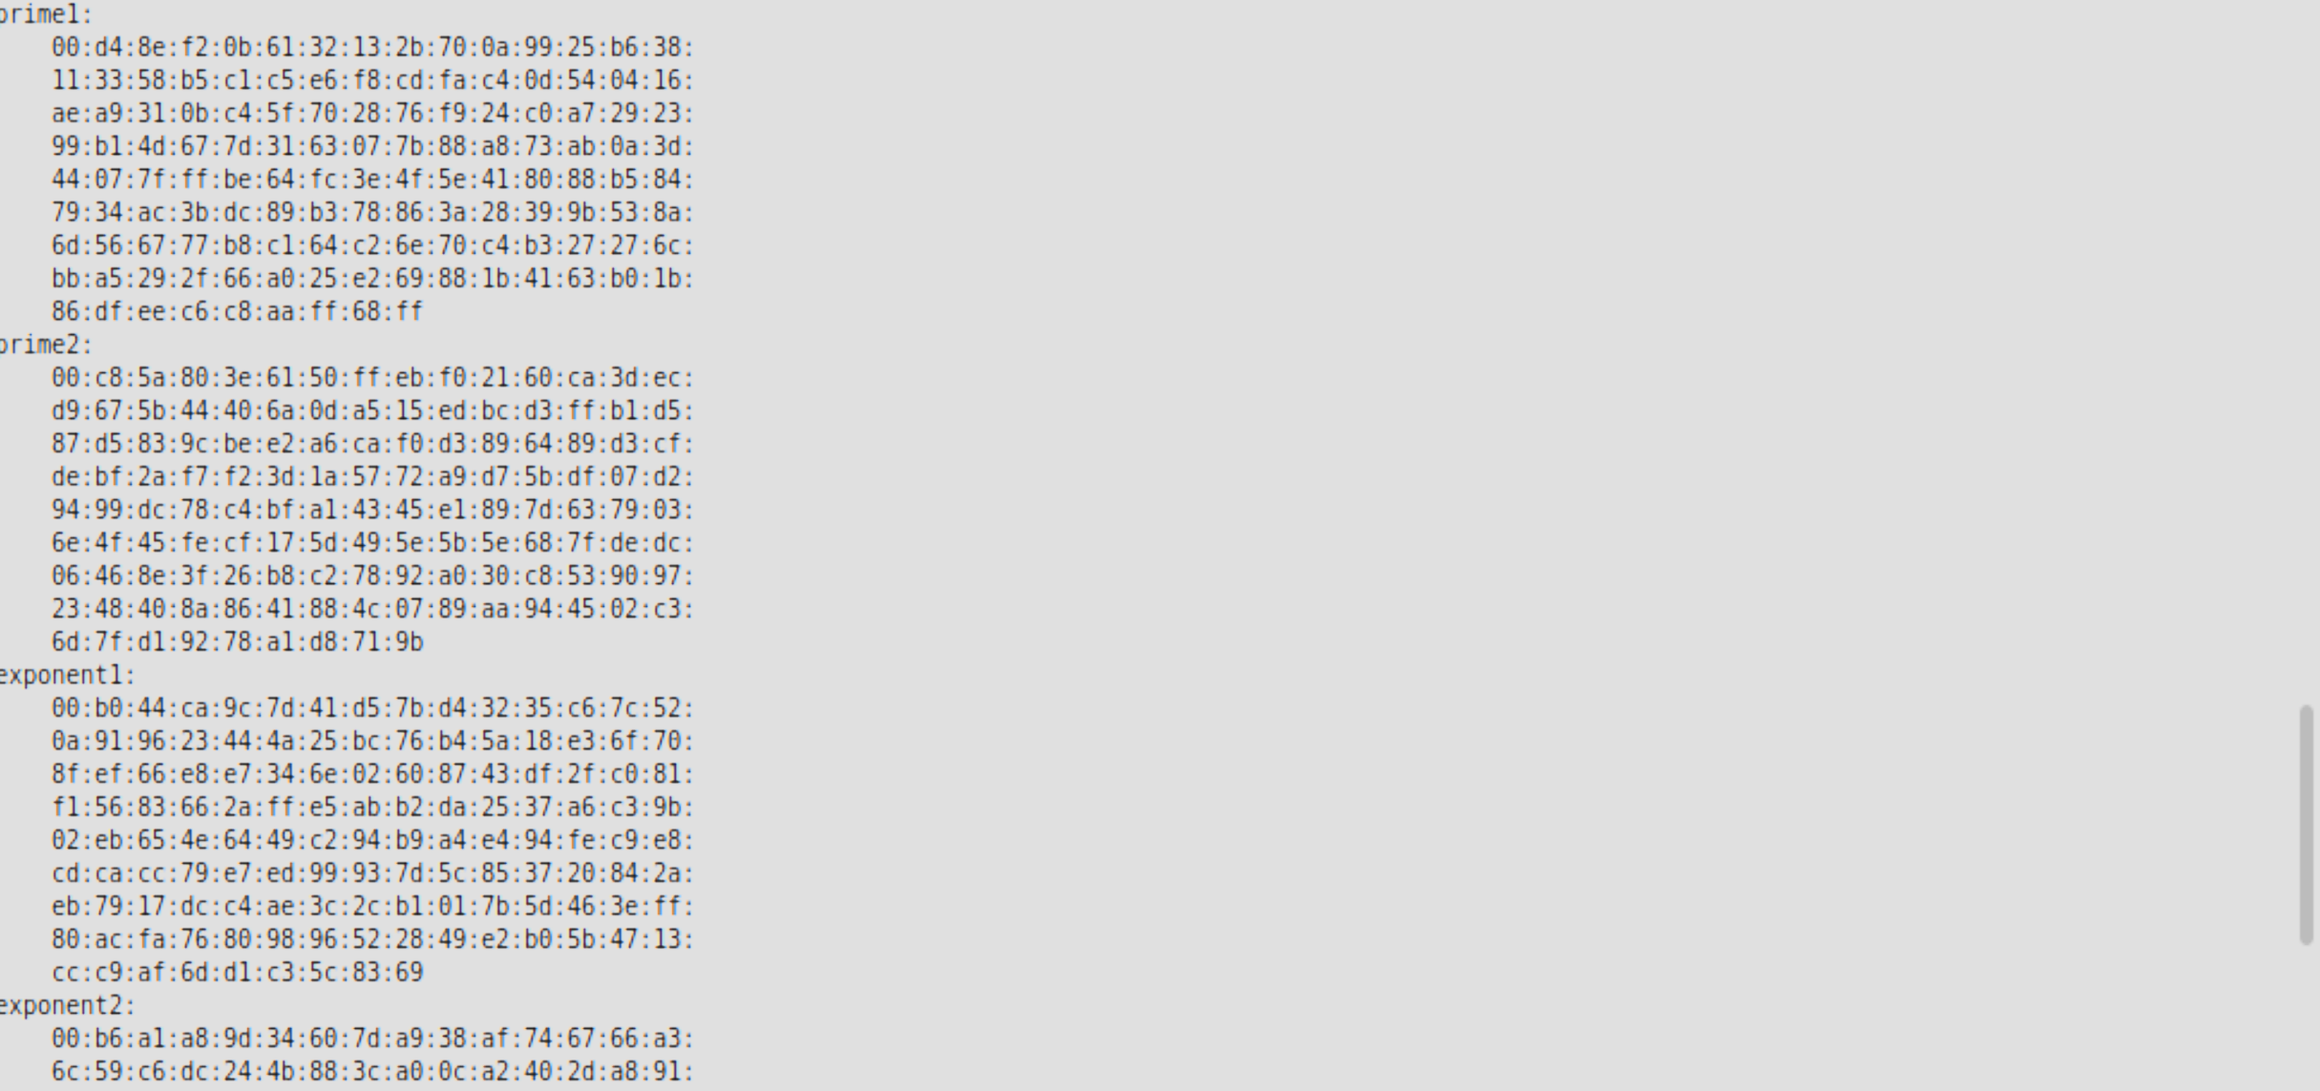
可以看到私钥文件的公开指数等相关信息。

6、修改默认配置文件
7、生成证书文件server.crt
8、查看证书文件

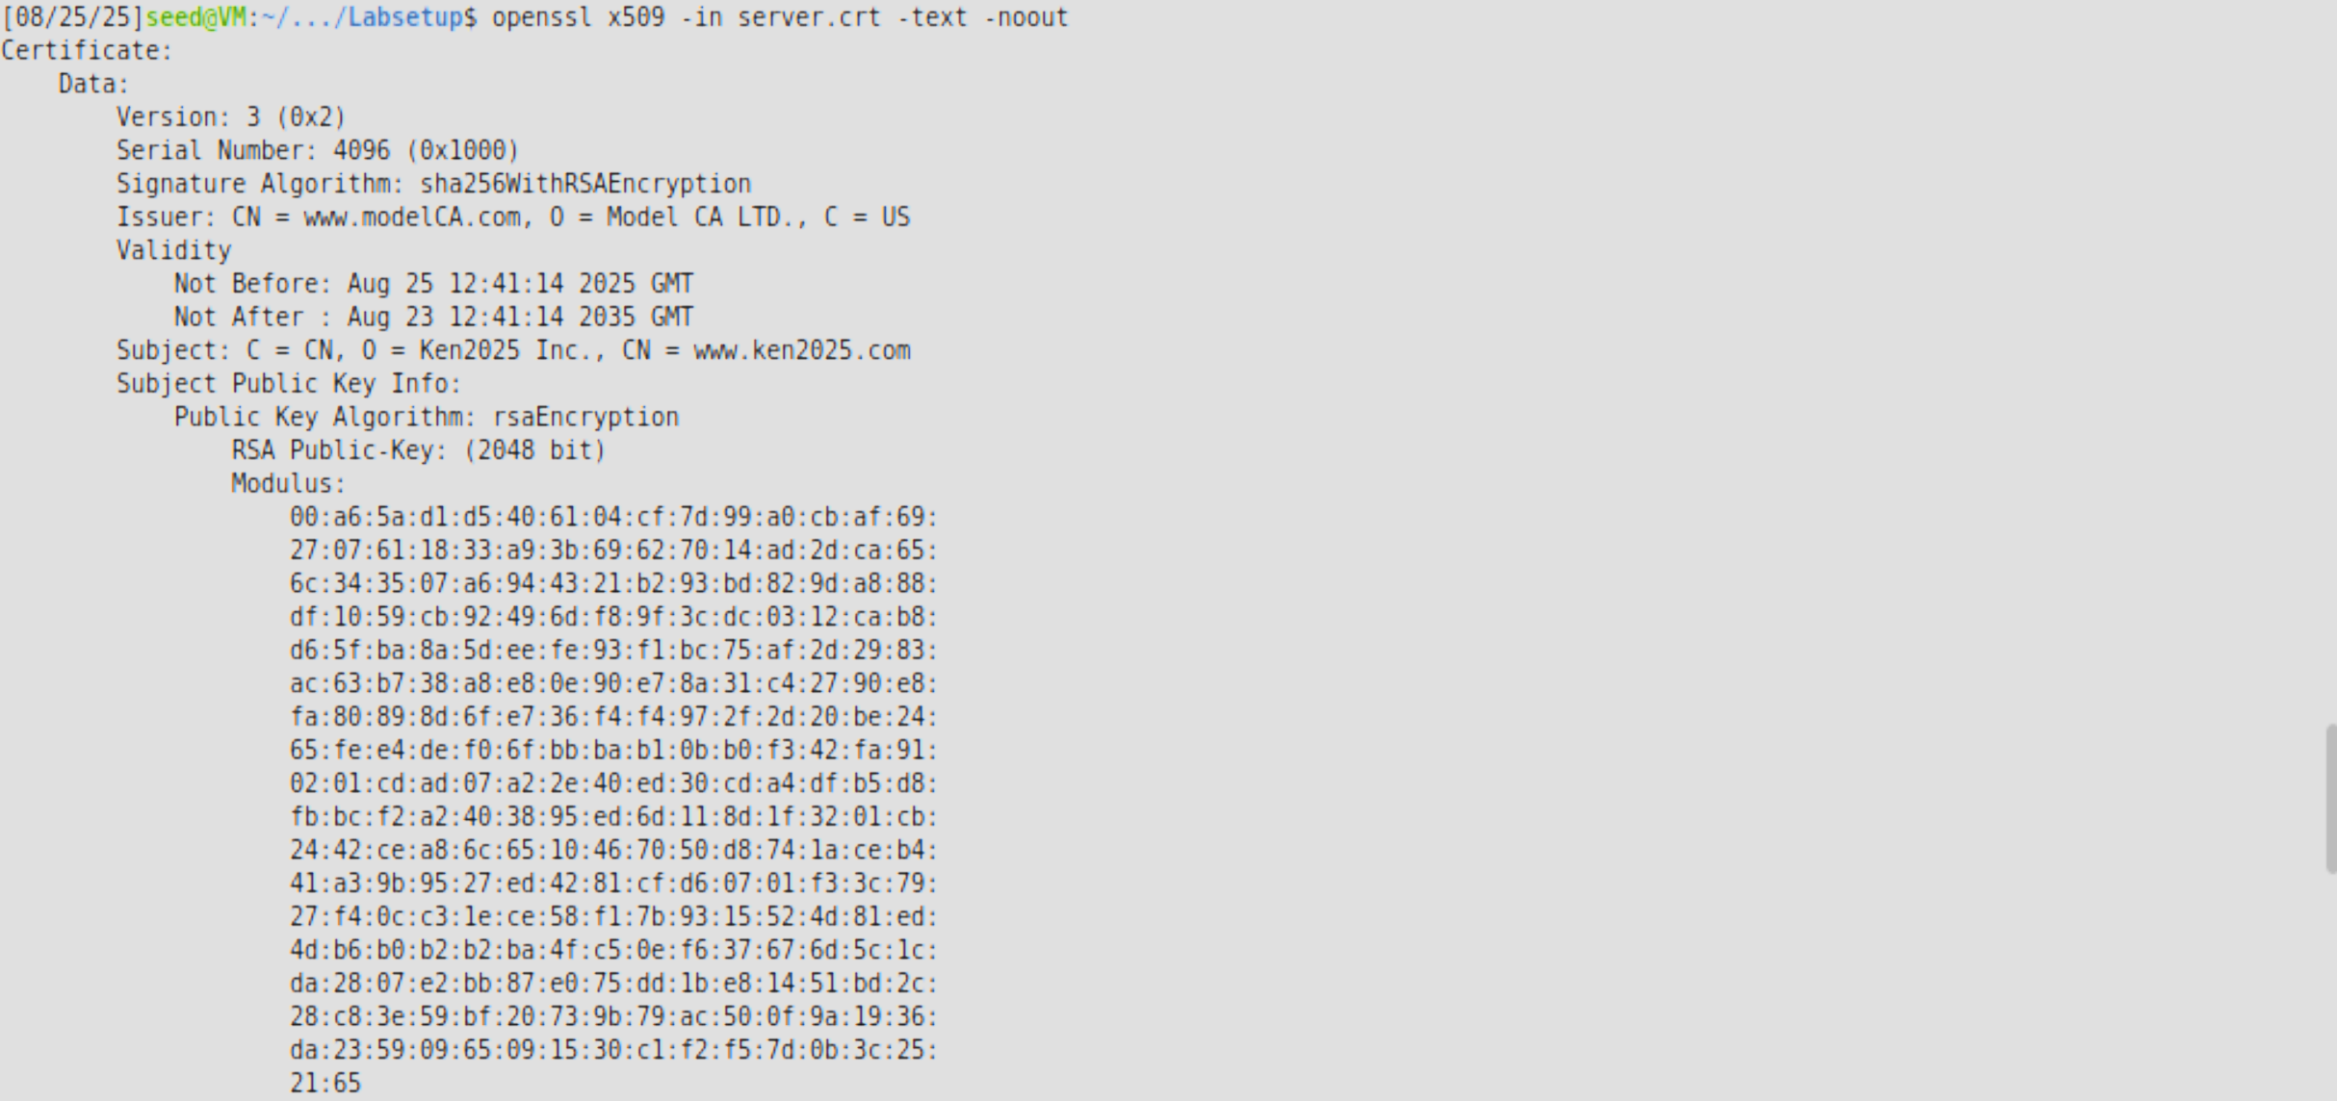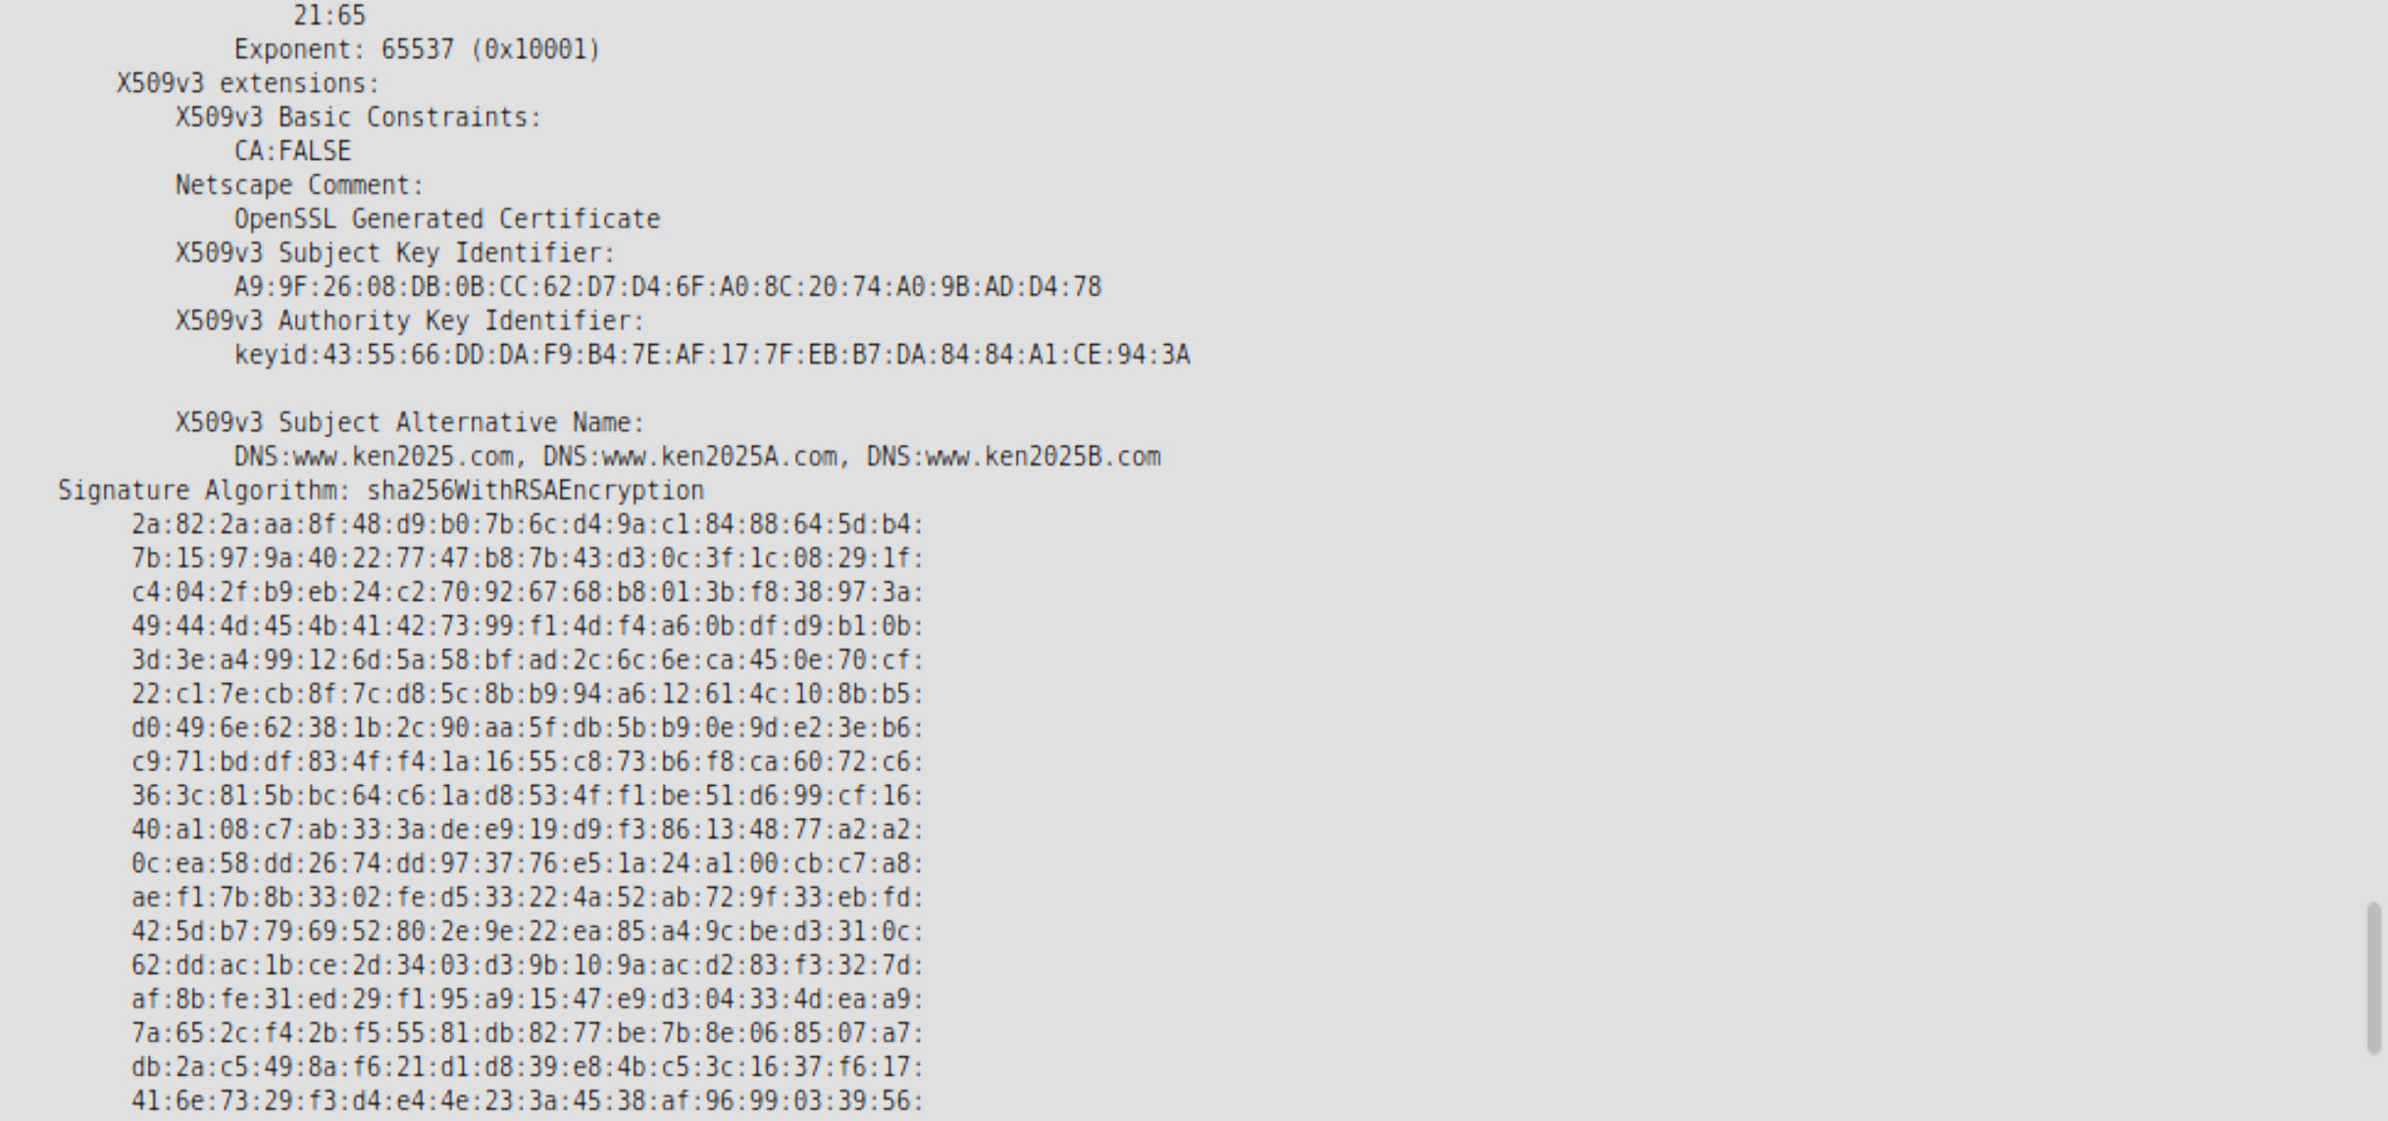
可以看到证书颁发者，序列号，签名算法等信息。

9、在虚拟机VM上当前实验目录的Labsetup下，启动容器
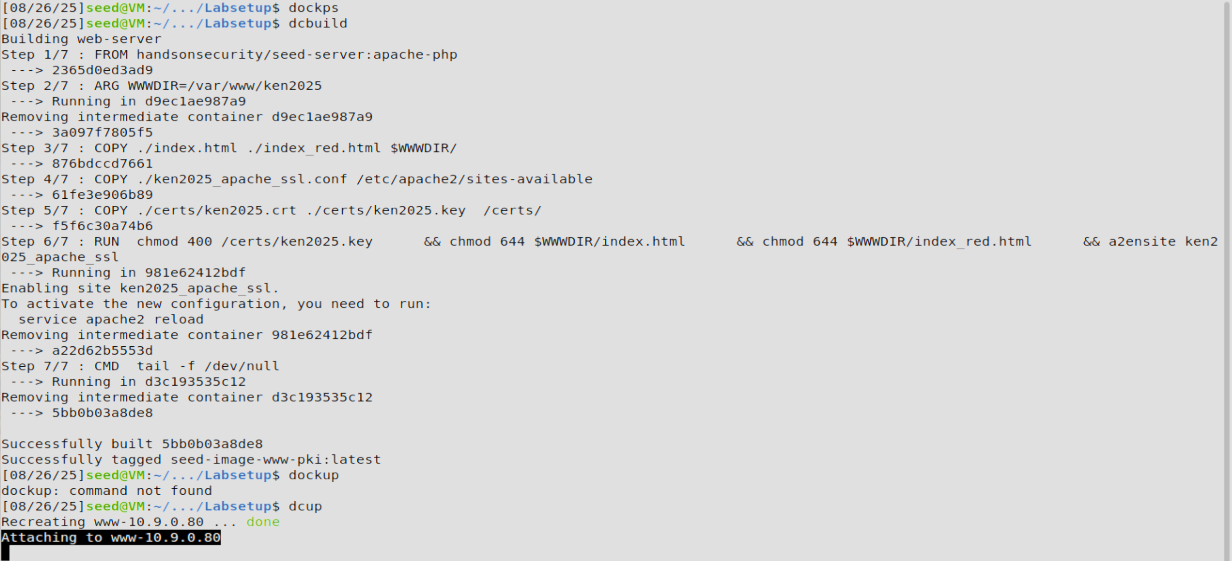

10、进入容器，查看Apache相关配置文件
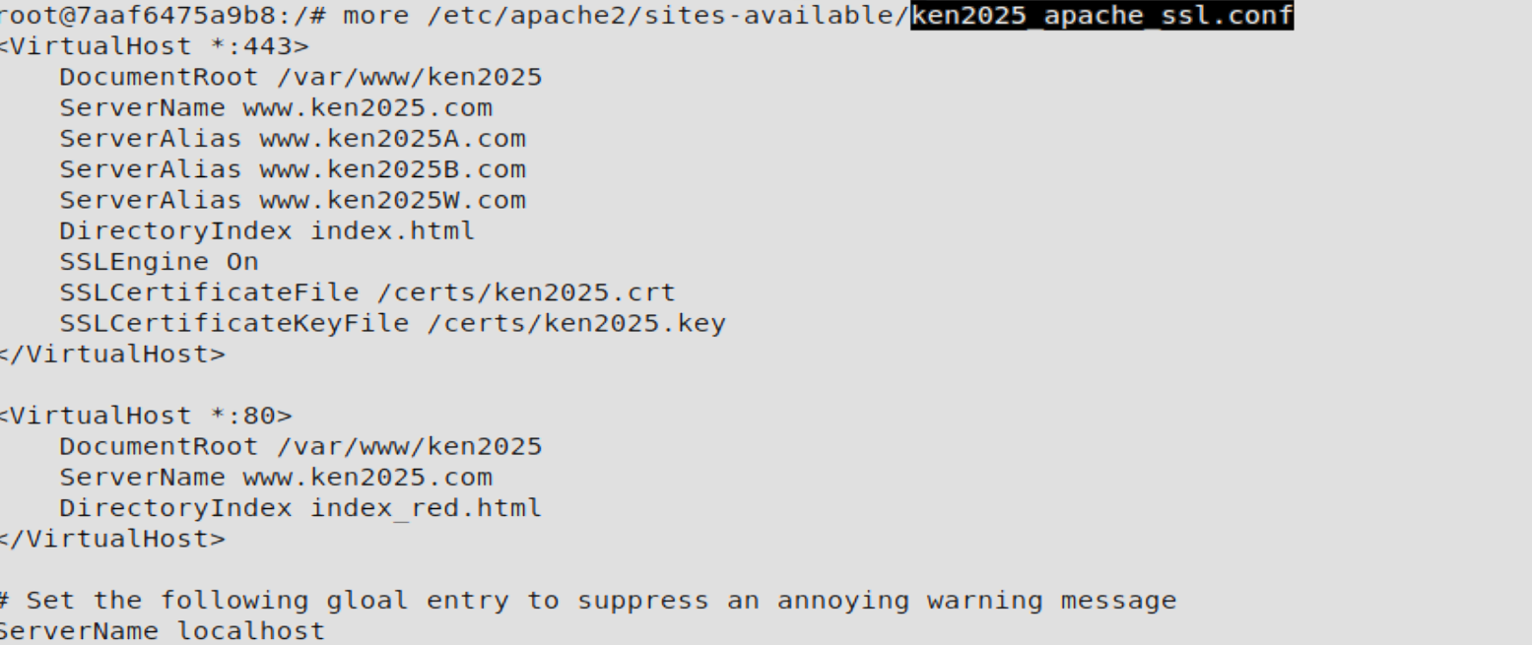

11、部署新的证书文件（含私钥和证书）
12、启动Apache服务器，在容器上执行

13、在虚拟机上修改/etc/hosts，配置域名访问
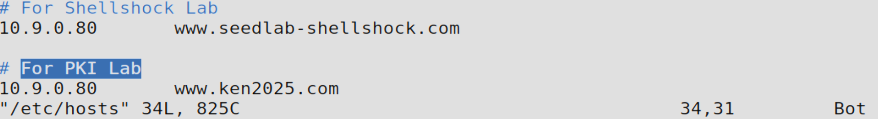

14、打开浏览器，输入https://www.ken2025.com查看结果
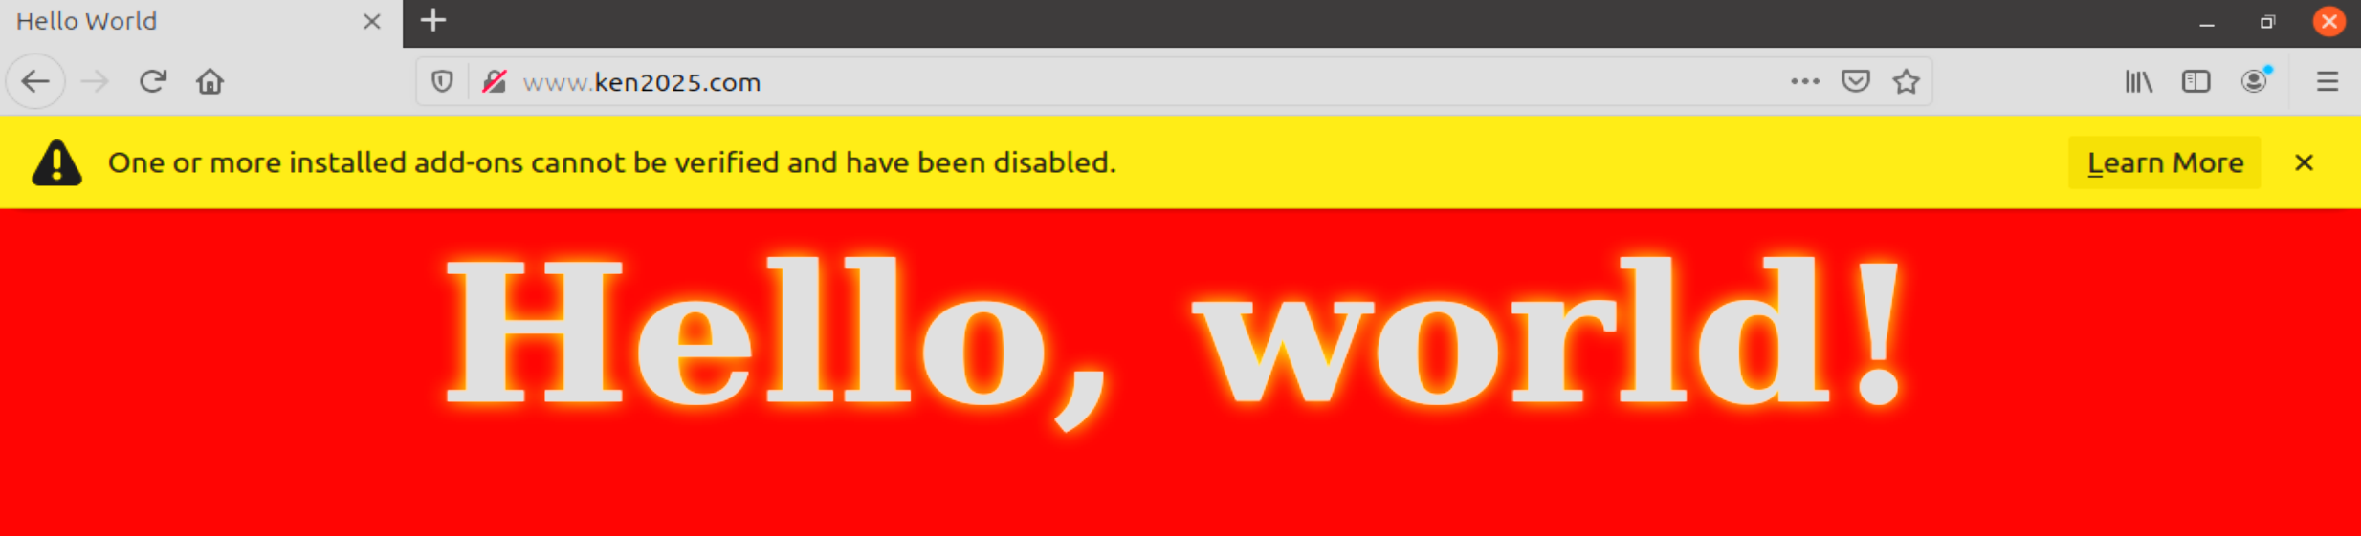

15、导入CA根证书，重新访问https://www.ken2025.com查看结果
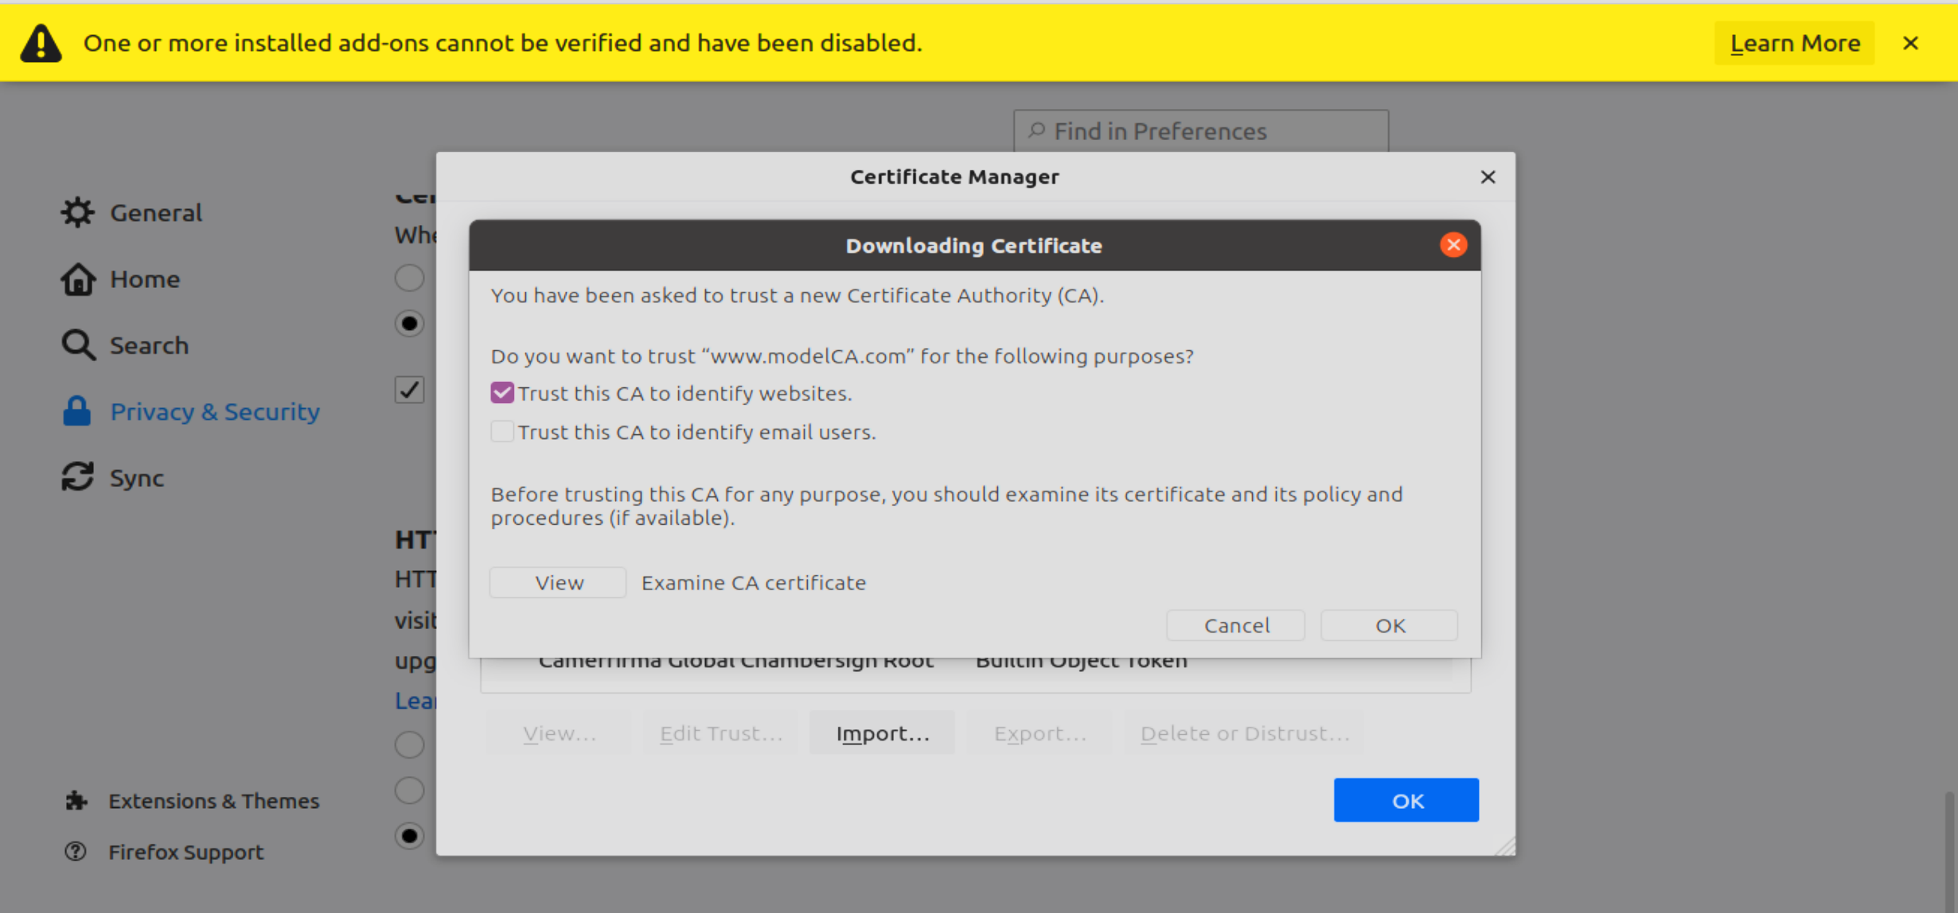
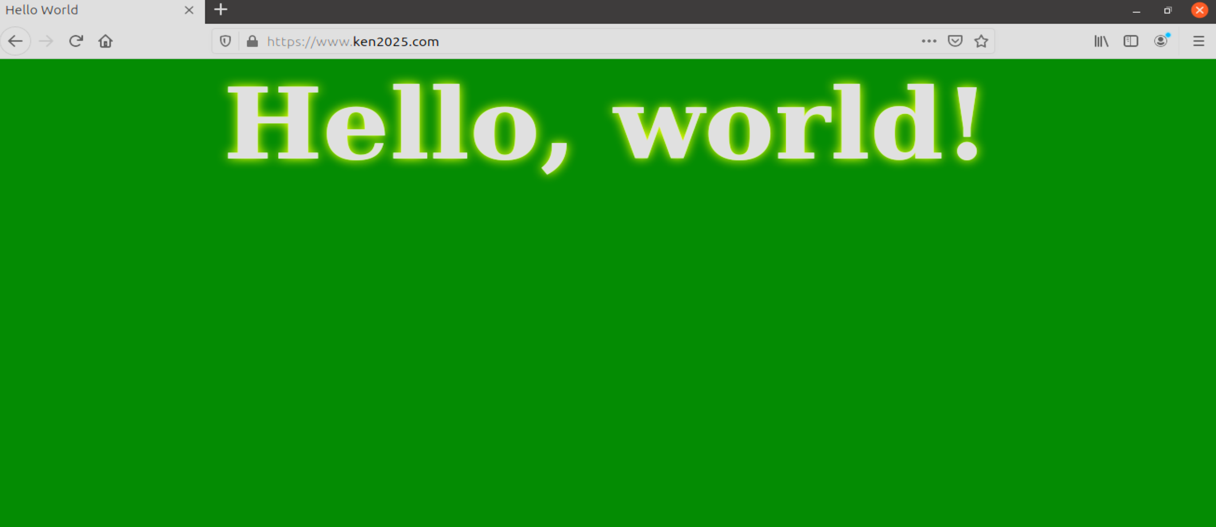

三、实验小结
（提示：主要包括实验总结、有待改进之处、实验体会）

本次实验通过实践操作了解到了对于PKI体系建立的流程，对于证书的请求，颁发，以及CA的建立有了详细了解。加强了对于X.509证书、CA、数字签名以及关于如何构建PKI体系的认识。

改进：对于bank32_apache_ssl.conf以及.crt文件的修改可以从文件夹中直接改动或通过vim修改，无需通过cd以及nano操作修改。

教师签字：
日期：

