# Getting Started with OpenWebGlobe Development

Version 1.0: August 20, 2012

Martin Christen, martin.christen@fhnw.ch

## Installing WebStorm

Feel free to use the development environment you think is the best. After evaluating many JavaScript IDEs we think WebStorm is the most suitable to develop OpenWebGlobe.

Download WebStorm from <http://www.jetbrains.com/webstorm/>

After installing you have a trial version 30 days, however OpenWebGlobe Developers/Contributors can get a free license of WebStorm for OpenWebGlobe development. Write to martin.christen@fhnw.ch to obtain your license key.

## Installing Python/Java

**Windows**: download Python 2.7.x (Windows Installer) from: <http://www.python.org/getit/>

**MacOS X**: Python is already included in MacOS X.

## Installing Java Runtime

**Windows**: Download Java Runtime from: <http://www.java.com/en/download/manual.jsp>

**MacOS X**: Open Terminal (Applications/Utilities/Terminal) and enter "java".

## Create a Github Account

If you don't already have a github account you can create one at: https://github.com/

Follow these Steps:

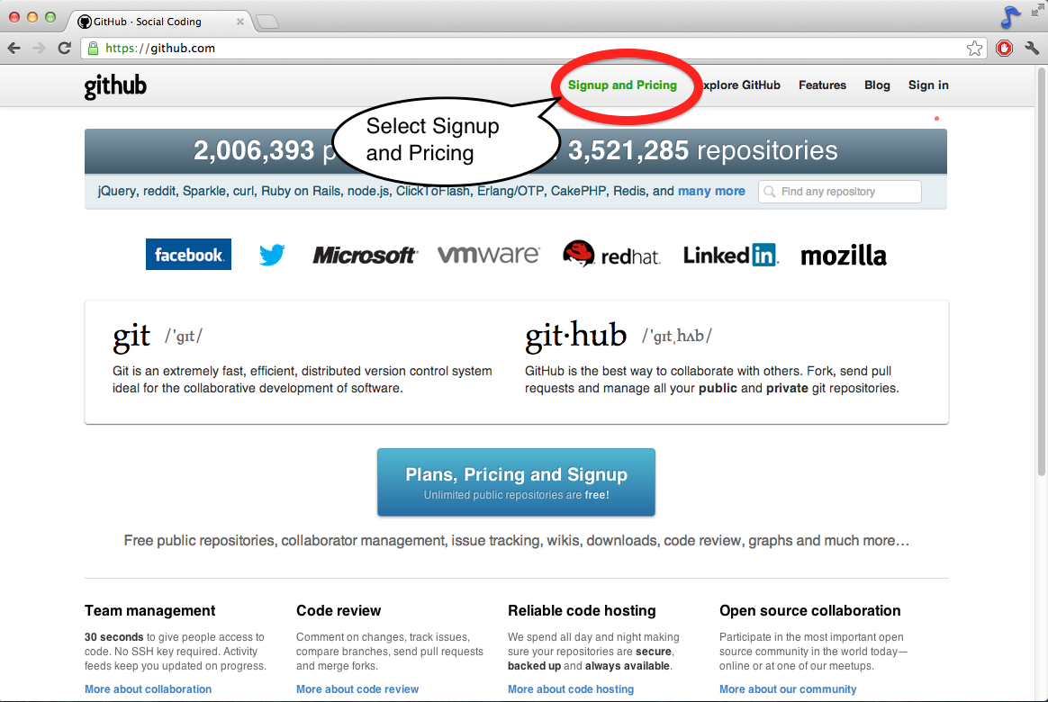

Figure : Select Signup and Pricing

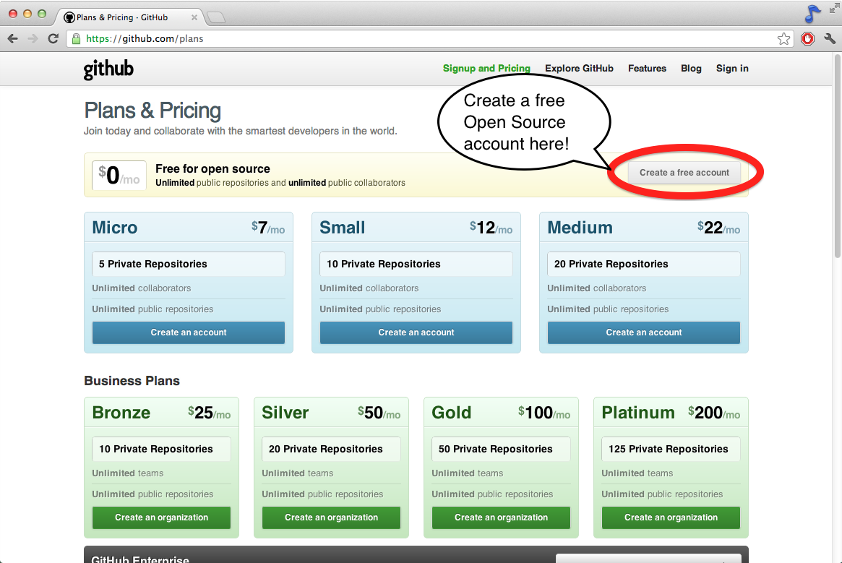

Figure : Create a free open source account!

After selecting your plan you fill out your name, email and password.

## Download github Application

**Windows**: <http://windows.github.com>

**MacOS X**: <http://mac.github.com/>

#todo

## Download OpenWebGlobe WebViewer

#todo