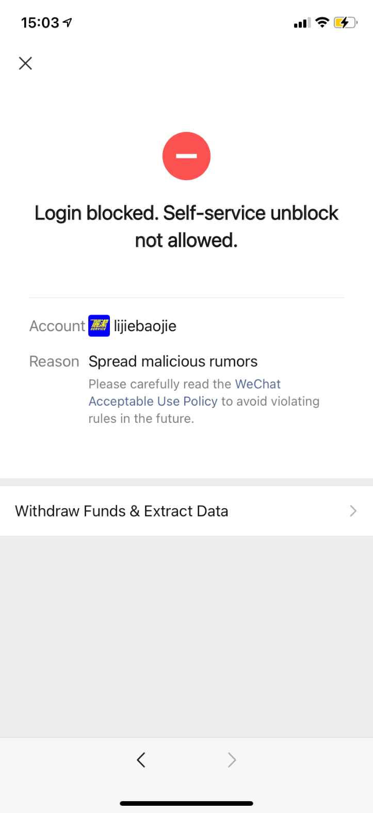
Li Yuejin’s WeChat account is disabled, due to her activist activities on WeChat.
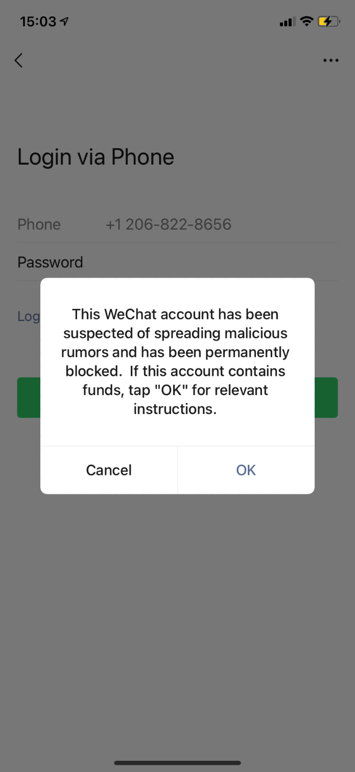
See information above

