https://faluninfo.net/persecution-of-falun-gong-intensifies-ahead-of-winter-olympics/

Opening ceremony at the National Stadium in Beijing, 2008.
Persecution of Falun Gong Intensifies Ahead of Winter Olympics
01-17-2022
With the Winter Olympics in Beijing fast approaching, the Chinese Communist Party (CCP) has begun yet another round of campaigns of what the Party calls “maintaining social stability.” Falun Gong practitioners in the three Games zones of Beijing, Yanqing (a rural District in Beijing), and Zhangjiakou in Hebei Province have especially been targeted.

Current circumstances mirror trends seen in the 2008 Olympics. Following the 2008 Olympics, where over 8000 Falun Gong adherents were arrested for their faith and at least one hundred died in the same year.

The aftermath of the 2022 Olympics could be even more devastating if the trend continues.

“[Following the 2008 Olympics,] The [increased] persecution of Uyghur Muslims and, to a lesser extent, faithful Christians, is carried out by many of the same people, with the same tactics, that the Falun Gong have endured for decades: mass imprisonment, torture, forced labour, religious de-conversion and, perhaps, organ harvesting,” noted filmmaker Caylan Ford and human rights lawyer David Matas in a recent article.

Millions of Dollars Funding Repression
Plans for “Olympic security” began as early as 2020, according to Minghui.org, which received leaked information on the “Zhangjiakou Police Department 2020 Budget”.

Scenery from Zhangjiakou City, in Hebei Province, China. Known for its varied topography, Zhangjiakou City will host the majority of skiing and snowboarding events during the 2022 Olympics.
This document estimated expenditure of 481 million yuan ($72.3 million USD) for 2020. This was a 5.1% increase from the previous year and its primary reason was to prepare for the 2022 Winter Olympics. Among the funding dedicated to the domestic security bureau, Falun Gong was listed as the primary group to be targeted.

The document further explained that the budget increase should cover big data infrastructure costs, public security video surveillance funding, and auxiliary police expense. In particular, 16 million yuan ($2.47 million) was appropriated for big data infrastructure while 18 million yuan ($2.74 million) went to video information platforms with new surveillance cameras to be installed at 3,680 locations.

Present Impact
An increasing number of Falun Gong practitioners have been arrested or surveilled in the last two months.

A recent case is Ms. Cao Wen, mother of international student Jack Liu, who studies at the Carleton University in Canada.

Jack told The Epoch Times on Dec. 29 that his mother remains under close police surveillance. This is since being released after five-day detention for sending Falun Gong materials over Bluetooth on Beijing subways. (This is one way Falun Gong practitioners in China raise awareness of the persecution).

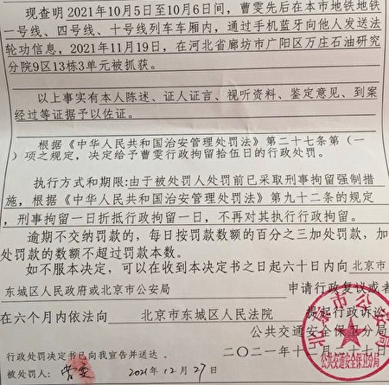
The penalty notice against Falun Gong practitioner Cao Wen, issued by Beijing Public Security Bureau on Dec. 27, 2021. (Courtesy of Jack Liu)
Minghui.org also received many other reports of harassment or arrest in Beijing and Zhangjiakou City in Hebei.

Ms. Han Fei from the Chaoyang district, home to the National Stadium, has been followed and monitored since November. It is said that quite a few practitioners from the area had been arrested.
Police officers from the Yanqing Districts have also arrested and harassed Falun Gong adherents.

The Wei County Police Department in Zhangjiakou City has also been holding events since the beginning of December to defame Falun Gong practitioners. They are also offering financial rewards to ordinary citizens for reporting practitioners.

Several Falun Gong practitioners have since been arrested, including a woman’s non-practitioner husband, who may face charges for helping his wife transport materials intended for use to produce New Year calendars with Falun Gong phrases.

Lessons From 2008: Negligence Feeds Atrocity
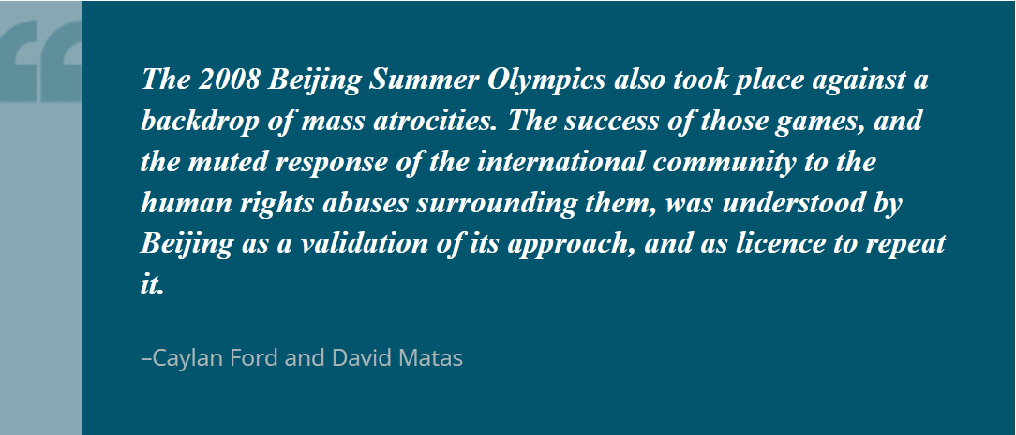
Documentary filmmaker Caylan Ford and human rights lawyer David Matas recently wrote an article titled, “Keeping Our Eyes Open to China’s Machinery of Repression.” They noted in the aftermath of the 2008 Olympics, the machinery of oppression that was built to crush Falun Gong has metastasized. That is, it has become a permanent feature of the Chinese Communist Party’s governance apparatus.

In the past 20 years, Falun Gong believers were the largest group of prisoners of conscience in China, with hundreds of thousands, and probably millions of victims. “In prisons, forced labour camps, and reeducation centres, they are subjected to high-pressure tactics to forcibly ‘transform’ their minds, including beatings, sleep deprivation, sexual humiliation and rape, suspension in stress positions, shocks with electric batons, and injections with unknown psychotropic drugs,” the pair noted.

These same techniques of repression are now being used against other ethnic and religious groups, political dissidents, and even ordinary citizens in China.

Although the United States, Canada, the UK, and other world players have announced diplomatic boycotts of the upcoming Winter Olympics,

“The success of those games [in 2008], and the muted response of the international community to the human rights abuses surrounding them, was understood by Beijing as a validation of its approach, and as licence to repeat it.”

Based on an original report from Minghui.org:

