https://www.state.gov/statement-on-china/

JULY 18, 2019
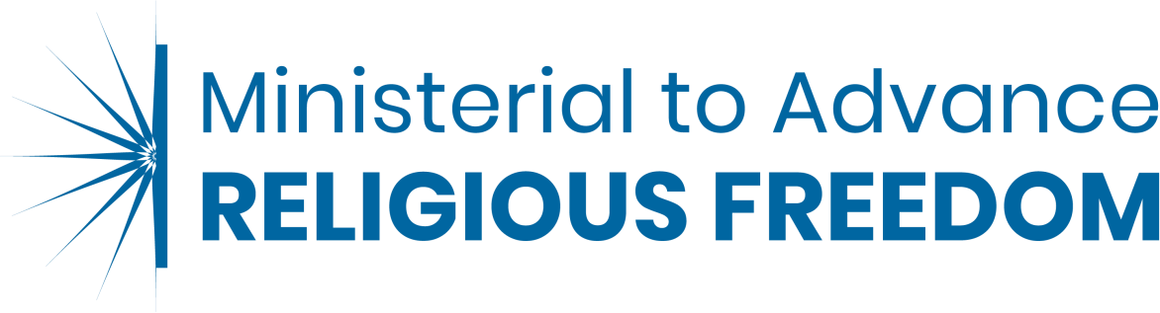

Ministerial to Advance Religious Freedom

Statement on China

As representatives of the international community, we are deeply concerned about China’s escalating, widespread, and undue restrictions on religious freedom, and call on the Chinese government to respect the human rights and fundamental freedoms of all individuals. Many members of religious groups in China – including ethnic Uighur, Kazakh and other Muslims, Tibetan Buddhists, Catholics, Protestants, and Falun Gong – face severe repression and discrimination because of their religious beliefs.

These communities regularly report incidents in which authorities have tortured, physically abused, arbitrarily arrested, detained, and tried and sentenced without legal safeguards adherents of both registered and unregistered religious groups for activities related to their religious beliefs, affiliations, and peaceful practices. Authorities also restrict travel for members and interfere with the selection, education, and veneration of the leaders of many religious groups. Tibetan Buddhists and all other faith communities should be able to select, educate, and venerate their religious leaders without government interference. We are concerned by the Chinese Communist Party’s longstanding efforts to suppress Muslims’ and Tibetan Buddhists’ religious, linguistic, and cultural identities.

We are deeply alarmed by the highly repressive campaign against Muslims, including Uighurs, ethnic Kazakhs, Kyrgyz, and members of other Muslim minority groups in Xinjiang. We are particularly concerned that the Chinese government has detained more than one million individuals in camps since April 2017, where they are subjected to “reeducation.” In these camps, the Chinese government requires individuals to renounce their ethnic identities and religious beliefs, and refrain from prayer and other cultural and religious practices. These arbitrary detentions have lasted from months to years without procedural protections or contact with families. We have received many credible reports of deaths in custody and allegations of forced labor, torture, and inhumane conditions. We call for an end to China’s mass detentions and its repressive controls on the cultural and religious practices and identities of members of religious and ethnic minority groups.

We also call on the Chinese government to cease its crackdown on churches that have not registered with the government-controlled Three-Self Patriotic Movement. We call on China to release the Early Rain leader Pastor Wang Yi and two elders, and to allow religious believers of all churches to exercise their right to religious freedom. We urge the Chinese government to end

a clampdown on believers trying to exercise their rights to freedoms of expression and association.

We strongly urge the Chinese government to protect the internationally recognized right to religious freedom of all individuals and to respect the human rights of members of all religious groups in accordance with China’s human rights commitments. Doing so will further peace, security, and stability in China and among its neighbors.
Co-Signatories: Canada, Kosovo, Marshall Islands, United Kingdom, United States of America

2

