https://www.business-standard.com/article/international/china-seeks-common-stand-with-iran-on-afghanistan-under-taliban-121090500414_1.html
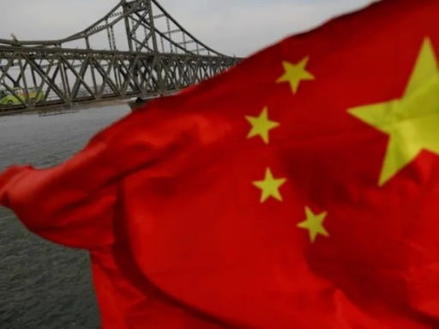
China is already coordinating its evolving policy on Afghanistan with its all-weather ally Pakistan and Russia which also share borders with Afghanistan.
China seeks common stand with Iran on Afghanistan under Taliban
September 5, 2021
A wary China is seeking to strike a common position with Afghanistan's key neighbour Iran to firm up its growing role in the war-torn country as it waits for the Taliban to form an open and inclusive government that makes a "clean break" from all terrorist groups.
China is already coordinating its evolving policy on Afghanistan with its all-weather ally Pakistan and Russia which also share borders with Afghanistan.
Beijing, which has kept its Embassy open in Kabul along with Pakistan and Russia, is awaiting the formation of a government by the Taliban to decide on recognising it amidst firm indications by the US, the UK and other western countries that they will not be in a hurry to endorse the new government.
China is also keeping a close watch on the Panjshir Valley fighting between the Taliban and the militias of Ahmad Massoud-led National Resistance Front (NRF) which has reportedly delayed the formation of the new government in Afghanistan.
On Saturday, Chinese Foreign Minister Wang Yi held a telephonic conversation with his Iranian counterpart Hossein Amir-Abdollahian.
Iran, which is struggling under the US sanctions over its nuclear policy, has warmed up to China in recent years with Beijing steadily expanding its investments in the oil-rich nation which shares its borders with Pakistan.
In his talks with Amir-Abdollahian, Wang said China has noted that the Taliban might announce the formation of a new government in the coming days.
He hoped that the the new government will be open and inclusive, make a clean break with terrorist organisations, and establish and develop good relations with other countries, especially neighbouring countries, according to a press release issued by the Chinese Foreign Ministry.
As common neighbours of Afghanistan, China and Iran need to strengthen communication and coordination to play a constructive role in achieving a smooth transition and peaceful reconstruction of Afghanistan, he said.
Wang has also lashed out at the US, saying that the claim of the United States that the withdrawal from Afghanistan allows it to shift its focus to China and Russia not only serves as an excuse for its own failure, but also reveals the nature of its pushing for power politics in the world.
If the US is unable to learn due lessons, it is bound to make mistakes more serious than those in Afghanistan, Wang warned.
Amir-Abdollahian said that the root cause of the chaos in Afghanistan is the irresponsibility of the US.
Iran also holds that Afghanistan should establish a broad and inclusive government reflecting the interests of all ethnic groups in the country, the press release quoted him as saying.
The Iranian side calls on the international community to spare no effort to provide humanitarian assistance to Afghanistan and prevent any turmoil in Afghanistan from triggering a wave of refugees, he said, adding that Iran is ready to strengthen coordination with China to help Afghanistan get out of difficulties at an early date.
Since the Taliban seized power in Afghanistan, China has been vocal in expressing its concern over the Uygur militants of the East Turkistan Islamic Movement (ETIM) fighting for the independence of Xinjiang, regrouping in Afghanistan under the rule of the Afghan militant group as the volatile province shares a narrow border with the war-ravaged country.
Beijing has already extracted a firm commitment from a Taliban delegation headed by Mullah Abdul Ghani Baradar during a visit to China in July that they will not permit the ETIM to operate from its soil.
China, at the same time, is eyeing the extension of its USD 60 billion China Pakistan Economic Corridor to Afghanistan besides exploiting the mineral-rich mines there.
The Taliban has already said that China has a big role to play in Afghanistan in the reconstruction of the war-raved country.
China is a big country with a huge economy and capacity. They can play a big role in rebuilding, reconstruction of Afghanistan, Taliban spokesman Suhail Shaheen told China's state-run China Global Television Network in an interview recently.
We have relationship with China and Russia during the past years. We have told them they should not have any concern from Afghanistan, he added.

