https://www.npr.org/sections/goatsandsoda/2022/02/17/1080115082/the-mystery-of-the-chained-woman-in-china
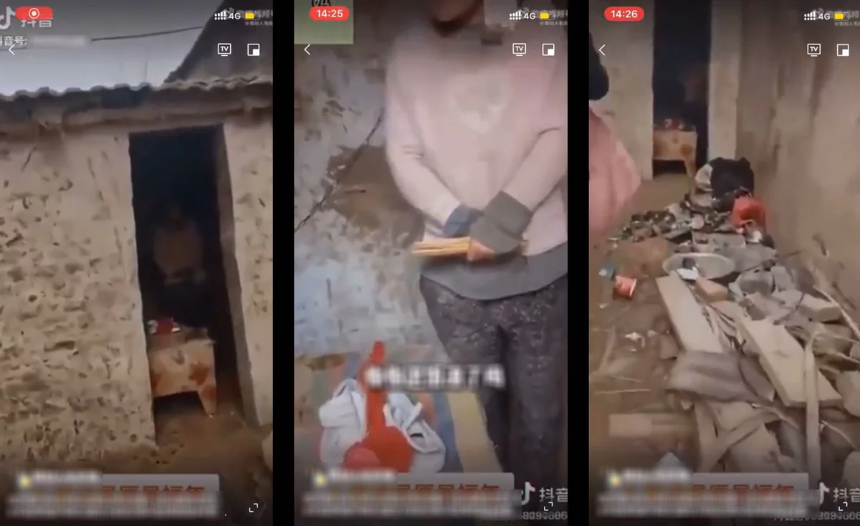
Three screen grabs from a video that recently went viral in China show a woman chained to a wall in a doorless shed in a rural Chinese village. The video got nearly 2 billion views and has prompted a heated discussion about the trafficking of women.
Screen grabs by NPR/TikTok
The mystery of the chained woman in China
February 17, 2022
BEIJING — The video begins cheerfully, with upbeat music and shots of a quaint, rural village. Then the phone camera pans to a disheveled woman mumbling incoherently, shivering slightly in the winter cold. A chain runs from her neck to a wall inside a doorless shed.
She had been found by a vlogger who seeks out subjects living in poverty to raise internet donations for them. The video of her that he posted on Jan. 28 on Douyin (the Chinese version of TikTok) exploded, generating an estimated 1.92 billion clicks on different social media platforms.
The video sparked public outrage, a provincial investigation and a soul-searching national conversation about the ubiquity of human trafficking in China. It has also inspired a wave of amateur muckraking, after internet users began to question how the woman had ended up in chains in a rural village in eastern Jiangsu province.

The same day the video came out, officials in Feng county, where the woman lives, released a statement about the woman. They said that her family name was Yang, that she had been tied up because of her violent fits, that she had married a man named Dong in 1998 and that together, they had eight children.
Thousands of internet users pushed back against this explanation. They wondered: How had Yang managed to birth eight children under strict national birth policies that until 2016 had restricted families to only one child? Was there any evidence she had been abused or trafficked — sold as a bride under fraud or coercion?
China's domestic media has been decimated by censorship and political controls, causing many of the country's top investigative journalists to leave the profession in the last decade. Demanding answers, internet users had to dig into the story on their own.
Two women go on a mission to show support
Wuyi and Quanmei, two friends living in China's Anhui and Jiangsu provinces, respectively, followed Yang's case closely. Six days after the video went viral, they jointly wrote a short message of support to the woman on their social media pages: "The world has not abandoned you. Your sisters are coming!"
Then the two women packed up their car and drove to Feng county. They hoped to visit Yang, who according to authorities had been hospitalized. They also posted daily online updates of their journey, in the vein of China's citizen bloggers who frequently cover major news events in the absence of an independent domestic press corp. They scrawled messages in red lipstick on their car doors, urging people to pay attention to Yang's case.
"Have you ever seen the righteous ardor of a woman? Have you ever seen the power of women?" Wuyi wrote.
Meanwhile, disturbing stories were starting to emerge from Feng county suggesting women are routinely trafficked there and forced to marry local men.
"My aunt was trafficked from Sichuan province to marry my uncle. After giving birth to a son, she ran away," one Feng county resident recalled in a post on Weibo, a Chinese social media platform, admitting that human trafficking is quite common in villages like Feng and widely accepted by county residents. "Villagers are themselves the children of trafficked women. Do you think they should revolt and put their own fathers in prison?"
"No one had ever wondered why this happened, because to them it is natural for men to benefit and for women to suffer," wrote a Feng county resident who called herself Luodan. She claimed local people who had two children — permitted in rural areas if the first child was a girl — used to marry off their daughter for a large dowry payment, which the family then used to purchase a trafficked woman for their son to marry.
Another woman chimed in that local officials had looked the other way when her mentally ill mother had been allegedly trafficked — "picked up" by a villager in a neighboring province, given a new false identity and forced to live with a man who sexually abused her for a decade.
"Our family and my mother are victims, but we were blackmailed by the local government," she wrote. Her post was censored from the internet within days.
Meanwhile, Wuyi and Quanmei were quickly encountering state obstruction. They said that local hotels refused to let them check in — and that police officers even confiscated one hotel's front desk computer to prevent the two women from making a reservation. They posted on Weibo that they resorted to sleeping in their car, parked outside the hospital where Yang was allegedly being treated.
Their social media posts, documenting street interviews with Feng county residents and their confrontations with local police, racked up thousands of likes and reshares before internet censors quickly blocked the women from posting. So they simply opened new social media accounts. (They also declined an interview request from NPR but did not give a clear reason why.)
When reporters from a Hong Kong outlet tried to visit Yang, they found that nonresidents were banned from entering her village and that her family home was guarded by plainclothes security. Not a single Chinese mainstream outlet has reported on the case yet.
Why trafficking persists in China
Decades of China's one-child policy has created enormously skewed gender ratios because parents historically have favored boys over girls. (There are just 100 women for every 105 men in China, or 34.9 million more men than women, according to China's last national census, in 2020.)
The discrepancy has exacerbated the practice of single men purchasing trafficked women from remote areas like Yunnan and Sichuan provinces or from Southeast Asian countries and North Korea.
"The profound reason behind the trafficking of women is gender inequality," says Feng Yuan, the director of Equality Beijing, a Beijing-based nongovernmental organization that assists victims of gender-based violence. "Some people still treat women as property, as objects that can be traded and as a tool for a patrilineal inheritance."
China has been working on prohibiting human trafficking for years, but the practice remains endemic. Traffickers face sentences ranging from a minimum of five years in prison to the death penalty, depending on the gravity of the case. However, purchasing trafficked people was not covered by criminal law until 1997, and a serious loophole allowed the crime to avoid prosecution until 2015, after which a purchaser now faces a maximum three-year prison sentence — a lighter punishment than that for purchasing an endangered wild animal, legal experts point out.
Back in Feng county, local officials repeatedly denied that Yang had been trafficked. They published a second statement on Jan. 30 claiming she had been a young, schizophrenic street beggar who was taken in and adopted by a man and then married to his son.
By contrast, Yang's husband, Dong, had branded himself as a model parent of eight. He posted daily videos of himself dressing his children or feeding them from a giant wok on several social media accounts he ran to generate charitable donations. Yang was never shown in his videos.

The question of how he fathered so many children in a country that only recently lifted its one-child policy was addressed in this second statement by officials, noting that contraception had failed and that Dong had been avoiding birth control administrators.
"Trying to cover up everything by claiming the woman is mad is ridiculous," wrote Peng Ruiping, a well-known legal commentator and criminal lawyer. Mental disorders remain heavily stigmatized in rural China, and women with mental illness are also more likely to become trafficking victims, according to research done at Beijing's Renmin University.
Wuyi and Quanmei were also not convinced by the story of the woman being adopted. They questioned how Dong had obtained a marriage certificate and whether Yang had voluntarily married him and given birth to his children. "Do public servants not know the law which says a man who has sex with a mentally ill woman can be suspected of rape?" wrote Wuyi.
An unexpected twist
In early February, Xuzhou city issued a bombshell statement, refuting its own explanations on how the woman had ended up in Feng county, in China's Xuzhou city.
The family name of Yang was false, the city admitted. The woman's real name, they believed, was Xiaohuamei — which means "little plum blossom." It was also the name of a woman who had been reported missing from Yagu village, a small hamlet in southwestern Yunnan province, on the border with Myanmar. And somehow, she had ended up shackled and freezing some 1,800 miles away from home.
More information on this case has been released, although it doesn't necessarily shed light on what happened that led to this woman being chained in a shed.
In a third statement, government investigators claimed that sometime after 1996, the woman's mother had requested that a local villager named Sang bring a young Xiaohuamei to Jiangsu province to seek medical treatment for an unknown ailment.

Then, somehow, Sang lost track of Xiaohuamei in Jiangsu.
The statement noted that Xiaohuamei's parents are now deceased.
Once again, this explanation struck internet users as odd. Thousands of skeptics wrote online: Why would a mother entrust her daughter to a stranger and ask that she bring the child for medical care so far from home? Was Xiaohuamei even her legal name?
"This is probably the longest-running and most followed women's rights topic in China in recent years, making it impossible this time for the local authorities, who could have fooled the public in the past, to make excuses," says Feng, Equality Beijing's director.
Finally, on Feb. 10, the city of Xuzhou confirmed it had arrested Xiaohuamei's husband on suspicion of illegal detention of his wife and had arrested Sang, the villager, and her husband on suspicion of human trafficking. The city's online statement garnered more than 300 million views, making it the top trending topic on social media, exceeding public interest in the Winter Olympics that week.
"We really should not stand by and watch. If we do not speak up for those who are suffering, when misfortune happens to us or our relatives, who will speak up on our behalf?" wrote a Weibo user, one of nearly 152,000 people who left comments underneath the statement.
Wuyi and Quanmei, the two women who drove down in an attempt to visit the woman named Xiaohuamei, left warm comments of support as well. But the next day, they were detained by police in Feng county for "picking quarrels and provoking trouble," a catchall legal term frequently used by local authorities to stop political irritants. They have since been released from detention.
The whereabouts of the woman who authorities claim is Xiaohuamei are also uncertain. Authorities say she remains hospitalized for mental health treatment, unable to take media interviews. Her silence has left questions swirling about her identity.
Ma Sa and Tie Mu, two former investigative journalists, managed to visit the border village in Yunnan province that authorities identified as Xiaohuamei's hometown.
What they found suggests the story is not over. A woman who was identified as Xiaohuamei's half sister, her closest living relative, said she has yet to see the results of a DNA test that authorities had conducted to determine if the chained woman was in fact related to her. But nothing about the woman in the Xuzhou hospital reminded her of her long-lost sister, said the half sister.
"I cannot recognize her from the videos and pictures," she said. "But if they are sure she is my sister, I would definitely like to visit her."

