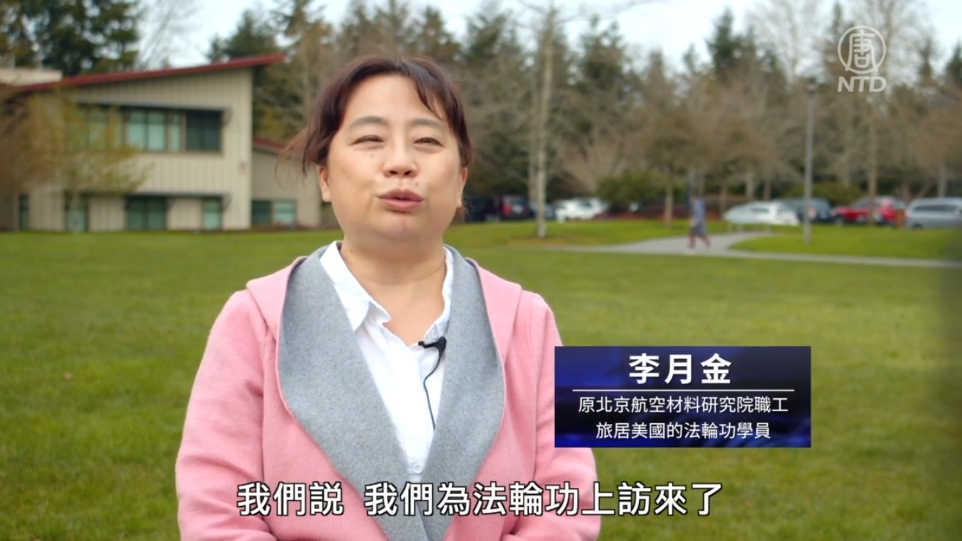
Li Yuejin, while being interviewed by NTDTV, talking about her experiences as a Falun Gong practitioner in Beijing (04/24/2022)
https://www.ntdtv.com/gb/2022/04/24/a103408816.html

