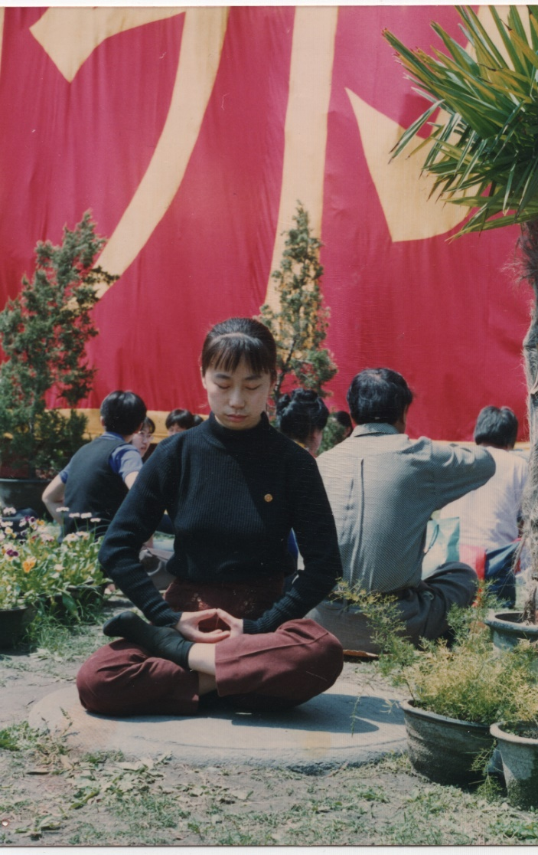
Li Yuejin, practicing Falun gong at a park, [Time?, Place?, Why?]
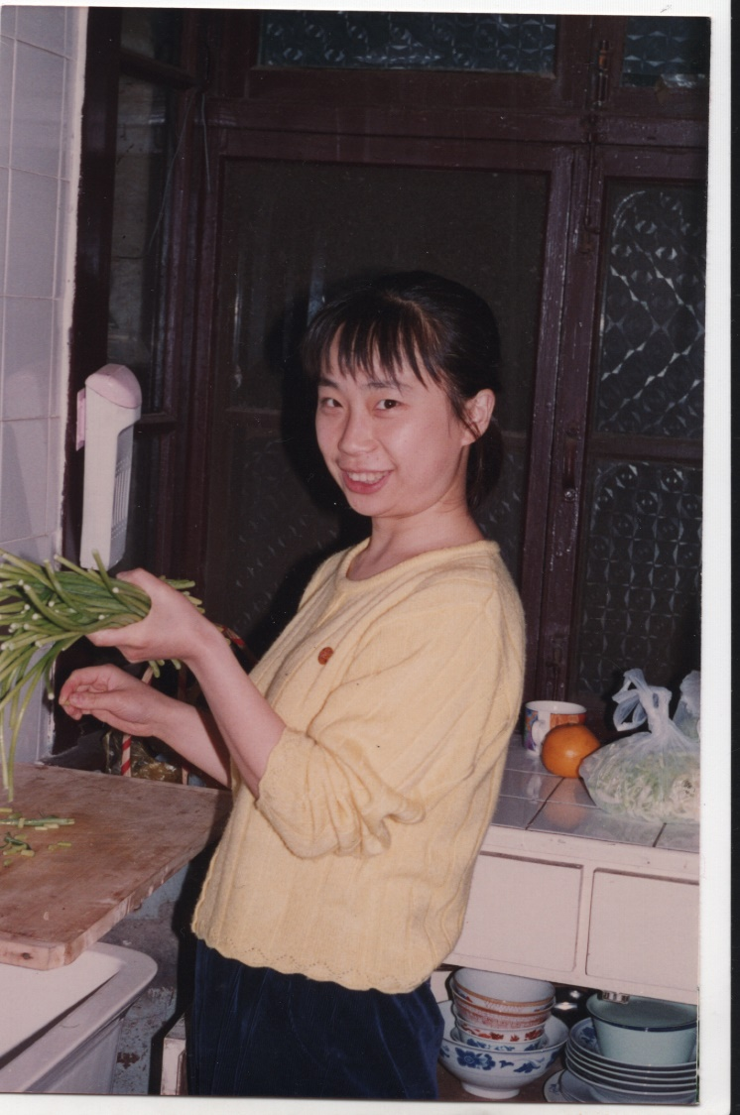
Li Yuejin, seen wearing a Falun Gong pin [Time?, Place?, Why?]
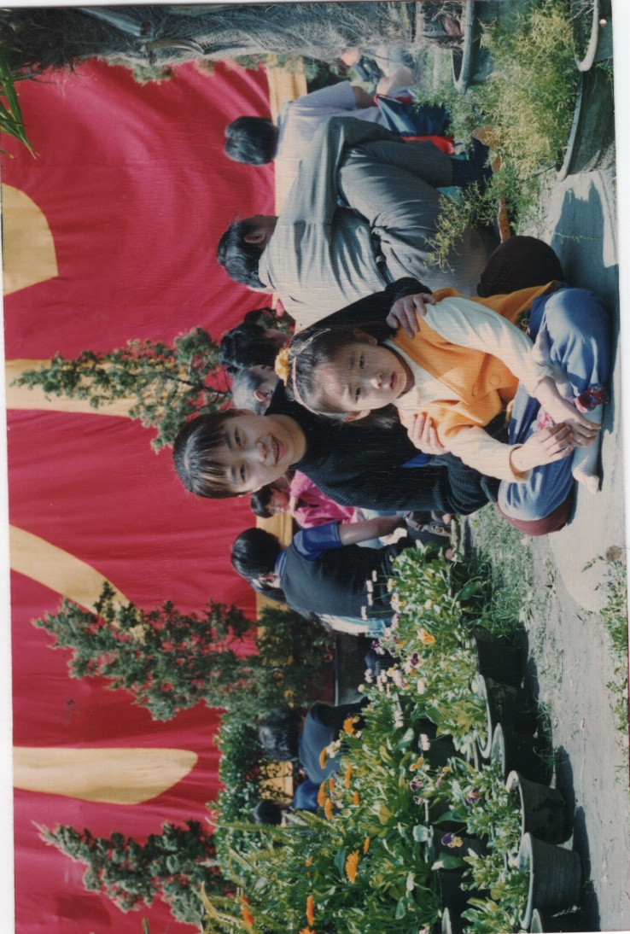
Li Yuejin, with her niece at a Falun Gong practicing event[When, Where, Why]

